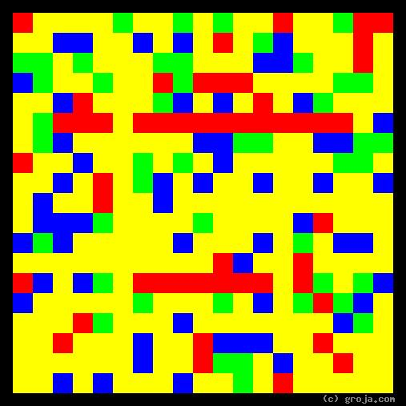
Han Solo
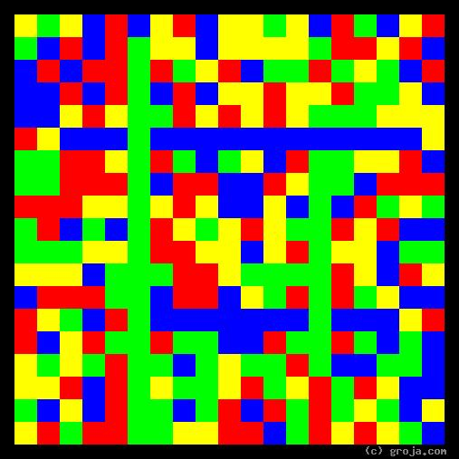
Princess Leia Organa
Comparing Grojas¹: Princess Leia and Han Solo
By Tom W. Hartung, 2018.
These spiritual portraits of Princess Leia Organa and Han Solo, from the original Star Wars trilogy, show they are opposites, for the most part.
______________________
(Interesting, they look kind of like JFK and LBJ!)
______________________

¹ Grojas are Graphical Representations of Jungian Archetypes. Grojas are images composed of four primary colors, put into rectangular shapes, and they depict the essential personality functions everyone exhibits to at least some degree. These personality functions are traits initially identified by Carl Jung in his writings about psychological types in the early 1920s, and more recently made popular by psychologists such as Isabel Myers Briggs and David Keirsey. For more information, consult StarWars.com, Groja.com, SeeOurMinds.com, the Wikipedia, or your favorite search engine.

