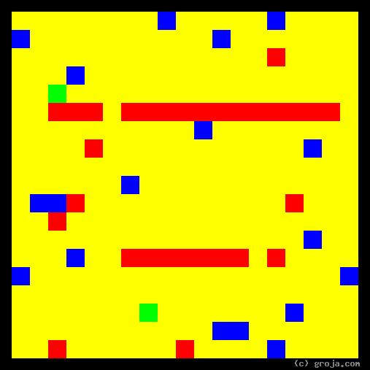
Norm Peterson
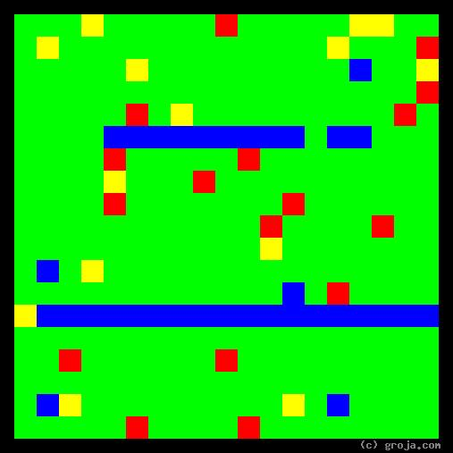
Lilith Sternin
Comparing Grojas¹: Lilith Sternin and Norm! Peterson
- or -
Polar Opposites: Lilith and Norm!
By Tom W. Hartung, 2018.
The images above are Grojas¹ – images representing the personalities of Lilith Sternin and Norm Peterson from the show Cheers.
A single color dominates each of these images, with Lilith’s portrait containing mostly Green, and Norm’s portrait containing mostly Yellow. The preponderance of a single color in these images reflects the fact that Lilith and Norm have extreme personalities.
These spiritual portraits also show how different the personalities Norm and Lilith are, with the very logical, decisive Lilith’s image contrasting strongly with the very down-to-earth, open image of Norm’s personality. Norm and Lilith are not just different, they are extreme, polar opposites.
Norm! and Lilith
Norm Peterson is Cheers’ most popular customer, and was frequently greeted with a shout of “Norm!” upon walking into the bar. He appeared in all 275 episodes and, after a few seasons, picked his favorite bar stool and claimed it as his own. When the series starts, Norm is an accountant, but as it progresses he finds it more and more difficult to find work. It becomes clear that Cheers is the only thing Norm is passionate about, so he eventually winds up just hanging out there full-time.
Lilith Sternin’s introduction to Cheers comes on a date with Frasier Crane, who spent some time as Diane Chambers’ boyfriend. It’s easy to see how Frasier would turn to a decisive woman like Lilith after being dumped by the indecisive Diane. Lilith is a psychiatrist, and in the episode Rat Girl she shows how difficult it is for her to show emotion when mourning the death of one of the subjects of her experiments: Whitey, her favorite rat.
Lilith’s Sea of Green
These spiritual portraits use a long horizontal line in the bottom half of the image to depict an introvert’s dominant preference. The long Blue horizontal line in Lilith’s portrait represents her openness to ideas. Her decisiveness plays a bigger role in her persona, that is, her public self, than her openness to new ideas. This is because her openness is directed inwards rather than outwards, explaining why Lilith’s image is a sea of Green rather than Blue.
In these images, Green and Red depict decisiveness. The Green in Lilith’s portrait shows she is much more logical than emotional. And indeed, although it becomes apparent she can see the humor in irony, and feels sorrow when her favorite rat dies, she has a great deal of trouble when it comes to laughing and expressing sorrow.
As with all introverts, there is more to Lilith than meets the eye. Most significantly, she is intelligent: as a psychiatrist, her life’s work is to take abstract theories and use real data to confirm or refute them. And as a woman and a human being, Lilith has emotions, she just doesn’t have a lot of experience expressing them.
In the episode Abnormal Psychology, Diane gives Lilith a makeover, getting her to let her hair down – both literally and figuratively. Fully aware of the cliché, Frasier admits to reacting like a “Pavlovian Dog.” He takes Lilith in his arms, they leave the bar together to “be animals,” and in a later episode viewers learn they have gotten married.
Norm’s Sea of Yellow
These spiritual portraits use a long vertical line in the left half of the image to depict an extravert’s dominant preference. Norm’s preferences are so strong, the long Yellow vertical line in his image is lost in the sea of Yellow.
In these images, Yellow and Blue depict openness. The vast amount of Yellow in Norm’s portrait shows he is much more open to new experiences than to new ideas. He demonstrates this preference when, like most of the rest of the gang at Cheers, he shows much more interest in down-to-earth pursuits like sports and women than in theoretical sciences such as psychology and psychiatry.
As a full-time barfly, Norm has no interest in making decisions, and his image has very little of the decisiveness represented in these spiritual portraits by the colors Red and Green. As Cheers’ best customer, he enjoys being around people and knows how to be friendly. Hence Norm’s image has more Red than Green.
Norm is outgoing, open, and friendly, and this helps explain why he would trade a career in a field like accounting, that is very logical, for a central position in his favorite bar, surrounded by his friends. How he can get away with this financially is something the viewers never fully learn, but it appears he gets some help from his wife Vera. Also, Norm is the owner of Cheers, Sam Malone’s good friend, so he lets Norm get away with having a very large tab.
Extreme Personalities
Norm and Lilith have virtually nothing in common, other than being customers of Cheers – and having extreme personalities. They have very little reason to talk, but when they do talk during one scene, they get along just fine. In this case it’s safe to say, however, that opposites do not attract.
Because their distinctive characteristics are exaggerated, Lilith and Norm are actually caricatures. Lilith is so straight-laced, cold, and logical that her own husband calls her a “robot,” and Norm is so resistant to making decisions that he does not even have a job during many seasons of the show.
An example of another fictional character with an extreme personality is Margaret Lanterman of Twin Peaks – better known as the “Log Lady.” Her spiritual portrait is like Norm’s, except it is a sea of Blue rather than Yellow.
When it comes to extreme personalities, there are definitely more in Green than any other color. Mr. Spock of Star Trek is one classic example of a very logical individual. Another show with several extremely logical personalities is Game of Thrones. The spiritual portraits of Stannis Baratheon, Tywin Lannister, and his two oldest children Jamie and Cersei all have a sea of Green.
All of these characters differ from Lilith, however, in that the second-most common color in their images is Yellow. Spock and the high-born of Westeros are much more down-to-earth than Lilith.
Extreme personalities such as these may not be realistic, but they can be entertaining and informative. They can also be liberating for people who may be repressing or holding back a side of themselves in an effort to be more “normal.”
Extreme personalities can also help us better understand other people and hopefully – since we live on Earth and not Westeros, where everyone wants to kill everyone else – learn to get along better. And helping people learn to get along better is the main reason I came up with this idea, and is the main goal of my sharing these images.

¹ Grojas are Graphical Representations of Jungian Archetypes. Borrowing ideas about abstract art from the painters Piet Mondrian and Wassily Kandinsky, these images make the psychologist Carl Jung’s ideas about personality visible. Grojas use rectangular shapes of opposing primary colors to depict personal preferences, giving viewers insight into the personalities of themselves and others. For more information about all this, see the Cheers Wiki at cheers.wikia.com, Groja.com, the Wikipedia, SeeOurMinds.com, or your favorite search engine.

