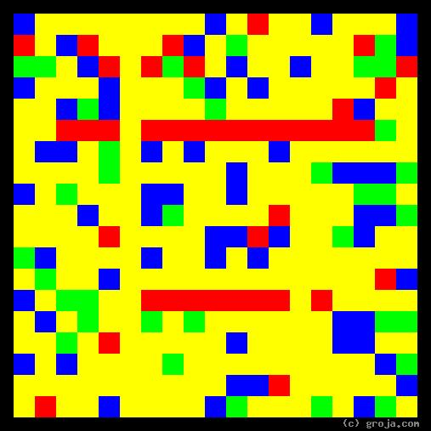
Trixie
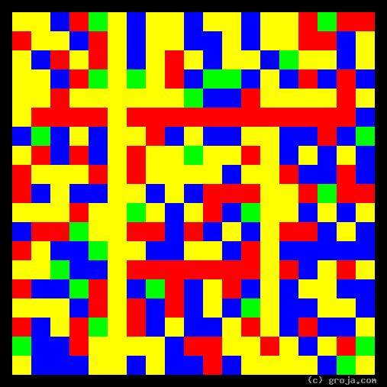
Shae
Comparing Grojas¹: Shea and Trixie
- or -
“It’s a Man’s Man’s Man’s World”
By Tom W. Hartung, 2018.
The images above are Grojas¹ – images representing the personalities of two fictional characters, who happen to share the same profession. They live in two different but fairly primitive worlds, and could well be considered to be among the best at their chosen line of work.
Fans of the show Game of Thrones are familiar with Tyrion Lannister’s favorite girl Shae, and fans of the show Deadwood are familiar with Al Swearengen’s favorite girl Trixie. These spiritual portraits show the two characters have similar personalities, the Yellow and Blue reflecting their openness and the Red depicting their shared preference for emotion over logic.
It is important to realize that having a spiritual portrait that looks like one of the images above doesn’t necessarily mean someone is well-suited to Shae and Trixie’s chosen occupation! For one thing, these primitive spiritual portraits do not incorporate a person’s morals or ethics.
Additionally, another example, albeit an extreme one, of this personality type is Norm Peterson of the show Cheers. And Norm is never anyone’s man – not even his wife Vera’s – much less someone’s “girl.” Yet Norm has a similar personality in that he’s definitely open, rarely making a decision, and is certainly much more warm and friendly than cool and interested in things. But that’s a different story.
The Yellow in Shae’s and Trixie’s images show they are open to new experiences, and the Blue shows they are are open to new ideas. Both of these traits help them to be at peace with and even embrace their choices, even if many members of the societies in which they live have a much different opinion.
It’s clear from these portraits that Trixie is a bit more open than Shae. Evidence of Trixie being more open relative to Shae becomes apparent later in the show, when she actually pursues other career options. Meanwhile Shae is a bit more stubborn, defying Tyrion and ultimately sticking with what she knows best.
The Red in their images represents their passion, which they exercise by choosing to work with people rather than things. In both of the shows’ cultures – in the Westeros of Game of Thrones (that resembles Europe during the Middle Ages) and the circa 1873 South Dakota of Deadwood – women’s options were extremely limited. Unless they are high-born (in Westeros) or willing and able to stay in a big city (as opposed to the frontier town of Deadwood), they have little choice but to look for help from men in order to survive. By choosing to earn their livings by the “world’s oldest profession,” they may sacrifice some of their dignity but they are also able to maintain some of their independence.
(That says about all there is to say, and it’s close to 350 words, which is sufficient, so figure out a way to somehow use the song in the title to wrap it up.)
______________________

¹ Grojas are Graphical Representations of Jungian Archetypes. Composed of rectangular shapes drawn in four primary colors, Grojas depict the essential personality functions and traits Carl Jung identified in his theory of psychological types. For more information about Jung’s personality types, see Groja.com, the Wikipedia, SeeOurMinds.com, or your favorite search engine.

