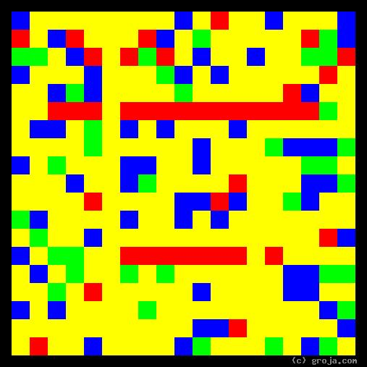
Trixie
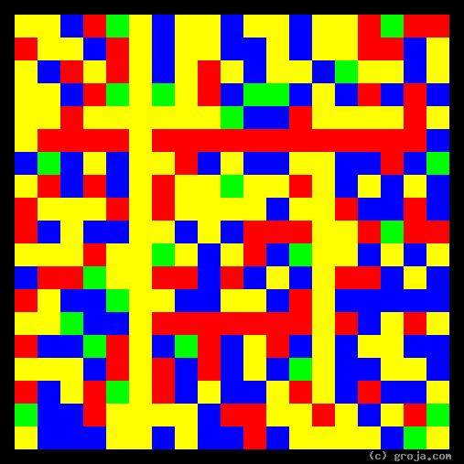
Shae
Comparing Grojas¹: Shea and Trixie
- or -
“The World Moves on a Woman’s Hips”
By Tom W. Hartung, 2018.
______________________

¹ Grojas are Graphical Representations of Jungian Archetypes. Composed of rectangular shapes drawn in four primary colors, Grojas depict the essential personality functions and traits Carl Jung identified in his theory of psychological types. For more information about Jung’s personality types, see Groja.com, the Wikipedia, SeeOurMinds.com, or your favorite search engine.

