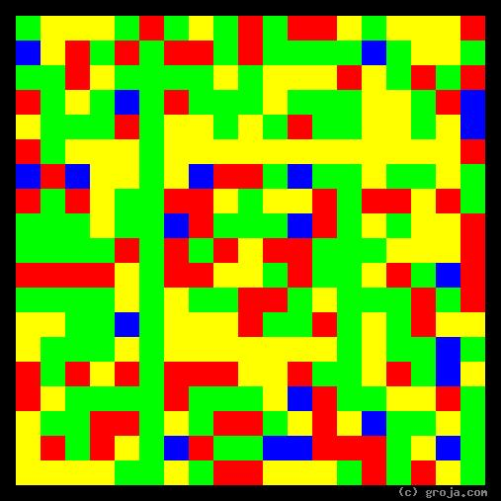
Tony Soprano
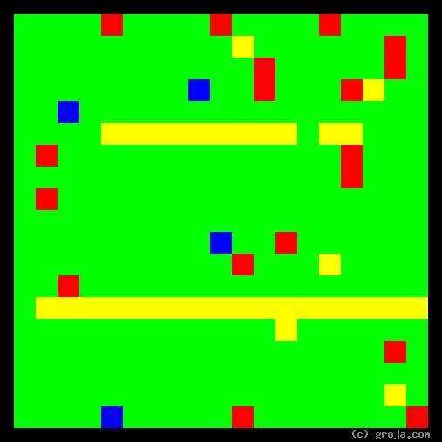
Tywin Lannister
Comparing Grojas¹: Tywin Lannister and Tony Soprano
- or -
“Meet the New Boss, Same as the Old Boss?”
By Tom W. Hartung, 2018.
The images above are Grojas¹ – images representing the personalities of the fictional characters Tywin Lannister, of the show Game of Thrones, and Tony Soprano, of the show The Sopranos. Both shows are examples of the excellent programming HBO has developed over the years.
These spiritual portraits both have a lot of Green and Yellow, showing their personalities are similar. They also show that Tywin Lannister’s personality is much more extreme than Tony Soprano’s.
Note: Tywin appears in only a few episodes of season 1, episodes 4-10 of season 2, 8 of the 10 episodes in season 3, 7 of the 10 episodes in season, and only the first episode of season 5.
For Tony: do we want to rewatch earlier or later episodes – or do we want to rewatch any at all?
Set the scene: who they are and what they do
Tywin is head of the Lannister family. His goal is to have a legacy that will last long after he is dead.
Tony is head of the DiMeo crime family. His goal is to make as much money as possible, and maybe advance in the ranks?
Describe what the colors represent in PERSON 1, and give an example
Green is a good color for a ruler or someone in business, and people who have a lot of it are natural-born bosses. It’s rather like they have so much decisiveness they need to use it on others.
Because logic is the same for everyone, people are more likely to support someone who is logical and makes objective rather than personal decisions.
So Green is a good color for a boss.
Yellow is also a good color for a ruler or someone in business, because it represents pragmatism. Realistic people outnumber idealists in the cultures portrayed in these shows, so people are more likely to support a boss who is down to earth than someone who has their head in the clouds.
So Yellow is also a good color for a boss, but Green is better, because frequently a bad decision is better than no decision. And both these images share those emphases.
Describe what the colors represent in PERSON 2, and give an example
Same for Tony as for Tywin.
What do they have in common?
Both are bosses, but Tywin a much bigger boss than Tony.
What makes them different?
Treatment of family: compared to Tywin, Tony is actually a great parent.
What makes their relationship unique? (N/A – or mention HBO??)
Is there anything else interesting and specific to this pair of images? (I think we covered that already!)
Conclusion:
Song by the Who – bosses are all similar, but different.

¹ Grojas are Graphical Representations of Jungian Archetypes. Combining ideas from Carl Jung and painters such as Piet Mondrian and Wassily Kandinsky, Grojas use rectangular shapes of opposing primary colors to depict personal preferences. For more information about all this, see Groja.com, the Wikipedia, SeeOurMinds.com, or your favorite search engine.

