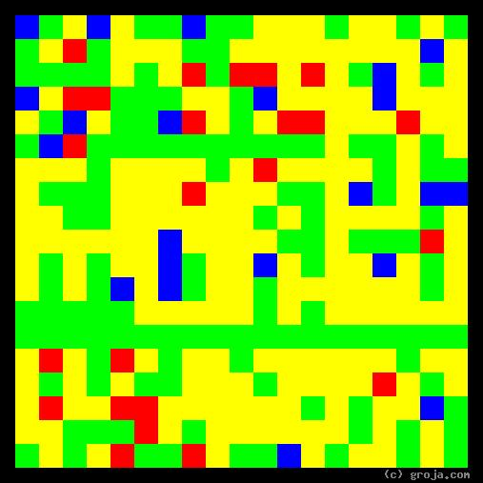
R2-D2
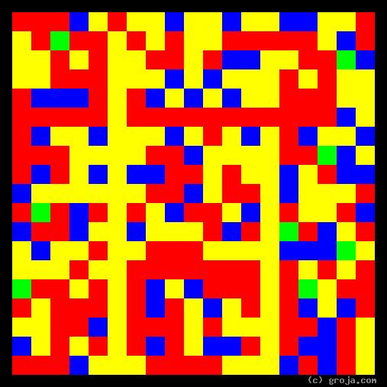
C-3PO
Comparing Grojas¹: C-3PO and R2-D2
By Tom W. Hartung, 2018.
These spiritual portraits of the original Star Wars droids C-3PO and R2-D2 show how different their personalities are. As a protocol droid, C-3PO is fluent in a large number of languages and not only has a head, arms, and legs like a human, he also has emotions. As an astromech droid, R2D2 looks like a trash can on wheels, sounds like a video game, and is far more interested in getting things done than making friends.
The portraits of both droids have ample amounts of Yellow, which represents their pragmatic, realistic outlooks. In this way, their images stand in contrast to the images of many humans, and are very different from the spiritual portraits of most of the idealistic Jedi, which in general feature great amounts of Blue. (As fans might suspect, Anakin Skywalker is one exception to this generalization, but that’s a different story.)
It’s relatively easy for a machine to perceive facts. Even with today’s relatively primitive technology, computers have sensors that can see, hear, and touch. However, programming a machine to understand complex concepts such as ethics and morality is problematic. Indeed, it is apparent that plenty of people still struggle seeing the value of these ideals, otherwise wars, police, the courts, jails, and even entire governments would not be necessary.
Although the perceptions of both droids are limited by technology, their duties and abilities are vastly different. Their images reflect this, the Red in C-3PO’s image showing he has been programmed to be emotional and the Green in R2-D2’s image showing he’s been programmed to be logical.
In the original Star Wars movie, now know as The New Hope, C-3PO rides an emotional roller-coaster. His despair when their ship is attacked turns to bliss when Luke Skywalker gives him an oil bath. Soon they are escaping from Imperial Stormtroopers and he’s distressed again. Ultimately, though, he’s full of self-pity but realistic nonetheless, telling R2-D2 they suffer because “It’s our lot in life.”
R2-D2 on the other hand is usually calm, cool, and focused on the task at hand. When a trash compactor threatens Luke, Princess Leia, Han Solo, and Chewbacca with certain death, it is R2-D2’s cool head that saves the day.
Clearly the two droids were programmed to make a good team, each having abilities that complement the other’s. In people, strong differences such as these can cause serious disagreements, but that is not the case with these two. Undoubtedly, the fact that they share similar perceptions helps them get along.
______________________

¹ Grojas are Graphical Representations of Jungian Archetypes. Composed of four primary colors in rectangular shapes, Grojas depict our most essential personality functions and make visible the traits Carl Jung identified in his ground-breaking observations of psychological types in the early 1920s. For more information about Jung’s personality types, consult MyersBriggs.org, Groja.com, SeeOurMinds.com, or your favorite search engine.

