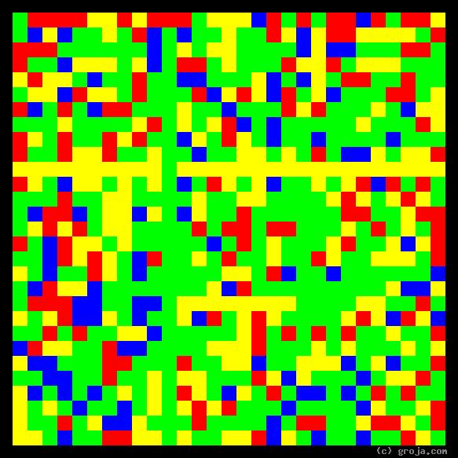
FBI Special Agent Dana Scully
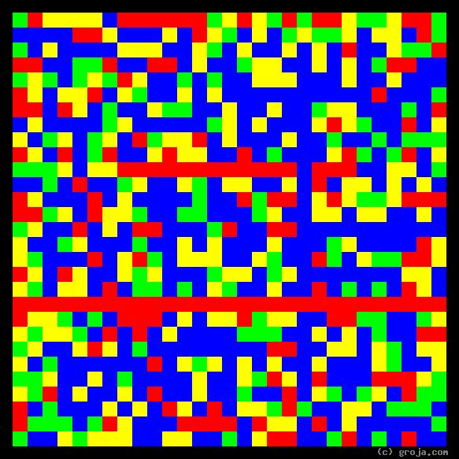
FBI Special Agent Fox Mulder
Comparing Grojas¹: Special Agents Mulder and Scully
By Tom W. Hartung, 2018.
These spiritual portraits of FBI Special Agents Fox Mulder and Dana Scully show how they have opposite personalities, but are flexible enough to get along.
The long horizontal Red line near the bottom of Mulder’s portrait depicts his emotional decision to learn what happened to his beloved half-sister, whom he believes was abducted by aliens. For obvious reasons, he keeps his lifelong goal mostly to himself, leading his colleagues to be suspicious of his motives and mock him with the nickname “Spooky.”
In contrast, Scully’s portrait is full of Green, the opposite of Red, depicting her preference for logical decisions. This is an important preference for people who take on the role of a guardian to have, because incarcerating someone based on an emotion – a feeling or superstition of some sort – is obviously wrong. In an organization like the FBI Scully can, unlike Mulder, easily afford to be vocal in expressing her preference.
Fox and Dana also see the world differently. The Blue in Mulder’s image represents his openness to ideas – his willingness to “want to believe” not just in aliens, but in all sorts of paranormal activities. It is Mulder’s openness to these ideas that makes the X-Files so different from the standard police procedurals such as Dragnet, Hill Street Blues, and the various Law and Order and CSI series.
In contrast, Scully’s portrait has more Yellow, the opposite of Blue, depicting her preference for facts. This is preference is only natural for people in authoritarian positions to have, because incarcerating someone based on an idea is something they did long ago. Thankfully, witches and heretics no longer have to suffer being burned at the stake, at least not in most of today’s moder, civilized countries. And again, because people are prone to expect this preference in law enforcement officers, Dana can afford to express her preference for facts, because everyone else can see them. Ideas, on the other hand, are more often than not in the mind of the beholder.
Fox Mulder’s personality is similar to director Woody Allen’s, Taxi Driver’s Travis Bickle, and my own. Dana Scully’s personality is similar to Alexander Hamilton’s, Tony Soprano’s, Jamie Lannisters on Game of Thrones, and both Presidents Roosevelt. Although they say opposites attract, it’s difficult to imagine Woody Allen being buddies with Teddy Roosevelt, or Travis Bickle teaming up with Tony Soprano to do … what? What would they even talk about, much less plan together?
Once Mulder and Scully survive several hair-raising, life-threatening experiences, they establish trust in each other and form a team unlike any other. Unfortunately, their ethics and morality – their concern for others and their sense of fair play – are traits not represented in these primitive images. But along with a preference for facts and logic, these are also traits we hope to find in people worthy of the public trust. These shared goals compel Scully and Mulder to combine their skills, and ultimately they learn they’re capable of facing any challenge, whether it be real, unreal, or something in between.
It is this pairing of opposite personalities – two people who manage to find common ground and support each other despite their differences – that gives the X-Files its enduring quality. It is so unique that, if another show came along with similar characters, many people would no doubt see it as a rip-off.

¹ Grojas are Graphical Representations of Jungian Archetypes. Using rectangular shapes and primary colors to depict basic personality traits, Grojas make visible the ideas Carl Jung expressed in his ground-breaking observations in the early 1920s. For more specific information, consult the Wikipedia, Groja.com, SeeOurMinds.com, or your favorite search engine.

