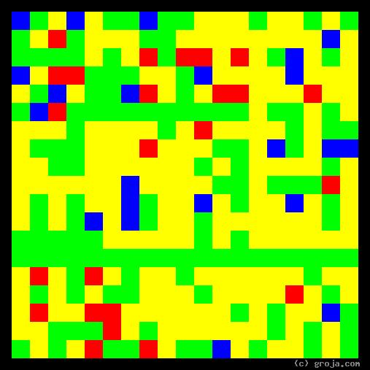
R2-D2
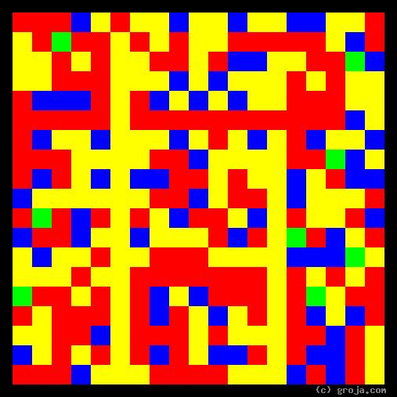
C-3PO
Comparing Grojas¹: C-3PO and R2-D2
By Tom W. Hartung, 2018.
These spiritual portraits of the original Star Wars droids C-3PO and R2-D2 show how different their personalities are. As a protocol droid, C-3PO not only has a head, arms, and legs like a human, he also has emtions.

¹ Grojas are Graphical Representations of Jungian Archetypes. Composed of four primary colors in rectangular shapes, Grojas depict our most essential personality functions and make visible the traits Carl Jung identified in his ground-breaking observations of psychological types in the early 1920s. For more information about Jung’s personality types, consult myersbriggs.org, Groja.com, SeeOurMinds.com, or your favorite search engine.

