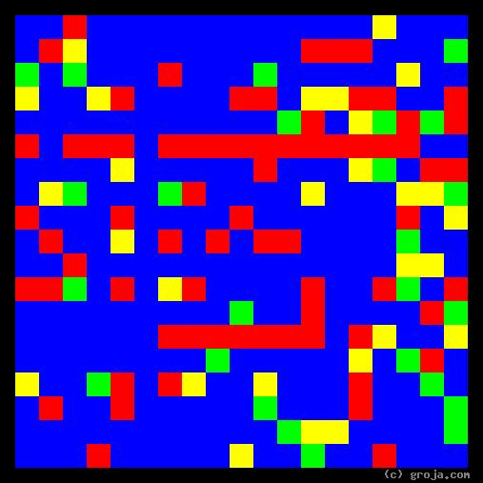
Diane Chambers
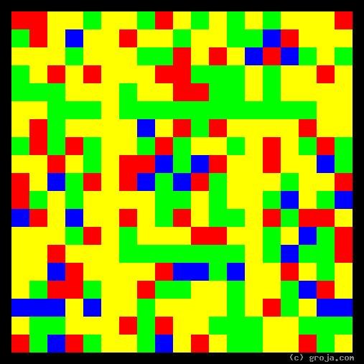
Sam Malone
Comparing Grojas¹: Sam Malone and Diane Chambers
- or -
Do Opposites Attact, or Is That BS?
By Tom W. Hartung, 2018.

¹ Grojas are Graphical Representations of Jungian Archetypes. Borrowing from the ideas of painters such as Piet Mondrian and Wassily Kandinsky, they make Carl Jung’s ideas about personality palpable. In other words, Grojas use rectangular shapes of opposing primary colors to depict personal preferences, giving viewers insight into the personalities of others, and ultimately themselves. For more information about all this, see Groja.com, the Wikipedia, SeeOurMinds.com, or your favorite search engine.

