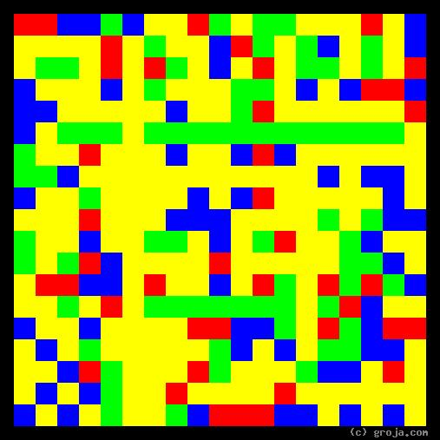
Big Edie Bouvier
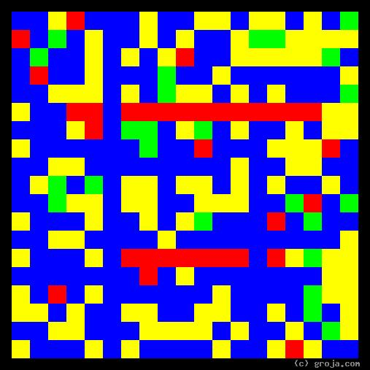
Little Edie Bouvier Beale
Comparing Grojas¹: Little Edie and Big Edie
- or -
The Bouviers of Grey Gardens
By Tom W. Hartung, 2018.

¹ Grojas are Graphical Representations of Jungian Archetypes. They are unique abstract compositions which depict the personality traits of sentient beings that Carl Jung described in his writings about human psychological types in the early 1920s. For more information about Grey Gardens, abstract art, and Carl Jung’s personality types, consult GreyGardensOnline.com, the Wikipedia, SeeOurMinds.com, Groja.com, or your favorite search engine.

