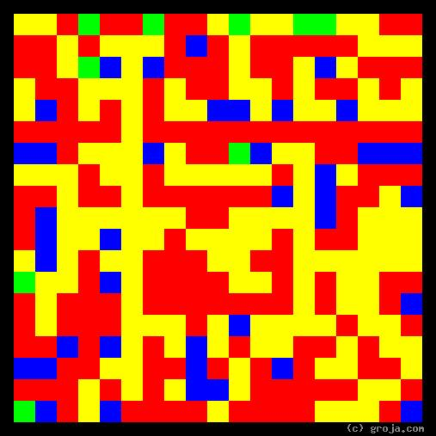
Dr. McCoy

Mr. Spock
Comparing Grojas¹: Mr. Spock and Dr. McCoy
- or -
The Head and the Heart of the U.S.S. Enterprise (NCC-1701)
By Tom W. Hartung, 2018.
The images above are Grojas¹, images representing the personalities of Dr. McCoy and Mr. Spock, from the Original Star Trek series. The two are archetypal characters on a classic show, and they demonstrate a powerful dichotomy in the human psyche.
Mr. Spock is the science officer aboard the Starship Enterprise, and the Green in his spiritual portrait depicts his preference for making logical decisions. He is highly intelligent, and has dedicated his life to understanding science and knowing how machines work. Spock’s cool, calm mantra is “It’s logical,” and as one of ship captain James T. Kirk’s most trusted advisors, he functions as the Enterprise’s head.
Dr. Leonard McCoy is the chief medical officer aboard the Starship Enterprise, and the Red in his spiritual portrait depicts his preference for making emotional decisions. He is passionate and has dedicated his life to working with and healing people. McCoy’s heated, passionate mantra is “Dammit, Jim!” and as another of ship captain James T. Kirk’s most trusted advisors, he functions as the Enterprise’s heart.
The decision to use Green to represent what Carl Jung called the Thinking mental function was a no-brainer. As the painter Wassily Kandinsky observed, Green “is the most restful color, lacking any undertone of joy, grief, or passion.” It is the color of chlorophyll and hence the color of plants, which are necessary to support life as we know it on the planet. It is the color of Mr. Spock’s blood and, in our culture, it also happens to be the color of money. Is it mere coincidence it is the color celebrated in the cruel logic of Saint Patrick’s day, If you don’t wear Green, then you will get pinched?
Most importantly – at least when it comes to visualizing personalities – Green is the opposite of Red.
It is likewise only natural to choose Red to represent what Carl Jung called the Feeling mental function. Red conveys warmth, and is the color of fire and blood, of the heart and of love. The passion we feel for someone we hate and for people we “like-like” makes us feel warm, as blood flows increase and prepare us for fight, flight, or love-making. In our culture it also happens to be the color of Valentine’s Day and the “red-light” districts, where people can exchange cool, Green money for warm, Red “love.”
Mr. Spock exemplifies the cool, calm, rationality of logical decision-making, and his spiritual portrait reflects this with its massive amount of Green. His image also contains some Red, reflecting the fact that he does have some emotions, but he does his best to keep these emotions to himself.
Dr. McCoy likewise exemplifies the warm, fiery, passion of emotional decision-making, and his spiritual portrait reflects this with its ample amounts of Red. His image contains very little Green, indicating his preference for the emotion of humans is at least as strong, if not stronger, than Spock’s preference for the logic of the Vulcans.
The Yellow in their portraits represents the fact that both Spock and McCoy share a preference for pragmatism. This enables them to work well together despite their differences. They can see things the same way, they just frequently differ on what to do about it.
Captain Kirk is wise to seek the advice of two people who have such different temperaments. As a leader, he frequently sides with Mr. Spock, because often the logical thing to do is indeed the best thing to do. But he never fails to consult with Dr. McCoy, and he always considers the lives of his crew to be more important than his own. One could say that James T. Kirk is more passionate about his crew’s lives than he is about his own – and hence he is more than worthy of his crew’s respect and allegiance.
Soon after the original Star Trek series began airing, viewers responded very positively to Mr. Spock’s character. In 1967 the Boston Globe coined the term “Spockmania” in an effort to describe this response. Series creator Gene Roddenberry once claimed that the number one request of fans was for more conflict between him and his foil, Dr. Leonard McCoy.
This is of course because many of us feel this conflict between logic and emotion, and hence find seeing this internal torment played out in a dramatic series as enlightening, and almost like looking into our own minds.

¹ Grojas are Graphical Representations of Jungian Archetypes. Inspired by the abstract art of Piet Mondrian and Wassily Kandinsky, Grojas seek to demonstrate harmony in rectangular shapes of opposing primary colors. The colors in the Grojas depict the pairs of opposing personality functions Carl Jung detailed in his writings about human psychological types in the early 1920s. For more information about Wassily Kandinsky and Carl Jung’s personality types, consult the Wikipedia, SeeOurMinds.com, Groja.com, or your favorite search engine.

