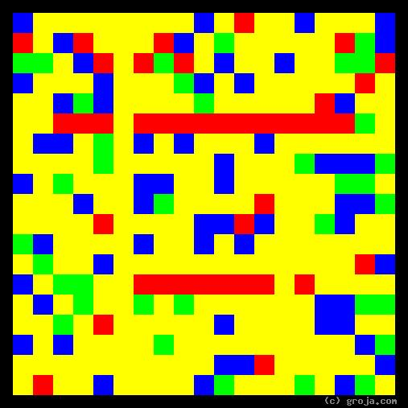
Trixie
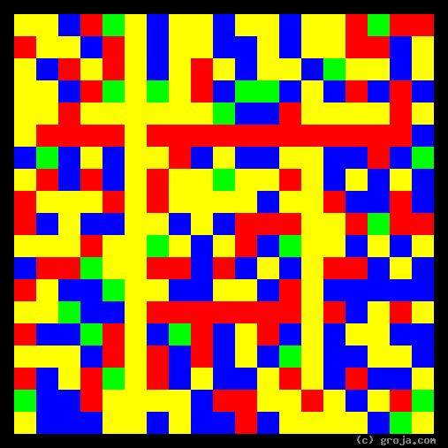
Shae
Comparing Grojas¹: Shae and Trixie
- or -
“It’s a Man’s Man’s Man’s World”
By Tom W. Hartung, 2018.
The images above are Grojas¹ – images representing the personalities of Shae and Trixie. They are fictional characters who share the same profession, but they live in two fairly primitive but otherwise entirely different worlds.
Fans of the show Game of Thrones are familiar with Tyrion Lannister’s favorite girl Shae, and fans of the show Deadwood are familiar with Al Swearengen’s favorite girl Trixie. Both of them are prostitutes and among the best at their chosen line of work. These spiritual portraits show the two characters have similar personalities, the Yellow and Blue reflecting their openness and the Red depicting their shared preference for emotion over logic.
It is important to realize that having a spiritual portrait that looks like one of the images above doesn’t necessarily mean someone is well-suited to Shae and Trixie’s chosen occupation! For one thing, these spiritual portraits do not attempt to incorporate a person’s morals or ethics; and for another, the shows take place in societies where women have very limited options. Last but not least, most women could be excused for being envious of Trixie’s and Shae’s youthful good looks and hot sexuality – but the obvious traits that everyone can see are not what this article is about.
The Yellow in Shae’s and Trixie’s images show they are open to new experiences, and the Blue shows they are are open to new ideas. Both of these traits help them to be at peace with and even embrace their choices, even if many members of the societies in which they live have a much different opinion.
It’s clear from these spiritual portraits that Trixie is a bit more open to new experiences than Shae, because her image has a bit more Yellow. An example of how Trixie is more open than Shae comes when Trixie pursues career options other than prostitution, at the hardware store working for Sol Star. Meanwhile Shae’s portrait has more Red, showing she is a bit more stubborn and emotional than Trixie. An example of her stubbornness comes when she defies Tyrion and decides to find a new customer rather than flee King’s Landing.
The Red in both Shae’s and Trixie’s images represents their passion, which they demonstrate by choosing to work with people in a business that can entail understanding strong emotions. In both of the shows’ cultures – in the Westeros of Game of Thrones (that resembles Europe during the Middle Ages) and the circa 1873 South Dakota of Deadwood – women’s options were extremely limited. Unless a woman is high-born (in Westeros) or willing and able to stay in a big city (as opposed to the frontier town of Deadwood), she has little choice but to look for help from men in order to survive.
More decisive women would choose marriage, but Shae and Trixie are not like those women. By choosing to earn their livings by the “world’s oldest profession,” they may sacrifice some of their dignity, but they are also able to maintain some of their independence.
Another, albeit rather extreme, example of this personality type is Norm Peterson of the show Cheers. Norm’s personality is similar in that he’s outgoing and open, warm and friendly, and rarely makes a decision. His personality is extreme in that for many seasons of the show Norm somehow gets away with having no job, no direction, and no visible source of income. But that, of course, is a different story.
It’s easy to see how indecisive people – both women and men – would shy away from marriage and promising to love only one person in their lifetime. In the primitive societies of Deadwood and Westeros, it’s definitely more acceptable for men to choose this path – they are both man’s worlds.
It’s also easy to see how Shae and Trixie might have chosen a different path. As viewers we don’t know much about their backgrounds and how they wound up being prostitutes, only that they must be good, because their men are very powerful. Again, Westeros and Deadwood are man’s worlds, and the success of these two women is defined by the successfulness of their men.
Westeros and Deadwood may be man’s worlds, but – as James Brown famously observed – they’re worth “nothing without a woman or a girl.” Trixie and Shae may be excluded from the man’s worlds, but James identifies how they can end up doing very well for themselves.
Trixie’s and Shae’s line of work may be considered immoral by some, but they find themselves with no other recourse if they want to make the best of their assets – both physical and psychological. Open-minded women like Trixie and Shae offer men who are too irresponsible for marriage a few moments of heavenly bliss.
And the best of them – the Shaes and Trixies – offer busy, powerful men who can’t be tied down for one reason or another, a more permanent outlet for their need to be more than “nothing” themselves.
Trixie’s and Shae’s spiritual portraits show they have the internal, psychological qualities – in addition to the external, physical attributes – needed to appeal to the richest and most powerful men in the societies in which they live. It’s only proper that their images convey the same warm, openness that the characters show.

¹ Grojas are Graphical Representations of Jungian Archetypes. Composed of rectangular shapes drawn in four primary colors, Grojas depict the essential personality functions and traits Carl Jung identified in his theory of psychological types. For more information about Jung’s personality types and why I like to draw personalities, see Groja.com, the Wikipedia, medium.com/@tomwhartung, SeeOurMinds.com, or your favorite search engine.

