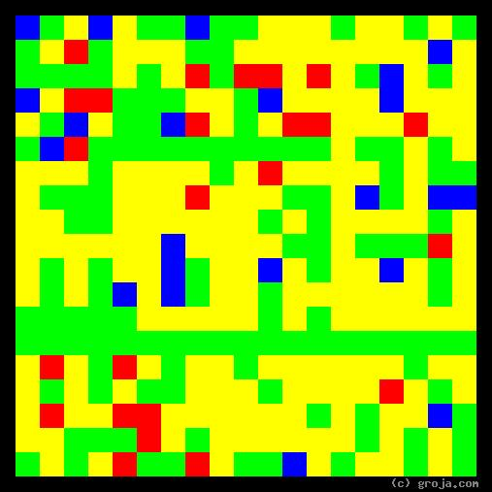
R2-D2
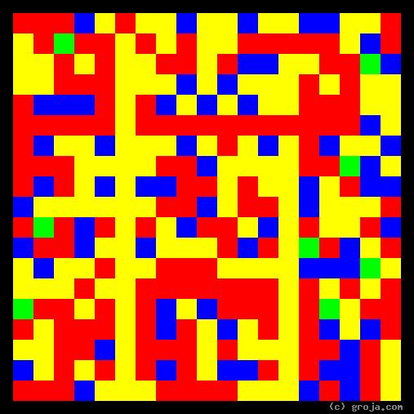
C-3PO
Comparing Grojas¹: C-3PO and R2-D2
- or -
Are Droids Just Slaves?
By Tom W. Hartung, 2018.
The images above are Grojas¹ – images representing the personalities of the original Star Wars droids C-3PO and R2-D2. These spiritual portraits show how different their personalities are, the Red in the portrait of the warm, friendly C-3PO contrasting strongly with the Green in the portrait of the cool, logical R2-D2.
As a protocol droid, C-3PO is fluent in a large number of languages. Protocol droids are built to look like a person, with a head, arms and legs, and they are also programmed to show emotion.
As an astromech droid, R2-D2 sounds more like a video game than a person. Astromech droids look more like a trash can on wheels than anything else, and R2-D2 is far more interested in getting things done than making friends or wasting time complaining.
The spiritual portraits of both droids have ample amounts of Yellow, which represents their pragmatic, realistic outlooks. In this respect, their images are similar, but contrast strongly with the spiritual portraits of most of the Jedi, who tend to be idealistic – and whose portraits contain generous amounts of Blue. (As some fans might suspect, the impatient and temperamental Anakin Skywalker is one exception to this generalization, but that’s a different story.)
It’s relatively easy for a machine to perceive facts. Even with today’s relatively primitive technology, computers have sensors that can see, hear, and touch. However, programming a machine to understand complex concepts such as ethics and morality is problematic. Indeed, it is obvious that plenty of people continue to struggle to seeing the value of these ideals – otherwise wars, police, the courts, jails, and even entire governments would not be necessary.
Although the perceptions of both droids are limited by technology, their duties and abilities are vastly different. Their images reflect this, the Red in C-3PO’s image showing he has been programmed to show emotions, and the Green in R2-D2’s image showing he’s been programmed to be logical.
In the original Star Wars movie, now known as The New Hope, C-3PO rides an emotional roller-coaster right from the start. His despair when their ship is attacked turns to bliss when Luke Skywalker gives him an oil bath. Soon they are escaping from Imperial Stormtroopers and he’s distressed again. Ultimately, when he has a moment to reflect, he’s full of self-pity but realistic nonetheless, telling R2-D2 they are destined to suffer because “It’s our lot in life.”
R2-D2 on the other hand is usually calm, cool, and focused on the task at hand. When a trash compactor threatens Luke, Princess Leia, Han Solo, and Chewbacca with certain death, it is R2-D2’s cool head that saves the day.
Clearly the two droids were programmed to make a good team, each having abilities that complement the other’s. In people, strong differences such as these can cause serious disagreements, but that is not the case with these two. Undoubtedly, the fact that they share similar perceptions helps them get along.
It is interesting to see how different characters in the movies treat their droids. Unlike many humans, Luke Skywalker can understand R2-D2’s beeps, and they form a close bond. Han Solo and Princess Leia, on the other hand, do not hesitate to tell the kindly C-3PO to shut up, even turning him off at one point. Of course, this might have something to do with the way C-3PO frequently shows up just when Leia and Han are starting to show some affection for each other.
Is it just coincidence that droids excel at three out of the five human senses – sight, hearing, and touch – and slaves in pre-Civil War America were counted as three-fifths of a person when calculating taxes and legislative representation? The parallels are kind of spooky, and there are plenty of movies, such as Bladerunner and Terminator, that examine the perils of treating droids as machines, objects, and yes, even as slaves.
With the horrors of slavery still affecting people, visible in the racism stubbornly persisting in developed countries, and with estimates of over 48 million slaves worldwide, this is not a silly question!
As an idealistic person, this author believes it’s better to be safe than sorry, and advises readers to use respect when conversing with Google’s Assistant, Amazon’s Alexa, and all of their siblings and descendants. (This does not mean we need to be nice when getting interrupted, the way C-3PO interrupts Han and Leia, when trying to get with a member of our preferred gender!)
Luke is a great role model in this respect, and Poe Dameron, who appears in The Force Awakens and The Last Jedi, is an even better one. Seeing him express his fondness for BB-8 is truly wonderful!
If nothing else, treating others – including droids – with kindness and respect is a good habit to get into.

¹ Grojas are Graphical Representations of Jungian Archetypes. Composed of four primary colors in rectangular shapes, Grojas depict our most essential personality functions and make visible the traits Carl Jung identified in his ground-breaking observations of psychological types in the early 1920s. For more information about Grojas and Star Wars and Psychology, see the book Star Wars Psychology: The Dark Side of the Mind, edited by Travis Langley, or visit Groja.com or SeeOurMinds.com, or consult your favorite search engine.

