
Donald Trump
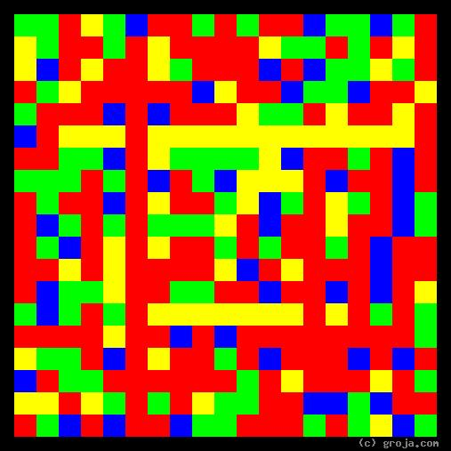
Charles Foster Kane
Comparing Grojas¹: Charles Foster Kane and Donald Trump
- or -
Citizen Kane and Donald Trump: Two Peas in a Pod
By Tom W. Hartung, 2018.
The images above are Grojas¹ – images representing the personalities of Charles Foster Kane, the fictional subject of Orson Welles’ film Citizen Kane (1941), and Donald Trump, the 45th President of the United States.
Needed: not al ESFJs are like Trump.
Perhaps: mention that Patrick Henry has a similar personality.
Maybe: Add Patrick Henry for a “threesome?” They sure can’t be a “team.” That would be a lot of work, and this one is already almost twice as long as the others.

Peas in a Pod
These spiritual portraits are very similar, and show Charles Foster Kane and Donald Trump have very similar personalities. The images show that both are outgoing, passionate, decisive, and realistic. Anyone who is familiar with one of them, has a head start on understanding the other.
Charles Foster Kane is the protagonist in the film Citizen Kane, and his character is loosely based on George Hearst, a media mogul associated with yellow journalism. Kane’s success in the newspaper business – in addition to his ego – leads him to run for Governor of New York. As the newsreel announcer proclaims early in the film, Charles Foster Kane “Spoke for millions of Americans. Was hated by as many more.”
Similarly, Donald Trump also found fame in the media, first with his reality TV show The Apprentice, and later with his persistent exhortations that President Obama’s birth certificate is invalid. His opinionated, decisive personality and presence in the media – in addition to his ego – led him to run for President of the United States.
Donald Trump’s election shows he does indeed, like Charles Foster Kane, speak “for millions of Americans.” And the aftermath of his victory makes it equally plain he is “hated by as many more.”
Rich Kids Can Do Whatever They Feel Like Doing
Both Charles Foster Kane and Donald Trump benefited from large inheritances, enabling them to run their own companies at an early age. This wealth also made both of them virtually immune to the ill effects of their mistakes – unlike most people, they could literally do no wrong.
The freedom granted by this wealth means Kane and Trump could hire people at will, tell them to do whatever they felt like telling them to do, and fire them for any offense, big or small, real or imagined. This ability to be tyrannical, along with their opinionated and outspoken manner, fuels the love-hate relationship they have with the public.
Love and hate are two of the strongest human emotions. The spiritual portraits of Charles Foster Kane and Donald Trump both feature a long vertical Red line on the left side of their images, indicating they are comfortable expressing their emotions. It is only natural for both to get emotional reactions from their supporters and detractors alike.
As outgoing and decisive people, Kane and Trump are anything but shy, retiring, and contemplative. They relish being the center of attention, and their passion is further evident in their speeches and volatile temperaments. Their personalities are quite different from those of the more quiet, idealistic presidents such as Thomas Jefferson, Abraham Lincoln, and John F. Kennedy.
Illogical and Atypical Political Leaders
The tendency for Charles Foster Kane and Donald Trump to favor emotion over reason – evidenced by the presence of more Red than Green in their spiritual portraits – makes them unlike most other American presidents.
While most politicians prefer to appeal to logic that everyone can understand – if you commit murder, then you will go to jail – these two prefer to appeal to people’s emotions. Trump made the power of this sort of appeal plain when he infamously claimed he could “shoot somebody” and not “lose any voters.”
During his campaign, Citizen Kane declared he would clean up the current corrupt administration run by Jim W. Gettys. Similarly, during his campaign, Donald Trump declared he would clean up the current, corrupt administration by “draining the swamp.”
The corrupt Gettys ultimately defeats the populist Kane, however, by exposing his extramarital affair with Susan Alexander. It is only natural that, upon losing the election, the headline on the front page of Kane’s Inquirer decried “Fraud at Polls!”
Donald Trump showed he was of a similar mind when during one of the debates he was asked whether he would accept the results if he lost the election. He declared the only way he could lose if if there was fraud at the polls. And even though the he won the electoral vote and hence the election, Trump still insisted he did not win the popular vote because of election fraud.
A Pair of Realists
The portraits of Charles Foster Kane and Donald Trump each have a horizontal Yellow line, shorter than the Red one, near the top – indicating they have a tendency to be realistic.
At one point in the film, Kane writes a “Declaration of Principles,” but it is not nearly as high-minded as it sounds. It turns out there are only two statements in Kane’s “Declaration,” and both start with the personal pronoun “I.” As Kane’s “oldest friend” Jedidiah Leland points out, Kane “never believed in anything except Charles Kane.”
Trying to identify Trump’s ideals leads to a similar conclusion: he doesn’t have any. Does he even have a friend – like Kane’s Jedidiah – brave enough to state he “never believed in anything except” Donald Trump? Given the churn in his administration, it seems unlikely. Trump is so tyrannical and narcissistic that the most cynical of his opponents – and there are many – believe he thinks he’s God.
Differences in Context, Not Substance
The main difference between Charles Foster Kane and Donald Trump – other than the obvious fact that Kane is a fictional character while Trump is real – is not in their personalities, but in the times in which they lived.
Ultimately, this comparison shows a decline in the importance of morality to Americans during the time between Kane’s rise, from the 1900s to 1940s, and Trump’s rise, from the 1970s to the 2010s. Those intervening decades have seen the rise of American exceptionalism after World War II, the invention of the birth control pill and the resultant loosening of sexual morality, and the rise of the internet and social networking – to mention only a very few but major advances.
As abstract images of their personalities, these spiritual portraits of course do not make any attempt to depict these differences, because they are differences in context rather than of substance.
When Style Reveals Substance
Decades after its production, movie critics continue to admire – and film students continue to learn to appreciate – Citizen Kane more for its revolutionary style than for its substance. One of the most important ways Citizen Kane differs from the films before that time is its narrative structure.
The film actually begins with the death of the protagonist and reveals Charles Foster Kane’s life through a series of flashbacks. The first word uttered in the film – “Rosebud” – comes just as Kane dies. This ability to see Kane’s entire life as a reporter tries to learn the significance of the word gives viewers an insight into Kane that is currently unattainable with Trump.
Over the course of the film, viewers learn Kane has died a lonely old man. Having reached a pinnacle of success unimaginable to most, in the end he has driven everyone else away with his self-centered, irrational, tyrannical ways. As Kane’s “oldest friend” Jedidiah Leland observes, “That must have been pretty unpleasant.”
It is the flashbacks of Jedidiah Leland – who confesses he may have been more of a “stooge” than a friend – that give viewers the deepest insight into Kane’s character. In one of the film’s most enlightening scenes Jedidiah claims Charles Foster Kane “did everything,” from getting married to going into politics, “for love.”
Spoiler Alert!
If you haven’t seen Citizen Kane, and now want to see it, consider stopping here.
And if you’re a fan of Donald Trump, also consider stopping here, because the following is rather sad – and I do not want to upset people, only enlighten them.
Can’t Buy Me Love
Most viewers probably get the impression “Rosebud” is an object, but I assert it is an emotion – represented by the Red line in Kane’s image – his need for love. As Jedidiah observes after Kane is gone: “All he really wanted out of life was love. That's Charlie's story, how he lost it. You see, he just didn't have any to give. He loved Charlie Kane, of course. [Chuckles.] Very dearly.”
Is this how things will end with Donald Trump? Will he wind up dying a lonely old man, yearning for a love he experienced only as a child, before he was corrupted by wealth he did not earn? Given his volatile temperament, it’s easy to imagine him experiencing a similarly miserable fate.
What will be Donald Trump’s Rosebud? Only time will tell.
Will there be a “film at 11?” Of course there will be – some day! And when it comes to people who are more emotional than logical, that is one of the few things we can predict with certainty.

¹ Grojas are Graphical Representations of Jungian Archetypes. These images use four primary colors in rectangular shapes to depict the core personality functions Carl Jung identified in his writings about psychological types in the early 1920s. For more information about Grojas and Jung’s psychological types, see the Wikipedia or visit Groja.com or SeeOurMinds.com, or consult your favorite search engine.

