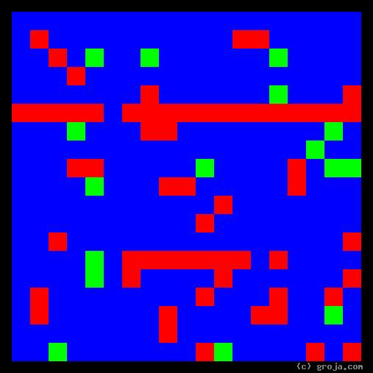
PERSON 2
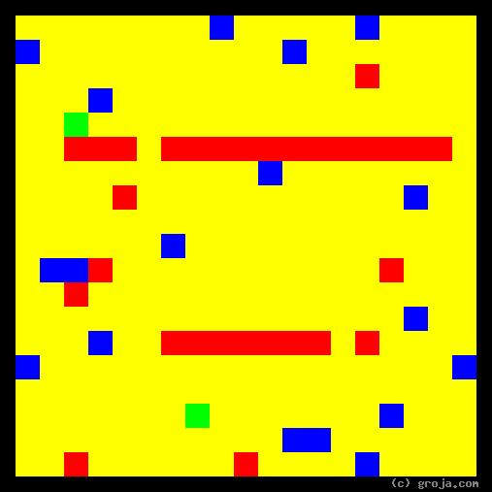
PERSON 1
Comparing Grojas¹: PERSON 1 and PERSON 2
- or -
SUBTITLE HERE
By Tom W. Hartung, 2018.
The images above are Grojas¹ – images representing the personalities of PERSON 1 and PERSON 2 of .
These spiritual portraits show how (overview – the big picture).
Set the scene: who they are and what they do
Describe what the colors represent in PERSON 1, and give an example
Describe what the colors represent in PERSON 2, and give an example
What do they have in common?
What makes them different from each other?
If they are related, what makes their relationship unique?
Is there anything else interesting and specific to this pair of images?
Conclusion

¹ Grojas are Graphical Representations of Jungian Archetypes. Borrowing from the ideas of painters such as Piet Mondrian and Wassily Kandinsky, they make Carl Jung’s ideas about personality palpable. In other words, Grojas use rectangular shapes of opposing primary colors to depict personal preferences, giving viewers insight into the personalities of others, and ultimately themselves. For more information about all this, see the Cheers Quotes pages at en.wikiquote.org/wiki/Cheers, SeeOurMinds.com, the Wikipedia, Groja.com, or your favorite search engine.

