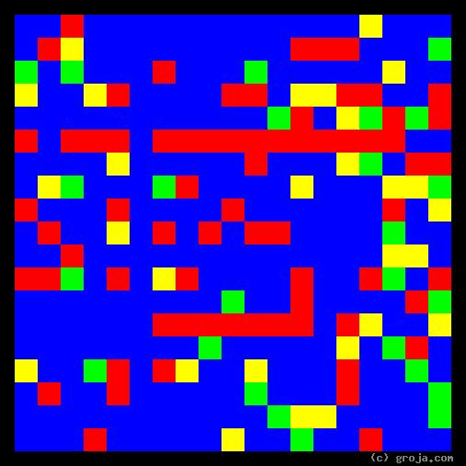
Diane Chambers
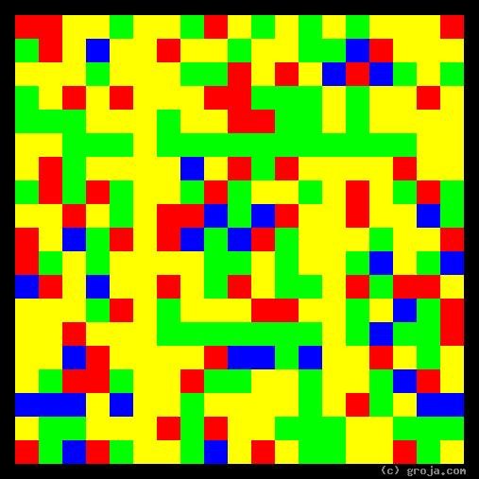
Sam Malone
Comparing Grojas¹: Sam Malone and Diane Chambers
- or -
Do Opposites Attact, or Is That BS?
By Tom W. Hartung, 2018.
The images above are Grojas¹ – images representing the personalities of Sam Malone and Diane Chambers of the TV show Cheers.
These spiritual portraits show how different their personalities are, with Sam’s very realistic perspective and his preference for making logical decisions contrasting strongly with Diane’s very idealistic perspective and her tendency to make emotional decisions.
Sam Malone is a good-looking ex-baseball player who runs a bar named Cheers in Boston. Women are attracted to Sam, and in the bar he is legendary for his conquests. He has a little black book full of the names of women he’s dated, and at least his two most regular patrons, Norm Peterson and Cliff Clavin, enjoy hearing about his exploits – and even openly admit to living vicariously through him.
One night Diane Chambers, an equally attractive college student, comes in with Sumner Sloane, planning to elope with him. She is Sumner’s teaching assistant and he leaves her at Cheers to get a wedding ring from his wife for Diane. When he breaks his promise and fails to return, Sam consoles Diane and ends up offering her a job as a waitress.
It is obvious from the start that Sam and Diane are very different. Sports form a large part of Sam’s identity, but Diane shows little interest in any sort of competition. Her interests are broad yet mostly academic in nature, and Sam has little interest in learning foreign languages, reading poetry or the classics, and discussing topics such as psychology. Moreover, Sam can’t stand to attend the sort of refined events Diane is most fond of, such as the opera and symphony performances.
These superficial differences are only manifestations of the deeper differences made evident by these portraits of their personalities.
The Yellow in Sam’s image depicts his realistic perspective, while the Blue in Diane’s portrait depicts her preference for ideas. Because Sam’s realism is better suited than Diane’s scholarly interests to the down-to-earth atmosphere in the bar, Diane admits to feeling “like an alien” there.
The images also show Sam and Diane have different ways of making decisions. The Green in Sam’s portrait depicts his preference for being logical, while the Red in Diane’s image depicts her preference for being emotional.
A perfect example of this difference comes in the episode A House Is Not a Home, when they buy a house together. To Sam the house is just a building, but Diane meets the couple who is selling the home, hears about their experiences while living there for 40 years, and decides they cannot take the home from the elderly couple. This is just one example of many in which her emotions collide with Sam’s rationality, but certainly buying a house and refusing to live in it is the epitome of silliness and irrationality.
Both Sam and Diane profess to being accustomed to dating people with whom they have more in common, and at times confess to realizing their differences must contribute to their heightened sense of mutual attraction. The newness they experience in each others’ presence makes them feel younger somehow – as if they are falling in love for the first time.
Their fresh sense of attraction causes them to act childish at times, and in the episode Sumner’s Return they actually have a water gun battle. In the episode Strange Bedfellows Part 3 they deign to make silly faces to distract each other, and when their relationship is “on” the gang at Cheers sometimes gets tired of their public displays of attraction and frequently teases them for acting like young lovers in high school.
Sometimes their childishness causes them to compete over silly things, like who dumped whom first. And when they discuss whether they are actually “in love,” Diane’s emotions (Red) and quest for the ideal relationship (Blue) collides yet again with Sam’s rationality (Green) and ability to be content with purely physical relations (Yellow).
Diane’s intelligence and self-awareness makes her a bit of a femme fatale. She refuses to take any guff from Sam, and gives as good as she gets.
In the episode Showdown Part 1 Sam gaslights her three times, saying she is free to leave for a weekend with his brother when talking to her face, then using a lower tone of voice to say she should stay with him when she turns her back. Diane confronts him all three times, but he denies his mumbling that she should stay, and after the third time she plays the same game with him, using a lower tone of voice to “agree” they should stay together after she turns away, causing Sam to say “What?!?”
Ultimately though, it is Diane’s indecisiveness that proves fatal to their relationship. It is impossible for a couple to live happily ever after when one of them spends her time contemplating what their love means, while the other just wants to get down to “business,” if you will, without further delay.
Looked at through the lens of the psychological preferences identified by Carl Jung, Sam and Diane’s relationship is analogous to Frankin and Eleanor Roosevelt’s. Where Eleanor was idealistic, Franklin was pragmatic, and where she exuded compassion no matter what the cost, he was rational and knew how to get things done.
It is interesting to recognize how these patterns can surface in a variety of relationships through history. And it is my personal hope that being able to actually visualize these preferences and their corresponding strengths can help keep us from falling into the same traps as those who have found themselves in similar situations before us.

¹ Grojas are Graphical Representations of Jungian Archetypes. Borrowing from the ideas of painters such as Piet Mondrian and Wassily Kandinsky, they make Carl Jung’s ideas about personality palpable. In other words, Grojas use rectangular shapes of opposing primary colors to depict personal preferences, giving viewers insight into the personalities of others, and ultimately themselves. For more information about all this, see the Cheers Quotes pages at en.wikiquote.org/wiki/Cheers, SeeOurMinds.com, the Wikipedia, Groja.com, or your favorite search engine.

