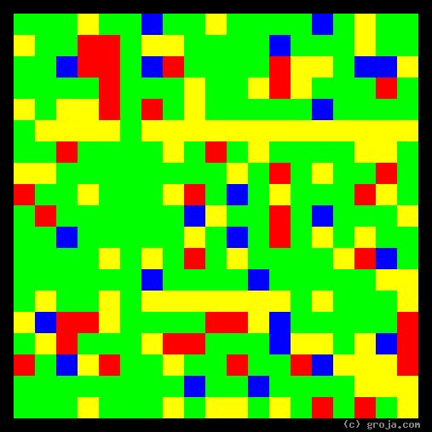
FBI Special Agent Dana Scully
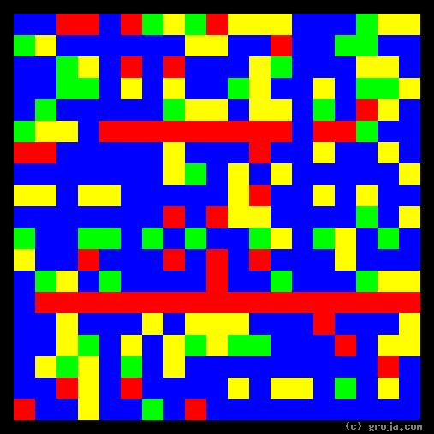
FBI Special Agent Fox Mulder
Comparing Grojas¹: Special Agents Mulder and Scully
- or -
How to Build a Team With Only Two People
By Tom W. Hartung, 2018.
The abstract images above are “Grojas¹” depicting the personalities of the X-Files’ fictional FBI Special Agents Fox Mulder and Dana Scully. These spiritual portraits show how they have opposite personalities, but are flexible enough to get along.
The warm Red and deep Blue in Mulder’s image contrasts strongly with the cool Green and flat Yellow in Scully’s portrait. The following story describes how these qualities combine to make this two-person team uniquely capable to handle even the most bizarre situations.

The long horizontal Red line near the bottom of Mulder’s portrait depicts his preference for making emotional decisions. This preference is most obvious in his decision to dedicate his life to learning what happened to his beloved half-sister, whom he believes was abducted by aliens. For obvious reasons, he keeps this goal mostly to himself, leading his colleagues to be suspicious of his motives and mock him with the nickname “Spooky.”
In contrast, Scully’s portrait is full of Green, the opposite of Red, depicting her preference for logical decisions. This is an important preference for people who take on the role of a guardian to have, because incarcerating someone based on an emotion – a feeling or superstition of some sort – is obviously wrong. In an organization like the FBI Scully can, unlike Mulder, easily afford to be vocal in expressing her preference.
Fox and Dana also see the world differently. The Blue in Mulder’s image represents his openness to ideas – his willingness to “want to believe” not just in aliens, but in all sorts of paranormal activities. It is Mulder’s openness to these ideas that makes the X-Files so different from the standard police procedurals such as Dragnet, Hill Street Blues, and the various Law and Order and CSI series.
In contrast, Scully’s portrait has more Yellow, the opposite of Blue, depicting her preference for facts. This is preference is only natural for people in authoritarian positions to have, because incarcerating someone based on ideas rather than facts is clearly an abuse of power. Thankfully, witches and heretics no longer have to suffer being burned at the stake, at least not in most of today’s moder, civilized countries.
As is the case with logical decision making, people are prone to expect law enforcement officers to have a preference for facts over ideas – because everyone else can see them. Ideas, on the other hand, are more often than not in the mind of the beholder. So again, Dana can afford to express her pragmatic perceptions, while Mulder is best off keeping his ideas to himself.
Fox Mulder’s personality is similar to director Woody Allen’s, Taxi Driver’s Travis Bickle, and my own. Dana Scully’s personality is similar to Alexander Hamilton’s, Tony Soprano’s, Jamie Lannisters on Game of Thrones, and both Presidents Roosevelt. Although they say opposites attract, it’s difficult to imagine Woody Allen being buddies with Teddy Roosevelt, or Travis Bickle teaming up with Tony Soprano to do … what? What would they even talk about, much less plan together?
Once Mulder and Scully survive several hair-raising, life-threatening experiences, they establish trust in each other and form a team unlike any other. It is important to note that these primitive images do not depict traits such as their ethics and morality – concern for others and a sense of fair play.
Like Scully’s preferences for facts and logic, ethics and morality are traits we hope to find in people worthy of the public trust. It is these shared goals that enable the seemingly mismatched Scully and Mulder to combine their skills and successfully face any challenge, whether it is real, unreal, or something in between.
It is this pairing of opposite personalities – two people who manage to find common ground and support each other despite their differences – that gives the X-Files its enduring quality. It is so unique that, if another show came along with similar characters, many people would no doubt see it as a rip-off.

¹ Grojas are Graphical Representations of Jungian Archetypes. Using rectangular shapes and primary colors to depict basic personality traits, Grojas make visible the ideas Carl Jung expressed in his ground-breaking observations in the early 1920s. For more specific information, consult the Wikipedia, Groja.com, SeeOurMinds.com, or your favorite search engine.

