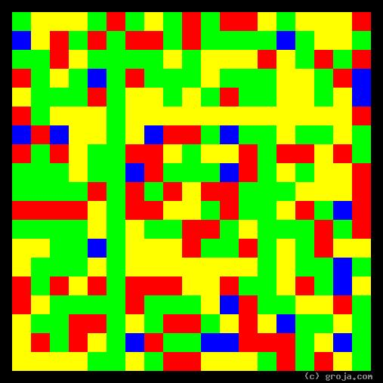
Tony Soprano
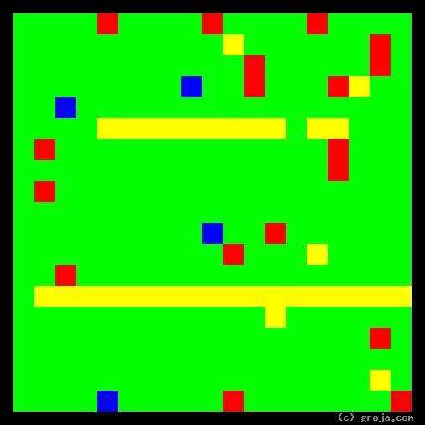
Tywin Lannister
Comparing Grojas¹: Tywin Lannister and Tony Soprano
- or -
“Meet the New Boss, Same as the Old Boss?”
By Tom W. Hartung, 2018.

¹ Grojas are Graphical Representations of Jungian Archetypes. Combining ideas from Carl Jung and painters such as Piet Mondrian and Wassily Kandinsky, Grojas use rectangular shapes of opposing primary colors to depict personal preferences. For more information about all this, see Groja.com, the Wikipedia, SeeOurMinds.com, or your favorite search engine.

