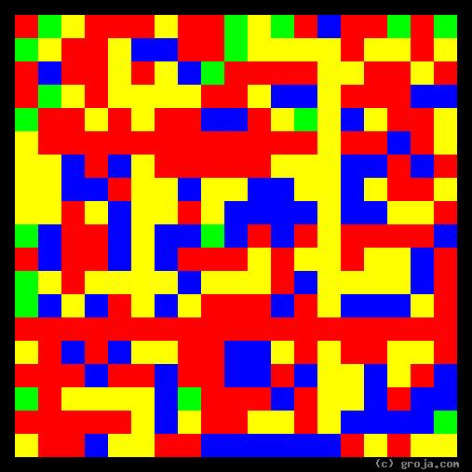
Mildred: Shy Grey Tabby Cat
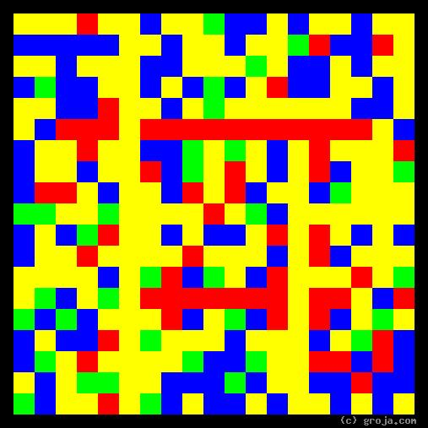
Zeronimo: Outgoing Tuxedo Cat
Comparing Grojas¹: Mildred and Zeronimo
By Tom W. Hartung, 2018.
These spiritual portraits of two of my kitty cats, Mildred and Zeronimo, show how different their personalities are. The long, vertical Yellow line on the left side of Zeronimo’s image jumps out at the viewer right away, while the long, horizontal Red line towards the bottom of Mildred’s image is almost hidden in comparison.

When I told my dance teachers, Dan and Tiffiny, about how my orange tabby Marvin died while I was at a Lindy Exchange in New Orleans, they said they were moving and looking to find a new home for Mildred, who did not get along well with their other cats. They had found her abandoned – crying in an empty neighboring apartment after the thoughtless humans had moved – and adopted her immediately.
They brought Mildred over to my house on a Friday, and she immediately ran around looking for a place to hide. She found refuge under my bed, and stayed there the entire weekend, except to get some food and use the litter box while I was in bed. On Sunday I told her, with tears in my eyes, about how Marvin had died the week before and I really needed a new friend. After a few moments she finally showed her face, and we quickly became best buddies!
The Red in Mildred’s portrait shows the true essence of her personality: her warmth. Once I’d earned her trust, she was very affectionate. She was like that with my friends as well: hiding when they first came over, but usually coming out to “say hi” when the excitement had died down – as long as only one or two friends were visiting. Mildred was definitely not one for parties! But sometimes when we were sitting on the sofa together, she would stroke my arm affectionately with her tail. I have never seen anything like that, neither before nor since!
A Mildred grew older, I began dreading the thought of losing her. The inevitability of these losses are truly the single worst thing about having pets, and the only remedy is to tell them you love them every single day!
So when Mildred was well into her teenage years, I got Zeronimo from the Denver Dumb Friends League. His name there was Zero, and hearing it caused the Smashing Pumpkins’ song to immediately sound in my head, so I decided to go with it – at least at first.
It quickly became obvious that gently introducing him and Mildred, letting them sniff each other under a door and such, as the nice experts at the DDFL like to recommend, was out of the question. Zeronimo was not going to be shut in a room without complaint, and Mildred was here first, so it became sink or swim.
Zeronimo is clearly a force of nature! I soon decided maybe not everyone had heard the song, and moreover that he was much, much, much more than “nothing,” so we needed a new name. A bit of thinking, “Zero, Zero, Zero,” somehow led to “Zeronimo,” which is entirely appropriate!
Zeronimo is a jumper. He can jump from the floor to the counter to the top of the refrigerator and cabinets in two leaps, and can take the 16 steps between the floors of my place in four leaps, bam bam bam bam. In comparison, I am clearly just a clumsy human, barely able to take two steps at a time.
The Yellow in Zeronimo’s portrait depicts how he is outgoing and into having new experiences. He demands to be the center of attention and gets jealous when I talk on the phone. To say he follows me from room to room is an understatement, because he likes to anticipate where I’m going so he can get there first. I admit, sometimes I like to fake him out, and pretend like I’m going upstairs, then “change my mind.” Hey, we all need exercise, and surely chasing the dot must get old after awhile!
Mildred and Zeronimo mostly got along together at first, but as she got older, she lost her hearing, her sight – and her patience for Zeronimo. Life was a bit difficult here towards the end of her life, and eventually each kitty had to live on a separate floor. But love is love and we do what we have to do.
I miss Mildred, but am richer for having known her. Zeronimo can be a bit over-bearing at times, but I love him dearly and give him a big hug every day – for as long as he can stand it – which is rarely as long as I’d like it.
To all the pet lovers out there, who know that pets are people, these Grojas are for you!

¹ Grojas are Graphical Representations of Jungian Archetypes. Grojas use primary colors and rectangular shapes to depict the essential personality functions Carl Jung described in his ground-breaking observations, originally published in the early 1920s. For more information see Groja.com, SeeOurMinds.com, the Wikipedia, or your favorite search engine.

