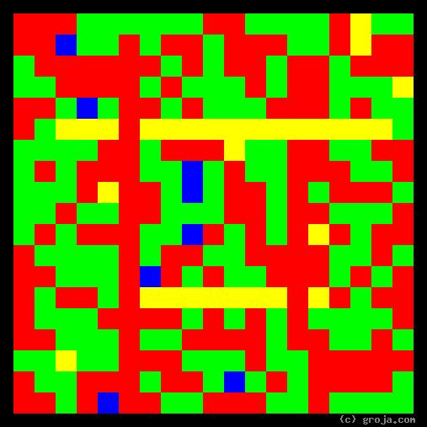
Sybil Fawlty
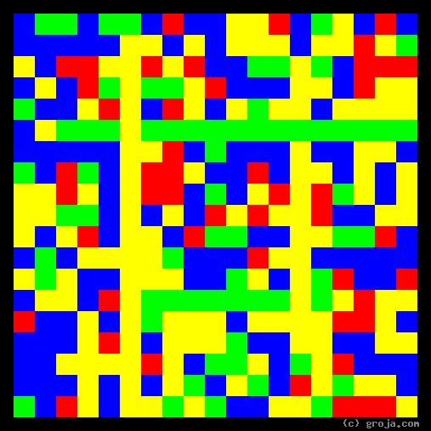
Basil Fawlty
Comparing Grojas¹: Basil and Sybil Fawlty
- or -
The Schemer and the Control Freak
By Tom W. Hartung, 2018.
The abstract images above are “Grojas¹” depicting the personalities of the fictional characters Basil and Sybil Fawlty, who run a fictional hotel in southern England known as Fawlty Towers. These spiritual portraits show a henpecked, even frightened, yet determined schemer and his decisive, condescending, manipulative wife.
Full of Blue and Yellow, Basil’s portrait reveals his openness and a strong desire for stimulation. He is , ostensibly the manager but largely unsuited for the role.
Whether it’s trying to appeal to a higher class of customer, save a little money on construction costs, or place a bet on a horse after hearing about a sure thing, Basil’s carelessness, haplessness, and bad luck never fail to get the best of him. Despite Sybil’s best efforts – or quite possibly because of them – he time and again fails to learn a lesson, and as a result, hilarity ensues.
Full of Red and Green, Sybil’s portrait stands in stark contrast to Basil’s. It reveals her confidence, decisiveness, and a need to control others, but she is willing to actually lift a finger and help out – albeit begrudgingly – during emergencies.
Sybil’s mantra is “I know, I know,” and she is too busy fussing with her hair and nails to care for any of Basil’s schemes. If only Basil would just obey her every demand, and not stray into his hare-brained schemes, the Fawlty Towers universe would be perfect – and no doubt the show would be incredibly boring.
The contrast between Basil and Sybil’s personalities is just one of the aspects of the show that puts it in the #1 position on the BFI TV 100 –the list of the top 100 TV shows compiled by the British Film Institute in 2000.² The supporting characters – Manuel the linguistically challenged busboy, bellboy and outlet for Basil’s wrath, and Polly the maid, hostess, art student and primary voice of reason – each lend a hand in trying to keep the chaos Basil’s scheming causes from Sybil’s watchful, critical eye.
With Manuel and Polly helping them, Basil and Sybil form a unique team: Team Fawlty. Together the four of them are capable of handling almost any situation, including health inspectors, drunk contractors, Germans, possible marital infidelity, and even the occasional dead guest.
Working together, Team Fawlty is capable of just about anything – anything, that is, except making a simple Waldorf Salad.

¹ Grojas are Graphical Representations of Jungian Archetypes. Inspired by the pure plastic art of Piet Mondrian, Grojas seek to find harmony in rectangular shapes of opposing primary colors. To think that Grojas are somehow related to black-and-white QR codes might be insulting if it wasn’t so deliciously dumb. Seriously dude, wake up and read the stories! To the contrary, the colors in the Grojas depict the pairs of opposing personality functions Carl Jung detailed in his writings about human psychological types in the early 1920s. For more information about Jung’s personality types, consult Keirsey.com, SeeOurMinds.com, Groja.com, your favorite search engine, or the Wikipedia, which is probably doing more than any of us are to Set the People Free. Seriously, QR codes? Smh.…
² Dr. Who appears third on the list, and John Cleese’s original effort, Monty Python’s Flying Circus, appears fifth.

