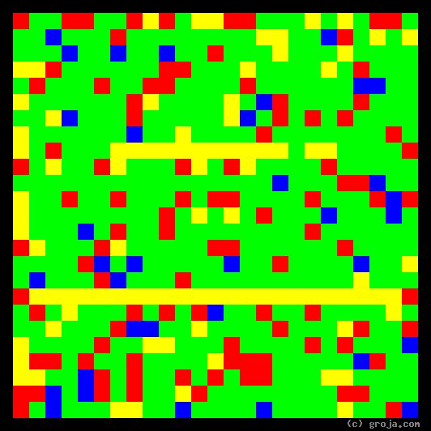
Mr. Spock
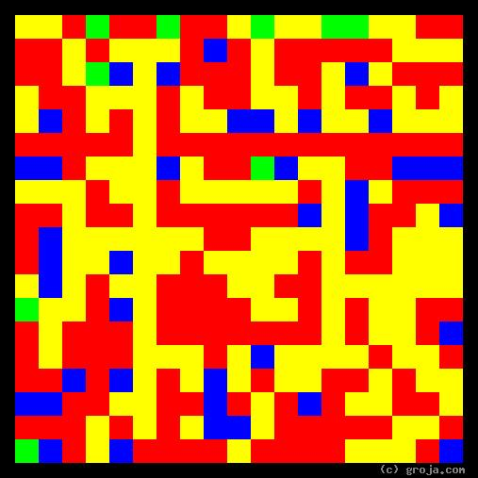
Dr. McCoy
Comparing Grojas¹: Dr. McCoy and Mr. Spock
By Tom W. Hartung, 2018.
Dr. McCoy and Mr. Spock, from the Original Star Trek series, are classic characters on a classic show demonstrating a classic dichotomy in the human psyche.
Dr. Leonard McCoy is the chief medical officer aboard the Starship Enterprise. As one of ship captain James T. Kirk’s most trusted advisors, he functions as the starship’s heart. McCoy’s heated, passionate mantra is “Dammit, Jim!” The Red in his spiritual portrait depicts his emotions.
Mr. Spock is the science officer aboard the Starship Enterprise. As one of ship captain James T. Kirk’s most trusted advisors, he functions as the starship’s head. Spock’s cool, calm mantra is “It’s logical.” The Green in his spiritual portrait depicts his rationality.

¹ Grojas are Graphical Representations of Jungian Archetypes. Inspired by the abstract art of Wassily Kandinsky, Grojas seek to demonstrate harmony in rectangular shapes of opposing primary colors. The colors in the Grojas depict the pairs of opposing personality functions Carl Jung detailed in his writings about human psychological types in the early 1920s. For more information about Wassily Kandinsky and Carl Jung’s personality types, consult the Wikipedia, SeeOurMinds.com, Groja.com, or your favorite search engine.

