**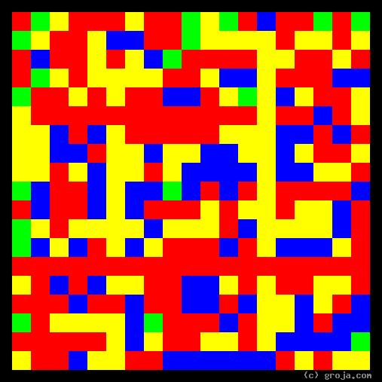  
Mildred: Shy Grey Tabby Cat**

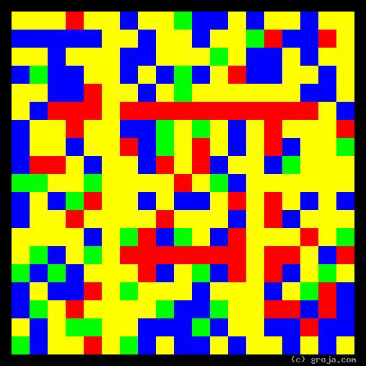  
**Zeronimo: Outgoing Tuxedo Cat**

**Comparing Grojas¹: Mildred and Zeronimo**

1. Introduction

2. Mildred, the Introvert

Hid under the bed for two days.

3. Zeronimo, the Extravert

Follows me around and gets jealous when I talk on the phone.

4. Conclusion

¹ Grojas are Graphical Representations of Jungian Archetypes. Grojas use primary colors and rectangular shapes to depict the essential personality functions Carl Jung wrote about in 1921. For more information see Groja.com, SeeOurMinds.com, or your favorite search engine.