Task 1 – Produce Database Designs for the following problems:

a) Online blog example. A blog management site has a set of blogs. Each blog has a   
title and a creator and a set of articles. Each article has a headline, a text and an   
author, and appears in a single blog.

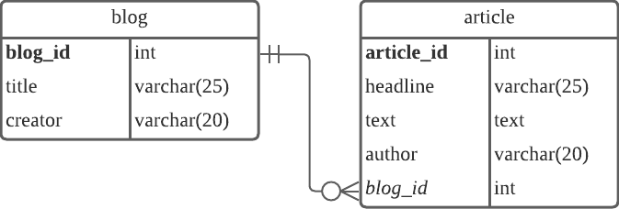

b) Online newspaper example. A newspaper has a set of (daily) issues. Each issue has a   
set of articles. Each article has a headline, a text, an author and a set of photos, and   
appears in a single issue. Each photo has a caption, a photographer and an image,   
and may appear in different articles.

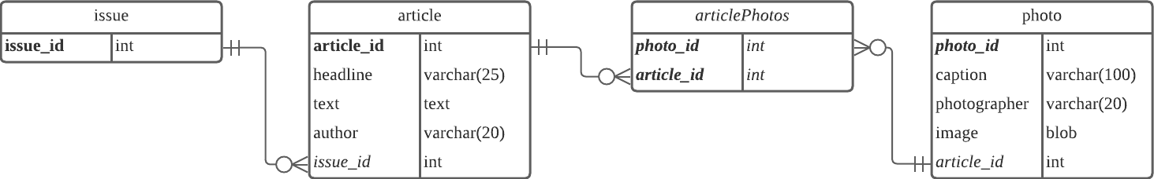

c) Online journal example. A journal has a name, a date, and a set of articles. Each   
article has a title, a date, a set of authors, a body, and a set of references (which are   
themselves articles). Furthermore, an article may be referenced by other articles.   
Each author has a name and an affiliation. An author may contribute to different   
articles.

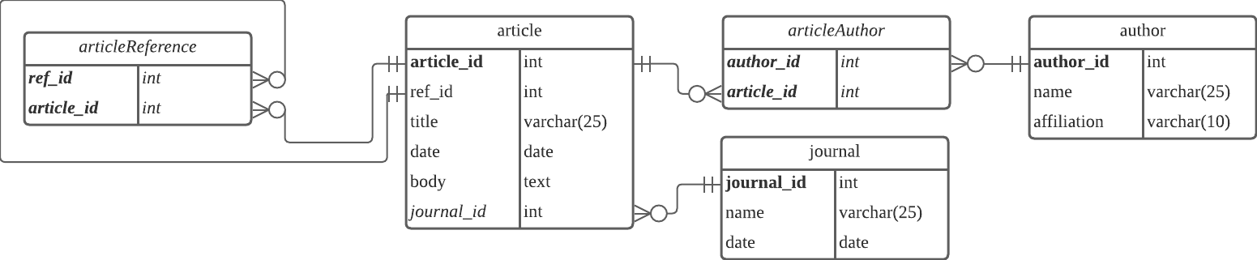

Task 2 – Write SQL queries for the following based on the blog example from Task 1:   
a) What are the titles of all blogs with "Japan" in the title?

SELECT

title

FROM blog

WHERE title LIKE “%JAPAN%”;

b) What are the titles of all blogs that contain an article with "Japan" in the headline?

SELECT

b.title

FROM blog as b, article as a

WHERE b.blog_id = a.blog_id AND a.headline LIKE “%JAPAN%”;

c) What are the titles of all blogs that contain an article written by the blog creator?

SELECT

b.title

FROM blog as b, article as a

WHERE b.blog_id = a.blog_id AND a.author = b.creator;

Task 4 – Write the following queries for stockdatabase and test them in SQLite:

1. Which stock has Sally ordered?

Query:

SELECT S.Name FROM Stock as S, Orders as O, Customers as C WHERE C.Name = 'Sally' AND O.CustId = C.Id AND S.Id = O.ItemId;

Result:

Fred's Fries

1. What are the names of customers who live in Nathan?

Query:

SELECT Name FROM Customers WHERE Address LIKE "%Nathan%";

Result:

Sally

c) What are the names of customers who have bought Marcel’s Morsels? Note: there is

a small catch here where you need to deal with ‘ in the string.

Query:

SELECT C.Name FROM Stock as S, Orders as O, Customers as C WHERE S.Name = "Marcel's Morsels" AND O.CustId = C.Id AND S.Id = O.ItemId;

Result:

Bob

John