CONTENT

1. Create IBM Cloud account

<https://www.ibm.com/blogs/bluemix/2017/11/introducing-ibm-cloud-lite-account/>

1. Instantiate a Kubernetes cluster

<https://console.bluemix.net/docs/containers/cs_clusters.html#clusters>

1. Download IBM Cloud CLI

<https://console-dal10.bluemix.net/docs/cli/reference/bluemix_cli/get_started.html#getting-started>

1. Download Kubernetes CLI

https://kubernetes.io/docs/tasks/tools/install-kubectl/

1. Link your kubernetes instance to your command line

Run

* 1. bx plugin install container-service -r Bluemix
  2. bx login (introduce your credentials)
  3. bx cs cluster-config <Cluster Name>

ex. bx cs cluster-config TomyoCluster

* 1. Set KUBECONFIG environment variable

ex: export KUBECONFIG=/Users/ibm/.bluemix/plugins/container-service/clusters/TomyoCluster/kube-config-hou02-TomyoCluster.yml

1. Deploy to Kubernetes

Run the following command:

Kubectl -f <https://raw.githubusercontent.com/tomyogms/kubeSandbox/master/nodered.yaml>

Note: You can see how the file is structured on https://github.com/tomyogms/kubeSandbox

1. How to access the service

Run

* 1. Get your public IP.

bx cs workers <Cluster Name>

ex.



* 1. Get your services port

kubectl get services

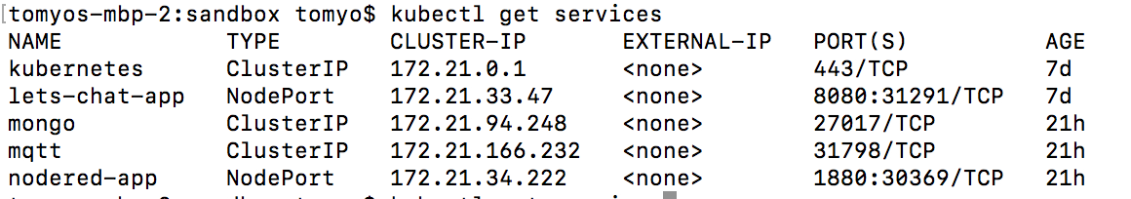

1. Insert on your browser the http://<PUBLIC IP>:<nordered-app port>

