I am using my MacBook with mac OS High Sierra Version 10.13.5

My editor is TexEdit.

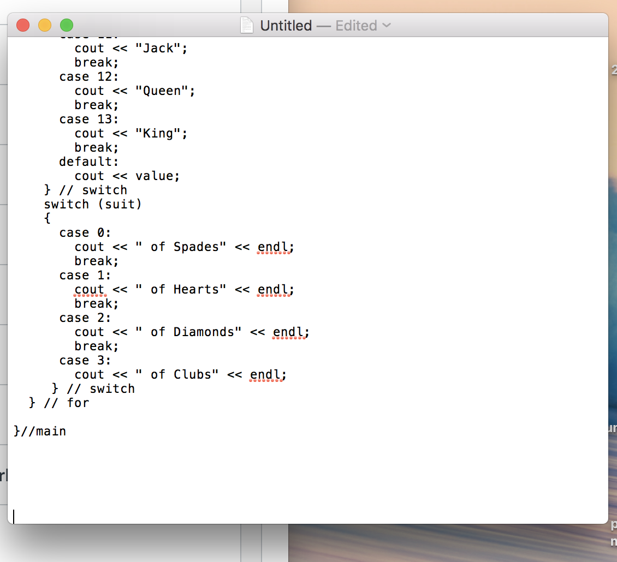

I have installed Xcode, and I am going to use its command line tool.

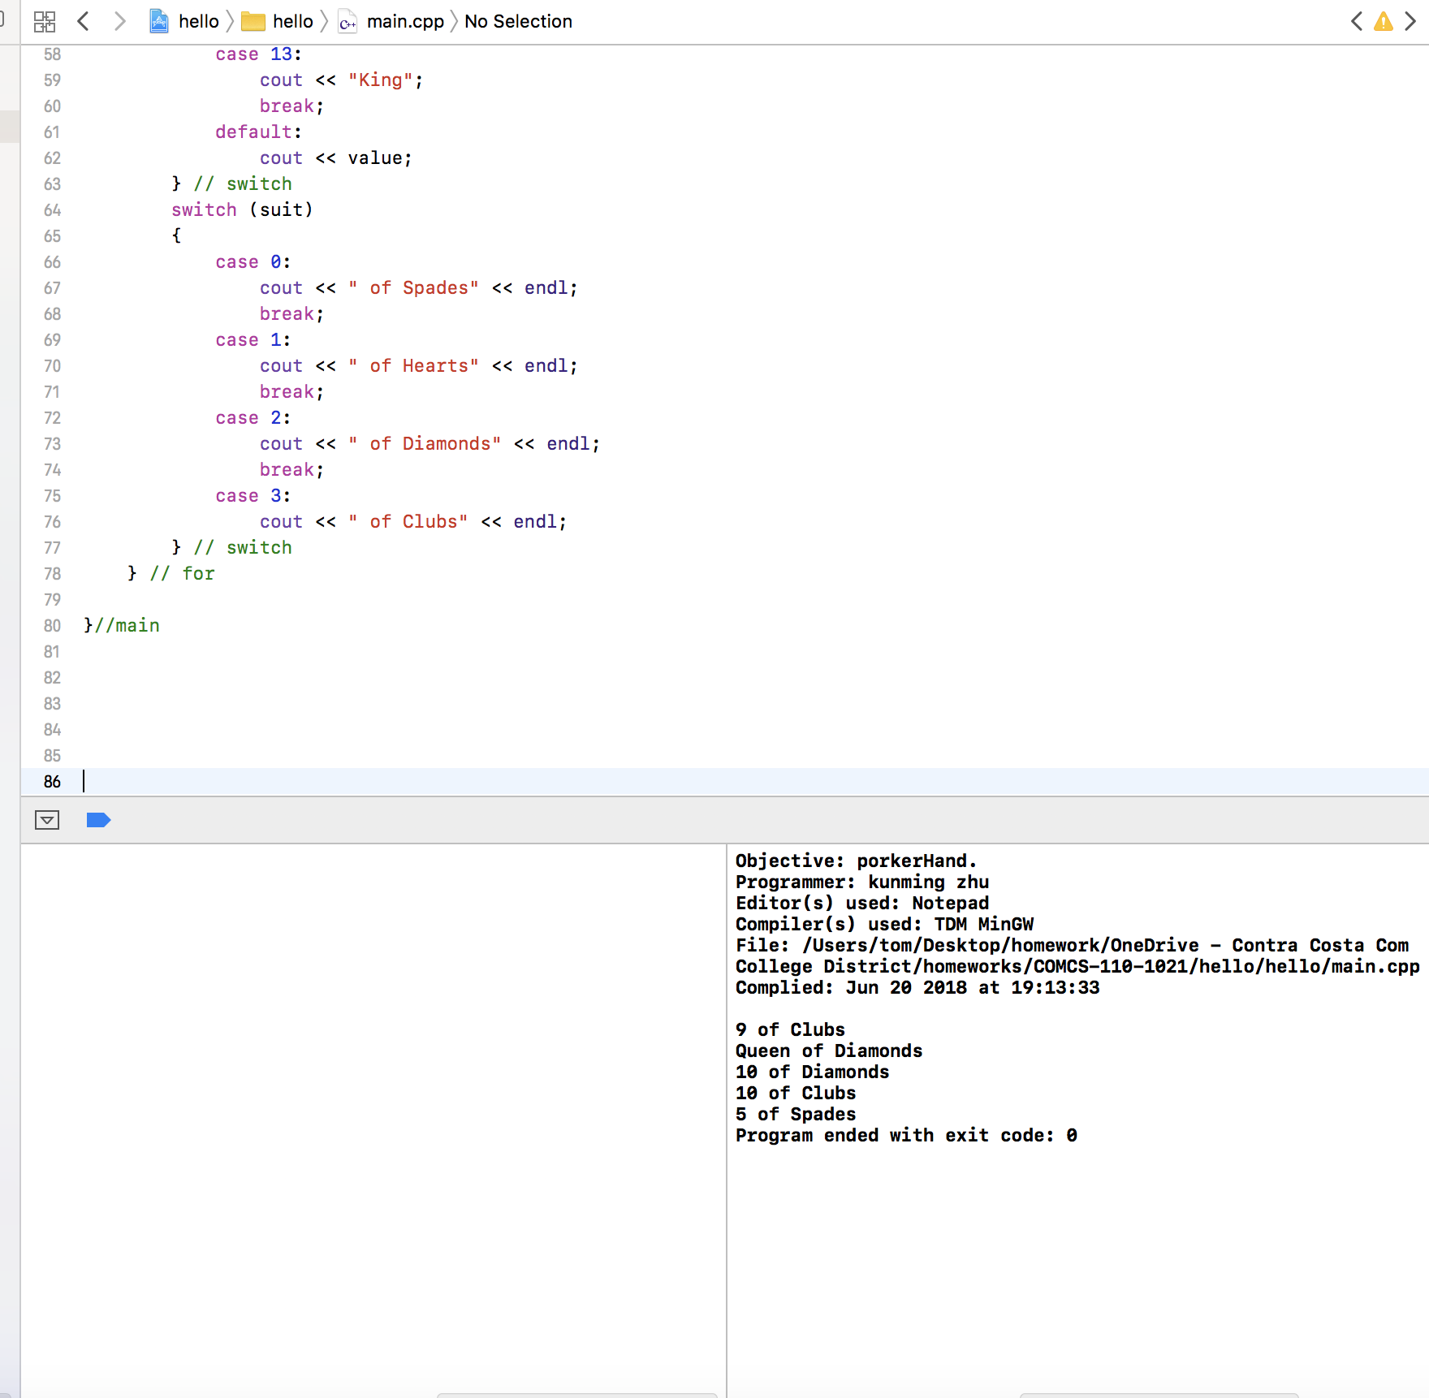

My working folder is named “COMCS-110-1021.” It is my one drive’s ghost folder on my MacBook.

