Source Code – Exercise 1 | Memory Map
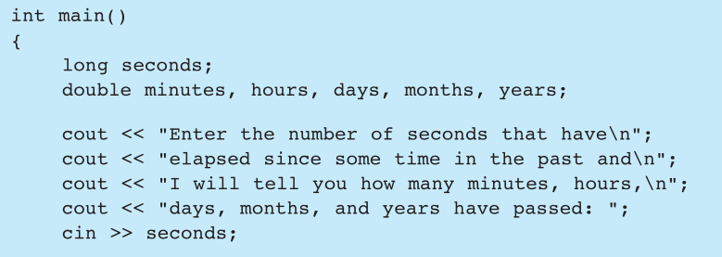  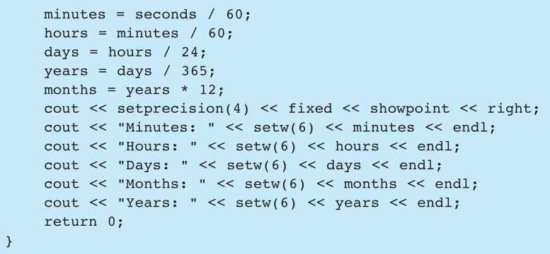
  seconds | minutes | hours | days | months | years
  ? | ? | ? | ? | ? | ?
  ? | ? | ? | ? | ? | ?
  3600.0 | ? | ? | ? | ? | ?
  3600.0 | 60.0 | ? | ? | ? | ?
  3600.0 | 60.0 | 1.0 | ? | ? | ?
  3600.0 | 60.0 | 1.0 | 0.04166667 | ? | ?
  3600.0 | 60.0 | 1.0 | 0.04166667 | ? | 0.00011416
  3600.0 | 60.0 | 1.0 | 0.04166667 | 0.00136986 | 0.00011416
  3600.0 | 60.0 | 1.0 | 0.0417 | 0.0014 | 0.0001

Source Code – Exercise 2 | Memory Map
int main()  {  long x, y, z, w;  x = y = z = 99;  x += 2;  y -= 1;  z *= 3;  w = x;  x = y;  y = z;  z = w;  cout << x << “ “ << y << “ “  << z << endl;  }
  w | x | y | z
  ? | ? | ? | ?
  ? | 99 | 99 | 99
  ? | 101 | 99 | 99
  ? | 101 | 98 | 99
  ? | 101 | 98 | 297
  101 | 101 | 98 | 297
  101 | 98 | 98 | 297
  101 | 98 | 297 | 297
  101 | 98 | 297 | 101
  101 | 98 | 297 | 101

