CMPSC Assignment3 Report

Xiangfeng Yuan

1. My own unit test:

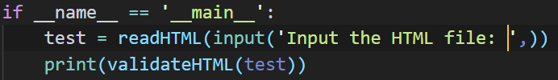

Result:





2. testing with the validHTML.html in the same folder:

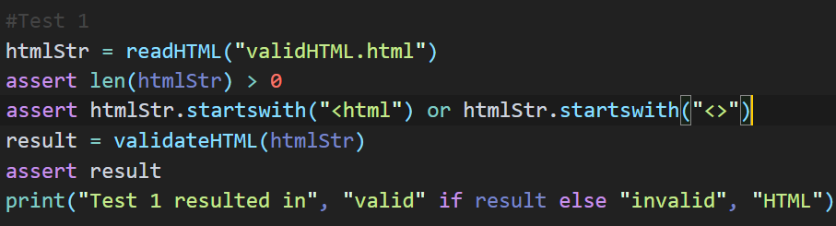

Result:



3. testing with the invalidHTML.html in the same folder:

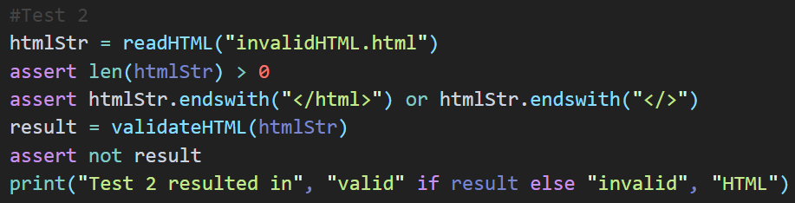

Result:



4. testing with my custom-made test1.html in the same folder (which should be valid):

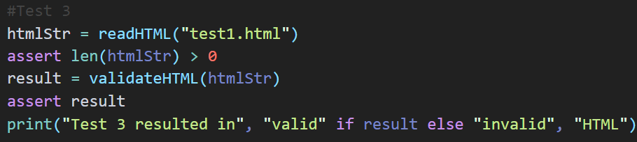

Result:



5. testing with the online url: <http://redive.estertion.win> (source: a friend of mine) (for the bonus point)

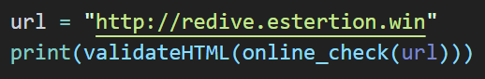

Result:

True.