UI Preview — iOS · Android · Web
Generated: 2026-05-24

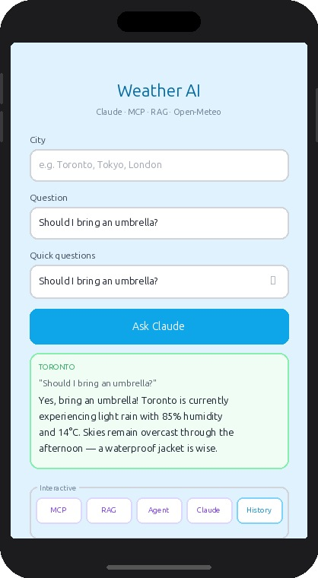  iOS — iPhone 14 | 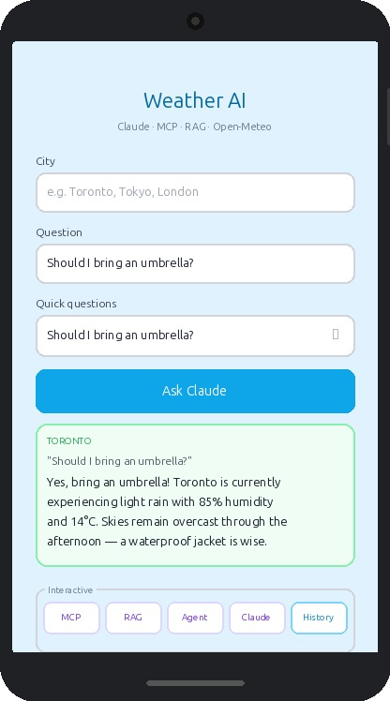  Android — Pixel | 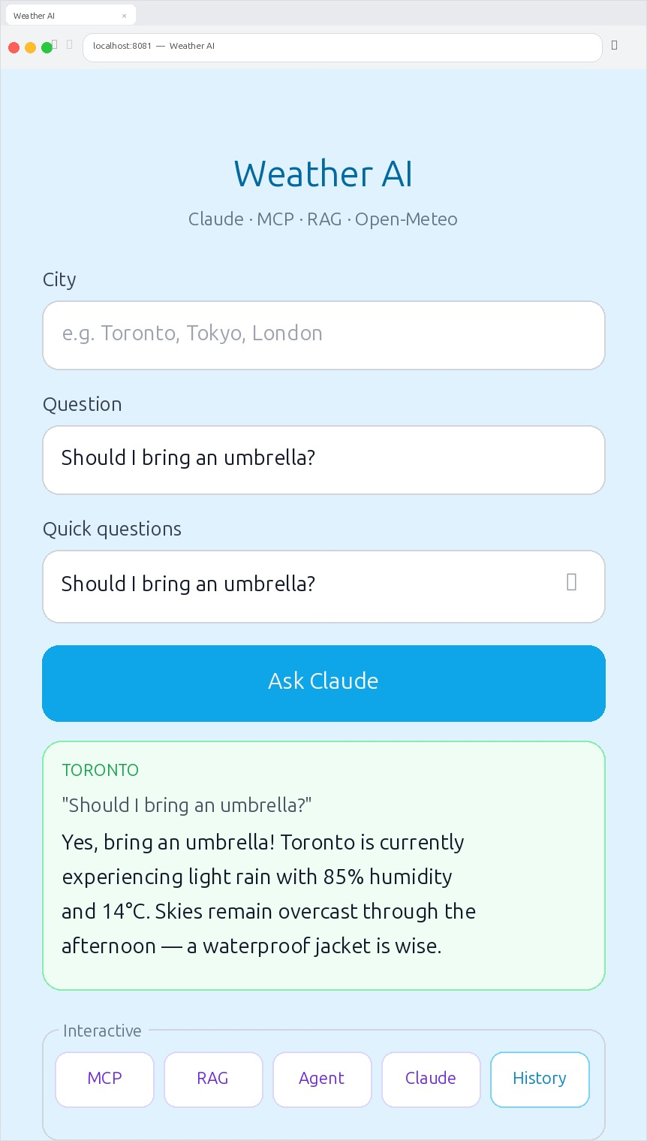  Web — Browser

UI Preview — iPad

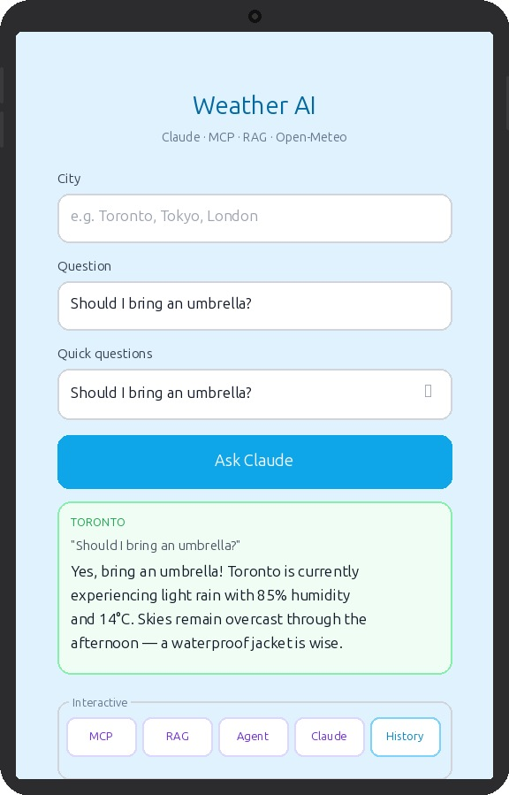  iPad — Portrait (full page) | 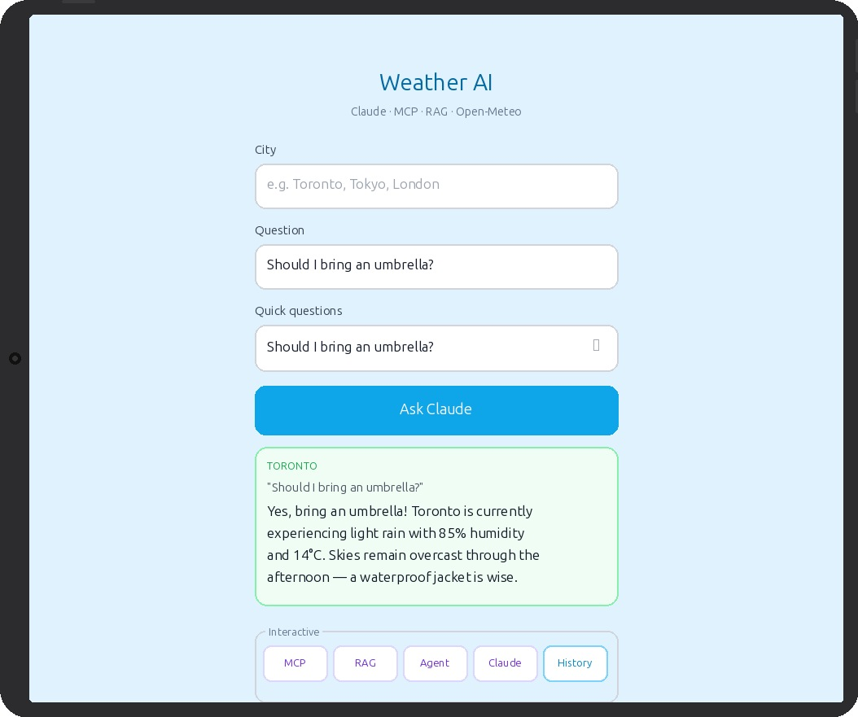  iPad — Landscape (full page)

UI Preview — Settings & Sync State Modal

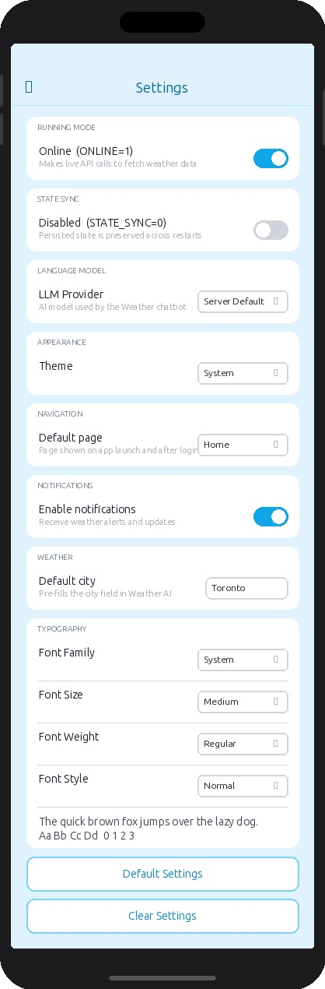  Settings — iOS | 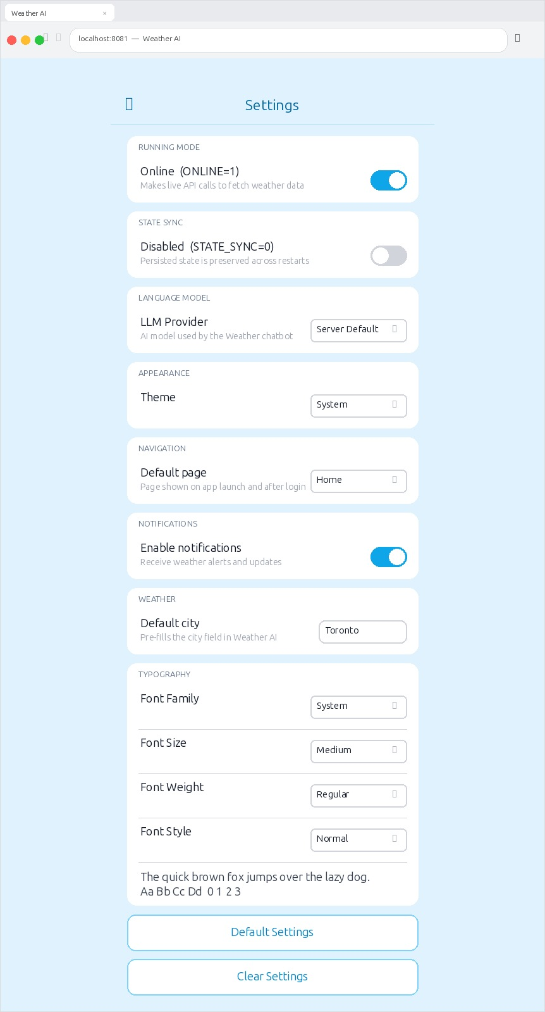  Settings — Web | 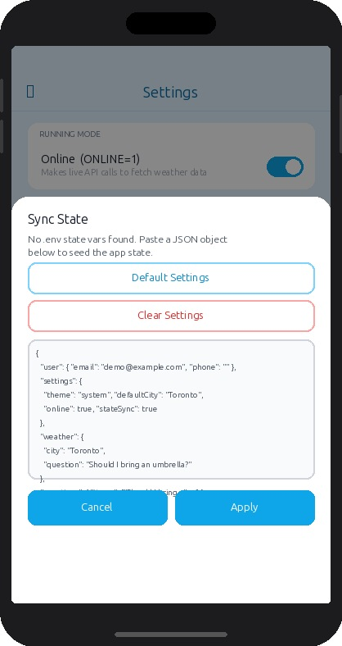  Sync State Modal — iOS

UI Preview — History Page

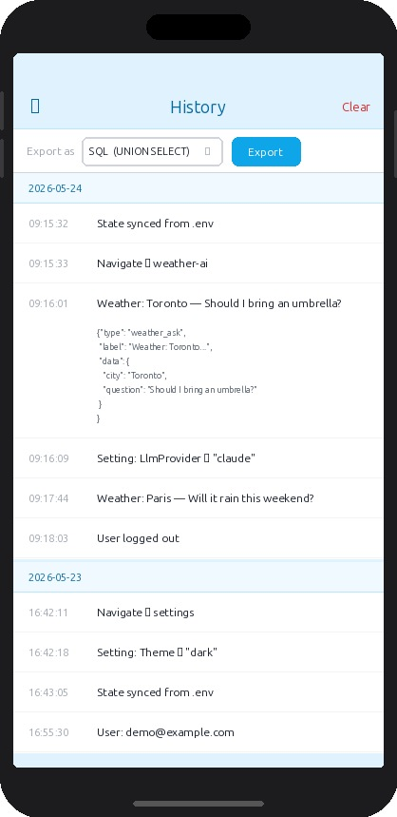  History — iOS | 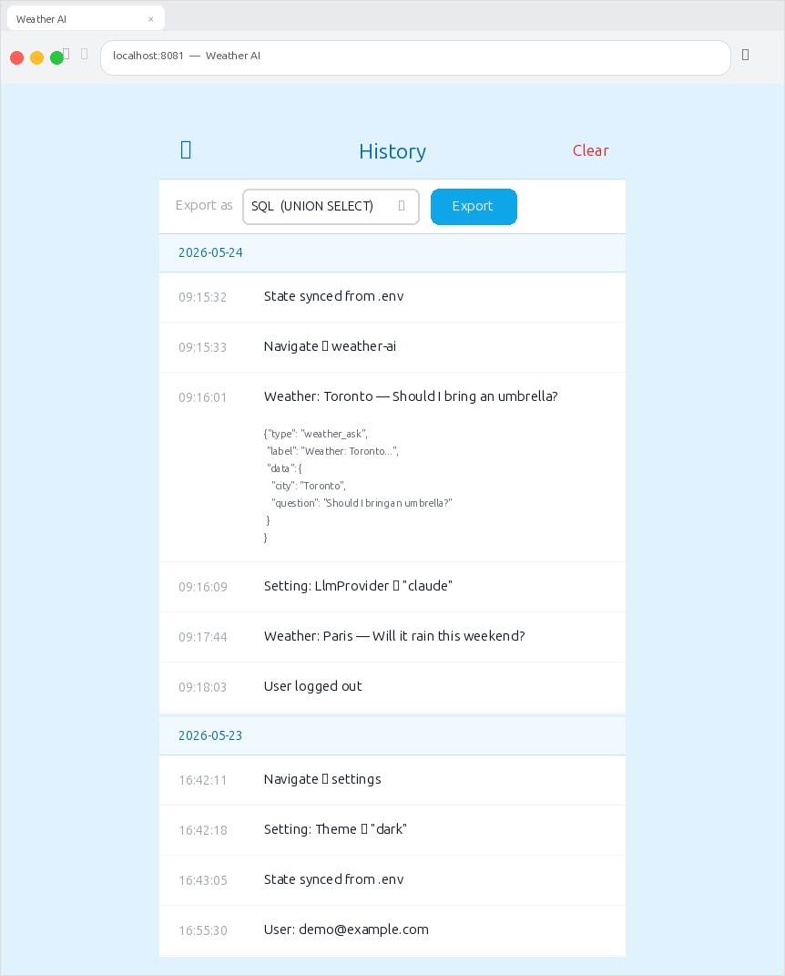  History — Web

