SOLUTION PROPOSAL
Finished Goods Cold Store — Management & Automation System | Costa Mushroom, Plant M1 & M2

Item | Detail
Client | Costa Mushroom — Plant M1, M2
Scope | Finished goods cold store: from completed pallet to container dispatch
Design capacity | 60 tonnes/day peak (M1 + M2 combined)
Issue date | 20 August 2026
Validity | 60 days from issue date
Status | Preliminary proposal — subject to site survey confirmation

TABLE OF CONTENTS
- EXECUTIVE SUMMARY
- DESIGN BASIS
- CURRENT STATE & CHALLENGES
- THREE OPTIONS
- SYSTEM ARCHITECTURE — OPTION A
- AUTOMATED PALLETISING SYSTEM DESIGN
- RECOMMENDATION: THREE-PHASE ROADMAP
- TECHNICAL DESIGN
- TRACEABILITY & INTEGRATION — OUR DIFFERENTIATOR
- SAFETY & COMPLIANCE
- IMPLEMENTATION PLAN — OPTION A
- COMMERCIAL STRUCTURE
- PERFORMANCE GUARANTEES
- ASSUMPTIONS, EXCLUSIONS AND RISKS
- NEXT STEPS

1. EXECUTIVE SUMMARY
We propose upgrading Costa Mushroom’s finished goods cold store through a three-phase roadmap, beginning with a software layer that can be deployed quickly with negligible production disruption, then progressively extending into mechanical automation once the business case has been evidenced.
Three options compared:
Criterion | Option A | Option B | Option C
 | Digitalisation & WMS | Semi-automated | Full AS/RS
Scope | Scale station + pallet identification, WMS/WCS, forklift terminals | Adds robotic palletising + through-wall conveyor + shuttle racking | Adds AS/RS stacker crane in cold store
Automated palletising | — | Yes — 2 robot cells | Yes — 2 robot cells
Cold store floor area | Unchanged | ~87 m² (from ~296 m²) | ~48 m²
Implementation time | 3–5 months | 12–18 months | 24–30 months
Production disruption | Negligible | Moderate | High
Indicative budget | AUD 250–500 k | AUD 2.2–4.0 M | AUD 4.5–8.0 M
Delivery risk | Low | Moderate | High
Our recommendation: commence with Option A.
Not because it is the cheapest, but because Costa currently lacks the operating data required to make a sound decision on Option B or C. After six months of running Option A, Costa will hold measured data on hourly throughput, actual dwell time, error rates and forklift hours spent inside the cold store — precisely the figures that determine whether an AUD 2.2 M or AUD 8.0 M investment will return.
Option A is architected so that no element is discarded when upgrading to Option B or C.
Our differentiator: Costa’s iZiiApp platform already manages harvest planning by zone (M1/M2), by picking crew, and by grade (Button, Cup, Flat), with output counted in boxes. Critically, box-level barcoding is already deployed — carrying crew, grade and grow room. The upstream data therefore already speaks the language of this problem. The one missing link is the box → pallet → container aggregation, and that is precisely the scope of this proposal. See Sections 5 and 9.

2. DESIGN BASIS

2.1 Input data
Parameter | Value | Source
Peak output | 60 tonnes/day (M1 + M2) | Costa
Weight per box | 4 kg | Costa
Box types | 2 types, differing dimensions | Costa
Box construction | Open-top vented tray | Costa
Box dimensions | ~400 × 300 × 130 mm | ASSUMED — both types to be measured
Palletising rule | The two box types are never mixed on one pallet | Costa
SKU matrix | 2 colours × 3 grades × 2 box types = 12 SKUs | Costa
Concurrent SKUs | 4 – 6 SKUs per shift | Costa
Palletising area temperature | 20 – 25 °C | Costa
Pallet standard | Australian Standard Pallet 1165 × 1165 mm (AS 4068) | National standard

2.2 Calculated pallet pattern
For a 400 × 300 mm box on the Australian Standard Pallet, with the 20 mm clearance required by a mechanical gripper (mandatory, since an open-top vented tray cannot be handled by vacuum):
Layers | Boxes/pallet | kg/pallet | Pallet height | Pallets/day
8 layers | 64 | 256 | 1.19 m | 234
9 layers | 72 | 288 | 1.32 m | 208
10 layers | 80 | 320 | 1.45 m | 188
11 layers | 88 | 352 | 1.58 m | 170
8 boxes per layer. Notably, the 20 mm gripper clearance does not reduce the boxes per layer compared with a tight pattern; only beyond 25 mm does it fall to 7 boxes per layer. This is a favourable finding for gripper selection.

2.3 Derived figures
Metric | Value
Total boxes per peak day | 15,000 boxes
Total pallets per peak day | ~208 pallets (9 layers × 8 boxes)
Split evenly across two plants | ~104 pallets/plant/day
Equivalent 40 ft containers | ~10 containers/day
Note on rounding: the capacity and floor-area tables below use 200 pallets/day as a round planning figure. The 4% difference against 208 sits comfortably within the 20% design margin applied to storage capacity. Once both box types are physically measured, we will confirm exact figures per product line.

2.4 Required throughput
Operating hours | Pallets/h (avg) | Seconds/pallet | Peak (×1.5) | Boxes/min
8 hours | 25.0 | 144 | 37.5 | 31.2
10 hours | 20.0 | 180 | 30.0 | 25.0
12 hours | 16.7 | 216 | 25.0 | 20.8
16 hours | 12.5 | 288 | 18.8 | 15.6
20 hours | 10.0 | 360 | 15.0 | 12.5
Engineering observation: at 12 operating hours, the peak rate of 25 pallets/h equates to one pallet every 2.4 minutes. A single scale conveyor station handles this comfortably, and it also sits within the duty of a single AS/RS stacker crane (typically 25–35 dual cycles/h). In other words, Costa’s problem is not throughput- limited — it is limited by storage density and data accuracy. This observation drives every recommendation that follows.

2.5 Cold store capacity vs dwell time
Dwell time | Pallets on hand | +20% contingency | Scenario
8 hours | 67 | 80 | Dispatched within shift
12 hours | 100 | 120 | Dispatched same day
18 hours | 150 | 180 | Overnight
24 hours | 200 | 240 | Proposed design basis
36 hours | 300 | 360 | 1.5 days
48 hours | 400 | 480 | Weekend buffer
72 hours | 600 | 720 | Public holiday / transport disruption
This is the single parameter Costa should confirm first. Actual dwell time drives capital cost directly — the difference between 12 hours and 48 hours is a fourfold change in required capacity.

2.6 Floor area by storage technology (240-pallet capacity)
Technology | Levels | Utilisation | Floor m² | Refrigerated m³
Block stacking | 2 | 55% | 296 | 1,184
Selective racking | 3 | 40% | 271 | 1,900
Double-deep racking | 3 | 50% | 217 | 1,520
Drive-in racking | 4 | 65% | 125 | 1,128
Pallet shuttle racking | 5 | 75% | 87 | 955
Mobile racking | 3 | 65% | 167 | 1,169
AS/RS stacker crane | 8 | 85% | 48 | 862
The final column matters more than floor area: refrigerated volume drives energy cost across the whole asset life. Moving from block stacking to shuttle racking cuts refrigerated volume by ~19%; AS/RS cuts it by ~27%. For a store running 24/7 year-round, this compounds materially.

2.7 Dispatch doors
Scenario | Movements/day | Pallets/movement
40 ft interstate containers (70%) | 7.0 | 20
Refrigerated supermarket trucks, intrastate (30%) | 7.5 | 8
Total | ~14.5 movements/day | —
Over a 10-hour dispatch window this is 1.45 vehicles/h. Applying a 1.5 peak factor, a minimum of three dispatch doors is required to avoid vehicle queuing.

3. CURRENT STATE & CHALLENGES

3.1 Current process
Box packing → Palletising (two box types kept separate) → Stretch wrapping
→ Forklift places pallet on scale conveyor → Into cold store
→ Container / truck collects against order

3.2 Five challenges identified
(1) Brownfield constraint — upgrading a live facility. Costa has an existing cold store requiring upgrade, not a greenfield build. This constrains available clear height, column positions, floor loading and installed refrigeration capacity. Every option must be installed while the store continues to operate — the heaviest constraint of all, and the principal reason we recommend starting with software.
(2) Relative humidity above 95% — a harder problem than temperature. Mushrooms store best at 0–2 °C with relative humidity above 95%. Under these conditions:
- Barcode readers and cameras fog over, and misread rates rise sharply
- Enclosures and sensors require IP65 or better with anti-condensation heating
- Metal corrosion proceeds far faster than in ambient warehousing
- Paper pallet labels delaminate and smear
This is why we specify RFID rather than barcode for pallet identification inside the chilled envelope — see Section 8.3.
(3) Box-level data already exists — only the aggregation step is missing.
Costa already operates box-level barcoding, carrying picking crew, grade and grow room. This is an excellent foundation and materially changes the problem in Costa’s favour: traceability does not need to be built from scratch — only one link needs closing.
ALREADY IN PLACE MISSING
──────────────────────────────── ──────────────────────────────
Grow Room · Crew · Grade Which boxes are on which pallet?
↓ (barcode on every box) Which pallets went on which container?
BOX [in place] --X-- PALLET → CONTAINER
Consequences of the broken link:
- No means of tracing a pallet back to its grow rooms
- Reconciling harvested output against dispatched output is a manual exercise
- When a supermarket raises a quality claim, isolating the affected lot requires working back through paperwork
The key point: because barcodes already exist on every box, the box → pallet aggregation can be captured fully automatically with no additional labour, by placing a reader immediately upstream of the palletiser pick point. Put differently, the palletising system and the traceability requirement solve one another — see Section 6.5.
(4) A 12-SKU matrix — automated palletising required.
The real product matrix has three dimensions:
Dimension | Values | Count
Colour | White, Brown | 2
Grade | Button, Cup, Flat | 3
Box type | Box A, Box B (different dimensions) | 2
Total combinations |  | 12 SKUs
At 208 pallets/day across 12 SKUs, the average is only 17 pallets/day per SKU. Many SKUs will not fill a single pallet in a day if demand splits evenly.
This — not throughput — is the real challenge. Pallets must be built to order, not to SKU, which means several different pallets must be open simultaneously. With 4–6 SKUs running concurrently in a shift, manual palletising leads to mis-selected pallets, part-built pallets occupying floor space, and no reliable means of recording which box went onto which pallet.
This is why Costa requires an automated palletising system — design detail in Section 6.
(5) Personnel hours inside the chilled envelope. Forklift operation at 0–2 °C attracts allowances, limits shift duration, and carries occupational health obligations under WHS legislation. This is a hidden cost that is routinely under-counted when options are compared.

4. THREE OPTIONS

4.1 Option A — Digitalisation & WMS (recommended starting point)
Scope of supply:
Item | Description
Intelligent scale station | Integration with existing scale conveyor; automatic weight capture, no manual entry
Pallet identification | Humidity-rated RFID tags; read portals at scale station and dispatch doors
Print & apply labelling | Humidity-resistant labels, printed automatically post-weighing, carrying GS1 SSCC
WMS/WCS on the iZiiApp platform | Location management, dispatch orders, output reconciliation, traceability
Forklift-mounted terminals | Cold-rated displays providing directed put-away and retrieval
Real-time dashboard | Throughput, stock on hand, open orders, stock-ageing alerts
Integration | Connection to the existing harvest module; ERP-ready interfaces
Advantages:
- Deployed in 3–5 months with negligible production disruption
- No structural works, no shutdown required
- Generates the data needed to decide between B and C — the greatest single value of this option
- Every element is retained on upgrade
Limitations — stated plainly:
- Does not increase storage density
- Does not reduce personnel hours inside the cold store
- Does not add capacity should output exceed 60 tonnes/day
Indicative budget: AUD 250,000 – 500,000

4.2 Option B — Semi-automated
Added to Option A:
Item | Description
Automated palletising system | 2 robot cells (one per plant), 4 build positions + roller conveyor — Section 6
Barcode reader upstream of pick point | Creates the box → pallet link automatically, with no additional labour
Automatic stretch wrapper | In-line, immediately downstream of the palletiser
Through-wall pallet conveyor | Moves pallets from packing hall into the cold store without forklift door transits
High-speed doors | Reduce cold loss and condensation
Pallet shuttle racking | 5 levels, high density — floor area from ~296 m² down to ~87 m²
Shuttle carriers | 2–3 units operating within lanes; forklifts load/unload at lane face only
Extended WCS | Coordination of palletiser, conveyor and shuttle carriers
Category 3 safety system | Perimeter guarding, interlocks and E-stop for the robot cell — Section 6.8
Advantages:
- Eliminates box-type mixing errors entirely — the system refuses an incorrect SKU placement
- Automatic box → pallet traceability at near-zero marginal cost (Section 6.5)
- Releases ~70% of floor area compared with block stacking
- Cuts refrigerated volume by ~19% — sustained energy saving
- Materially reduces forklift hours inside the cold store
- Shortens time at ambient temperature — continuous conveying replaces forklift waiting steps, partially mitigating the issue raised in Section 6.7
- Retains forklift flexibility for exception handling
Limitations:
- Structural works required — a phased changeover plan is essential
- Implementation 12–18 months (extended by the palletising scope)
- Floor loading and clear height must be verified
- Floor space required for a robot cell at both plants
- The robot cell requires a full safety dossier to AS/NZS 4024
Indicative budget: AUD 2.2 – 4.0 M (of which the two palletising cells represent approximately AUD 1.0 – 1.6 M)

4.3 Option C — Full AS/RS
Added to Option B:
Item | Description
AS/RS stacker crane | 1–2 rail-guided cranes within the cold store, 8 levels
High-bay racking | Designed to available clear height
Full infeed/outfeed conveyor | Fully automated from packing through to dispatch door
Category 3 safety system | Per AS/NZS 4024 — perimeter guarding and interlocks
Advantages:
- Highest density: ~48 m² floor, refrigerated volume reduced ~27%
- Effectively no personnel required inside the cold store during normal operation — the single largest benefit, in both cost and WHS-obligation terms
- Near-absolute inventory accuracy
Limitations — stated plainly:
- Major capital outlay, 24–30 month programme
- Existing clear height may render this option unfeasible on a brownfield site — must be surveyed before any commitment
- System-down risk: if the crane fails there is no manual fallback unless designed in
- Installation within a live cold store is highly complex
Indicative budget: AUD 4.5 – 8.0 M (inclusive of all Option B scope)
Regarding the budget figures: these are order-of-magnitude ranges for planning purposes, not quotations. The two most volatile items — and the two that cannot be estimated without a site survey — are (a) refrigeration plant upgrade and (b) structural/floor strengthening. Firm pricing follows the survey described in Section 15.

5. SYSTEM ARCHITECTURE — OPTION A
This section defines the technical design of Option A. Four views are presented: system architecture, data flow, data model, and process sequence.

5.1 Architecture overview
The solution is structured in four layers. Green elements already exist at Costa and are reused, not replaced.
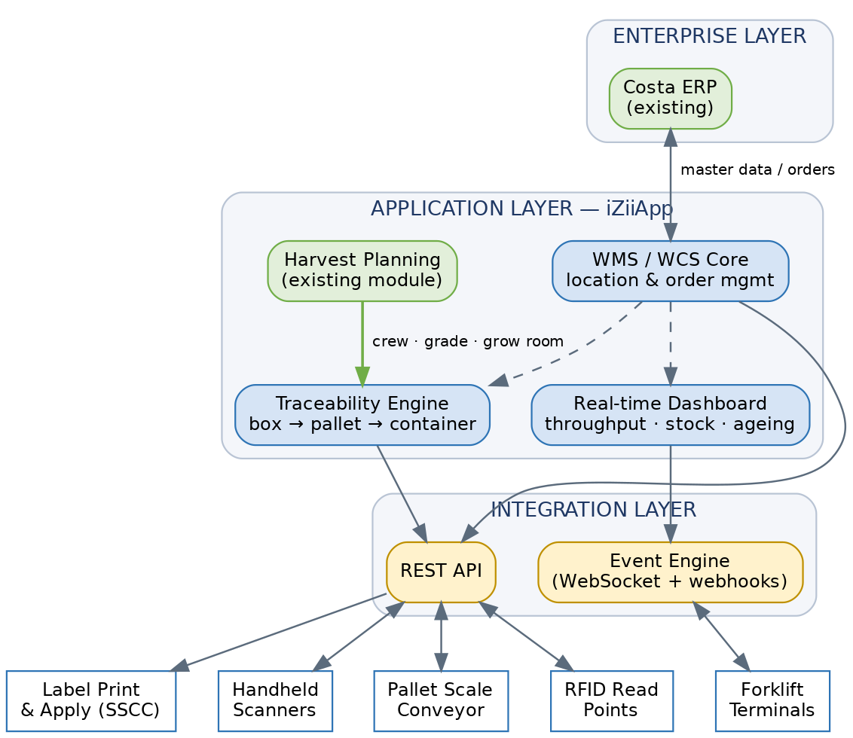
Figure 1 — Option A system architecture.
Key architectural decisions:
Decision | Rationale
Reuse the existing harvest module rather than replace it | Crew, grade and grow-room data already exist and are trusted by operations
WMS/WCS deployed on the existing iZiiApp platform | Avoids a second platform, second login and second support contract
Integration layer isolated from the application layer | Field devices can be added or changed without altering application logic
No safety function implemented in software | All machinery safety resides in independent certified hardware — see Section 10
ERP interface is bidirectional but non-blocking | Loss of the ERP link must not stop the floor

5.2 Data flow — closing the aggregation link
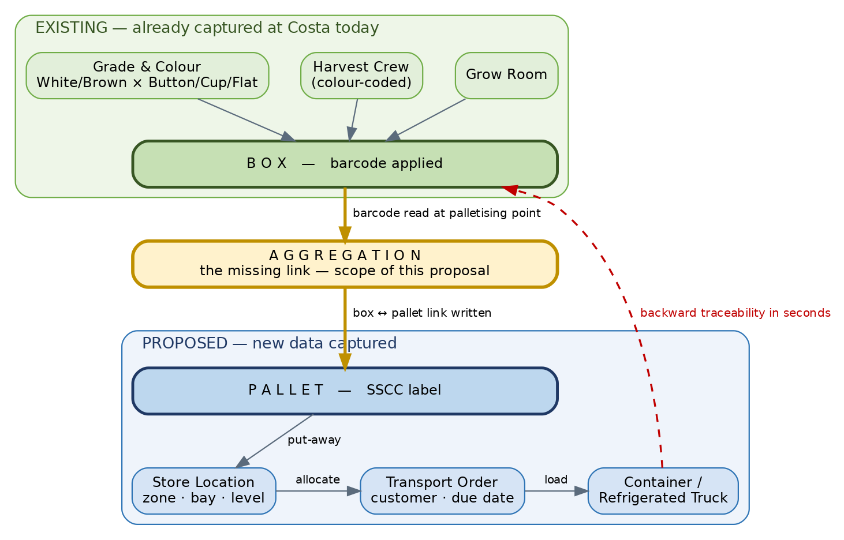
Figure 2 — Data flow showing the aggregation event.
The dashed return path is the commercial value of this proposal: given a container number, the system resolves the full set of contributing grow rooms, crews and harvest dates in seconds rather than hours.

5.3 Data model (ERD)
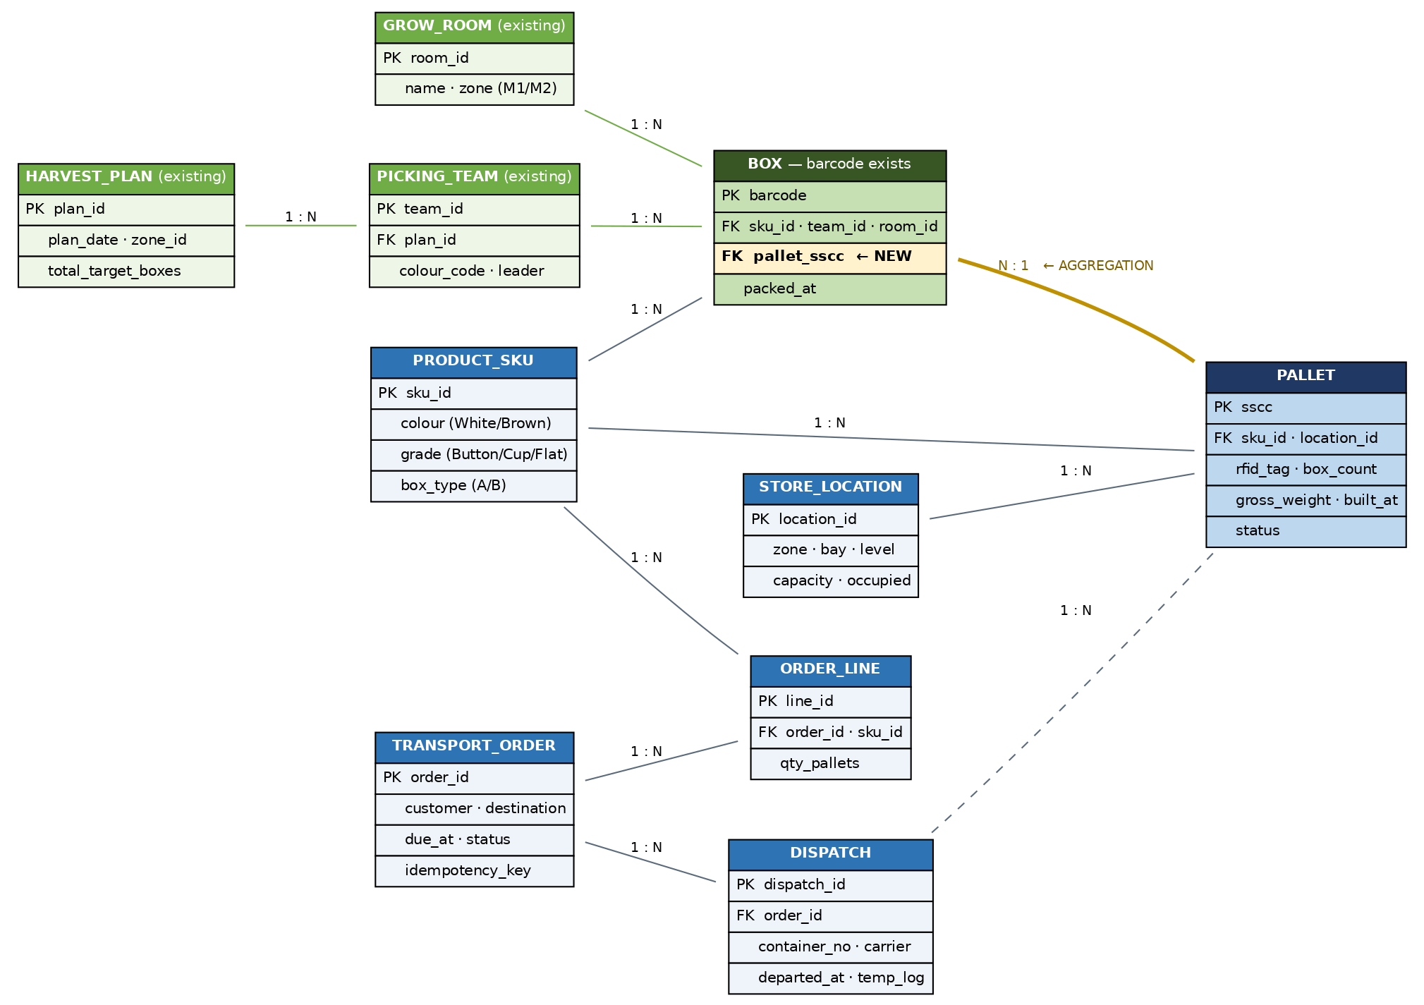
Figure 3 — Entity relationship diagram.
The critical addition is the single foreign key BOX.pallet_sscc. Everything else either already exists or is conventional warehouse data. This is worth emphasising in commercial terms: the traceability capability Costa gains rests on one new relationship, not on a new system.
Two design notes:
- TRANSPORT_ORDER.idempotency_key — orders received more than once must never create duplicate movements. This mirrors the pattern already proven in Costa’s existing synchronisation layer.
- PALLET.status follows a controlled state model: building → wrapped → weighed → stored → allocated → picked → dispatched. Status transitions are the audit trail.

5.4 Pallet lifecycle sequence
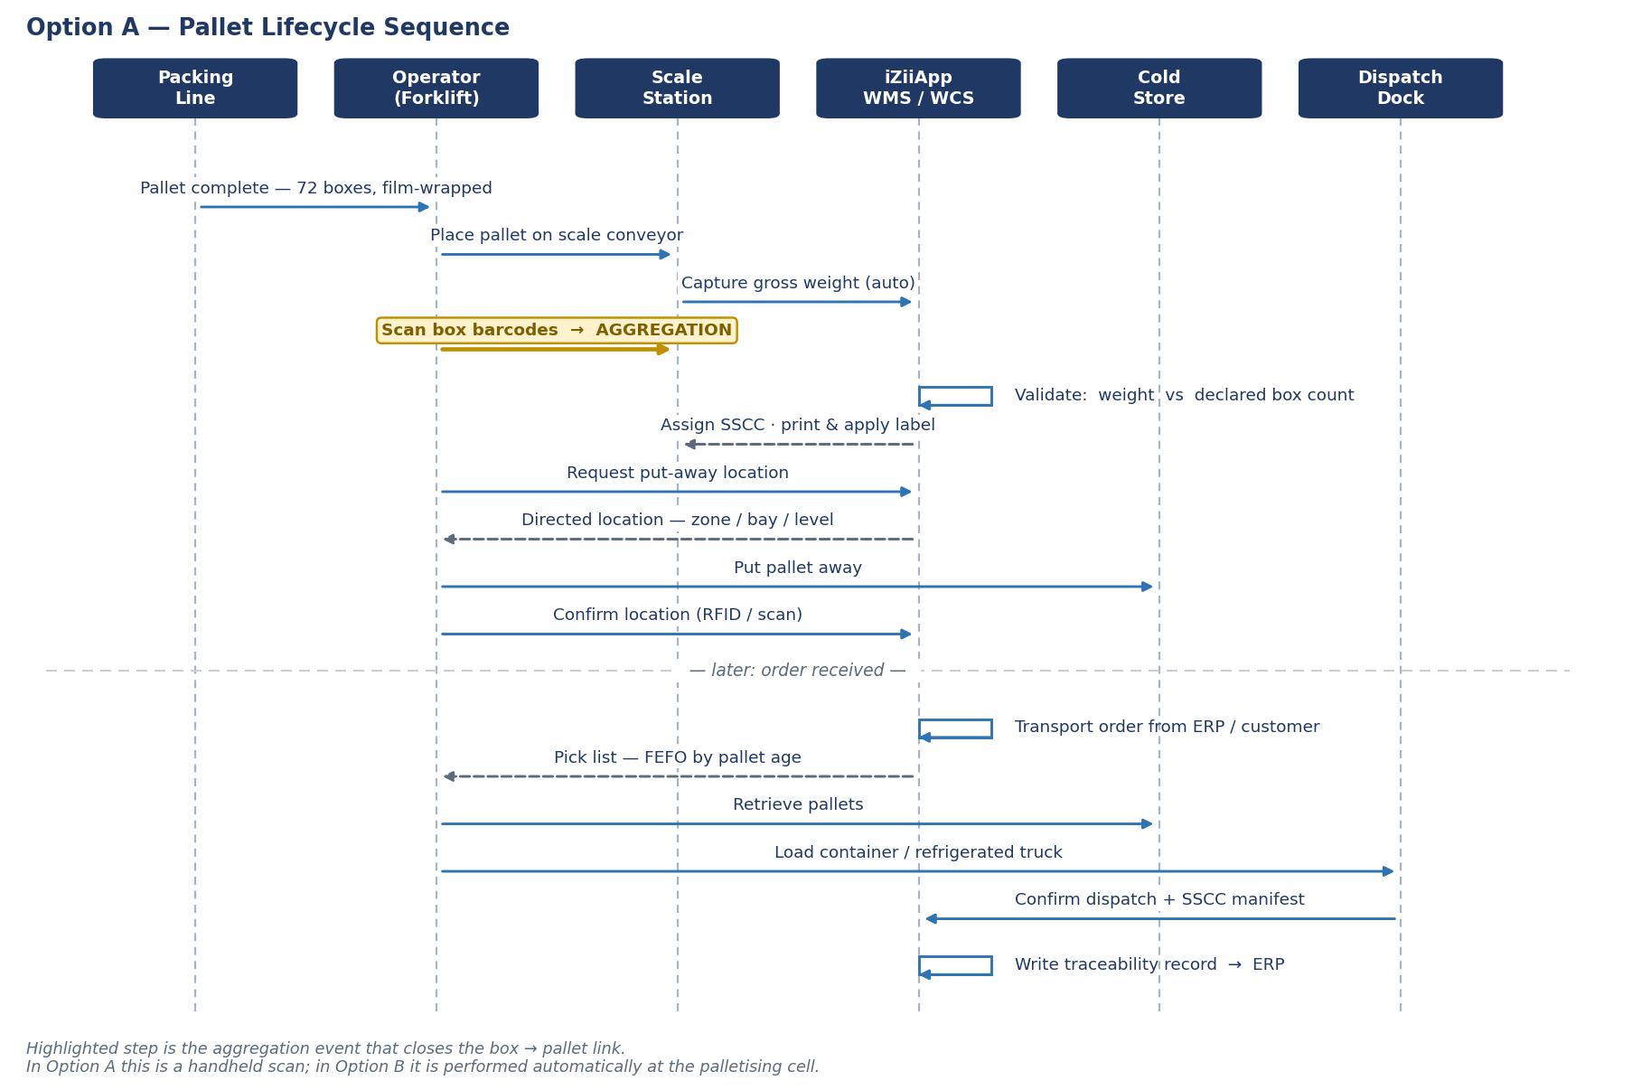
Figure 4 — Pallet lifecycle sequence, Option A.
Step 4 is the aggregation event. In Option A it is a handheld scan performed by the operator; in Option B the identical data is captured automatically at the palletising cell with no operator action. The data model does not change between options — only the capture mechanism — which is why Option A is not discarded on upgrade.
FEFO note: pick lists are sequenced first-expired-first-out by pallet build timestamp, not by location convenience. Given a 14–20 day shelf life at 1 °C, this is the single most effective software control over product wastage.

5.5 Technology stack and interfaces
Layer | Technology | Notes
Application | iZiiApp platform (existing) | No new platform introduced
API | REST/JSON over HTTPS | Idempotent order endpoints
Real-time | WebSocket + outbound webhooks | Dashboard and terminal updates
Pallet identification | UHF RFID (AS/NZS-compliant band) | See Section 8.3
Labelling | GS1 SSCC, print & apply | Supermarket-compatible
Box identification | Existing barcode symbology | Reused unchanged
Device connectivity | Industrial Wi-Fi / wired Ethernet | Wireless never in a control or safety path
ERP integration | REST or file-based, to suit Costa’s ERP | Confirmed at survey
Architectural constraint retained throughout: the WMS/WCS performs no safety function. All machinery safety is delivered by independent certified hardware to AS/NZS 4024. This boundary is maintained in every phase — for engineering reasons, and because it keeps responsibility under the WHS Act unambiguous.

6. AUTOMATED PALLETISING SYSTEM DESIGN

6.1 Design requirements
Requirement | Value
Output | 15,000 boxes/day (M1 + M2)
Box | ~400 × 300 × 130 mm, open-top vented tray, 4 kg
SKUs | 12 combinations; 4–6 running concurrently per shift
Rule | The two box types must never be mixed on one pallet
Pallet | Australian Standard 1165 × 1165 mm, 8 boxes/layer × 9 layers = 72 boxes
Environment | 20 – 25 °C
Traceability | Record every box against its pallet

6.2 Throughput — and why robotic rather than layer palletising
Configuration | Boxes/min per machine | Cycles/min (single pick) | Cycles/min (double pick)
1 machine serving M1+M2, 12 h | 20.8 | 20.8 | 10.4
2 machines (one per plant), 12 h | 10.4 | 10.4 | 5.2
2 machines, 8 h | 15.6 | 15.6 | 7.8
Reference capacities:
Machine type | Capacity | Suitable?
Layer palletiser | 60–120 cases/min | No — very fast but slow to change SKU; unsuitable for 12 SKUs
Industrial 4-axis robot | 20–30 cycles/min | Yes — correct selection
Collaborative robot | 5–9 cycles/min | Marginal — only viable at 2 machines × 20 hours
Conclusion: two robot cells (one per plant) operate at 10.4 cycles/min — roughly 42% of rated robot capacity, a design margin of 2.4×. Practically, this means that if Costa increases output beyond 60 tonnes/day, or compresses operating hours, the equipment still meets demand without further capital investment.

6.3 Gripper design for open-top vented trays — the critical technical point
The boxes are open-top vented trays. This immediately eliminates the most common end-of-arm tooling:
Gripper type | Viable? | Comment
Vacuum | No | Open top provides no sealing surface
Side clamp | Yes | Requires clearance between boxes
Fork / blade | Limited | Requires clearance beneath the tray base
Side clamp + bottom support plate | Recommended | Most secure for open trays; prevents drop-through
A favourable finding from the pattern calculation: the 20 mm clearance required by a clamp gripper does not reduce boxes per layer — still 8, identical to a tight pattern. Only beyond 25 mm does it fall to 7 per layer (a 12.5% capacity loss). Therefore:
Design constraint: the gripper must operate within a clearance of ≤ 20 mm. This figure must appear in the equipment specification at tender. It is not negotiable.
Three constraints observed from the product itself:
- Carton walls are thin and flexible — clamping force must be distributed across a broad contact area to avoid crushing the tray
- Mushrooms frequently sit proud of the tray rim — the gripper must approach from the sides only, with no component passing over the product
- Handhold cut-outs in the tray sides can be exploited as location features for gripper fingers, improving positional repeatability
Consequence for pallet stability. A 20 mm gap between boxes produces a less interlocked load than a tight pattern. This is compensated by:
- Stretch wrapping with calibrated film tension (already in Costa’s process)
- Interlayer pads — to be evaluated during sample trials
- Alternating layer orientation to improve interlock

6.4 Cell layout
With 4–6 concurrent SKUs, the number of pallet build positions governs the layout:
Build positions | Span required | Robot reach required | Feasible?
4 positions | 5.3 m | ~3.2 m | Yes — one standard robot (3.1–3.2 m reach)
6 positions | 8.0 m | ~4.6 m | No — exceeds standard palletising robot reach
Recommended solution — 4 active positions served by roller conveyor:
[ Box infeed conveyor ]
|
+---------v---------+
| Barcode reader | <- traceability capture point
+---------+---------+
|
+----------v----------+
| 4-AXIS ROBOT |
+--+-----+-----+---+--+
| | | |
[P1] [P2] [P3] [P4] <- 4 active build positions
| | | |
====+=====+=====+===+==== <- powered roller conveyor
^ |
empty pallets in full pallets out -> stretch wrap
-> weigh -> SSCC label -> cold store
The roller conveyor allows completed pallets to exit and empty pallets to enter automatically, so four positions within robot reach can serve six SKUs in rotation. This is substantially cheaper than deploying two robots, and simpler than specifying an extended-reach machine.

6.5 Barcode integration — where two problems solve one another
This is what distinguishes this proposal from the purchase of a standard palletiser.
Because every box already carries a barcode encoding crew, grade and grow room, a reader array placed immediately upstream of the pick point achieves three things at once:
Box on infeed conveyor -> Barcode read -> System resolves SKU
|
+--> Routing: select correct build position (P1..P4)
|
+--> Interlock: reject wrong-SKU placement
|
+--> Traceability: write box -> pallet SSCC link
All three occur with no additional operator time whatsoever:
- Automatic sortation — the robot places each box on the correct pallet
- Mixing prevention — the system refuses to place Box A onto a Box B pallet
- Traceability capture — the box → pallet link is created at the moment of placement
When a pallet is complete, the system prints a GS1 SSCC label carrying the full manifest of boxes it contains. This is the resolution of Challenge (3) in Section 3.
In short: the palletiser is not merely materials handling equipment — it is also the traceability data capture device. The marginal cost of the traceability capability is close to zero because the barcode infrastructure already exists.
Technical caveat: a consistent barcode position on the box must be agreed. If label placement is arbitrary, a multi-angle reader array or vision system is required — significantly more expensive and slower. This must be verified during the site survey.

6.6 Complete line configuration
Box packing -> Accumulation conveyor -> BARCODE READ -> ROBOT PALLETISER (4 positions)
-> Full-pallet conveyor -> Automatic stretch wrapper -> CHECK-WEIGH
-> SSCC print & apply -> Cold store
Two notable changes against the current process:
- The forklift transfer of pallets onto the scale conveyor is eliminated — pallets travel directly on conveyor
- Weighing becomes in-line, rather than a discrete stop

6.7 Ambient palletising temperature — a significant finding
Costa has confirmed the palletising area operates at 20–25 °C. We wish to draw particular attention to this, because it carries financial consequences that are commonly overlooked.
Consequence 1: refrigeration load increases 44%
Product temperature entering store | Product cooling load @ 12 h
18 °C | 87 kW
20 °C | 98 kW
22 °C | 108 kW
25 °C | 125 kW
From 18 °C to 25 °C, product cooling load rises 44%. Where the existing cold store has limited installed refrigeration capacity, this may prove to be the genuine bottleneck — not storage capacity.
Consequence 2: respiration heat and shelf life
Mushrooms are living tissue and continue to respire after harvest, generating heat. The respiration rate rises steeply with temperature:
Temperature | Respiration heat, 60 t | Relative to 2 °C
2 °C | ~1.2 kW | 1.0×
10 °C | ~4.2 kW | 3.5×
20 °C | ~12 kW | 10×
25 °C | ~18 kW | 15×
Respiration coefficients are indicative figures drawn from post-harvest literature and require confirmation for Costa’s specific cultivars.
In practical terms: every minute spent at 25 °C consumes shelf life roughly 15 times faster than at 2 °C. The interval between packing and entry to the cold store is the most expensive period in the entire chain.
Consequence 3: condensation at dispatch
The reverse direction also presents a problem. Pallets at 0–2 °C moved into a 25 °C dispatch area will condense moisture onto the cartons — wet cartons, label failure, and mould risk in transit.
Three mitigations, in our order of preference:
# | Approach | Assessment
1 | Minimise time at ambient | Cheapest. The automated conveying in Section 6.6 already helps materially by removing forklift waiting steps
2 | Chill the palletising hall to 8–12 °C | Industry standard for produce packing. Industrial robots operate normally in this range; condensation control on equipment required
3 | Add pre-cooling downstream of palletising | Most effective for product quality, but adds plant and a process step
Dispatch doors require dock seals and a staging area to limit condensation.
We propose including product temperature measurement at four points — leaving the grow room, after packing, before entering the store, and after four hours in store — within the survey scope. This is inexpensive to measure but may materially reorder investment priorities.

6.8 Robot cell safety
A palletising robot cell is high-hazard plant and must comply with AS/NZS 4024:2019:
Item | Requirement
Perimeter guarding | Fixed guarding to standard height
Maintenance access door | Monitored interlock
Conveyor entry/exit apertures | Safety light curtain or guarded tunnel
Emergency stop | Category 3 circuit — dual channel with cross-monitoring
Maintenance mode | Safely-limited speed plus three-position enabling device
Safety devices | Certified commercial products (Pilz / SICK / Siemens or equivalent)
Performance Level (PL) calculations and validation records will be delivered with the equipment, in accordance with the designer and supplier duties under Sections 22–25 of the WHS Act.

7. RECOMMENDATION: THREE-PHASE ROADMAP
Phase 1 (months 0–5): Option A → Six months of operation gathering measured data → Decision on evidence: proceed to B, proceed to C (if clear height permits), or remain at Phase 1 (a legitimate outcome).

Why we recommend this sequence rather than proposing the largest option
After six months running Option A, Costa will hold measured answers to questions that nobody can currently answer with confidence:
Question | Bearing on the decision
What is the actual dwell time? | Determines capacity — a fourfold range between 12 h and 48 h
What is the true hourly peak rate? | Determines crane count / shuttle count
How many person-hours per day are spent inside the cold store? | The basis of the payback calculation for B and C
What is the current mis-pick rate? | Quantifies the benefit of automation
Is output trending beyond 60 tonnes/day? | Determines design capacity
We do not believe it serves Costa’s interests to propose a multi-million dollar investment while these five questions remain unanswered by data.

8. TECHNICAL DESIGN

8.1 Mushroom storage conditions
Parameter | Recommended value | Note
Temperature | 0 – 2 °C | Below 0 °C introduces chilling-injury risk
Relative humidity | > 95% | Lower causes moisture loss and loss of gloss
Shelf life at 1 °C | 14–20 days | Against 2–3 days at 20 °C
Pre-cooling | Strongly recommended | Removes field heat before storage
Note: excessive humidity causes surface condensation on the product, accelerating microbial growth and discolouration. The optimum operating window is narrow and requires active control, not merely a setpoint.

8.2 Refrigeration load
Costa has confirmed the palletising area runs at 20–25 °C, so product enters the store warmer than a conventional assumption. Heat to be removed to reach 2 °C:
Distribution | Entering at 18 °C | Entering at 25 °C
Spread over 8 hours | 130 kW | 187 kW
Spread over 12 hours | 87 kW | 125 kW
Spread over 16 hours | 65 kW | 93 kW
Spread over 24 hours | 43 kW | 62 kW
This 44% differential may well be the true constraint on the existing cold store — rather than storage capacity. Full analysis and three mitigations at Section 6.7.
These figures exclude envelope heat gain, lighting, fan power, personnel, forklifts, door losses and respiration heat. Actual plant load is typically 1.6–2.2× the product load alone.

8.3 Pallet identification — why RFID rather than barcode
Criterion | Barcode | RFID
Performance when fogged | Poor | Unaffected
Line of sight required | Yes | No
Reads through stretch film | Difficult | Yes
Multiple pallets read simultaneously | No | Yes (dispatch portal)
Tag cost | Very low | Higher
Durability at 95% RH | Paper labels delaminate and smear | Robust polymer tag
Recommended combination: reusable RFID tags on pallets plus printed barcode/QR labels for carriers and customers — Australian supermarkets generally require a GS1 SSCC label readable by conventional scanners.

8.4 Scale station — the critical data capture point
The scale station is the one control point through which every pallet passes, making it the natural location to:
- Record actual net weight (for reconciliation against harvested output)
- Apply and commission the RFID tag
- Print and apply the label
- Photograph the pallet as condition evidence at handover
- Automatically verify that measured weight matches the declared box count
The final check is more valuable than it appears: if a pallet declares 72 boxes × 4 kg but weighs 268 kg, the system raises an exception at the point of packing rather than after the consignment has crossed a state border.
To be confirmed: where boxes carry a declared retail net weight, weighing may fall under Australian trade measurement requirements administered by the National Measurement Institute. Scope to be clarified at survey.

9. TRACEABILITY & INTEGRATION — OUR DIFFERENTIATOR

9.1 What already exists in Costa’s systems
Data | Existing field
Harvest plan by zone | MushroomHarvestPlans.zoneId — already distinguishes M1 and M2
Target output | MushroomHarvestPlans.totalTargetBoxes — already counted in boxes
Picking crews | MushroomPickerTeams — colour code, team leader, member list
Grade and grow room | MushroomYieldSurveys — strain (Button/Cup/Flat), cycle, room
Personnel, shifts, attendance | Complete
Box-level barcoding | Already deployed — carries crew, grade, grow room
The final row is the most significant. Because barcoding already operates at box level, the hardest part of traceability — capturing data at source — Costa has already completed.

9.2 The missing link — and the scope of this proposal
ALREADY IN PLACE (barcode per box) PROPOSED ADDITION
────────────────────────────────── ──────────────────────────────
Grow Room -> Crew -> Grade Pallet -> Store Location -> Container
-> BOX [in place] --X-- -> Transport Order
^
only the AGGREGATION step missing
This aggregation step is performed automatically by the palletising system (Section 6.5): a barcode reader immediately upstream of the pick point records which box goes onto which pallet, with no additional labour. The completed pallet receives a GS1 SSCC label carrying the manifest of its contents.
Under Option A (before the palletiser is installed), the same aggregation is performed by handheld scanning at the palletising point — slower, but producing an identical data structure, so nothing is rebuilt on upgrade to Option B.
Once complete, Costa can answer in seconds rather than hours:
- Which pallets were loaded onto container XYZ?
- Which grow rooms, crews and dates contributed to that pallet?
- If a supermarket raises a claim on one lot, which other pallets share its origin and must be considered for recall?
- Does declared harvested output reconcile against dispatched weight?
A conventional WMS vendor cannot deliver this, because they begin from zero on the farm side. We begin from a system that already holds the data.

9.3 Architectural principle
The WMS/WCS software performs no safety function. All machinery safety resides in independent certified hardware to AS/NZS 4024. This principle is maintained without exception across all phases — for engineering reasons, and because it keeps the boundary of responsibility under the WHS Act unambiguous.

10. SAFETY & COMPLIANCE
Domain | Standard / regulation | Application
Machinery safety | AS/NZS 4024:2019 series | All mechanical equipment, Options B and C
Electrical equipment of machines | AS/NZS 60204.1 | All phases involving electrical plant
Wiring rules | AS/NZS 3000 | Electrical installation by a licensed Australian contractor
AGV / AMR (if later added) | AS 5144.4:2021 | Not applicable within this scope
EMC / radio equipment | RCM (ACMA) | RFID equipment and wireless terminals
Work in chilled environments | State WHS Regulations | Shift duration limits, protective clothing
Food safety | HACCP; Costa’s certification scheme | Traceability, temperature records
Trade measurement | National Measurement Institute | To be clarified — Section 8.4
Duties under the WHS Act: we understand the obligations imposed on designers, manufacturers and suppliers of plant under Sections 22–25. All safety devices within scope will be certified commercial products (Pilz, SICK, Siemens or equivalent), supplied with Performance Level calculations and validation records to AS/NZS 4024.

11. IMPLEMENTATION PLAN — OPTION A
Stage | Activity | Duration | Deliverable
0 | Site survey and requirements confirmation | Weeks 1–3 | Survey report, confirmed design basis, firm quotation
1 | Detailed design | Weeks 4–7 | System design, interface specifications, test plan
2 | Software configuration and integration | Weeks 8–14 | WMS/WCS operating in test environment
3 | Field hardware installation | Weeks 13–16 | Scale station, RFID portals, terminals — installed outside production hours
4 | Integration testing and parallel run | Weeks 17–19 | Running alongside the existing process, at no risk
5 | Training and cutover | Weeks 20–21 | Operating documentation, shift-by-shift training
6 | Acceptance and warranty commencement | Week 22 | Acceptance certificate, 12-month warranty begins
Governing principle: the parallel run at Stage 4 means the current process continues to operate normally until the new system has been proven. Costa is never placed in a position without a fallback.

12. COMMERCIAL STRUCTURE

12.1 Proposed payment schedule — Option A
Milestone | Share | Condition
Contract execution | 20% | —
Detailed design approval | 20% | Costa approves the design documentation
Equipment delivered to site | 25% | —
Parallel run completed | 25% | Acceptance criteria in Section 13 met
End of 12-month warranty | 10% | Retention

12.2 Recurring charges
Item | Basis
Software subscription and support | Annual, by site and named user count
Technical support | Business hours included; 24/7 available as an option
Updates and upgrades | Included in subscription
Phase 2 option: survey and design costs incurred in Phase 1 will be credited against Phase 2 should Costa elect to proceed within 12 months.

13. PERFORMANCE GUARANTEES
Guaranteed for Option A, measured over 30 consecutive days following cutover:
Metric | Guarantee
Scale station processing rate | ≥ 30 pallets/h (exceeds the 25 pallets/h peak requirement)
RFID first-read success rate | ≥ 99.5%
Inventory data accuracy | ≥ 99.9% on reconciliation stocktake
System availability (production hours) | ≥ 99.5%
Time to trace a single pallet | ≤ 10 seconds
Response time, critical incident | ≤ 4 hours within business hours
Should a guarantee not be met following the agreed rectification period, we bear the cost of remediation and Costa may withhold the corresponding payment milestone.

14. ASSUMPTIONS, EXCLUSIONS AND RISKS

14.1 Assumptions requiring Costa’s confirmation
# | Assumption | Consequence if incorrect
1 | Box dimensions ~400 × 300 × 130 mm for both types | Governs pallet pattern, boxes/pallet and gripper design. Both types must be measured
1b | 72 boxes/pallet (8 per layer × 9 layers), 288 kg | Derived from (1). If incorrect, the entire scaling changes
1c | Barcodes applied at a consistent position on the box | If arbitrary, a multi-angle reader array or vision system is required — more costly and slower
2 | Dwell time of 24 hours | Fourfold capacity difference between 12 h and 48 h
3 | Australian Standard Pallet 1165 × 1165 mm | Affects racking and conveyor design
4 | 12 packing hours per day | Determines required throughput
5 | Existing refrigeration capacity is adequate | If not, a significant additional work package arises
6 | 70% container / 30% truck dispatch split | Affects dispatch door count
7 | Existing IT infrastructure is adequate | Network upgrade may otherwise be required

14.2 Exclusions from scope
- Refrigeration plant upgrade (compressors, evaporators) — quoted separately post-survey
- Structural works, floor strengthening, building approvals
- Electrical installation — to be performed by a licensed Australian contractor
- Supply of forklifts
- Permit and regulatory authority fees
- Modifications to Costa’s existing ERP

14.3 Principal risks
Risk | Rating | Mitigation
Clear height insufficient for Option C | High | Measured at Stage 0 survey before any commitment
Existing refrigeration capacity inadequate | Moderate | Cooling load assessment during survey
Humidity damage to electronic equipment | Moderate | IP65+ equipment with heated enclosures; separate warranty terms for chilled zone
Output growth beyond 60 tonnes/day | Moderate | 20% design margin applied; growth plan to be confirmed with Costa
Operator resistance to change | Moderate | Parallel running, shift-by-shift training, key users engaged from the outset
Floor loading inadequate for high-bay racking | Moderate | Structural assessment during survey

15. NEXT STEPS
We propose commencing with a two to three day site survey (nominal cost, credited in full should the engagement proceed), covering:
Cold store and structure
- Measure available clear height, column positions and floor loading at M1 and M2
- Assess installed refrigeration capacity and plant condition
- Record actual dwell time over the preceding two weeks
- Measure forklift hours spent inside the cold store
Product and packaging (governs palletising system design)
- Measure actual dimensions of both box types (L × W × H) and assess rigidity
- Obtain 10–20 sample boxes of each type for gripper trials
- Confirm whether barcode placement is consistent or arbitrary
- Confirm the existing barcode data structure (crew, grade, grow room)
- Record boxes per pallet currently applied to each type
Temperature (may reorder investment priorities — Section 6.7)
- Measure product temperature at four points: leaving the grow room · after packing · before entering the store · after four hours in store
- Record average elapsed time between packing and entry to the cold store
- Inspect for condensation at the dispatch doors
Operations and systems
- Observe hourly throughput profile across one genuine peak day
- Record the actual number of concurrent SKUs over one week
- Measure available floor area for a robot cell at both plants
- Review existing IT infrastructure and ERP
- Clarify trade measurement obligations applying to weighing
Deliverables following the survey: a current-state report, a confirmed design basis, and a firm quotation for Option A together with revised estimates for Options B and C.

This proposal is based on information provided by Costa Mushroom as at 20 August 2026. The engineering figures in Section 2 have been independently verified by calculation. Budget ranges are indicative for planning purposes and will be replaced by firm pricing following the site survey.

