Trương Quốc Toàn - 1250080203 - CNTT4

SHOW USER;
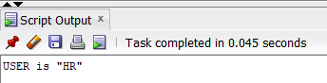

-- CAU 1: Ten va luong nhan vien co luong > 12000$
SELECT last_name,
salary
FROM employees
WHERE salary > 12000;
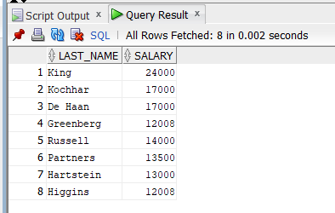
-- CAU 2: Ten va luong nhan vien co luong < 5000$ hoac > 12000$
SELECT last_name,
salary
FROM employees
WHERE salary < 5000
OR salary > 12000;
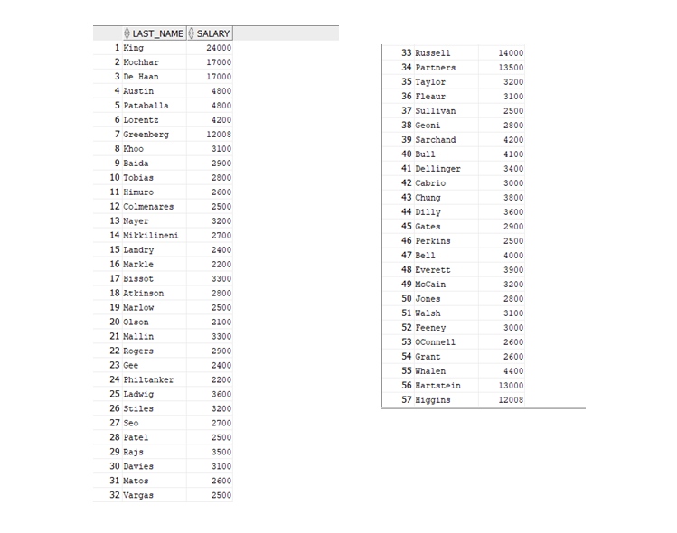

-- CAU 3: Ten, job_id, hire_date tu 20/02/1998 den 01/05/1998 sap xep tang dan theo ngay thue
SELECT last_name,
job_id,
hire_date
FROM employees
WHERE hire_date BETWEEN TO_DATE('20/02/1998','DD/MM/YYYY')
AND TO_DATE('01/05/1998','DD/MM/YYYY')
ORDER BY hire_date;
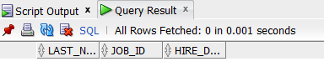
-- CAU 4: Nhan vien phong 20 va 50, sap xep theo ten
SELECT last_name,
department_id
FROM employees
WHERE department_id IN (20, 50)
ORDER BY last_name;

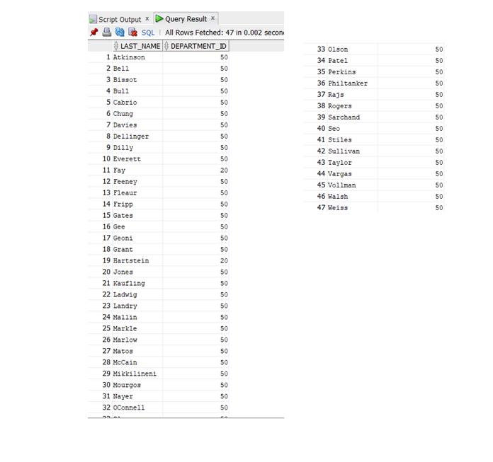
-- CAU 5: Nhan vien duoc thue nam 1994
SELECT last_name,
hire_date
FROM employees
WHERE TO_CHAR(hire_date, 'YYYY') = '1994';
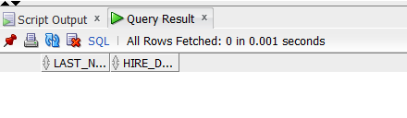
-- CAU 6: Ten, job_id cua nhan vien khong co nguoi quan ly
SELECT last_name,
job_id
FROM employees
WHERE manager_id IS NULL;
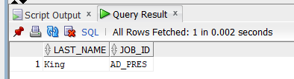
-- CAU 7: Nhan vien duoc huong hoa hong, sap xep giam dan theo luong va hoa hong
SELECT last_name,
salary,
commission_pct
FROM employees
WHERE commission_pct IS NOT NULL
ORDER BY salary DESC, commission_pct DESC;
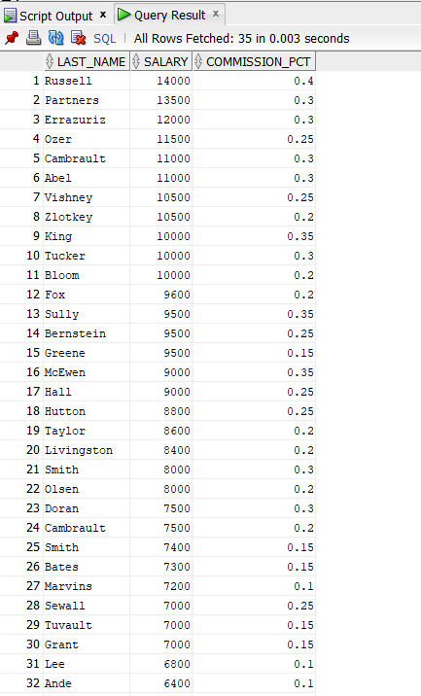
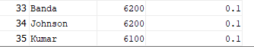
-- CAU 8: Nhan vien co ky tu thu 3 trong ten la 'a'
SELECT last_name
FROM employees
WHERE SUBSTR(last_name, 3, 1) = 'a';
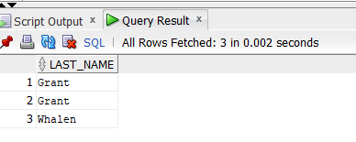
-- CAU 9: Nhan vien trong ten co ca chu 'a' va chu 'e'
SELECT last_name
FROM employees
WHERE LOWER(last_name) LIKE '%a%'
AND LOWER(last_name) LIKE '%e%';
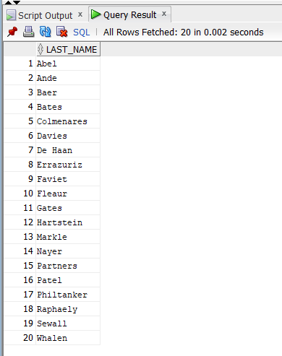
-- CAU 10: Ten, job_id, luong cua nhan vien lam 'Sales Representative' hoac 'Stock Clerk' va luong khac 2500, 3500, 7000
SELECT last_name,
job_id,
salary
FROM employees
WHERE job_id IN ('SA_REP', 'ST_CLERK')
AND salary NOT IN (2500, 3500, 7000);
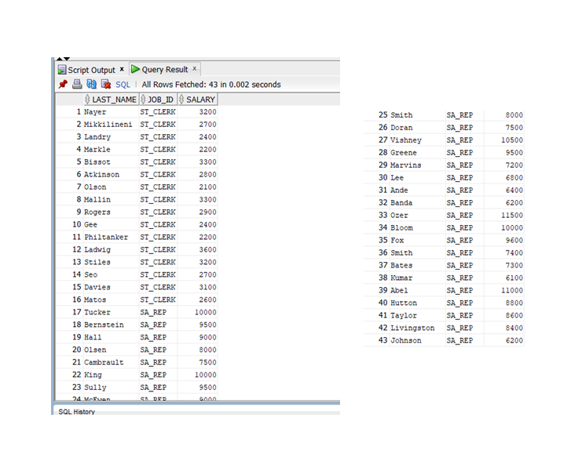
-- CAU 11: Ma NV, ten, luong tang 15% lam tron den hang don vi dat ten cot la "New Salary"
SELECT employee_id,
last_name,
salary,
ROUND(salary * 1.15, 0) AS "New Salary"
FROM employees;

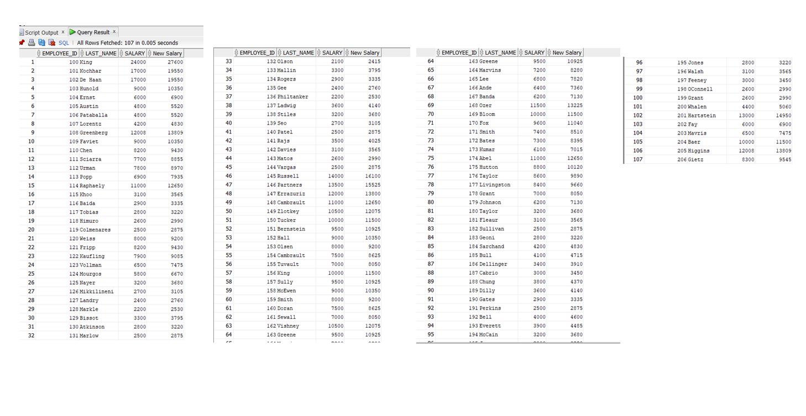
-- CAU 12: Ten nhan vien, chieu dai ten - ten bat dau bang J, A, L, M sap xep tang dan theo ten, chu dau viet hoa, con lai thuong
SELECT INITCAP(last_name) AS "Ten nhan vien",
LENGTH(last_name) AS "Chieu dai"
FROM employees
WHERE SUBSTR(last_name, 1, 1) IN ('J', 'A', 'L', 'M')
ORDER BY last_name;
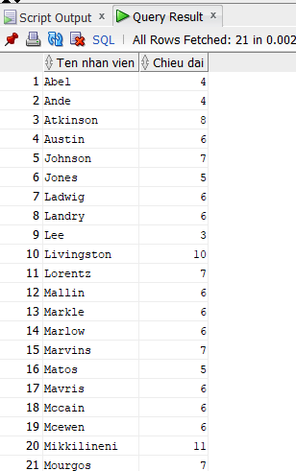
-- CAU 13: Ten nhan vien va so thang da lam viec (sap xep tang dan)
SELECT last_name,
ROUND(MONTHS_BETWEEN(SYSDATE, hire_date)) AS "So thang lam viec"
FROM employees
ORDER BY 2;
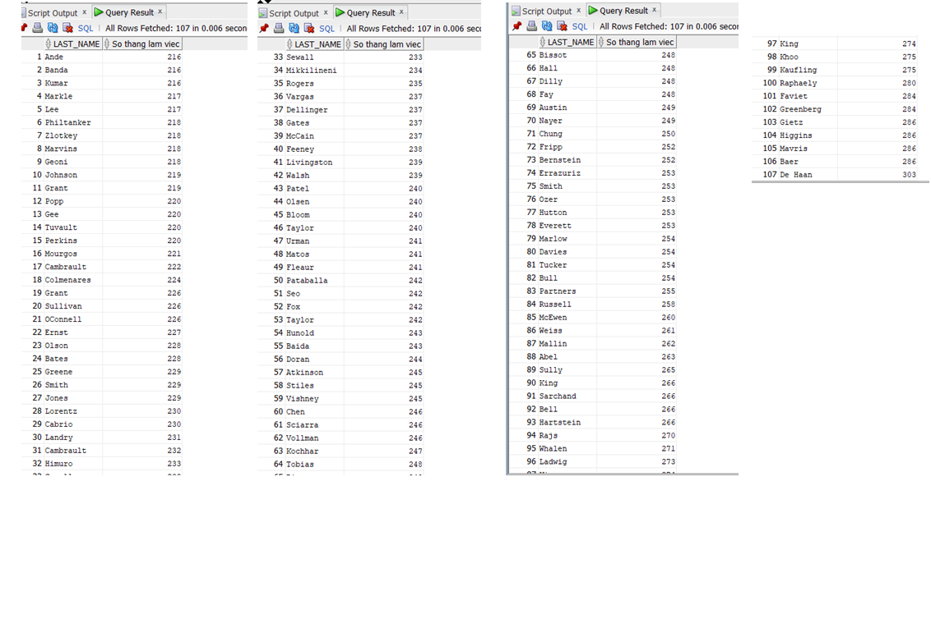

-- CAU 14: Dinh dang: <last_name> earns <salary> monthly but wants <3*salary> Cot ten la "Dream Salaries"
SELECT last_name || ' earns '
|| TO_CHAR(salary, '99999')
|| ' monthly but wants '
|| TO_CHAR(salary * 3, '99999') AS "Dream Salaries"
FROM employees;
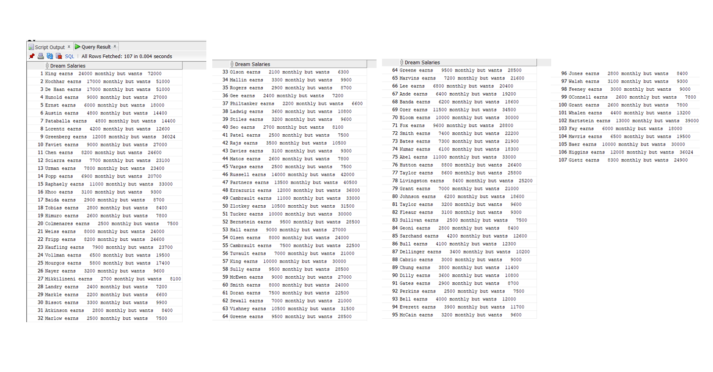
-- CAU 15: Ten nhan vien va hoa hong - neu khong co thi hien thi 'No commission'
SELECT last_name,
NVL(TO_CHAR(commission_pct), 'No commission') AS "Hoa hong"
FROM employees;
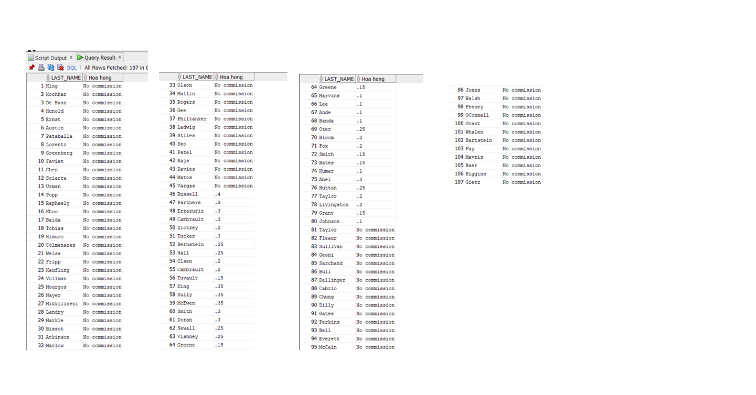
-- CAU 16: Phan loai nhan vien theo job_id (DECODE / CASE)
SELECT job_id,
DECODE(job_id,
'AD_PRES', 'A',
'ST_MAN', 'B',
'IT_PROG', 'C',
'SA_REP', 'D',
'ST_CLERK', 'E',
'0') AS "GRADE"
FROM employees;
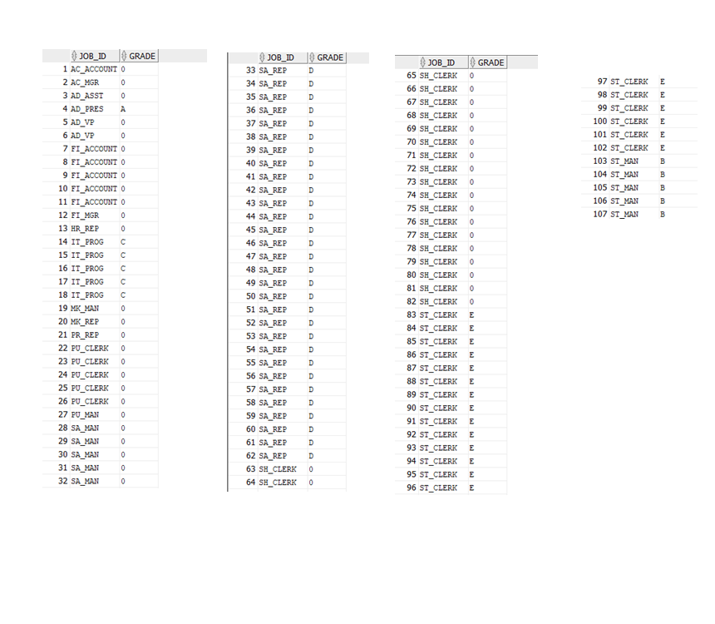
-- CAU 17: Ten NV, ma phong, ten phong - lam viec o thanh pho Toronto
SELECT e.last_name,
e.department_id,
d.department_name
FROM employees e
JOIN departments d ON e.department_id = d.department_id
JOIN locations l ON d.location_id = l.location_id
WHERE LOWER(l.city) = 'toronto';
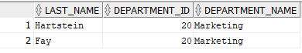
-- CAU 18: Ma NV, ten NV, ma quan ly, ten quan ly (Self Join)
SELECT e.employee_id AS "Ma nhan vien",
e.last_name AS "Ten nhan vien",
e.manager_id AS "Ma quan ly",
m.last_name AS "Ten quan ly"
FROM employees e
JOIN employees m ON e.manager_id = m.employee_id;
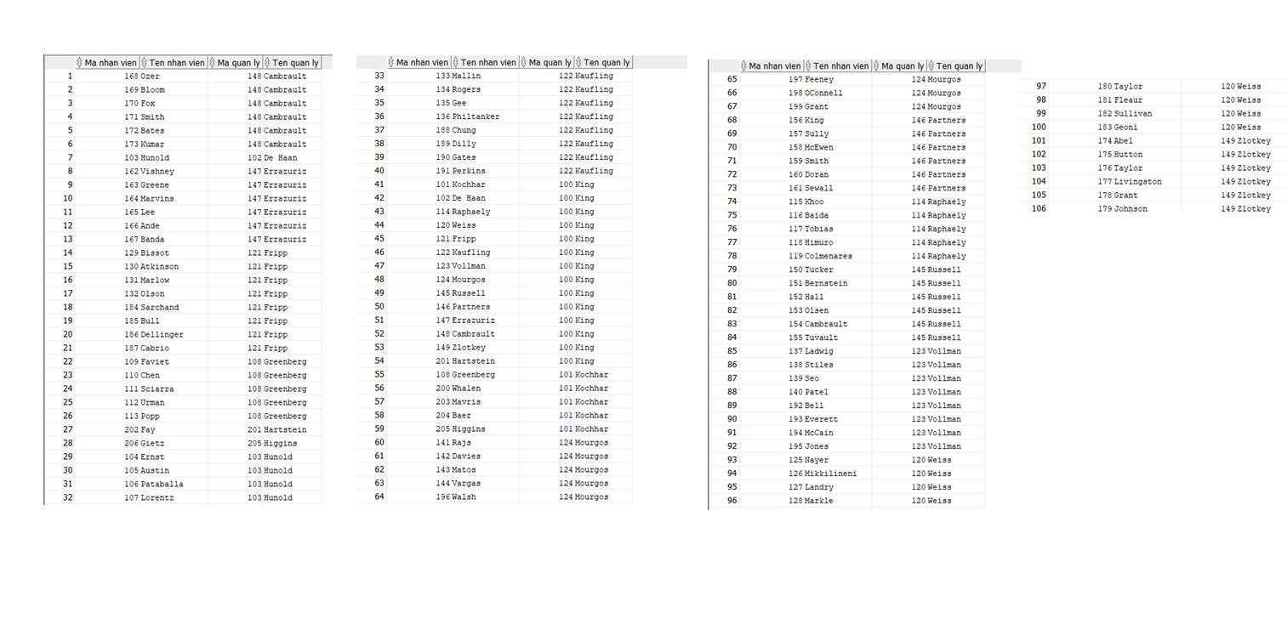
-- CAU 19: Nhan vien lam viec cung phong (Self Join)
SELECT e1.last_name AS "Nhan vien",
e1.department_id AS "Ma phong",
e2.last_name AS "Dong nghiep"
FROM employees e1
JOIN employees e2 ON e1.department_id = e2.department_id
AND e1.employee_id < e2.employee_id
ORDER BY e1.department_id, e1.last_name;
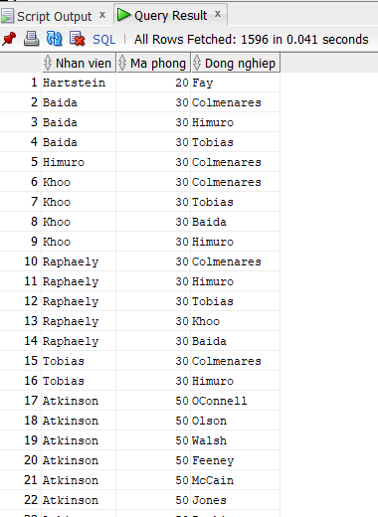
-- CAU 20: Nhan vien duoc thue sau nhan vien 'Davies'
SELECT last_name,
hire_date
FROM employees
WHERE hire_date > (
SELECT hire_date
FROM employees
WHERE last_name = 'Davies'
)
ORDER BY hire_date;
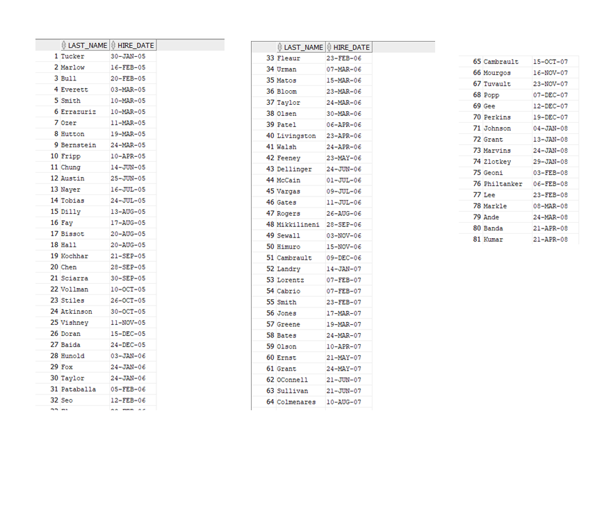
-- CAU 21: Nhan vien duoc thue truoc nguoi quan ly cua ho
SELECT e.last_name AS "Nhan vien",
e.hire_date AS "Ngay thue NV",
m.last_name AS "Quan ly",
m.hire_date AS "Ngay thue QL"
FROM employees e
JOIN employees m ON e.manager_id = m.employee_id
WHERE e.hire_date < m.hire_date;
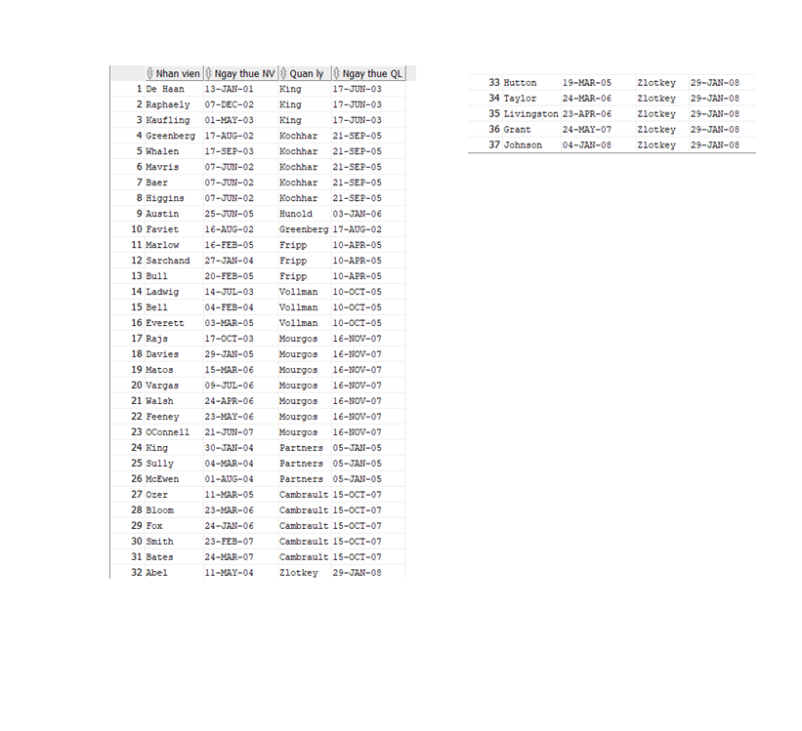
-- CAU 22: Luong thap nhat, cao nhat, trung binh, tong luong theo tung cong viec
SELECT job_id,
MIN(salary) AS "Luong thap nhat",
MAX(salary) AS "Luong cao nhat",
ROUND(AVG(salary), 2) AS "Luong trung binh",
SUM(salary) AS "Tong luong"
FROM employees
GROUP BY job_id
ORDER BY job_id;
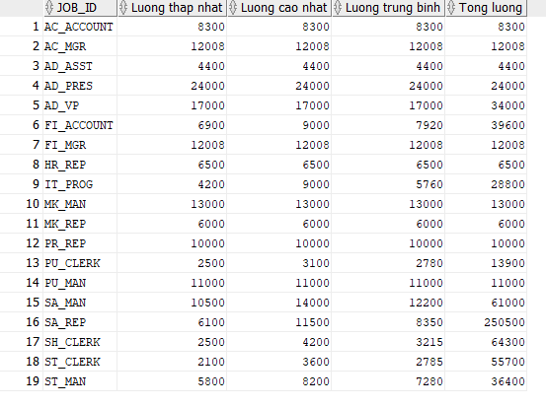
-- CAU 23: Ma phong, ten phong, so nhan vien tung phong ban
SELECT d.department_id,
d.department_name,
COUNT(e.employee_id) AS "So nhan vien"
FROM departments d
LEFT JOIN employees e ON d.department_id = e.department_id
GROUP BY d.department_id, d.department_name
ORDER BY d.department_id;
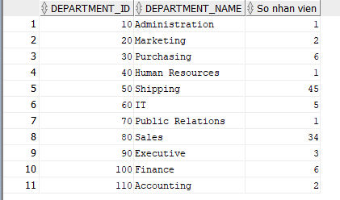
-- Tong so nhan vien va tong NV thue tung nam 1995-1998
SELECT COUNT(*) AS "Tong so nhan vien",
SUM(CASE WHEN TO_CHAR(hire_date,'YYYY') = '1995' THEN 1 ELSE 0 END) AS "Nam 1995",
SUM(CASE WHEN TO_CHAR(hire_date,'YYYY') = '1996' THEN 1 ELSE 0 END) AS "Nam 1996",
SUM(CASE WHEN TO_CHAR(hire_date,'YYYY') = '1997' THEN 1 ELSE 0 END) AS "Nam 1997",
SUM(CASE WHEN TO_CHAR(hire_date,'YYYY') = '1998' THEN 1 ELSE 0 END) AS "Nam 1998"
FROM employees;
-- CAU 25: Ten, ngay thue cua nhan vien cung phong voi 'Zlotkey'
SELECT last_name,
hire_date
FROM employees
WHERE department_id = (
SELECT department_id
FROM employees
WHERE last_name = 'Zlotkey'
)
AND last_name <> 'Zlotkey';
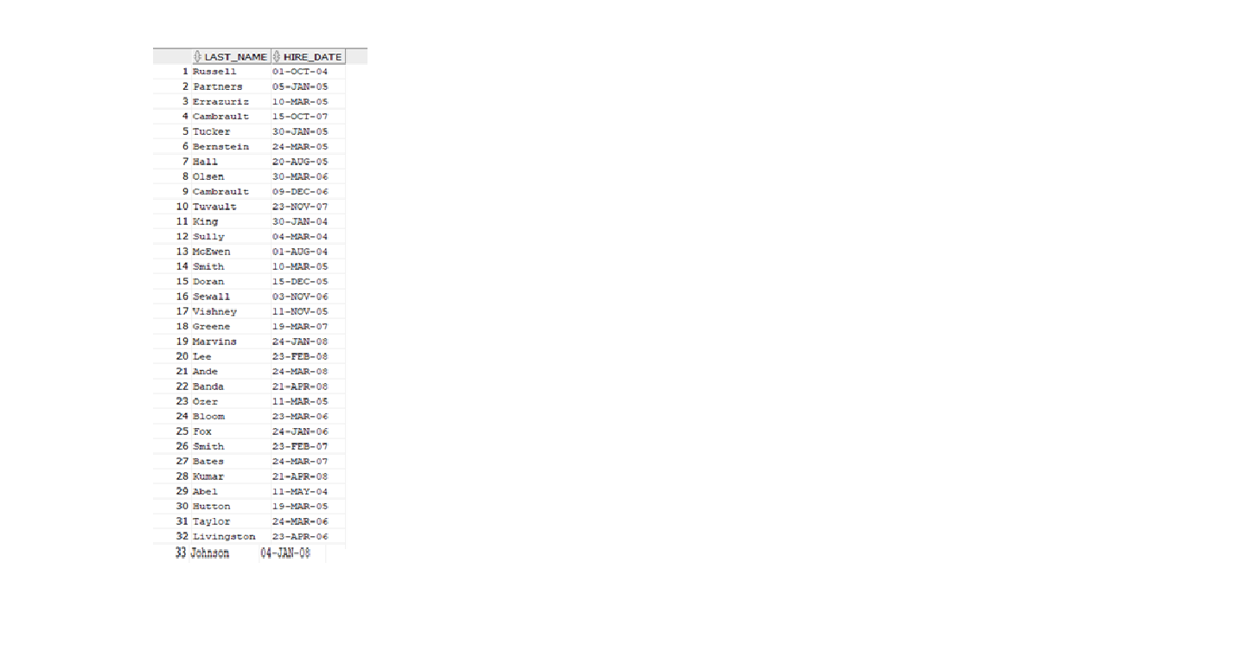
-- CAU 26: Ten, ma phong, job_id cua NV o location_id = 1700
SELECT e.last_name,
e.department_id,
e.job_id
FROM employees e
JOIN departments d ON e.department_id = d.department_id
WHERE d.location_id = 1700;
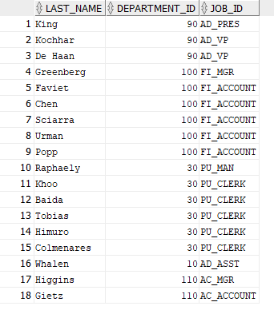
-- CAU 27: Nhan vien co nguoi quan ly ten 'King'
SELECT last_name,
manager_id
FROM employees
WHERE manager_id IN (
SELECT employee_id
FROM employees
WHERE last_name = 'King'
);
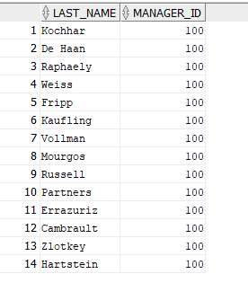
-- CAU 28: Nhan vien co luong cao hon TB va lam cung phong voi NV ten ket thuc bang 'n'
SELECT last_name,
salary,
department_id
FROM employees
WHERE salary > (SELECT AVG(salary) FROM employees)
AND department_id IN (
SELECT department_id
FROM employees
WHERE LOWER(last_name) LIKE '%n'
);
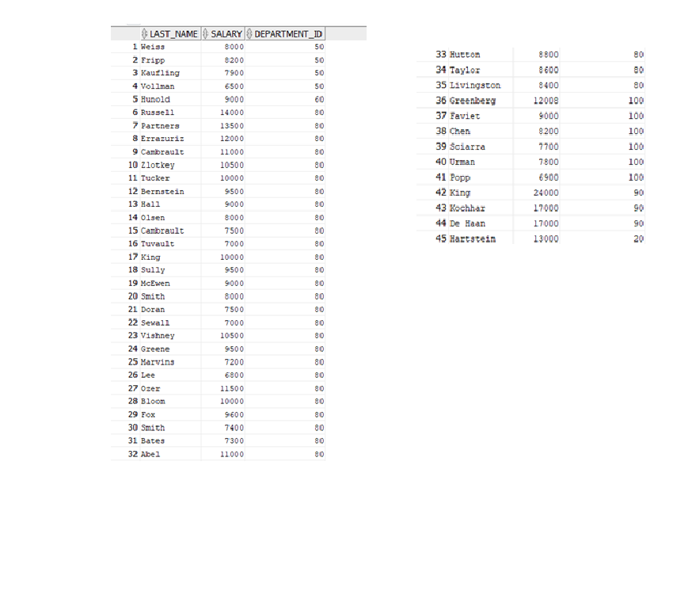
-- CAU 29: Ma phong, ten phong co it hon 3 nhan vien
SELECT d.department_id,
d.department_name,
COUNT(e.employee_id) AS "So nhan vien"
FROM departments d
LEFT JOIN employees e ON d.department_id = e.department_id
GROUP BY d.department_id, d.department_name
HAVING COUNT(e.employee_id) < 3
ORDER BY d.department_id;
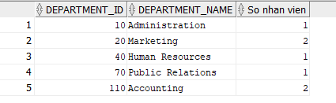
-- CAU 30: Phong ban co dong nhan vien nhat va it nhan vien nhat
-- Phong dong nhat:
SELECT department_id,
COUNT(*) AS "So nhan vien"
FROM employees
GROUP BY department_id
HAVING COUNT(*) = (
SELECT MAX(COUNT(*))
FROM employees
GROUP BY department_id
);
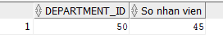
-- Phong it nhat:
SELECT department_id,
COUNT(*) AS "So nhan vien"
FROM employees
GROUP BY department_id
HAVING COUNT(*) = (
SELECT MIN(COUNT(*))
FROM employees
GROUP BY department_id
);
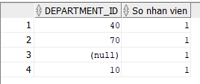

-- CAU 31: Nhan vien duoc thue vao ngay co nhieu NV duoc thue nhat (dung -
SELECT last_name,
hire_date,
TO_CHAR(hire_date, 'Day') AS "Thu trong tuan"
FROM employees
WHERE TO_CHAR(hire_date, 'Day') IN (
SELECT TO_CHAR(hire_date, 'Day')
FROM employees
GROUP BY TO_CHAR(hire_date, 'Day')
HAVING COUNT(*) = (
SELECT MAX(COUNT(*))
FROM employees
GROUP BY TO_CHAR(hire_date, 'Day')
)
)
ORDER BY hire_date;
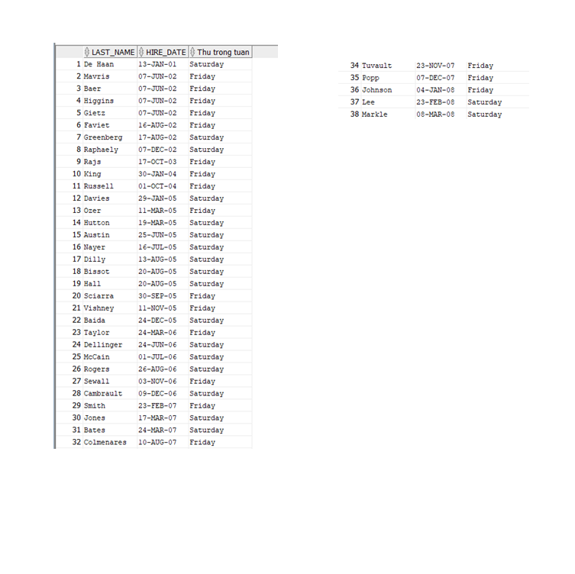
-- CAU 32: 3 nhan vien co luong cao nhat (Inline View + ROWNUM)
SELECT last_name,
salary
FROM (
SELECT last_name,
salary
FROM employees
ORDER BY salary DESC
)
WHERE ROWNUM <= 3;
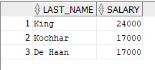
-- CAU 33: Nhan vien lam viec o tieu bang 'California'
SELECT e.last_name,
d.department_name,
l.city,
l.state_province
FROM employees e
JOIN departments d ON e.department_id = d.department_id
JOIN locations l ON d.location_id = l.location_id
WHERE LOWER(l.state_province) = 'california';
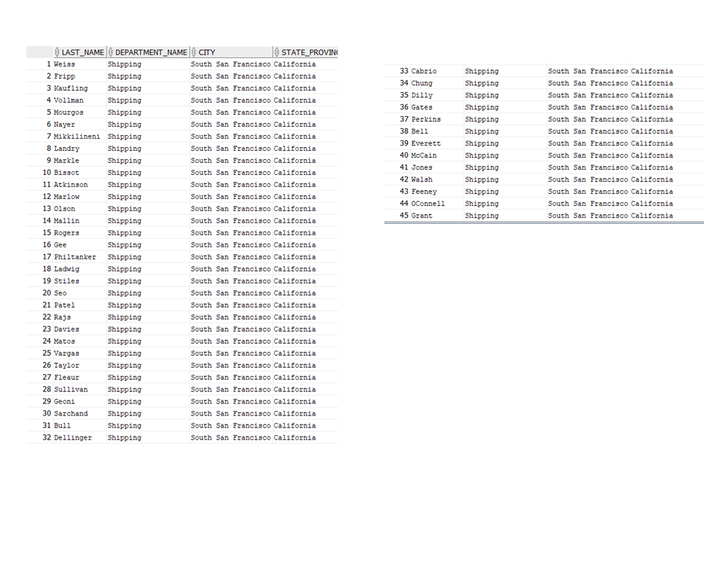
-- CAU 34: Cap nhat ten nhan vien co ma 3 thanh 'Drexler'
UPDATE employees
SET last_name = 'Drexler'
WHERE employee_id = 3;

COMMIT;
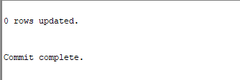
-- Kiem tra:
SELECT employee_id, last_name FROM employees WHERE employee_id = 3;

-- CAU 35: Nhan vien co luong thap hon luong TB cua phong ban minh
SELECT last_name,
salary,
department_id
FROM employees e1
WHERE salary < (
SELECT AVG(salary)
FROM employees e2
WHERE e2.department_id = e1.department_id
)
ORDER BY department_id;
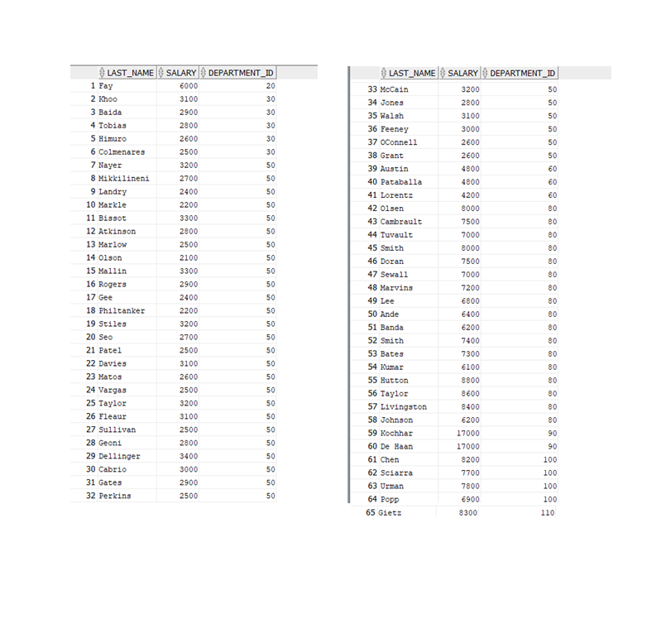
-- CAU 36: Tang them 100$ cho nhan vien co luong < 900$
UPDATE employees
SET salary = salary + 100
WHERE salary < 900;

COMMIT;

-- Kiem tra:
SELECT employee_id, last_name, salary
FROM employees
WHERE salary < 1000
ORDER BY salary;

-- CAU 37: Xoa phong ban 500
DELETE FROM departments
WHERE department_id = 500;

COMMIT;
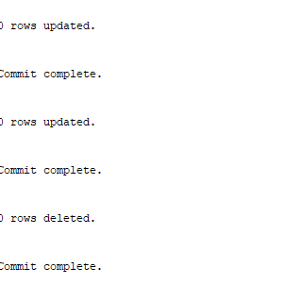
-- Kiem tra:
SELECT department_id, department_name
FROM departments
WHERE department_id = 500;
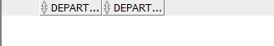
-- CAU 38: Xoa phong ban chua co nhan vien
DELETE FROM departments
WHERE department_id NOT IN (
SELECT DISTINCT department_id
FROM employees
WHERE department_id IS NOT NULL
);

COMMIT;
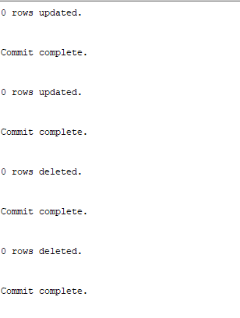
-- Kiem tra:
SELECT d.department_id,
d.department_name,
COUNT(e.employee_id) AS "So nhan vien"
FROM departments d
LEFT JOIN employees e ON d.department_id = e.department_id
GROUP BY d.department_id, d.department_name
ORDER BY d.department_id;
