Microsoft Windows [Version 10.0.26200.7922]
(c) Microsoft Corporation. All rights reserved.

C:\Users\TQUOCTOAN>sqlplus / as sysdba

SQL*Plus: Release 19.0.0.0.0 - Production on Mon Mar 2 10:00:40 2026
Version 19.3.0.0.0

Copyright (c) 1982, 2019, Oracle. All rights reserved.

Connected to:
Oracle Database 19c Enterprise Edition Release 19.0.0.0.0 - Production
Version 19.3.0.0.0
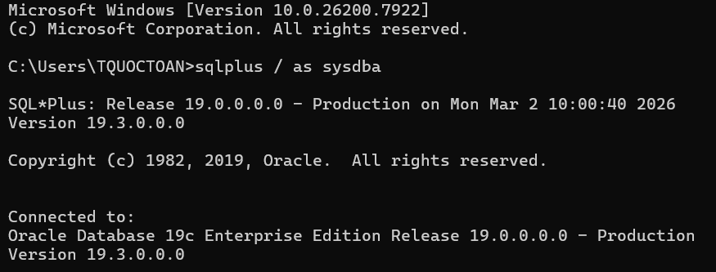
SQL> CREATE USER QUOCTOAN IDENTIFIED BY 123456;

User created.

SQL> GRANT CREATE SESSION TO QUOCTOAN;

Grant succeeded.

SQL> GRANT CREATE TABLE TO QUOCTOAN;

Grant succeeded.

SQL> GRANT CREATE PROCEDURE TO QUOCTOAN;

Grant succeeded.

SQL> GRANT CREATE VIEW TO QUOCTOAN;

Grant succeeded.

SQL> ALTER USER QUOCTOAN QUOTA UNLIMITED ON USERS;

User altered.
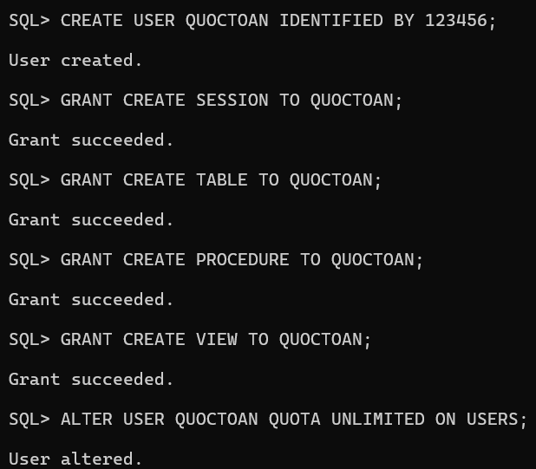
Phiếu BT1
SQL> CREATE TABLE KHOA (
2 Makhoa VARCHAR2(10) PRIMARY KEY,
3 Tenkhoa VARCHAR2(100),
4 Dienthoai VARCHAR2(20)
5 );

Table created.

SQL> CREATE TABLE LOP (
2 Malop VARCHAR2(10) PRIMARY KEY,
3 Tenlop VARCHAR2(100),
4 Khoa NUMBER,
5 Hedt VARCHAR2(50),
6 Namnhaphoc NUMBER,
7 Makhoa VARCHAR2(10),
8 CONSTRAINT fk_lop_khoa FOREIGN KEY (Makhoa) REFERENCES KHOA(Makhoa)
9 );

Table created.

SQL> INSERT INTO KHOA VALUES ('CNTT', 'Cong Nghe Thong Tin', '0123456789');

1 row created.

SQL> INSERT INTO KHOA VALUES ('QTKD', 'Quan Tri Kinh Doanh', '0987654321');

1 row created.

SQL> INSERT INTO KHOA VALUES ('KT', 'Ke Toan', '0112233445');

1 row created.

SQL> COMMIT;

Commit complete.
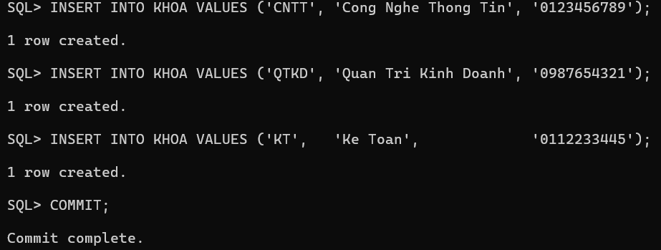

SQL> INSERT INTO LOP VALUES ('L001', 'CNTT-K1', 1, 'Dai hoc chinh quy', 2022, 'CNTT');

1 row created.

SQL> INSERT INTO LOP VALUES ('L002', 'CNTT-K2', 1, 'Dai hoc chinh quy', 2023, 'CNTT');

1 row created.

SQL> INSERT INTO LOP VALUES ('L003', 'QTKD-K1', 2, 'Cao dang', 2022, 'QTKD');

1 row created.

SQL> COMMIT;

Commit complete.
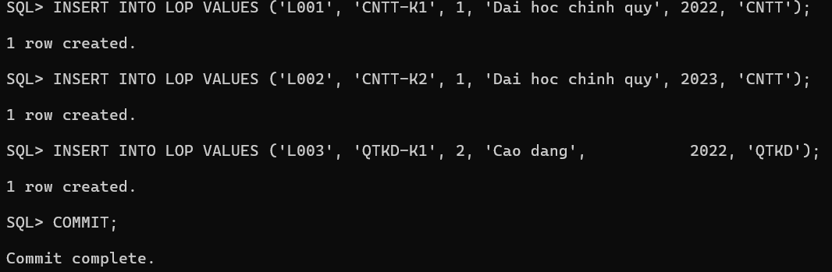

SQL> CREATE OR REPLACE PROCEDURE sp_them_khoa (
2 p_makhoa IN KHOA.Makhoa%TYPE,
3 p_tenkhoa IN KHOA.Tenkhoa%TYPE,
4 p_dienthoai IN KHOA.Dienthoai%TYPE
5 ) AS
6 v_dem NUMBER := 0;
7 BEGIN
8 SELECT COUNT(*) INTO v_dem FROM KHOA WHERE Tenkhoa = p_tenkhoa;
9 IF v_dem > 0 THEN
10 DBMS_OUTPUT.PUT_LINE('Thong bao: Ten khoa "' || p_tenkhoa || '" da ton tai!');
11 ELSE
12 INSERT INTO KHOA (Makhoa, Tenkhoa, Dienthoai)
13 VALUES (p_makhoa, p_tenkhoa, p_dienthoai);
14 COMMIT;
15 DBMS_OUTPUT.PUT_LINE('Them khoa thanh cong: ' || p_tenkhoa);
16 END IF;
17 END sp_them_khoa;
18 /

Procedure created.
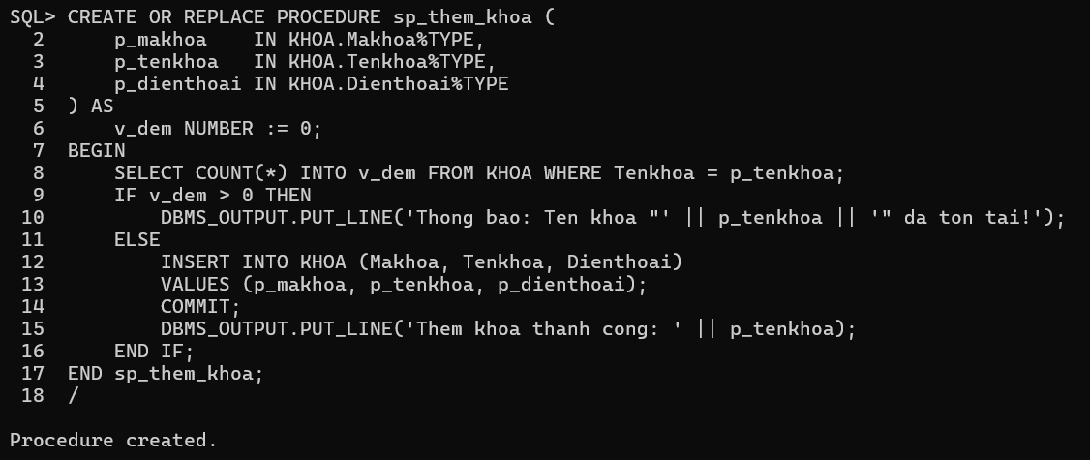

SQL> BEGIN
2 sp_them_khoa('DTVT', 'Dien Tu Vien Thong', '0334455667');
3 END;
4 /
Them khoa thanh cong: Dien Tu Vien Thong

PL/SQL procedure successfully completed.

SQL>
SQL> -- TH2: Tên khoa đã tồn tại → thông báo
SQL> BEGIN
2 sp_them_khoa('KT99', 'Ke Toan', '0999999999');
3 END;
4 /
Thong bao: Ten khoa "Ke Toan" da ton tai!

PL/SQL procedure successfully completed.

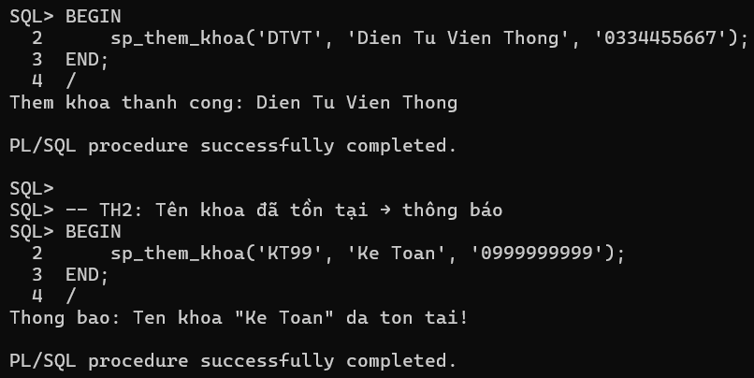

SQL> CREATE OR REPLACE PROCEDURE sp_them_lop (
2 p_malop IN LOP.Malop%TYPE,
3 p_tenlop IN LOP.Tenlop%TYPE,
4 p_khoa IN LOP.Khoa%TYPE,
5 p_hedt IN LOP.Hedt%TYPE,
6 p_namnhaphoc IN LOP.Namnhaphoc%TYPE,
7 p_makhoa IN LOP.Makhoa%TYPE
8 ) AS
9 v_dem_lop NUMBER := 0;
10 v_dem_khoa NUMBER := 0;
11 BEGIN
12 -- Kiểm tra tên lớp
13 SELECT COUNT(*) INTO v_dem_lop FROM LOP WHERE Tenlop = p_tenlop;
14 IF v_dem_lop > 0 THEN
15 DBMS_OUTPUT.PUT_LINE('Thong bao: Ten lop "' || p_tenlop || '" da ton tai!');
16 RETURN;
17 END IF;
18
19 -- Kiểm tra makhoa
20 SELECT COUNT(*) INTO v_dem_khoa FROM KHOA WHERE Makhoa = p_makhoa;
21 IF v_dem_khoa = 0 THEN
22 DBMS_OUTPUT.PUT_LINE('Thong bao: Ma khoa "' || p_makhoa || '" khong ton tai!');
23 RETURN;
24 END IF;
25
26 -- Thêm lớp
27 INSERT INTO LOP (Malop, Tenlop, Khoa, Hedt, Namnhaphoc, Makhoa)
28 VALUES (p_malop, p_tenlop, p_khoa, p_hedt, p_namnhaphoc, p_makhoa);
29 COMMIT;
30 DBMS_OUTPUT.PUT_LINE('Them lop thanh cong: ' || p_tenlop);
31 END sp_them_lop;
32 /

Procedure created.
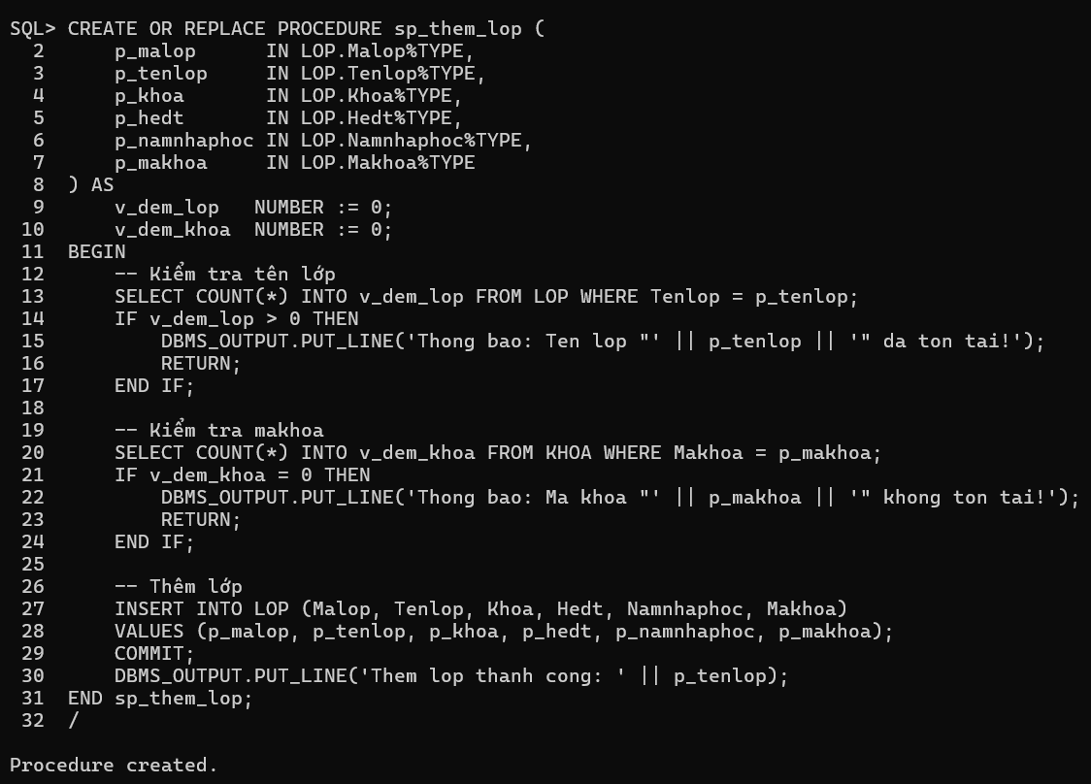

SQL> BEGIN sp_them_lop('L010', 'KT-K1', 3, 'Dai hoc chinh quy', 2023, 'KT'); END;
2 /
Them lop thanh cong: KT-K1

PL/SQL procedure successfully completed.

SQL> BEGIN sp_them_lop('L011', 'CNTT-K1', 1, 'Dai hoc chinh quy', 2023, 'CNTT'); END; -- tên đã có
2 /
Thong bao: Ten lop "CNTT-K1" da ton tai!

PL/SQL procedure successfully completed.

SQL> BEGIN sp_them_lop('L012', 'XD-K1', 4, 'Dai hoc', 2023, 'XD'); END; -- makhoa không có
2 /
Thong bao: Ma khoa "XD" khong ton tai!

PL/SQL procedure successfully completed.
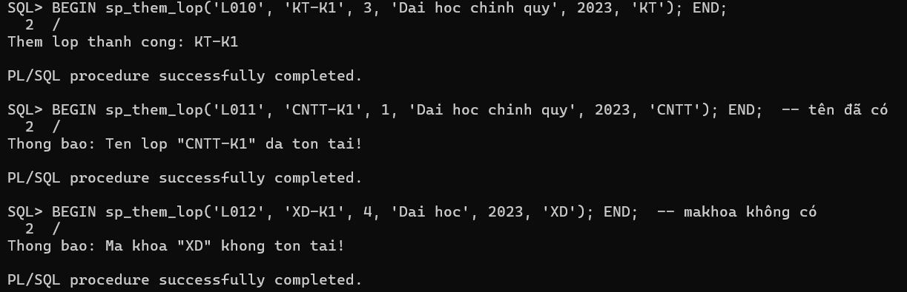

SQL> CREATE OR REPLACE PROCEDURE sp_them_khoa_out (
2 p_makhoa IN KHOA.Makhoa%TYPE,
3 p_tenkhoa IN KHOA.Tenkhoa%TYPE,
4 p_dienthoai IN KHOA.Dienthoai%TYPE,
5 p_ketqua OUT NUMBER
6 ) AS
7 v_dem NUMBER := 0;
8 BEGIN
9 SELECT COUNT(*) INTO v_dem FROM KHOA WHERE Tenkhoa = p_tenkhoa;
10 IF v_dem > 0 THEN
11 p_ketqua := 0; -- Đã tồn tại
12 ELSE
13 INSERT INTO KHOA (Makhoa, Tenkhoa, Dienthoai)
14 VALUES (p_makhoa, p_tenkhoa, p_dienthoai);
15 COMMIT;
16 p_ketqua := 1; -- Thêm thành công
17 END IF;
18 END sp_them_khoa_out;
19 /

Procedure created.
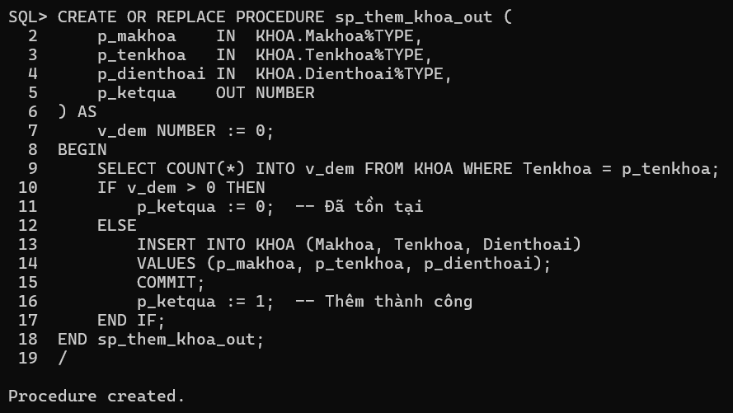

SQL> DECLARE v_kq NUMBER;
2 BEGIN
3 sp_them_khoa_out('MT', 'My Thuat', '0700000001', v_kq);
4 DBMS_OUTPUT.PUT_LINE('Ket qua: ' || v_kq); -- Mong doi: 1
5 END;
6 /
Ket qua: 1

PL/SQL procedure successfully completed.

SQL> DECLARE v_kq NUMBER;
2 BEGIN
3 sp_them_khoa_out('MT2', 'Ke Toan', '0700000002', v_kq);
4 DBMS_OUTPUT.PUT_LINE('Ket qua: ' || v_kq); -- Mong doi: 0 (ten da ton tai)
5 END;
6 /
Ket qua: 0

PL/SQL procedure successfully completed.
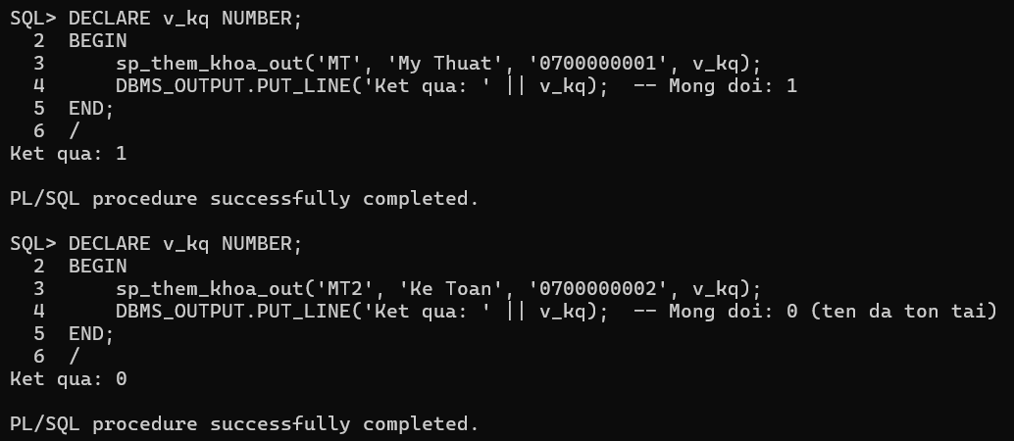

SQL> CREATE OR REPLACE PROCEDURE sp_them_lop_out (
2 p_malop IN LOP.Malop%TYPE,
3 p_tenlop IN LOP.Tenlop%TYPE,
4 p_khoa IN LOP.Khoa%TYPE,
5 p_hedt IN LOP.Hedt%TYPE,
6 p_namnhaphoc IN LOP.Namnhaphoc%TYPE,
7 p_makhoa IN LOP.Makhoa%TYPE,
8 p_ketqua OUT NUMBER
9 ) AS
10 v_dem_lop NUMBER := 0;
11 v_dem_khoa NUMBER := 0;
12 BEGIN
13 SELECT COUNT(*) INTO v_dem_lop FROM LOP WHERE Tenlop = p_tenlop;
14 IF v_dem_lop > 0 THEN
15 p_ketqua := 0; -- Tên lớp đã tồn tại
16 RETURN;
17 END IF;
18
19 SELECT COUNT(*) INTO v_dem_khoa FROM KHOA WHERE Makhoa = p_makhoa;
20 IF v_dem_khoa = 0 THEN
21 p_ketqua := 1; -- Makhoa không tồn tại
22 RETURN;
23 END IF;
24
25 INSERT INTO LOP (Malop, Tenlop, Khoa, Hedt, Namnhaphoc, Makhoa)
26 VALUES (p_malop, p_tenlop, p_khoa, p_hedt, p_namnhaphoc, p_makhoa);
27 COMMIT;
28 p_ketqua := 2; -- Thêm thành công
29 END sp_them_lop_out;
30 /

Procedure created.
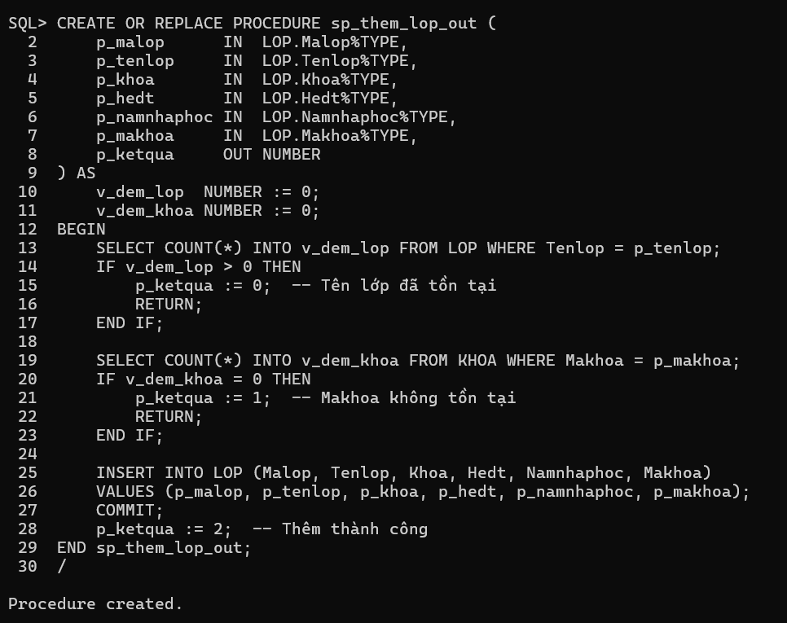

SQL> DECLARE v_kq NUMBER;
2 BEGIN
3 sp_them_lop_out('L020', 'MT-K1', 5, 'Cao dang', 2024, 'MT', v_kq);
4 DBMS_OUTPUT.PUT_LINE('Ket qua: ' || v_kq); -- 2 (thanh cong)
5 END;
6 /
Ket qua: 2

PL/SQL procedure successfully completed.

SQL> DECLARE v_kq NUMBER;
2 BEGIN
3 sp_them_lop_out('L021', 'CNTT-K1', 1, 'CQ', 2024, 'CNTT', v_kq);
4 DBMS_OUTPUT.PUT_LINE('Ket qua: ' || v_kq); -- 0 (ten lop da co)
5 END;
6 /
Ket qua: 0

PL/SQL procedure successfully completed.

SQL> DECLARE v_kq NUMBER;
2 BEGIN
3 sp_them_lop_out('L022', 'ABC-K1', 9, 'CQ', 2024, 'ZZZZ', v_kq);
4 DBMS_OUTPUT.PUT_LINE('Ket qua: ' || v_kq); -- 1 (makhoa khong co)
5 END;
6 /
Ket qua: 1

PL/SQL procedure successfully completed.
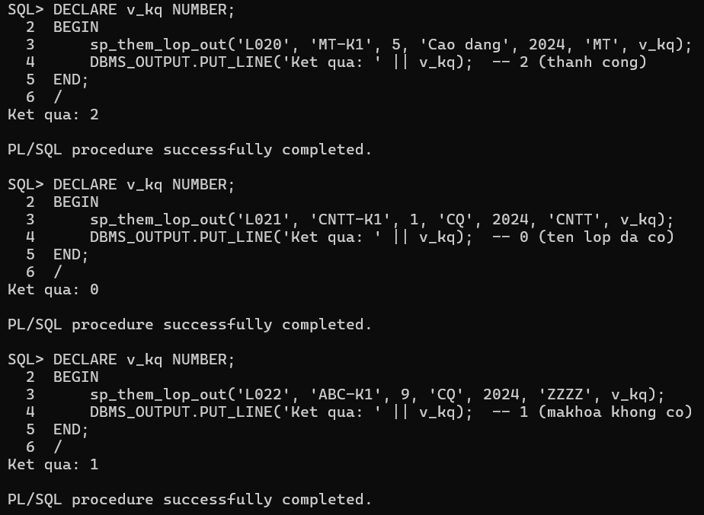

Phiếu BT2
SQL> CREATE TABLE tblChucVu (
2 MaCV VARCHAR2(10) PRIMARY KEY,
3 TenCV VARCHAR2(100)
4 );

Table created.

SQL> CREATE TABLE tblNhanVien (
2 MaNV VARCHAR2(10) PRIMARY KEY,
3 MaCV VARCHAR2(10),
4 TenNV VARCHAR2(100),
5 NgaySinh DATE,
6 LuongCanBan NUMBER(10,2),
7 NgayCong NUMBER,
8 PhuCap NUMBER(10,2),
9 CONSTRAINT fk_nv_cv FOREIGN KEY (MaCV) REFERENCES tblChucVu(MaCV)
10 );

Table created.
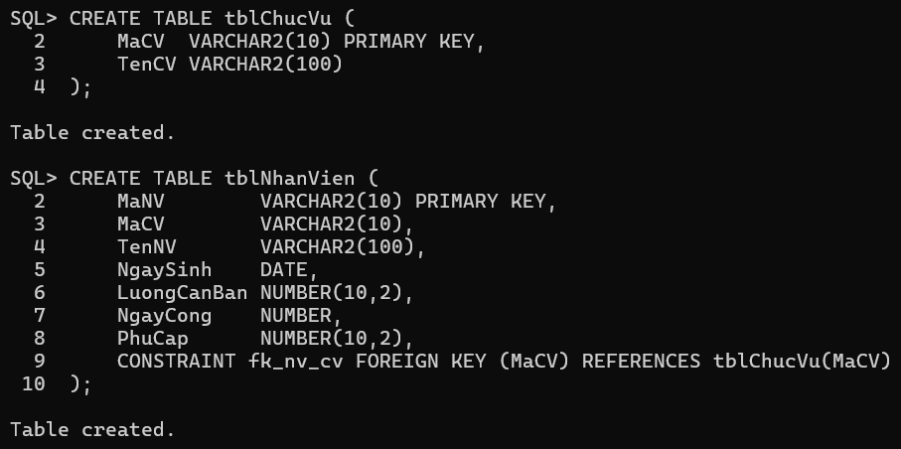

SQL> INSERT INTO tblChucVu VALUES ('CV01', 'Giam doc');

1 row created.

SQL> INSERT INTO tblChucVu VALUES ('CV02', 'Truong phong');

1 row created.

SQL> INSERT INTO tblChucVu VALUES ('CV03', 'Nhan vien');

1 row created.

SQL> INSERT INTO tblChucVu VALUES ('CV04', 'Ke toan truong');

1 row created.

SQL> COMMIT;

Commit complete.

SQL> INSERT INTO tblNhanVien VALUES ('NV01', 'CV01', 'Nguyen Van An', TO_DATE('15/03/1985','DD/MM/YYYY'), 15000000, 26, 2000000);

1 row created.

SQL> INSERT INTO tblNhanVien VALUES ('NV02', 'CV02', 'Tran Thi Binh', TO_DATE('20/07/1990','DD/MM/YYYY'), 10000000, 24, 1000000);

1 row created.

SQL> INSERT INTO tblNhanVien VALUES ('NV03', 'CV03', 'Le Van Cuong', TO_DATE('05/01/1995','DD/MM/YYYY'), 8000000, 25, 500000);

1 row created.

SQL> COMMIT;

Commit complete.
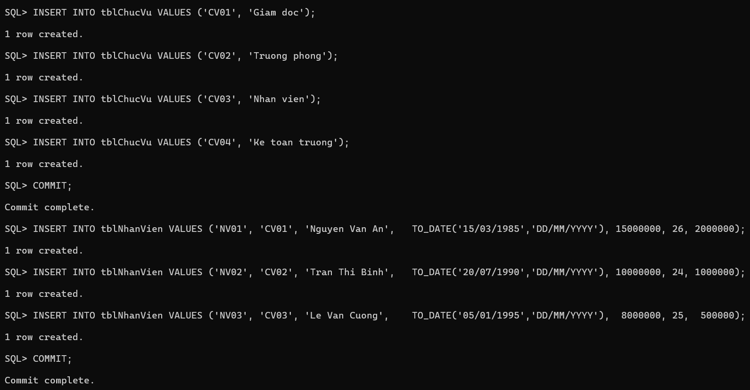

SQL> CREATE OR REPLACE PROCEDURE SP_Them_Nhan_Vien (
2 p_manv IN tblNhanVien.MaNV%TYPE,
3 p_macv IN tblNhanVien.MaCV%TYPE,
4 p_tennv IN tblNhanVien.TenNV%TYPE,
5 p_ngaysinh IN tblNhanVien.NgaySinh%TYPE,
6 p_luongcanban IN tblNhanVien.LuongCanBan%TYPE,
7 p_ngaycong IN tblNhanVien.NgayCong%TYPE,
8 p_phucap IN tblNhanVien.PhuCap%TYPE
9 ) AS
10 v_dem NUMBER := 0;
11 BEGIN
12 SELECT COUNT(*) INTO v_dem FROM tblChucVu WHERE MaCV = p_macv;
13 IF v_dem = 0 THEN
14 DBMS_OUTPUT.PUT_LINE('Thong bao: Ma chuc vu "' || p_macv || '" khong ton tai!');
15 ELSE
16 INSERT INTO tblNhanVien (MaNV, MaCV, TenNV, NgaySinh, LuongCanBan, NgayCong, PhuCap)
17 VALUES (p_manv, p_macv, p_tennv, p_ngaysinh, p_luongcanban, p_ngaycong, p_phucap);
18 COMMIT;
19 DBMS_OUTPUT.PUT_LINE('Them nhan vien thanh cong: ' || p_tennv);
20 END IF;
21 END SP_Them_Nhan_Vien;
22 /

Procedure created.
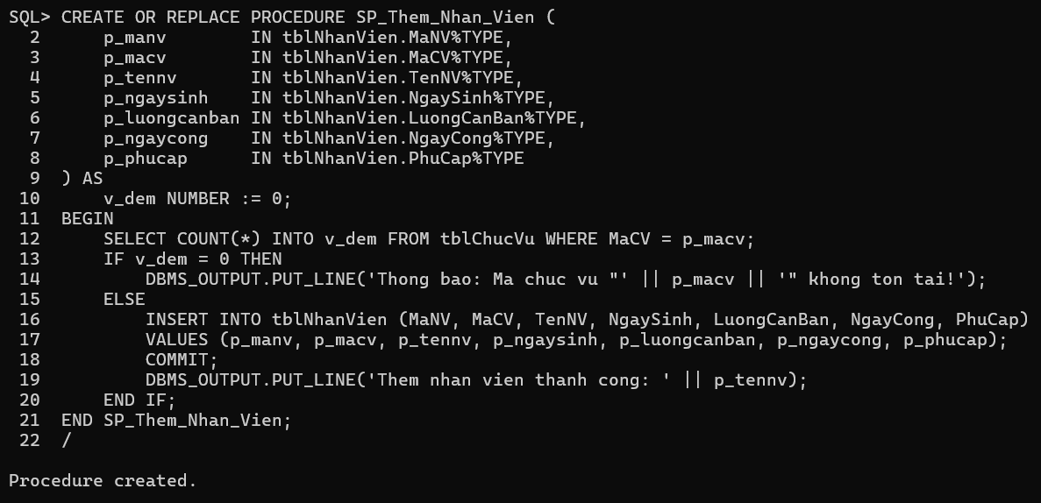

SQL> BEGIN
2 SP_Them_Nhan_Vien('NV04','CV03','Pham Thi Dao',TO_DATE('10/05/1998','DD/MM/YYYY'),7500000,22,300000);
3 END;
4 /
Them nhan vien thanh cong: Pham Thi Dao

PL/SQL procedure successfully completed.

SQL> BEGIN
2 SP_Them_Nhan_Vien('NV05','CV99','Nguyen Sai MaCV',TO_DATE('01/01/2000','DD/MM/YYYY'),5000000,20,200000);
3 END;
4 /
Thong bao: Ma chuc vu "CV99" khong ton tai!

PL/SQL procedure successfully completed.
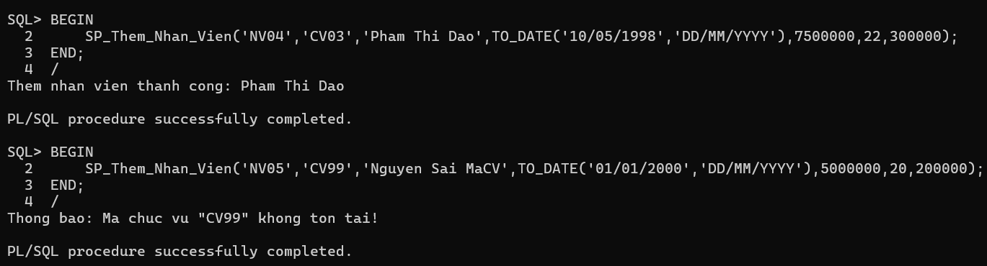

SQL> CREATE OR REPLACE PROCEDURE SP_CapNhat_Nhan_Vien (
2 p_manv IN tblNhanVien.MaNV%TYPE,
3 p_macv IN tblNhanVien.MaCV%TYPE,
4 p_tennv IN tblNhanVien.TenNV%TYPE,
5 p_ngaysinh IN tblNhanVien.NgaySinh%TYPE,
6 p_luongcanban IN tblNhanVien.LuongCanBan%TYPE,
7 p_ngaycong IN tblNhanVien.NgayCong%TYPE,
8 p_phucap IN tblNhanVien.PhuCap%TYPE
9 ) AS
10 v_dem_cv NUMBER := 0;
11 v_dem_nv NUMBER := 0;
12 BEGIN
13 SELECT COUNT(*) INTO v_dem_nv FROM tblNhanVien WHERE MaNV = p_manv;
14 IF v_dem_nv = 0 THEN
15 DBMS_OUTPUT.PUT_LINE('Thong bao: Ma nhan vien "' || p_manv || '" khong ton tai!');
16 RETURN;
17 END IF;
18
19 SELECT COUNT(*) INTO v_dem_cv FROM tblChucVu WHERE MaCV = p_macv;
20 IF v_dem_cv = 0 THEN
21 DBMS_OUTPUT.PUT_LINE('Thong bao: Ma chuc vu "' || p_macv || '" khong ton tai!');
22 RETURN;
23 END IF;
24
25 UPDATE tblNhanVien
26 SET MaCV = p_macv, TenNV = p_tennv, NgaySinh = p_ngaysinh,
27 LuongCanBan = p_luongcanban, NgayCong = p_ngaycong, PhuCap = p_phucap
28 WHERE MaNV = p_manv;
29 COMMIT;
30 DBMS_OUTPUT.PUT_LINE('Cap nhat nhan vien thanh cong: ' || p_manv);
31 END SP_CapNhat_Nhan_Vien;
32 /

Procedure created.
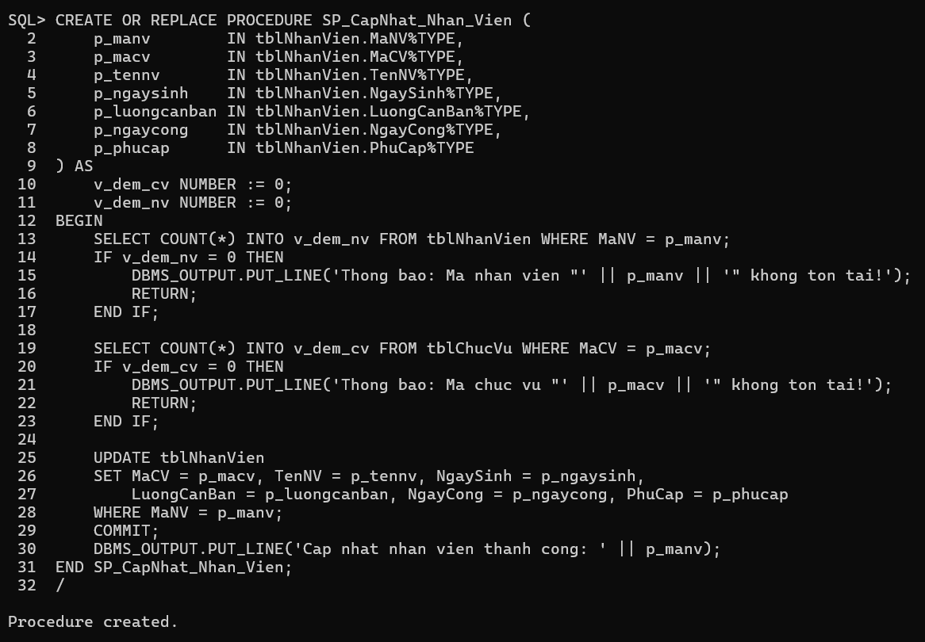

SQL> BEGIN
2 SP_CapNhat_Nhan_Vien('NV01','CV02','Nguyen Van An (updated)',TO_DATE('15/03/1985','DD/MM/YYYY'),16000000,26,2500000);
3 END;
4 /
Cap nhat nhan vien thanh cong: NV01

PL/SQL procedure successfully completed.

SQL> BEGIN
2 SP_CapNhat_Nhan_Vien('NV01','CVXX','Test sai MaCV',TO_DATE('15/03/1985','DD/MM/YYYY'),16000000,26,2500000);
3 END;
4 /
Thong bao: Ma chuc vu "CVXX" khong ton tai!

PL/SQL procedure successfully completed.

SQL> CREATE OR REPLACE PROCEDURE SP_LuongLN AS
2 CURSOR cur_nv IS
3 SELECT MaNV, TenNV, LuongCanBan, NgayCong, PhuCap FROM tblNhanVien;
4 v_luong NUMBER;
5 BEGIN
6 DBMS_OUTPUT.PUT_LINE('===== DANH SACH LUONG NHAN VIEN =====');
7 FOR r IN cur_nv LOOP
8 v_luong := r.LuongCanBan * r.NgayCong + r.PhuCap;
9 DBMS_OUTPUT.PUT_LINE('NV: ' || r.TenNV || ' | Luong: ' || TO_CHAR(v_luong,'999,999,999'));
10 END LOOP;
11 END SP_LuongLN;
12 /

Procedure created.
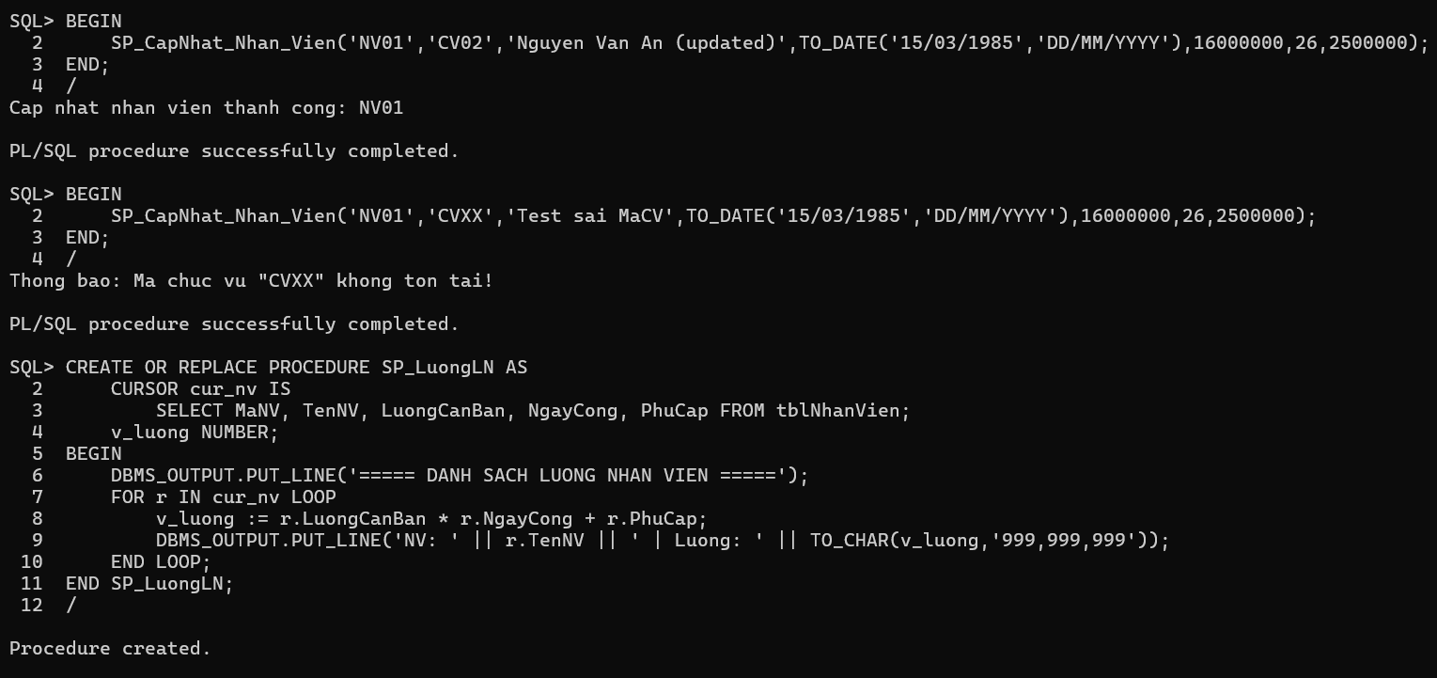

SQL>
SQL> -- Test SP_LuongLN
SQL> BEGIN
2 SP_LuongLN;
3 END;
4 /
===== DANH SACH LUONG NHAN VIEN =====
NV: Nguyen Van An (updated) | Luong: 418,500,000
NV: Tran Thi Binh | Luong: 241,000,000
NV: Le Van Cuong | Luong: 200,500,000
NV: Pham Thi Dao | Luong: 165,300,000

PL/SQL procedure successfully completed.
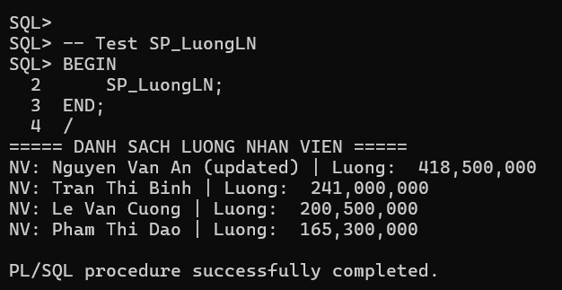

SQL> CREATE OR REPLACE PROCEDURE sp_them_nhan_vien1 (
2 p_manv IN tblNhanVien.MaNV%TYPE,
3 p_macv IN tblNhanVien.MaCV%TYPE,
4 p_tennv IN tblNhanVien.TenNV%TYPE,
5 p_ngaysinh IN tblNhanVien.NgaySinh%TYPE,
6 p_luongcb IN tblNhanVien.LuongCanBan%TYPE,
7 p_ngaycong IN tblNhanVien.NgayCong%TYPE,
8 p_phucap IN tblNhanVien.PhuCap%TYPE,
9 p_ketqua OUT NUMBER
10 ) AS
11 v_dem_cv NUMBER := 0;
12 BEGIN
13 SELECT COUNT(*) INTO v_dem_cv FROM tblChucVu WHERE MaCV = p_macv;
14 IF v_dem_cv = 0 THEN
15 p_ketqua := 0; -- MaCV chưa tồn tại
16 RETURN;
17 END IF;
18
19 INSERT INTO tblNhanVien (MaNV, MaCV, TenNV, NgaySinh, LuongCanBan, NgayCong, PhuCap)
20 VALUES (p_manv, p_macv, p_tennv, p_ngaysinh, p_luongcb, p_ngaycong, p_phucap);
21 COMMIT;
22 p_ketqua := 2; -- Thành công
23 END sp_them_nhan_vien1;
24 /

Procedure created.

Phiếu BT3
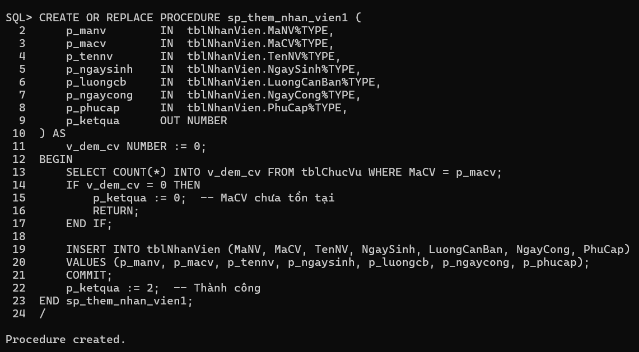

SQL>
SQL> -- Test Phiếu 3 – bài 1
SQL> DECLARE v_kq NUMBER;
2 BEGIN
3 sp_them_nhan_vien1('NV10','CV04','Ho Thi Em',TO_DATE('25/12/1993','DD/MM/YYYY'),9000000,23,800000,v_kq);
4 DBMS_OUTPUT.PUT_LINE('Ket qua: ' || v_kq); -- 2
5 END;
6 /
Ket qua: 2

PL/SQL procedure successfully completed.

SQL> DECLARE v_kq NUMBER;
2 BEGIN
3 sp_them_nhan_vien1('NV11','CV99','Test',TO_DATE('01/01/2000','DD/MM/YYYY'),5000000,20,200000,v_kq);
4 DBMS_OUTPUT.PUT_LINE('Ket qua: ' || v_kq); -- 0
5 END;
6 /
Ket qua: 0

PL/SQL procedure successfully completed.

SQL> CREATE OR REPLACE PROCEDURE sp_them_nhan_vien2 (
2 p_manv IN tblNhanVien.MaNV%TYPE,
3 p_macv IN tblNhanVien.MaCV%TYPE,
4 p_tennv IN tblNhanVien.TenNV%TYPE,
5 p_ngaysinh IN tblNhanVien.NgaySinh%TYPE,
6 p_luongcb IN tblNhanVien.LuongCanBan%TYPE,
7 p_ngaycong IN tblNhanVien.NgayCong%TYPE,
8 p_phucap IN tblNhanVien.PhuCap%TYPE,
9 p_ketqua OUT NUMBER
10 ) AS
11 v_dem_nv NUMBER := 0;
12 v_dem_cv NUMBER := 0;
13 BEGIN
14 -- Kiểm tra MaNV trùng
15 SELECT COUNT(*) INTO v_dem_nv FROM tblNhanVien WHERE MaNV = p_manv;
16 IF v_dem_nv > 0 THEN
17 p_ketqua := 0; -- MaNV đã tồn tại
18 RETURN;
19 END IF;
20
21 -- Kiểm tra MaCV
22 SELECT COUNT(*) INTO v_dem_cv FROM tblChucVu WHERE MaCV = p_macv;
23 IF v_dem_cv = 0 THEN
24 p_ketqua := 1; -- MaCV không tồn tại
25 RETURN;
26 END IF;
27
28 INSERT INTO tblNhanVien (MaNV, MaCV, TenNV, NgaySinh, LuongCanBan, NgayCong, PhuCap)
29 VALUES (p_manv, p_macv, p_tennv, p_ngaysinh, p_luongcb, p_ngaycong, p_phucap);
30 COMMIT;
31 p_ketqua := 2; -- Thành công
32 END sp_them_nhan_vien2;
33 /

Procedure created.

SQL> DECLARE v_kq NUMBER;
2 BEGIN
3 sp_them_nhan_vien2('NV01','CV03','Trung MaNV',TO_DATE('01/01/2000','DD/MM/YYYY'),5000000,20,100000,v_kq);
4 DBMS_OUTPUT.PUT_LINE('Ket qua: ' || v_kq); -- 0 (MaNV đã có)
5 END;
6 /
Ket qua: 0

PL/SQL procedure successfully completed.
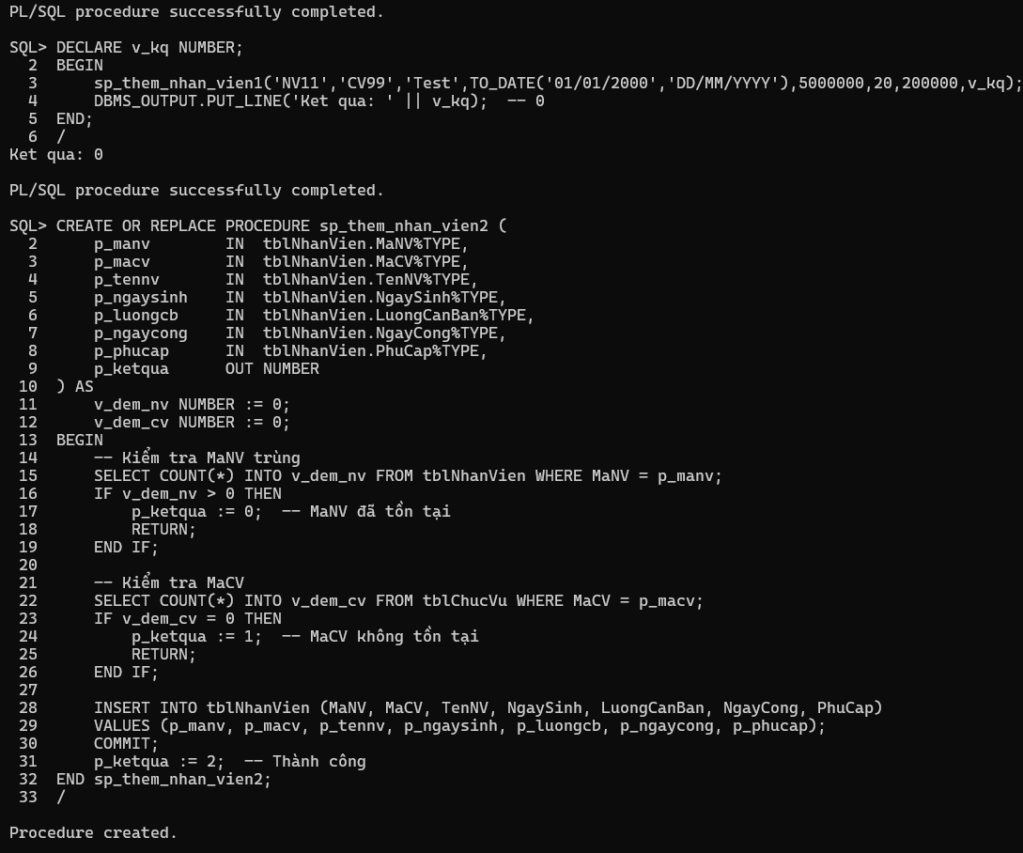

SQL> DECLARE v_kq NUMBER;
2 BEGIN
3 sp_them_nhan_vien2('NV20','CVXX','Sai MaCV',TO_DATE('01/01/2000','DD/MM/YYYY'),5000000,20,100000,v_kq);
4 DBMS_OUTPUT.PUT_LINE('Ket qua: ' || v_kq); -- 1 (MaCV không có)
5 END;
6 /
Ket qua: 1

PL/SQL procedure successfully completed.

SQL> DECLARE v_kq NUMBER;
2 BEGIN
3 sp_them_nhan_vien2('NV21','CV03','Nguyen Moi',TO_DATE('01/01/2000','DD/MM/YYYY'),6000000,22,400000,v_kq);
4 DBMS_OUTPUT.PUT_LINE('Ket qua: ' || v_kq); -- 2 (thành công)
5 END;
6 /
Ket qua: 2

PL/SQL procedure successfully completed.
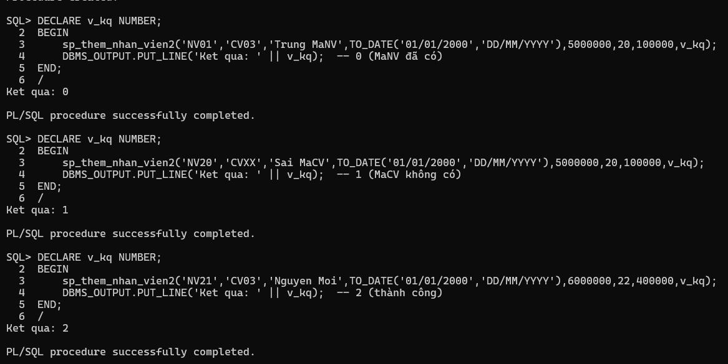

SQL> CREATE OR REPLACE PROCEDURE sp_capnhat_ngaysinh (
2 p_manv IN tblNhanVien.MaNV%TYPE,
3 p_ngaysinh IN tblNhanVien.NgaySinh%TYPE,
4 p_ketqua OUT NUMBER
5 ) AS
6 v_dem NUMBER := 0;
7 BEGIN
8 SELECT COUNT(*) INTO v_dem FROM tblNhanVien WHERE MaNV = p_manv;
9 IF v_dem = 0 THEN
10 p_ketqua := 0; -- Không tìm thấy nhân viên
11 ELSE
12 UPDATE tblNhanVien SET NgaySinh = p_ngaysinh WHERE MaNV = p_manv;
13 COMMIT;
14 p_ketqua := 1; -- Cập nhật thành công
15 END IF;
16 END sp_capnhat_ngaysinh;
17 /

Procedure created.
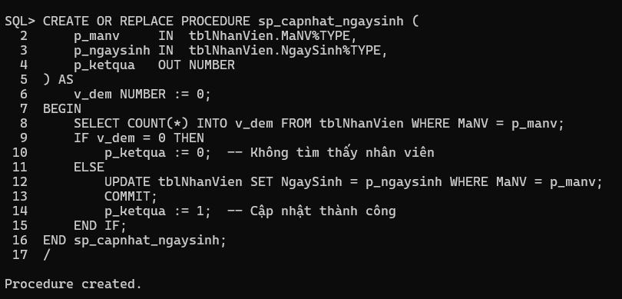

SQL>
SQL> -- Test Phiếu 3 – bài 3
SQL> DECLARE v_kq NUMBER;
2 BEGIN
3 sp_capnhat_ngaysinh('NV01', TO_DATE('01/04/1986','DD/MM/YYYY'), v_kq);
4 DBMS_OUTPUT.PUT_LINE('Ket qua: ' || v_kq); -- 1 (cập nhật thành công)
5 END;
6 /
Ket qua: 1

PL/SQL procedure successfully completed.

SQL> DECLARE v_kq NUMBER;
2 BEGIN
3 sp_capnhat_ngaysinh('NV99', TO_DATE('01/01/1990','DD/MM/YYYY'), v_kq);
4 DBMS_OUTPUT.PUT_LINE('Ket qua: ' || v_kq); -- 0 (không tìm thấy)
5 END;
6 /
Ket qua: 0

PL/SQL procedure successfully completed.
