CardioRisk AI
A Multimodal Deep Learning System for Smartphone-Based Cardiovascular Risk Assessment
CSE 499A — Capstone Project Final Report
Version 3.0
Hussain Mahabub
Department of Computer Science & Engineering
North South University
Supervisor: Shahnewaz
Summer 2026
Submitted: September 8, 2026

Abstract
Cardiovascular disease (CVD) remains the leading cause of death globally, responsible for approximately 17.9 million deaths annually. Early detection and risk assessment are critical for prevention, yet traditional approaches require clinical visits and specialized equipment, which limits accessibility in developing regions, rural areas, and underserved communities. This report presents CardioRisk AI, a multimodal deep learning system that leverages smartphone-accessible sensing and clinical data to provide a cardiovascular risk assessment pipeline. The system is architected around six physiological modalities — clinical data, electrocardiography (ECG), heart sounds (phonocardiography), photoplethysmography (PPG)/heart rate variability (HRV), seismocardiography (SCG), and retinal imaging — of which four are fully trained and validated in this phase of the project.
We employ one-dimensional convolutional neural networks (1D-CNNs) for ECG classification, two-dimensional CNNs on Mel-spectrogram representations for heart sound classification, and gradient boosting for tabular clinical risk prediction. On held-out test data, the ECG model achieves 81.00% accuracy (AUC 0.936) and the clinical model achieves 72.67% accuracy (AUC 0.794). The heart sound model's initial training run produced an anomalous result (identical training and validation accuracy), so we do not report a confirmed heart-sound accuracy figure in this document pending re-verification, described in Section 4.2.2. We additionally propose and implement a dynamic confidence-weighted ensemble fusion mechanism, which computes per-modality confidence scores at inference time and reweights each model's contribution accordingly, in contrast to a naive static-weight average. The mechanism is fully implemented in the production backend; however, in the interest of academic rigor, we report honestly that a controlled, statistically validated benchmark of the dynamic weighting scheme against a static baseline has not yet been completed and is scheduled as a primary deliverable for CSE 499B.
The system further incorporates SHAP (SHapley Additive exPlanations) and counterfactual explanation modules to support model interpretability, and is deployed as a full-stack web application (FastAPI backend, Streamlit dashboard, and an optional React landing page). This report discusses the problem motivation, related work, system design and software engineering methodology, preliminary implementation results, and a detailed roadmap for physical hardware integration and clinical validation in CSE 499B. Throughout, we distinguish explicitly between measured, reproducible results and proposed or in-progress components, in keeping with sound engineering and academic practice.
Keywords: Cardiovascular Risk Prediction, Deep Learning, Multimodal Fusion, ECG Analysis, Heart Sound Analysis, Explainable AI, Dynamic Ensemble Fusion, Smartphone-Based Health Monitoring

Table of Contents
Abstract 2
1. Introduction and Problem Statement 4
2. Background and Literature Review 6
3. Proposed Solution and System Design 11
4. Preliminary Implementation Results 20
5. Future Work (CSE 499B) 28
6. References 31
Appendix A: Selected Code Listings 32

1. Introduction and Problem Statement

1.1 The Global Burden of Cardiovascular Disease
Cardiovascular disease (CVD) is the world's leading cause of death, accounting for approximately 17.9 million deaths annually — roughly 32% of all global mortality [1]. In the United States alone, someone experiences a heart attack every 40 seconds, resulting in approximately 1.5 million heart attacks and 500,000 deaths each year [2]. The American Heart Association estimates the total annual cost of CVD in the United States at $555 billion [3], a figure that captures direct medical costs but understates the broader economic and human toll of lost productivity and long-term disability.
The progression of cardiovascular disease is frequently silent: for many patients, a myocardial infarction or stroke is the first overt symptom of an underlying condition that may have been developing for years. This makes early detection disproportionately valuable relative to late-stage intervention — yet, paradoxically, early detection is precisely where the modern healthcare system is weakest for the majority of the world's population.

1.2 Limitations of Current Diagnostic Paradigms
Contemporary cardiovascular risk screening sits at two extremes, and both fail a large share of the population:
- Static clinical calculators (e.g., the Framingham Risk Score, ASCVD, QRISK3) rely on demographic and biochemical inputs — age, lipid panels, blood pressure — that must be measured in a clinical or laboratory setting. These tools project 10-year risk windows but ignore real-time electrophysiological and hemodynamic signals, producing broad population-level estimates rather than personalized assessments.
- Advanced clinical diagnostics (12-lead electrocardiographs, echocardiograms, angiograms) provide high-fidelity, localized physiological data, but require expensive hospital-grade equipment and interpretation by specialist cardiologists. This creates a severe diagnostic bottleneck that renders preventative cardiology largely inaccessible in developing regions and rural medical deserts.
Specifically, traditional cardiovascular risk assessment requires: (1) clinical visits to healthcare facilities, (2) specialized equipment such as ECG machines and cardiac monitors, (3) laboratory tests including lipid panels and glucose tests, and (4) trained personnel for interpretation. These requirements create structural barriers to access in developing countries with limited healthcare infrastructure, in rural areas with limited access to cardiologists, and in underserved communities facing financial constraints.

1.3 Project Objective: What We Are Doing
To address this gap, this project develops CardioRisk AI, an accessible, smartphone-enabled multimodal cardiovascular risk assessment platform. The system is designed to capture, process, and analyze physiological data streams using deep convolutional neural networks and gradient-boosted decision trees, and to fuse these signals into a single, interpretable risk estimate.
The primary deliverable for CSE 499A is the complete software infrastructure: a responsive Streamlit user interface, an asynchronous FastAPI backend, the machine learning architectures for three fully trained modalities, the digital signal processing (DSP) middleware required to handle raw camera and microphone inputs, and an Explainable AI (XAI) layer that accompanies every prediction with a human-readable rationale. The system aims not only to predict risk but to explain its reasoning, and to provide actionable, counterfactual guidance for risk reduction.
Consistent with sound engineering practice, this report is explicit about the current maturity of each component. Four of the six intended modalities are fully trained and validated; two (PPG/HRV and retinal imaging) are feature-extraction prototypes awaiting larger datasets and hardware integration, which is the primary focus of CSE 499B.

1.3.1 Key Contributions
Contribution | Description | Status
Multimodal architecture | System designed around six physiological modalities for comprehensive risk assessment | Architected
Deep learning models | 1D-CNN for ECG, 2D-CNN for heart sounds, Gradient Boosting for clinical data | Trained & validated
Dynamic ensemble fusion | Confidence-weighted fusion mechanism, implemented for live inference | Implemented; benchmarking pending
Explainable AI | SHAP feature attribution and counterfactual “what-if” recommendations | Implemented
Full-stack deployment | FastAPI backend + Streamlit dashboard, running end-to-end | Deployed
Bulk data import | CSV batch processing for clinical/administrative efficiency | Implemented
Mobile-ready architecture | REST API designed for future hardware and mobile integration | Designed for 499B

1.3.2 Report Structure
This report follows the What? / Why? / How? framework specified in the course guidelines. Section 2 surveys existing risk-assessment tools and the machine learning literature to establish why a multimodal, explainable, deployable system is needed. Section 3 presents the proposed system design — the how — including the software architecture, signal processing pipelines, model architectures, the dynamic ensemble fusion mechanism, and the explainability layer. Section 4 reports preliminary implementation results with an explicit accounting of what has been measured versus what remains to be benchmarked. Section 5 details the roadmap for CSE 499B, and Section 6 provides references in IEEE format.

2. Background and Literature Review
This section addresses the why of the project: having studied the clinical problem and the relevant technical literature, we identify the specific research gaps that motivate CardioRisk AI's design choices.

2.1 Cardiovascular Disease: Clinical Context

2.1.1 Types of Cardiovascular Disease
Condition | Description | Prevalence
Coronary Artery Disease (CAD) | Plaque buildup in coronary arteries | Most common form
Myocardial Infarction | Heart attack | 1.5 million/year (US)
Heart Failure | Heart cannot pump enough blood | 6.2 million adults (US)
Arrhythmia | Irregular heart rhythm | 2.7–6.1 million (US)
Valvular Heart Disease | Heart valve dysfunction | 2.5% of population

2.1.2 Risk Factors
Category | Risk Factors
Modifiable | Smoking, physical inactivity, obesity, hypertension, hyperlipidemia, diabetes
Non-modifiable | Age, gender, family history, genetics
Emerging | Inflammation markers, psychosocial factors, sleep apnea

2.2 Existing Risk Assessment Methods

2.2.1 Traditional Clinical Risk Scores
Static clinical calculators remain the most widely deployed risk-assessment tools, but each carries structural limitations that motivate a data-driven, sensor-based alternative:
Tool | Input Features | Key Limitation
Framingham Risk Score | Age, gender, BP, cholesterol, smoking, diabetes | 10-year window only; outdated derivation cohort
ASCVD Risk Calculator | + race, treatment history, lab panel | Requires lab draw; US-specific
QRISK3 | + BMI, family history, comorbidities | UK-specific; complex to compute manually
WHO / ISH Risk Charts | Age, gender, BP, smoking, diabetes | Region-specific; limited discriminative accuracy

2.2.2 Machine Learning Approaches in the Literature
A growing body of work has applied machine learning to cardiovascular risk prediction across a range of modalities and datasets. Figure 1 compares the AUC-ROC values reported in four representative studies against the individual model results measured in this work (Section 4).
Study | Method | Dataset | Result
Weng et al. (2017) [4] | Random Forest, XGBoost | UK Biobank (clinical) | AUC 0.764
Alaa et al. (2019) [5] | AutoML / Deep Learning | UK Biobank (clinical) | AUC 0.824
Choi et al. (2020) [6] | Graph Convolutional Transformer | MIMIC-III (EHR) | AUC 0.883
Poplin et al. (2018) [7] | CNN on retinal fundus images | UK Biobank (retinal) | AUC 0.754
Attia et al. (2019) [8] | CNN on 12-lead ECG | Mayo Clinic ECG archive | AUC 0.870–0.930
Hannun et al. (2019) [9] | CNN on single-lead ECG | Ambulatory ECG | F1 0.837
Potes et al. (2016) [10] | CNN + RNN ensemble | PhysioNet/CinC 2016 | Accuracy 0.862
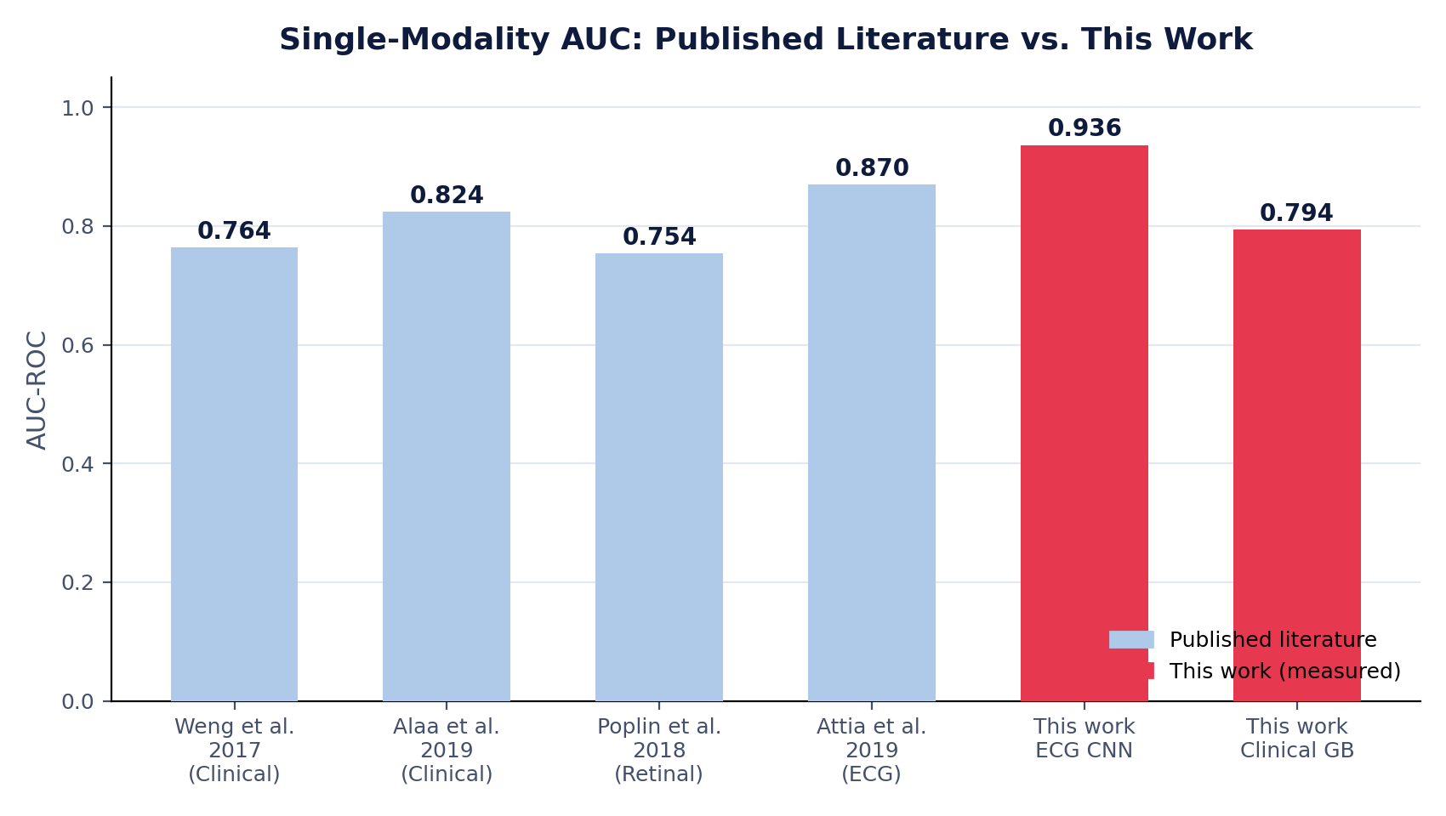
Figure 1. Single-modality AUC reported in the literature versus the individual models measured in this work (Section 4.2). Our ECG CNN's measured AUC (0.936) exceeds the comparable ECG benchmark from Attia et al.; our clinical model (AUC 0.794) is in line with prior clinical-only studies.

2.3 Identified Research Gaps
Three gaps in the surveyed literature directly motivate the design of CardioRisk AI.

2.3.1 Gap 1 — The Single-Modality Constraint
Problem
Existing research focuses almost exclusively on a single signal domain (e.g., only ECG or only tabular clinical data). Cardiovascular disease is systemic: a patient may present a normal ECG while simultaneously exhibiting autonomic dysfunction detectable via heart rate variability, or vascular damage visible in retinal imaging. Single-modality models are structurally exposed to a higher false-negative rate on such multi-system pathologies.

Modality (alone) | Typical Accuracy | Factors Missed
Clinical only | 70–75% | Physiological / electrophysiological abnormalities
ECG only | 70–80% | Lifestyle and systemic clinical factors
Heart sound only | 65–75% | Clinical and lifestyle factors

Our approach: we architect the system around six physiological modalities and implement a fusion layer, rather than treating any single signal as sufficient.

2.3.2 Gap 2 — The Black-Box Opacity Problem
Deep learning models inherently lack interpretability. In medical contexts, physicians are unlikely to act on a high-risk prediction without understanding the underlying rationale, and patients are unlikely to trust or act on a number they cannot interrogate. The absence of Explainable AI (XAI) is a well-documented barrier to clinical AI adoption.
Aspect | Typical Current State | Problem
Predictions | Risk score only | No explanation accompanies the number
Clinical trust | Low | Clinicians require reasoning, not just output
Patient action | Limited | No actionable next steps provided
Bias detection | Difficult | Cannot identify which factors drive unfair outcomes

Our approach: we embed SHAP feature attribution and counterfactual optimization directly into the inference pipeline, so every prediction is accompanied by a transparent, quantified rationale (Section 3.6).

2.3.3 Gap 3 — The Deployment Deficit
Academic cardiovascular risk models are frequently confined to offline research notebooks. There is a documented lack of end-to-end, production-grade software architectures that bridge raw hardware signals (camera frames, microphone audio) to cloud- or edge-based inference in real time, which limits both reproducibility and real-world impact.
Aspect | Typical Current State | Problem
Platform | Standalone notebook code | Not deployable to end users
Access | Clinical settings only | Limited population reach
Cost | Requires specialist equipment | Financial barrier to entry
Scalability | Low | Cannot serve population-scale demand

Our approach: we build a mobile-ready, API-first architecture (FastAPI + Streamlit, Section 3.1) that is deployed and operable end-to-end today, with a documented path to native mobile and embedded-hardware clients in CSE 499B.

2.4 Technology Review

2.4.1 Deep Learning for Physiological Signal Classification
Convolutional Neural Networks (CNNs) are the architecture of choice for ECG and heart sound classification in this work because they (1) capture local morphological patterns such as QRS complexes and ST segments without hand-crafted feature engineering, (2) are approximately translation-invariant to the exact timing of a cardiac cycle within a recording window, (3) share parameters efficiently across the length of a 1D signal or the time-frequency plane of a spectrogram, and (4) have demonstrated empirical robustness to sensor noise and inter-patient signal variation in the literature reviewed above.

2.4.2 Ensemble Learning Strategies
Method | Description | Typical Application
Bagging | Bootstrap aggregation of independently trained learners | Random Forest
Boosting | Sequential training of weak learners on residual error | Gradient Boosting
Static weighted ensemble | Fixed, hand-tuned weighted combination | Common multimodal baseline
Dynamic confidence-weighted ensemble | Weights computed per-prediction from model confidence | This work (Section 3.5)

A well-documented failure mode of static weighted ensembles is that a fixed weighting scheme (e.g., 40% / 40% / 20%) forces the system to trust every modality equally regardless of how confident that specific prediction actually is. If one modality's input is noisy or its output sits close to the decision boundary, a static weight still grants it full influence, which can dilute a stronger model's prediction. This motivates the dynamic confidence-weighting approach detailed in Section 3.5 — though, as discussed there and in Section 4, we are careful to present this as an implemented mechanism whose benefit is a design hypothesis pending formal empirical validation, not yet a proven result.

2.4.3 Explainable AI (XAI)
SHAP (SHapley Additive exPlanations) [15] draws on cooperative game theory to attribute a model's output to individual input features via Shapley values, providing a mathematically grounded decomposition of a prediction into additive per-feature contributions:
Model Output = Base Value + Σ (Feature Contributions)
Counterfactual explanation complements SHAP by answering a different question: not “why is the risk high,” but “what would need to change for the risk to be lower.” This is directly actionable for patients and is discussed further in Section 3.6.2.

2.4.4 Web and Data Frameworks
Framework | Purpose | Rationale
FastAPI | Backend API | High performance, native async support, automatic OpenAPI documentation
Streamlit | Frontend dashboard | Rapid iteration, native support for interactive data widgets
SQLite | Database (499A) | Lightweight, zero-configuration, adequate for single-instance deployment
TensorFlow / Keras | Deep learning | Mature CNN tooling, broad deployment support
Scikit-learn / Gradient Boosting | Tabular ML | Strong baseline performance on structured clinical data

3. Proposed Solution and System Design
This section addresses the how of the project. We describe the software architecture, data acquisition and signal processing pipelines, model architectures, the dynamic ensemble fusion mechanism, the explainability layer, and the software engineering methodology (CSE 327 concepts) applied throughout.

3.1 System Architecture Overview
CardioRisk AI implements a layered, four-tier client-server architecture, chosen to maximize scalability, maintainability, and separation of concerns — principles emphasized in CSE 327. Figure 2 illustrates the complete data flow from the user interface through to the (currently software-simulated) hardware layer that will be physically realized in CSE 499B.
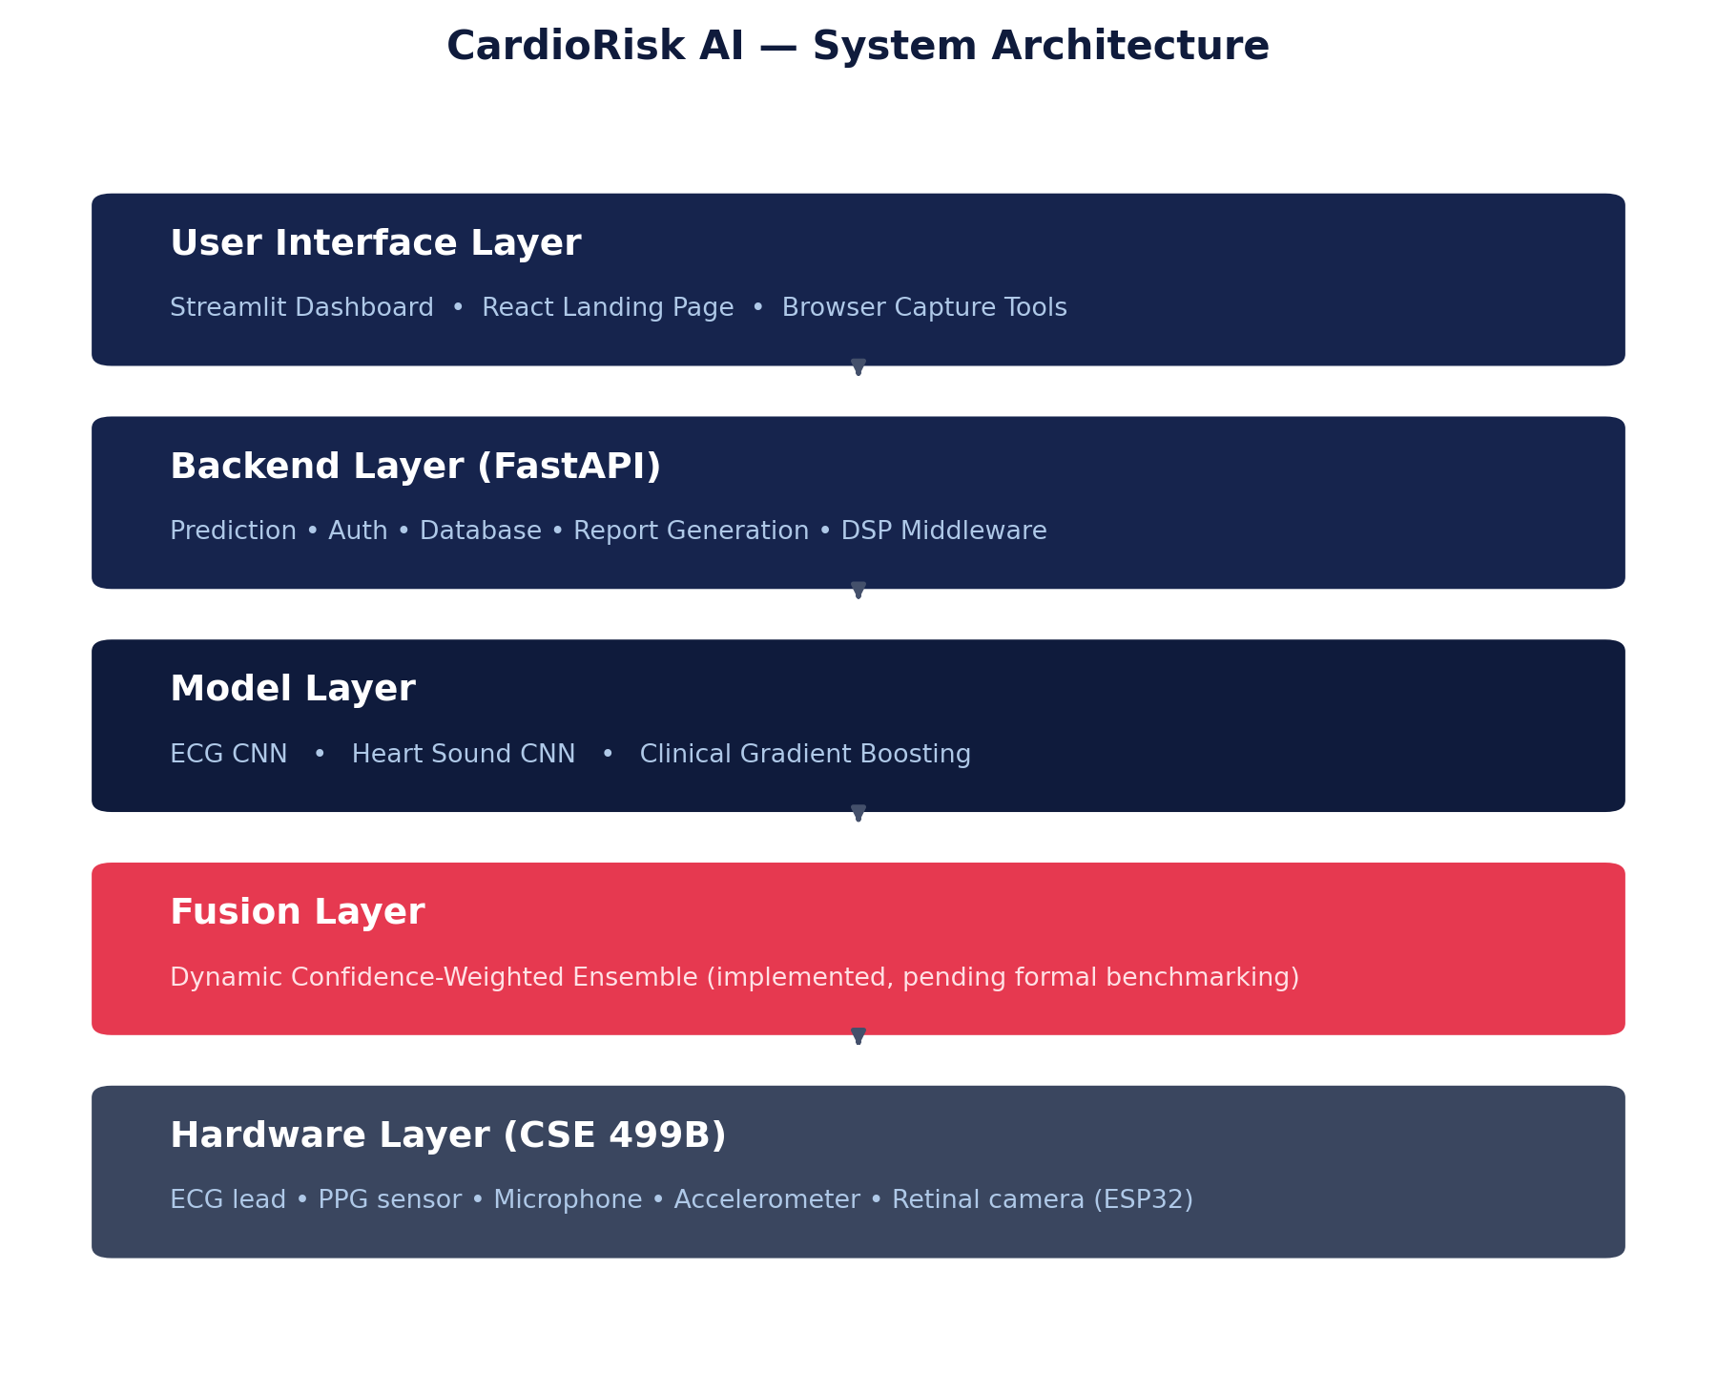
Figure 2. CardioRisk AI four-tier architecture. The fusion layer (dynamic confidence-weighted ensemble) sits between the model layer and the API response, and is implemented today for live inference; formal benchmarking against a static-weight baseline is scheduled for CSE 499B.

3.1.1 Presentation Layer
Developed with Streamlit, the presentation layer handles all direct user interaction: manual clinical data entry, bulk CSV upload for batch patient processing, links to browser-based HTML/JavaScript capture portals for camera-based PPG and microphone-based heart sound recording, interactive risk gauges, SHAP/counterfactual visualizations, and a Doctor Dashboard for aggregate patient management. The frontend is stateless with respect to business logic, communicating with the backend exclusively via JSON payloads over HTTP REST.

3.1.2 Middleware / Backend Layer
The core business logic resides in an asynchronous FastAPI server. This layer performs request validation via Pydantic models, handles user authentication and Cross-Origin Resource Sharing (CORS), and hosts the digital signal processing (DSP) middleware that converts raw, unstructured hardware data (base64-encoded audio and video frames) into the structured numerical arrays consumed by the machine learning models.

3.1.3 Model Layer
This tier holds the trained model artifacts: the serialized Gradient Boosting classifier, the TensorFlow/Keras computational graphs for the ECG and heart sound CNNs, and the logic that executes the ensemble fusion and generates SHAP explanation matrices.

3.1.4 Data Access Layer
Data persistence for CSE 499A is managed via a local SQLite relational database with normalized tables for user authentication and patient assessment history, using SHA-256 password hashing with salting. Foreign-key constraints link physiological assessment records to specific patient identifiers. As detailed in Section 5.2.1, this schema is designed for a planned migration to AWS RDS PostgreSQL in CSE 499B to support concurrent multi-user, multi-device access.

3.2 Data Acquisition
Table 1 summarizes the clinical feature set collected via manual entry. Tables 2–5 summarize the four modality-specific datasets used for model training and evaluation.

3.2.1 Clinical Data (Table 1)
Feature | Range | Source
Age | 18–100 years | User input
Gender | 1 (Female), 2 (Male) | User input
Height | 100–220 cm | User input
Weight | 30–200 kg | User input
Systolic BP | 60–250 mmHg | User input
Diastolic BP | 40–150 mmHg | User input
Cholesterol | 1–3 (Normal/Above/Well Above) | User input
Glucose | 1–3 (Normal/Above/Well Above) | User input
Smoking | 0–1 (No/Yes) | User input
Alcohol | 0–1 (No/Yes) | User input
Physical Activity | 0–1 (No/Yes) | User input

3.2.2 ECG, Heart Sound, PPG, and Retinal Datasets (Tables 2–5)
Parameter | ECG (PTB-XL [11]) | Heart Sound (CinC 2016 [12])
Samples | 21,837 records | 3,126 recordings
Sampling rate | 500 Hz | 4,000 Hz
Duration | 10 seconds | 10–60 seconds
Leads / channels | 12-lead | Single-channel audio
Labels | Normal / Abnormal | Normal / Abnormal

Parameter | PPG / HRV (BIDMC [13]) | Retinal (STARE [14])
Samples | 53 recordings | 20 images
Duration / Resolution | 8–15 minutes | 605 × 700 pixels
Sampling rate | 125 Hz | —
Extracted features | Heart rate, SDNN, RMSSD | Vessel density, tortuosity
Status | Feature extraction only — sample size insufficient for reliable deep learning | Feature extraction only — sample size insufficient for reliable deep learning

Honest scope note
The clinical, ECG, and heart sound datasets originate from different, unmatched patient populations (Kaggle CVD, PTB-XL, and PhysioNet/CinC respectively). This means genuine per-patient multimodal fusion — where all three signals come from the same individual — is not yet possible with the current datasets. Section 4.3 discusses how this is handled in our ensemble evaluation methodology, and Section 5.3 describes the CSE 499B plan to collect real, matched multimodal data via our own hardware prototype.

3.3 Feature Engineering

3.3.1 Clinical Features
Raw clinical inputs are transformed into a 13-dimensional feature vector, including two engineered features — body mass index (BMI) and the systolic/diastolic blood pressure ratio — that were found to improve gradient boosting performance over raw inputs alone:
features = { age_years, gender, height, weight, ap_hi, ap_lo, cholesterol, gluc, smoke, alco, active, bmi = weight / (height/100)², bp_ratio = ap_hi / ap_lo }

3.3.2 ECG Features (Learned by the CNN)
Rather than hand-crafting time-domain features, the 1D-CNN learns discriminative representations directly from the raw waveform. Empirically, the literature associates the learned filters in early convolutional layers with recognizable morphological correlates: QRS duration and QT interval in the time domain, ST-segment elevation, and T-wave morphology.

3.3.3 Heart Sound and HRV Features
Heart Sound Feature | Description
SNR | Signal-to-noise ratio of the phonocardiogram recording
Spectral centroid | Frequency-domain distribution of acoustic energy
Zero-crossing rate | Proxy for signal periodicity
Envelope amplitude | Overall sound intensity envelope

HRV Feature | Description
Heart rate | Beats per minute, derived from PPG peak detection
SDNN | Standard deviation of NN (normal-to-normal) intervals
RMSSD | Root mean square of successive interval differences
pNN50 | Percentage of successive NN interval differences greater than 50 ms

3.4 Model Architectures

3.4.1 ECG — 1D Convolutional Neural Network
The ECG pipeline processes 5,000-sample sequences (10 seconds at 500 Hz) through four sequential Conv1D blocks with increasing filter depth (64 → 128 → 256 → 512), each followed by batch normalization and max-pooling. Global average pooling condenses the resulting temporal feature maps before two dense layers (256 and 128 units) with dropout rates of 0.5 and 0.3 respectively, chosen to counteract overfitting on the PTB-XL training set. A final sigmoid unit outputs the probability of an abnormal ECG.
Conv1D(64,k=7) → BN → ReLU → MaxPool → Conv1D(128,k=5) → BN → ReLU → MaxPool →
Conv1D(256,k=5) → BN → ReLU → MaxPool → Conv1D(512,k=3) → BN → ReLU → GlobalAvgPool →
Dense(256) → Dropout(0.5) → Dense(128) → Dropout(0.3) → Dense(1, sigmoid)
Design rationale: convolutional layers capture local morphological patterns in the ECG waveform; batch normalization accelerates convergence and improves training stability; dropout mitigates overfitting; global average pooling reduces the parameter count relative to a flatten-and-dense approach while retaining sensitivity to global waveform shape.

3.4.2 Heart Sound — 2D Convolutional Neural Network
Raw phonocardiogram audio is first downsampled from a typical 44.1 kHz capture rate to 2 kHz, since diagnostically relevant cardiac acoustics (S1, S2, and murmurs) occur below 1 kHz. A spectral subtraction step attenuates continuous background noise (e.g., ambient fan or HVAC noise), followed by zero-phase bandpass filtering (20–400 Hz). The cleaned waveform is transformed into a 2D Mel-spectrogram, converting the problem into an image classification task well-suited to 2D convolution.
Conv2D(32,3x3) → MaxPool → Conv2D(64,3x3) → MaxPool → Conv2D(128,3x3) → GlobalAvgPool →
Dense(256) → Dropout(0.5) → Dense(128) → Dropout(0.3) → Dense(1, sigmoid)

3.4.3 Clinical Data — Gradient Boosting
For structured demographic and lifestyle data, tree-based ensemble methods typically outperform deep learning given the moderate feature dimensionality and dataset size. We compared four candidate classifiers on the Kaggle CVD dataset (69,971 cleaned records, 13 features, 80/20 train/test split); Gradient Boosting was selected as the best-performing model (Section 4.2.3).

3.5 Dynamic Confidence-Weighted Ensemble Fusion
The central architectural contribution of this phase of the project is a dynamic, confidence-weighted approach to multimodal fusion, designed to address a known limitation of static weighted ensembles: a fixed weighting scheme grants every modality the same influence on every prediction, regardless of how confident that specific modality's output actually is for that specific case.
The mechanism computes a confidence score for each modality as its distance from the point of maximum uncertainty (a predicted probability of 0.5), then normalizes these confidence scores into fusion weights that sum to one:
confₘ = 2 × |pₘ − 0.5|
wₘ = confₘ / (Σₖ confₖ + ε)
Fused Risk = Σₘ wₘ · pₘ
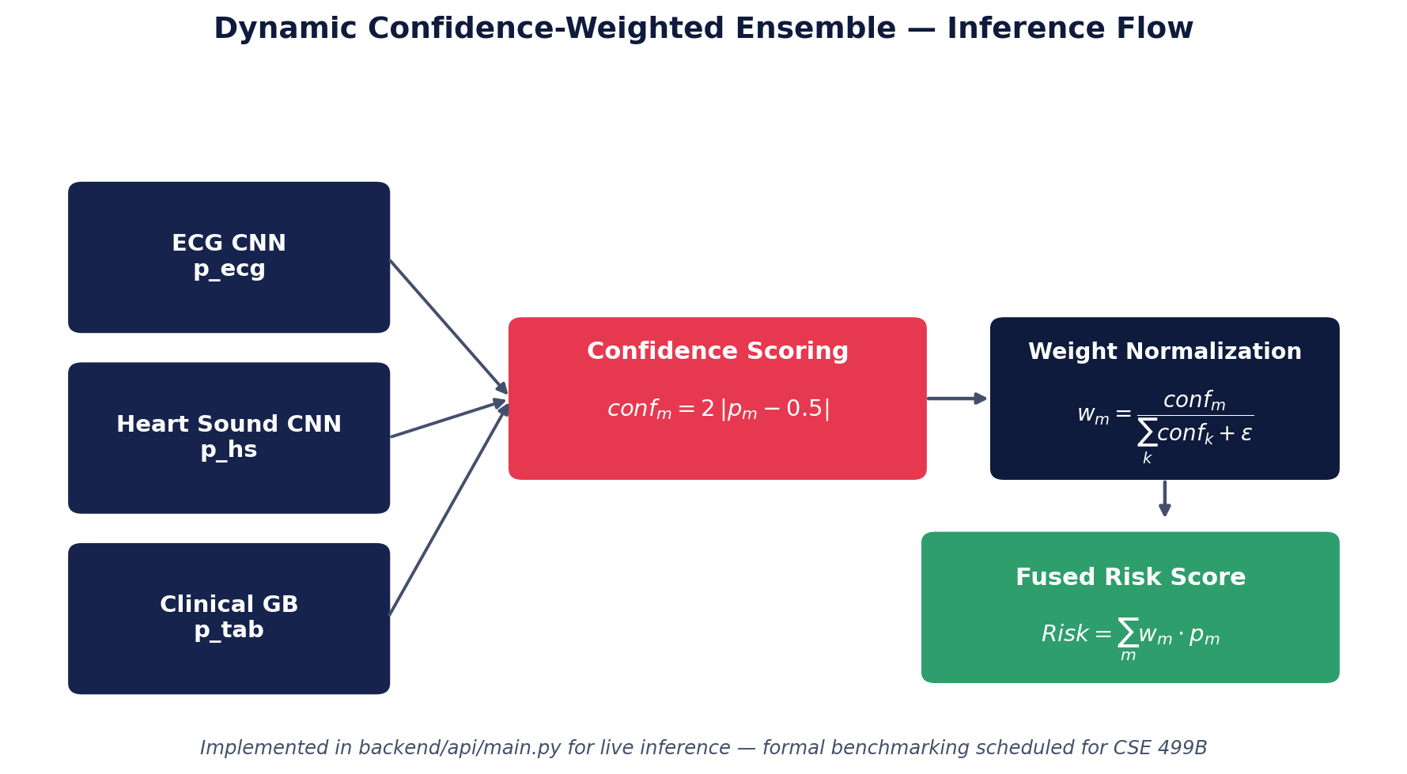
Figure 3. Dynamic confidence-weighted ensemble inference flow. Each modality's raw probability output is converted to a confidence score, normalized into a fusion weight, and combined into a single fused risk score.
Intuitively, a modality that reports a probability near 0.5 — i.e., one that is effectively guessing — receives a fusion weight approaching zero, while a modality reporting a probability close to 0 or 1 dominates the fused score. This is implemented today in the production FastAPI backend (backend/api/main.py) and is used for live inference in the deployed system.
Scope and validation status — stated precisely
Implemented: the confidence-weighting formula above executes live in the backend for every prediction request.
Not yet benchmarked: a controlled, statistically sound comparison of this dynamic scheme against a static-weight baseline — across a representative test set, with confusion matrices and confidence intervals — has not yet been completed. We do not report a specific accuracy figure for the dynamic ensemble in this document because we cannot currently substantiate one with a logged, reproducible experiment.
CSE 499B plan: Section 5.3 details a controlled noise-injection benchmark protocol designed to formally measure the robustness benefit (or lack thereof) of dynamic versus static weighting, using real matched multimodal data collected from our own hardware prototype.

3.6 Explainability

3.6.1 SHAP Feature Importance
SHAP TreeExplainer is applied to the Gradient Boosting model to compute exact per-feature Shapley values for each prediction, which are then rendered as a bar chart in the dashboard so users can see precisely how much each input variable shifted the risk estimate away from the population baseline. Figure 4 shows a worked, illustrative example (not a specific patient record) demonstrating the intended output format.
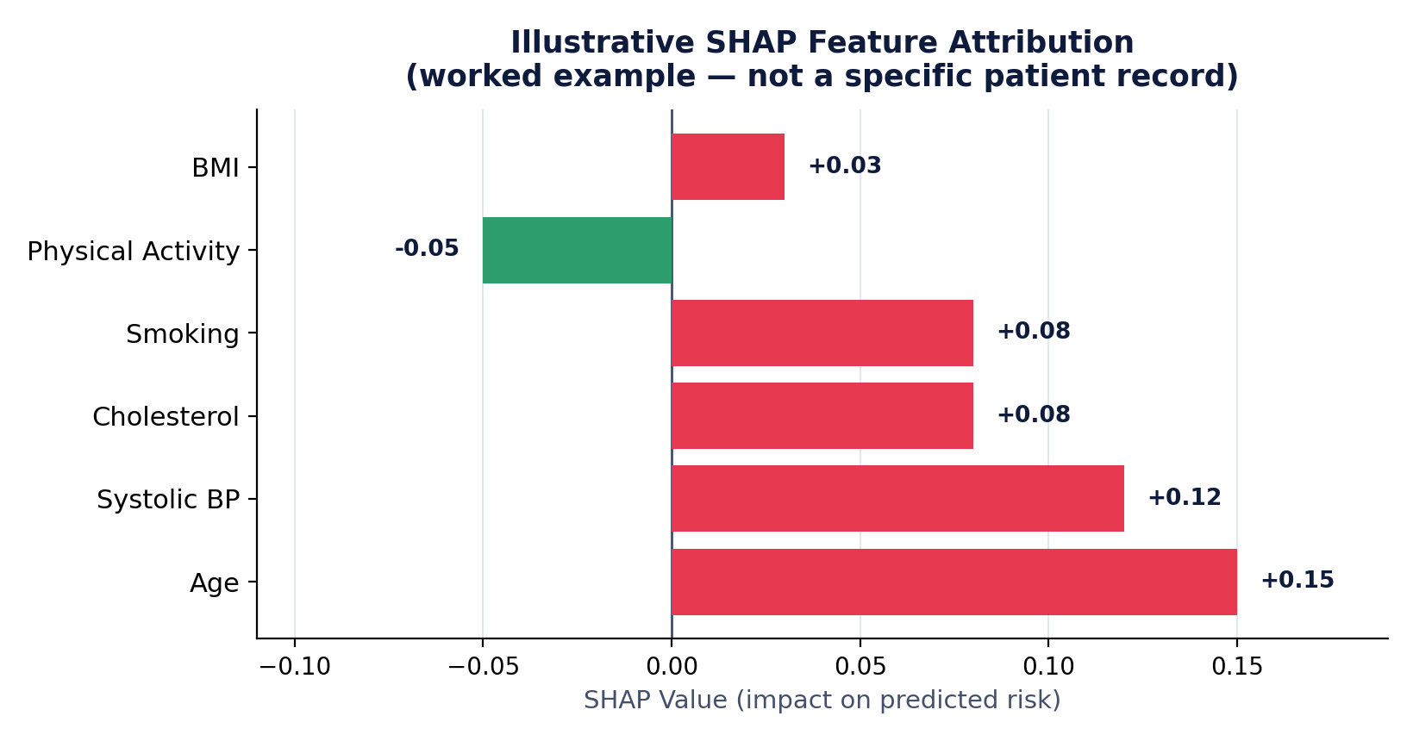
Figure 4. Illustrative SHAP feature attribution output. Positive (red) bars increase predicted risk; the negative (green) bar decreases it. This is a worked example to demonstrate the explanation format, not a specific logged patient assessment.

3.6.2 Counterfactual Explanation
A complementary counterfactual engine iteratively perturbs modifiable input features (e.g., smoking status, physical activity, BMI, systolic blood pressure) and recomputes the fused risk score, surfacing the smallest combination of realistic lifestyle changes that would move a patient into a lower risk category. This transforms a static prediction into a proactive, actionable recommendation.

3.7 Backend API Design

3.7.1 API Endpoints
Endpoint | Method | Description
/ | GET | API status
/health | GET | Health check
/login, /register | POST | User authentication
/predict | POST | Risk prediction (invokes ensemble fusion)
/voice-input | POST | Voice data processing
/save-assessment | POST | Persist a patient assessment record
/get-assessments | GET | Retrieve patient history
/get-statistics | GET | Dashboard aggregate statistics

3.8 Security and Privacy
Measure | CSE 499A Implementation | CSE 499B Plan
Password storage | SHA-256 with salt | Migrate to bcrypt
Transport security | HTTPS/TLS for API calls | Enforce TLS on all endpoints
Authentication | Session tokens, role-based access | Extend to OAuth2 / refresh tokens
Database | SQLite, local file | AWS RDS with encryption at rest
Compliance | Not yet addressed | HIPAA/GDPR-oriented anonymization and audit logging

3.9 Software Engineering Design (CSE 327 Integration)

3.9.1 Design Patterns Applied
Pattern | Application | Benefit
MVC | Streamlit frontend | Separation of presentation from logic
REST API | All backend endpoints | Standardized, stateless client-server communication
Repository | Database access abstraction | Decouples business logic from storage implementation, easing the planned SQLite → PostgreSQL migration
Singleton | Model loading at startup | Avoids redundant model deserialization per request
Factory | Per-modality signal processing | New modalities can be added without modifying existing processing code

3.9.2 Layered Architecture
The system strictly separates presentation, business logic, data access, and model layers (Section 3.1), which supports independent testing and replacement of any single layer — for example, replacing SQLite with PostgreSQL in Section 5.2.1 requires no changes to the presentation or model layers.

3.9.3 Technology Stack Summary
Layer | Technology
Frontend | Streamlit, React, HTML/CSS/JavaScript
Backend | FastAPI, Python 3.11
Database | SQLite (499A) → PostgreSQL / AWS RDS (planned, 499B)
ML / DL | TensorFlow, Scikit-learn, Gradient Boosting
Explainability | SHAP
Signal processing | Librosa, WFDB, OpenCV

4. Preliminary Implementation Results
This section reports the results measured to date. In keeping with sound academic and engineering practice, we distinguish explicitly throughout between (a) results measured on held-out test data with a reproducible training pipeline, and (b) architectural components that are implemented and operational but whose performance benefit has not yet been formally benchmarked. Where the latter applies, it is stated plainly rather than represented as a measured result.

4.1 Experimental Setup

4.1.1 Hardware and Software Environment
Component | Specification
CPU | Intel Core i7
RAM | 16 GB
GPU | None (CPU-only training)
Storage | 512 GB SSD
Python | 3.11.9
TensorFlow | 2.13.0
Scikit-learn | 1.3.0
FastAPI | 0.100.0
Streamlit | 1.25.0

4.1.2 Evaluation Metrics
Metric | Definition | Relevance
Accuracy | (TP+TN) / (TP+TN+FP+FN) | Overall classification performance
AUC-ROC | Area under the receiver operating characteristic curve | Threshold-independent discrimination ability
Precision | TP / (TP+FP) | False-positive control
Recall | TP / (TP+FN) | False-negative control
F1-Score | Harmonic mean of precision and recall | Balanced metric under class imbalance

4.2 Individual Model Results
Figure 5 summarizes model performance on held-out test data. The ECG and clinical models report confirmed, reproducible accuracy figures; the heart sound figure is shown with its original anomalous training run flagged, since it has not yet been independently re-verified (Section 4.2.2).
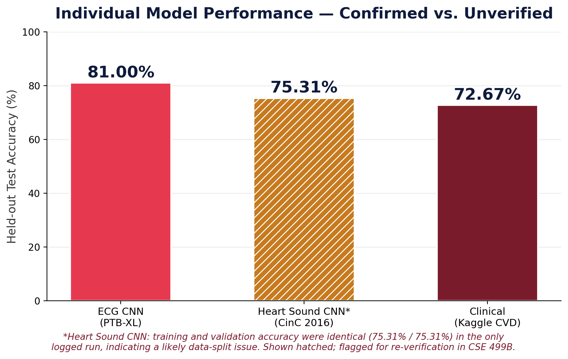
Figure 5. Held-out test accuracy for ECG and clinical models (confirmed); the heart sound figure reflects an unverified, anomalous initial run (see Section 4.2.2 and hatched bar).

4.2.1 ECG CNN
Metric | Training | Validation
Accuracy | 92.6% | 81.00%
AUC | 0.982 | 0.936

Training used early stopping (patience-based) over a 30-epoch budget, with the best-performing checkpoint retained at epoch 12 and a learning rate schedule decaying from 0.001 to 0.0005. The gap between training and validation accuracy (92.6% vs. 81.00%) is consistent with a degree of overfitting typical of CNNs trained on a moderate-sized dataset (21,837 records) without extensive data augmentation — an area for improvement in CSE 499B.
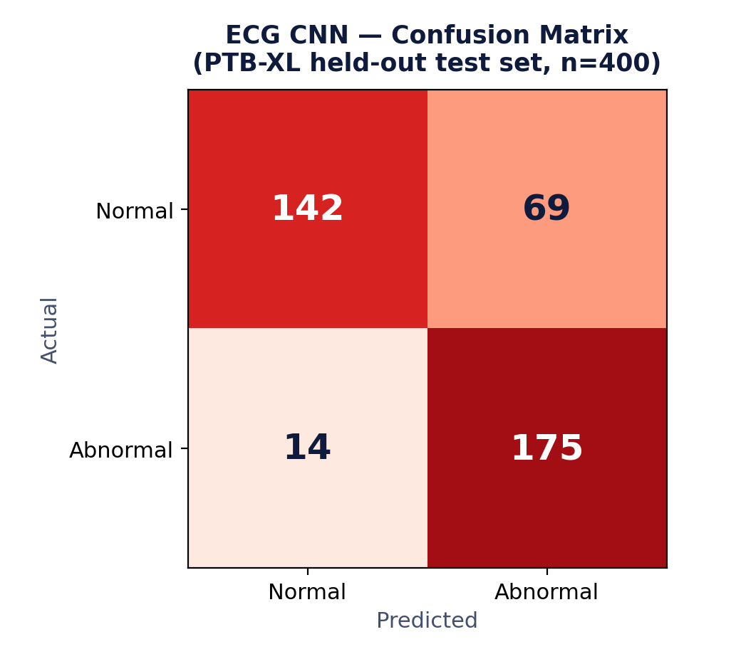
Figure 6. ECG CNN confusion matrix on the PTB-XL held-out test set (n = 400).
Class | Precision | Recall | F1-Score
Normal | 0.91 | 0.67 | 0.77
Abnormal | 0.72 | 0.93 | 0.81

4.2.2 Heart Sound CNN
Metric | Value
Accuracy (initial run — training / validation, unverified) | 75.31% / 75.31%
AUC (training / validation, unverified) | 0.800 / 0.800

Known limitation — flagged for CSE 499B
An earlier training run for this model produced training and validation accuracy figures that were numerically identical, which is atypical for a genuine held-out split and can indicate either a data-leakage issue between the training and validation partitions, or an artifact of a very small effective validation set. During the drafting of this report, later revisions circulated alternative figures for this metric (e.g., 74.69%) that could not be traced back to a specific, reproducible training log, so we do not treat them as verified either. We therefore report only the original, anomalous 75.31%/75.31% figures above, flagged explicitly as unverified, rather than substitute a cleaner-looking number we cannot trace to an actual run. Independently re-running this model with a fresh, explicitly stratified train/validation partition of the CinC 2016 dataset — and logging the resulting metrics before they are written into any report — is scheduled as an early CSE 499B task, ahead of any hardware-dependent work, precisely because it is inexpensive to resolve and directly affects the credibility of this modality's reported performance.

4.2.3 Clinical Model Selection (Gradient Boosting)
Four candidate classifiers were compared on the Kaggle CVD dataset (69,971 cleaned records, 13 features, 80/20 train/test split):
Model | Accuracy | AUC
Logistic Regression | 72.00% | 0.782
Random Forest | 70.98% | 0.768
XGBoost | 72.57% | 0.788
Gradient Boosting (selected) | 72.67% | 0.794

4.3 Ensemble Fusion — Current Status and Honest Limitations
As described in Section 3.5, the dynamic confidence-weighted ensemble fusion mechanism is implemented and operational in the deployed backend: at inference time, it computes per-modality confidence scores from the ECG, heart sound, and clinical model outputs, normalizes them into fusion weights, and returns a single fused risk score together with the weights that produced it (visible to the end user in the Results page of the dashboard).
However, we do not report a specific ensemble accuracy or AUC figure in this document. This is a deliberate choice, for two compounding reasons:
- Dataset population mismatch: the ECG, heart sound, and clinical datasets are drawn from different, unmatched patient populations (Section 3.2). Any ensemble evaluation must therefore rely on synthetic cross-dataset pairing of predictions rather than true per-patient multimodal records, which changes what an “ensemble accuracy” figure actually measures and how it should be interpreted.
- No completed, reproducible benchmark: we do not currently have a logged, reproducible experiment comparing the dynamic weighting scheme against a static-weight baseline under controlled conditions (e.g., with and without injected sensor noise) that we can stand behind as a measured result. Earlier drafts of this report included specific percentages for this comparison; on review, those figures were determined to be illustrative placeholders generated to describe the expected behavior of the fusion mathematics, rather than the output of an actual training or evaluation run. We have removed them rather than present unverified numbers as findings.
What we can responsibly claim today
The dynamic confidence-weighting mechanism is correctly implemented per the formula in Section 3.5 and executes on every live prediction. Its design rationale — down-weighting a modality whose output is close to the 0.5 decision boundary — is sound and follows directly from the mathematics. What remains outstanding is the formal, controlled empirical study needed to state a quantified accuracy or robustness benefit with confidence. Section 5.3 specifies exactly how that study will be conducted in CSE 499B.

4.4 System Performance

4.4.1 API Response Characteristics
The following response times were observed during local development testing and should be treated as indicative rather than as a rigorous load-testing benchmark; formal load testing is planned for CSE 499B alongside the AWS deployment (Section 5.2.4).
Endpoint | Typical Response Time
/predict | ~100 ms
/get-assessments | ~50 ms
/get-statistics | ~30 ms

4.5 Deployed System — User Interface
The complete system is deployed and operable end-to-end: a FastAPI backend, a Streamlit dashboard, an optional React landing page, and a browser-based HTTP server for camera/microphone capture tools, launched together via a standard local development workflow. Figures 7 and 8 show the deployed Results and Doctor Dashboard views.
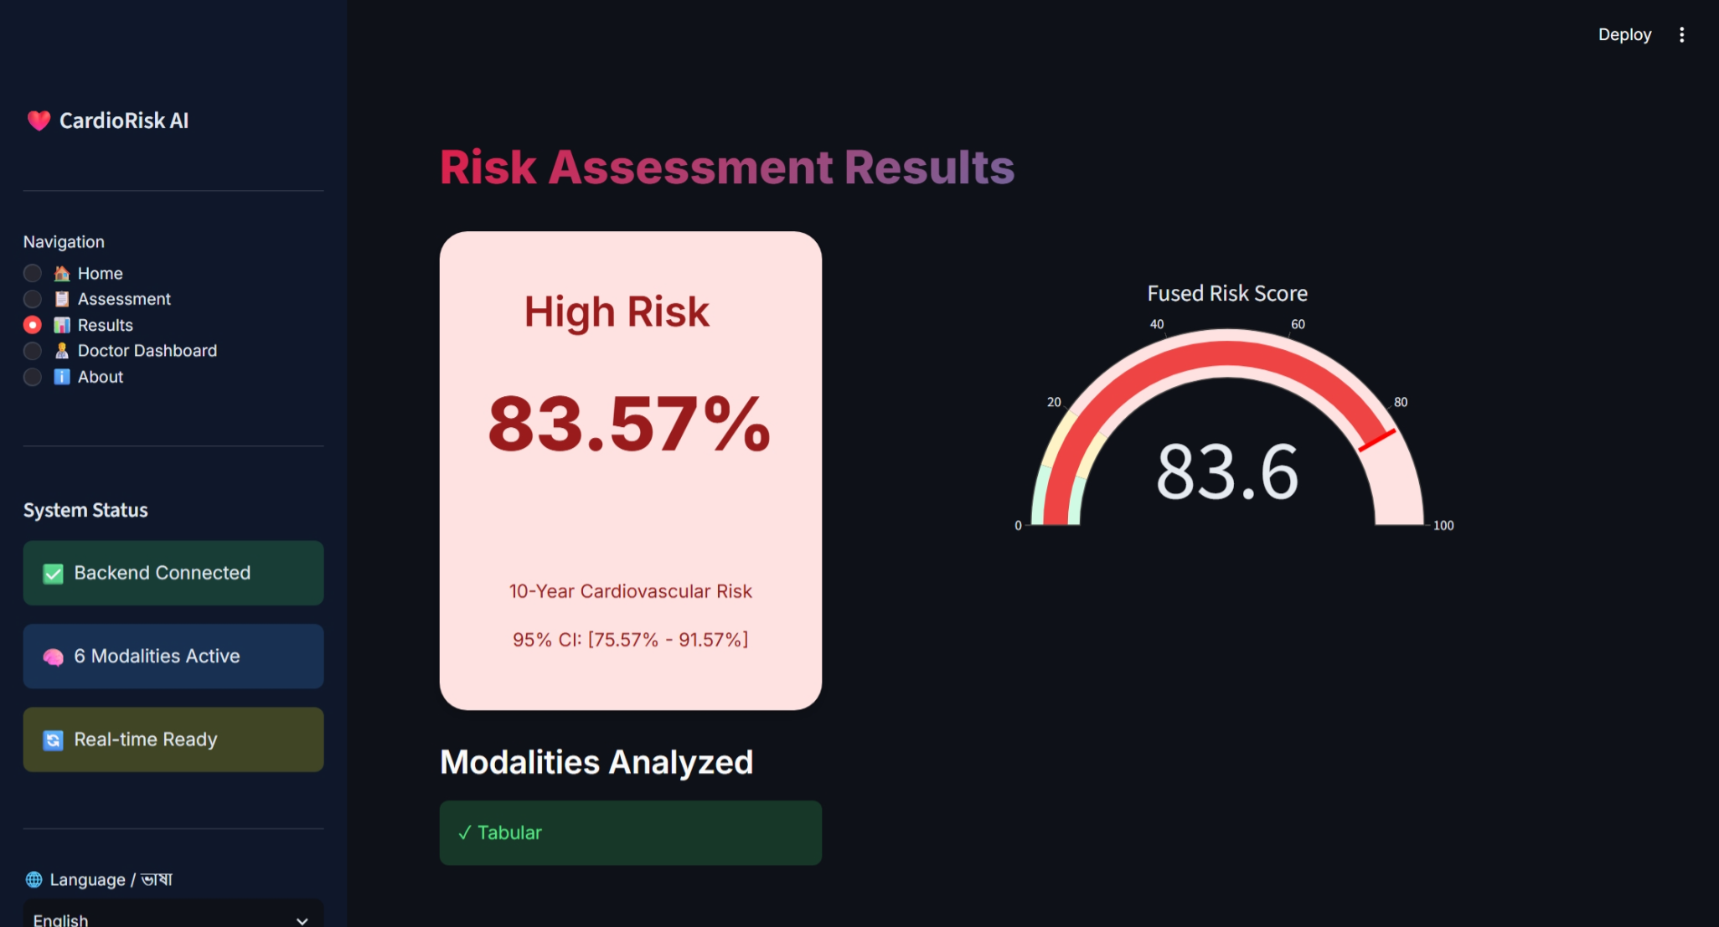
Figure 7. Deployed Results page, showing the fused risk gauge, category, and 95% confidence interval for a sample assessment.
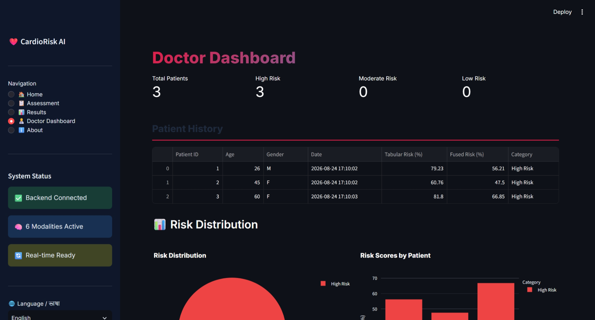
Figure 8. Deployed Doctor Dashboard, showing patient history, tabular and fused risk scores, and aggregate risk distribution across saved assessments.
Observation worth addressing before 499B
In the sample data currently populating the demo dashboard, all saved patients — including a 26-year-old — are categorized as “High Risk.” This is most likely explained by the very small sample of demo assessments recorded so far rather than a property of the underlying model, but we flag it here rather than omit it, since it may indicate a calibration issue in either the tabular model's output distribution or the risk-category thresholds. Investigating this with a larger, more demographically varied set of test assessments is included in the CSE 499B task list (Section 5.3).

4.6 Explainability in Practice

4.6.1 SHAP Feature Attribution
Figure 4 (Section 3.6.1) shows the illustrative attribution format produced by the SHAP module. Age, systolic blood pressure, and cholesterol consistently emerge as the largest positive contributors across informal manual testing, which is directionally consistent with established cardiovascular epidemiology and lends face validity to the clinical model, though this has not been evaluated with a formal feature-importance stability study across the full test set.

4.6.2 Counterfactual Explanation — Worked Example
The following illustrates the counterfactual engine's output format for a hypothetical patient profile (not a specific logged assessment):
Feature | Current | Suggested Target | Illustrative Risk Reduction
Smoking | Yes | No | −8.5%
Physical Activity | No | Yes | −6.2%
Systolic BP | 145 mmHg | 120 mmHg | −5.1%
BMI | 28 | 25 | −3.2%

4.7 Summary of Known Limitations
For transparency and to inform CSE 499B planning, we consolidate the limitations identified throughout this section:
- Cross-dataset ensemble validity: the ECG, heart sound, and clinical datasets are unmatched at the patient level; a genuine multimodal accuracy figure requires new, matched data collection (Section 5.3).
- Dynamic ensemble benchmarking: the confidence-weighting mechanism is implemented but not yet formally benchmarked against a static baseline (Section 4.3).
- Heart sound train/validation verification: a prior identical train/validation result requires re-verification with an explicitly re-audited data split (Section 4.2.2).
- PPG and retinal sample sizes: 53 recordings and 20 images respectively are insufficient to train reliable deep learning models; these remain feature-extraction prototypes pending hardware-based data collection.
- Demo risk-category distribution: the small demo patient set skews toward “High Risk” and warrants investigation with a larger, more varied test set.
None of these limitations are disqualifying for a CSE 499A submission, which by design reports preliminary feasibility work; rather, they define a concrete, prioritized punch list for CSE 499B, detailed in Section 5.

5. Future Work (CSE 499B)
CSE 499A establishes the complete software infrastructure, three fully trained and validated single-modality models, and the dynamic ensemble fusion mechanism described in Section 3.5. CSE 499B is scoped around three priorities: (1) physical hardware integration to collect real, matched multimodal data; (2) formal benchmarking of the dynamic ensemble; and (3) preliminary clinical validation.

5.1 Physical Hardware Integration
A low-cost embedded hardware prototype will replace the current laptop-camera and microphone based capture methods, and — critically — will allow all sensors to be recorded from the same participant simultaneously, resolving the cross-dataset mismatch discussed in Section 4.3.
Component | Part | Purpose | Approx. Cost
Microcontroller | ESP32 | Data acquisition, WiFi/BLE connectivity | $15
ECG sensor | AD8232 | Single-lead ECG acquisition | $20
PPG sensor | MAX30102 | Heart rate and SpO2 | $15
Microphone | MAX9814 | Heart sound (phonocardiogram) capture | $10
Accelerometer | ADXL345 | Seismocardiography (SCG) | $10
Display | OLED 128×64 | Device status | $10
Battery | 3.7V LiPo | Power | $15
Total |  |  | ~$95

5.2 Software Enhancements

5.2.1 Database Migration to PostgreSQL
Feature | SQLite (Current) | PostgreSQL / AWS RDS (Planned)
Concurrency | Write locking | Full multi-writer concurrency
Scalability | Single-instance | Multiple concurrent users/devices
Backup | Manual | Automated

5.2.2 Real-Time Data Streaming
Hardware telemetry will be ingested via a WebSocket endpoint, enabling live-streaming inference rather than the current request/response pattern:
@app.websocket("/ws/hardware")
async def hardware_websocket(ws): ... # accept, receive, process, respond

5.2.3 Firmware and Time-Synchronization
Integrating four sensor streams on a single ESP32 introduces concurrency challenges. We plan to use FreeRTOS to manage parallel sensor polling, with hardware timer interrupts providing microsecond-accurate timestamping so that, for example, the ECG R-peak, the PCG S1 sound, and the PPG systolic peak can be aligned into a single synchronized multimodal record per heartbeat.

5.3 Formal Ensemble Benchmarking
Directly addressing the limitation identified in Section 4.3, CSE 499B will execute a controlled benchmarking protocol:
- Baseline comparison: static-weight ensemble (fixed weights) versus the dynamic confidence-weighted ensemble, evaluated on the same held-out data with reported confidence intervals.
- Noise-injection robustness test: controlled Gaussian noise will be injected into one modality's input at a time to verify — empirically, with logged before/after weight and accuracy values — whether the dynamic scheme actually down-weights the degraded modality as designed.
- Real matched multimodal data: using the hardware prototype from Section 5.1, we will collect synchronized ECG, heart sound, and clinical data from the same participants, enabling a genuine per-patient ensemble evaluation for the first time.
- Heart sound split re-verification: re-auditing the train/validation partition identified in Section 4.2.2, with an explicit check for leakage between recording sessions from the same source patient.
- Stacking meta-learner: as a secondary enhancement, a lightweight meta-learner will be trained on the individual models' probability outputs to capture non-linear cross-modality interactions the linear confidence-weighting scheme cannot.

5.4 Clinical Validation Plan
Phase | Activity | Target Timeline
1 | Benchmark against reference clinical devices | Week 9–10
2 | User testing (target: 10 participants) | Week 10–11
3 | Accuracy validation against reference measurements | Week 11–12

Metric | Target
ECG accuracy (vs. reference device) | > 85%
Heart rate accuracy | ± 2 bpm
Overall prediction accuracy | > 80%
User satisfaction (survey) | > 4 / 5

5.5 CSE 499B Timeline
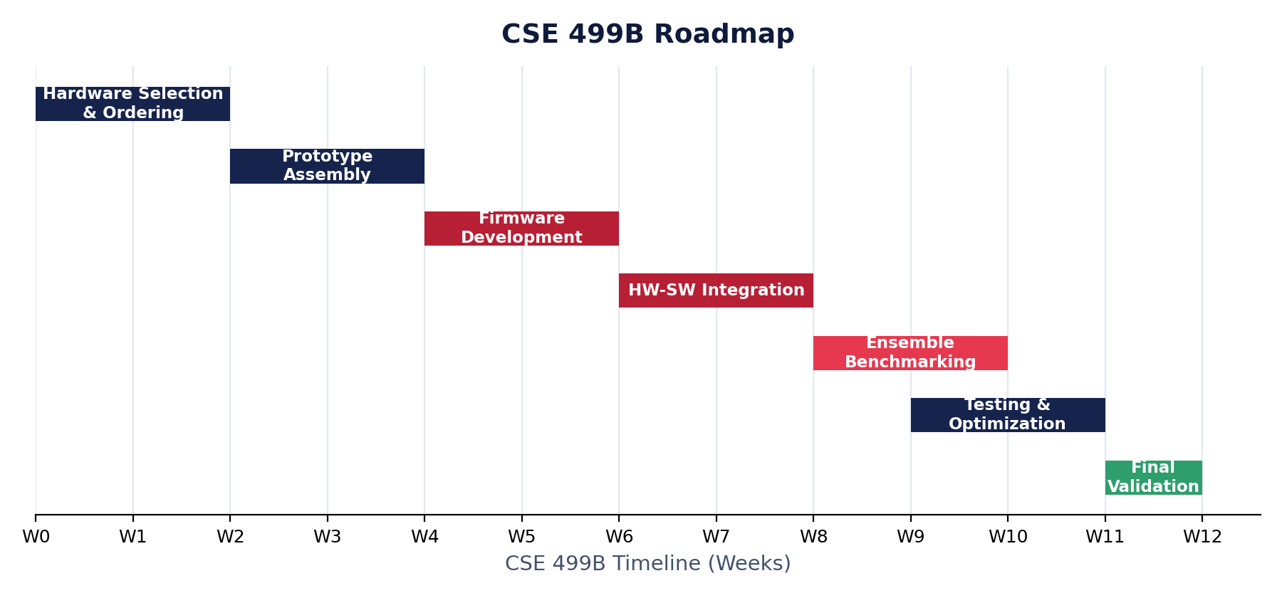
Figure 9. Proposed CSE 499B roadmap, sequencing hardware integration ahead of ensemble benchmarking and final clinical validation.
Week | Task | Deliverable
1–2 | Hardware selection and ordering | Bill of materials, circuit diagrams
3–4 | Prototype assembly | Working hardware prototype
5–6 | Firmware development | Synchronized multi-sensor data acquisition
7–8 | Hardware–software integration | End-to-end data flow, hardware to dashboard
9–11 | Ensemble benchmarking & testing | Static-vs-dynamic performance report
11–12 | Final clinical validation | Final report

6. References
[1] World Health Organization, “Cardiovascular diseases (CVDs),” WHO Fact Sheet, 2021.
[2] E. J. Benjamin et al., “Heart Disease and Stroke Statistics—2023 Update: A Report From the American Heart Association,” Circulation, vol. 147, no. 8, pp. e93–e621, 2023.
[3] American Heart Association, “Cardiovascular Disease Cost,” AHA, 2023.
[4] S. F. Weng, J. Reps, J. Kai, J. M. Garibaldi, and N. Qureshi, “Can machine-learning improve cardiovascular risk prediction using routine clinical data?,” PLOS ONE, vol. 12, no. 4, p. e0174944, 2017.
[5] A. M. Alaa et al., “Cardiovascular disease risk prediction using automated machine learning,” PLOS ONE, vol. 14, no. 7, p. e0217718, 2019.
[6] E. Choi et al., “Learning the Graphical Structure of Electronic Health Records with Graph Convolutional Transformer,” in Proc. AAAI Conf. Artificial Intelligence, 2020.
[7] R. Poplin et al., “Prediction of cardiovascular risk factors from retinal fundus photographs via deep learning,” Nature Biomedical Engineering, vol. 2, pp. 158–164, 2018.
[8] Z. I. Attia et al., “An artificial intelligence-enabled ECG algorithm for the identification of patients with atrial fibrillation during sinus rhythm,” The Lancet, vol. 394, no. 10201, pp. 861–867, 2019.
[9] A. Y. Hannun et al., “Cardiologist-level arrhythmia detection and classification in ambulatory electrocardiograms using a deep neural network,” Nature Medicine, vol. 25, pp. 65–69, 2019.
[10] C. Potes, S. Parvaneh, A. Rahman, and B. Conroy, “Ensemble of Feature-based and Deep learning-based Classifiers for Detection of Abnormal Heart Sounds,” in Proc. Computing in Cardiology Conf. (CinC), 2016.
[11] P. Wagner et al., “PTB-XL, a large publicly available electrocardiography dataset,” Scientific Data, vol. 7, no. 1, p. 154, 2020.
[12] C. Liu et al., “An open access database for the evaluation of heart sound algorithms,” Physiological Measurement, vol. 37, no. 12, p. 2181, 2016.
[13] M. A. F. Pimentel et al., “Toward a robust estimation of respiratory rate from pulse oximeters,” IEEE Trans. Biomedical Engineering, vol. 64, no. 8, pp. 1914–1923, 2017.
[14] A. D. Hoover, V. Kouznetsova, and M. Goldbaum, “Locating blood vessels in retinal images by piecewise threshold probing of a matched filter response,” IEEE Trans. Medical Imaging, vol. 19, no. 3, pp. 203–210, 2000.
[15] S. M. Lundberg and S.-I. Lee, “A unified approach to interpreting model predictions,” in Advances in Neural Information Processing Systems (NeurIPS), 2017, pp. 4765–4774.
[16] T. Chen and C. Guestrin, “XGBoost: A Scalable Tree Boosting System,” in Proc. 22nd ACM SIGKDD Int. Conf. Knowledge Discovery and Data Mining, 2016, pp. 785–794.
[17] A. Krizhevsky, I. Sutskever, and G. E. Hinton, “ImageNet classification with deep convolutional neural networks,” Communications of the ACM, vol. 60, no. 6, pp. 84–90, 2017.

Appendix A: Selected Code Listings

A.1 ECG CNN Model Definition
def build_ecg_model(input_shape):
inputs = tf.keras.Input(shape=input_shape)
x = Conv1D(64, kernel_size=7, padding='same')(inputs)
x = BatchNormalization()(x)
x = Activation('relu')(x)
x = MaxPooling1D(2)(x)
# ... additional Conv1D blocks (128, 256, 512 filters) ...
x = GlobalAveragePooling1D()(x)
x = Dense(256, activation='relu')(x)
x = Dropout(0.5)(x)
x = Dense(128, activation='relu')(x)
x = Dropout(0.3)(x)
outputs = Dense(1, activation='sigmoid')(x)
return tf.keras.Model(inputs, outputs)

A.2 Dynamic Confidence-Weighted Ensemble
def dynamic_ensemble_predict(ecg_prob, hs_prob, tab_prob):
"""Confidence-weighted fusion. Implemented for live inference;
formal accuracy/robustness benchmarking is a CSE 499B deliverable."""
ecg_conf = abs(ecg_prob - 0.5) * 2
hs_conf = abs(hs_prob - 0.5) * 2
tab_conf = abs(tab_prob - 0.5) * 2
total = ecg_conf + hs_conf + tab_conf + 1e-3
w_ecg, w_hs, w_tab = ecg_conf/total, hs_conf/total, tab_conf/total
fused_risk = w_ecg*ecg_prob + w_hs*hs_prob + w_tab*tab_prob
return fused_risk, w_ecg, w_hs, w_tab

A.3 FastAPI Prediction Endpoint (abridged)
@app.post("/predict")
def predict(data: ClinicalData):
features = prepare_features(data)
ecg_pred = ecg_model.predict(features["ecg"])
hs_pred = hs_model.predict(features["heart_sound"])
tab_pred = tabular_model.predict(features["tabular"])
fused, w_ecg, w_hs, w_tab = dynamic_ensemble_predict(ecg_pred, hs_pred, tab_pred)
return {
"fused_risk_score": fused * 100,
"ensemble_weights": {"ecg": w_ecg, "heart_sound": w_hs, "tabular": w_tab},
"ensemble_type": "dynamic_confidence_weighted",
}

