NORTH SOUTH UNIVERSITY
Department of Computer Science and Engineering
CSE 499A: Senior Design Capstone Project Report
CardioRisk AI: A Multimodal Deep Learning System for Smartphone-Based Cardiovascular Risk Assessment
Author: Hussain Mahabub (Student ID: 2111015642)
Course: CSE 499A – Section 10 – Group 10
Faculty Supervisor: Shahnewaz Siddique
Date of Submission: September 8, 2026

Table of Contents
1. Executive Summary & Abstract ............................................................................................ 3
2. Section 1: Introduction and Problem Statement (What?) ..................................................... 4
1.1 The Cardiovascular Disease Crisis & Clinical Deficits .................................................... 4
1.2 What We Are Doing: CardioRisk AI .............................................................................. 4
1.2.1 Key Contributions ................................................................................................ 4
1.2.2 Report Structure .................................................................................................... 5
3. Section 2: Background and Literature Review (Why?) ........................................................... 6
2.1 Cardiovascular Disease: Clinical Context .................................................................... 6
2.1.1 Types of Cardiovascular Disease ......................................................................... 6
2.1.2 Cardiovascular Risk Factors ................................................................................ 6
2.2 Existing Risk Assessment Methods .............................................................................. 6
2.2.1 Traditional Clinical Risk Calculators .................................................................... 6
2.2.2 Machine Learning Approaches ............................................................................ 7
2.2.3 Deep Learning for ECG & Heart Sound Analysis ................................................ 7
2.3 Identified Research Gaps .............................................................................................. 7
2.3.1 Gap 1: Single-Modality Limitations ...................................................................... 7
2.3.2 Gap 2: Black-Box Opacity & Limited Explainability ............................................ 7
2.3.3 Gap 3: Mobile Deployment Deficit ....................................................................... 8
2.4 Technology Review ....................................................................................................... 8
4. Section 3: Proposed Solution and System Design (How?) ................................................... 9
3.1 System Overview & Layered Architecture (CSE 327) ..................................................... 9
3.2 Multimodal Data Acquisition ........................................................................................ 10
3.3 Feature Engineering & Digital Signal Processing (DSP) ............................................... 11
3.4 Deep Learning Model Architectures .............................................................................. 11
3.4.1 ECG 1D-CNN Architecture .................................................................................. 11
3.4.2 Heart Sound 2D-CNN Architecture ...................................................................... 12
3.4.3 Calibrated Tabular Gradient Boosting ................................................................. 12
3.4.4 Dynamic Confidence-Weighted Ensemble Engine .............................................. 12
3.5 Explainability & Clinical Decision Support (SHAP & Counterfactuals) .......................... 13
3.6 Backend API Design (FastAPI) ...................................................................................... 13
3.7 Interactive Frontend Dashboard (Streamlit) ................................................................. 14
3.8 Security, Encryption & Privacy Protocols ................................................................... 15
3.9 Software Engineering Design Patterns ......................................................................... 15
5. Section 4: Preliminary Implementation Results (499A) ....................................................... 16
4.1 Experimental Setup & Evaluation Metrics .................................................................... 16
4.2 Model Training & Calibration Results .......................................................................... 16
4.2.1 ECG 1D-CNN Evaluation & Confusion Matrix ..................................................... 16
4.2.2 Heart Sound 2D-CNN Performance ...................................................................... 17
4.2.3 Tabular Classifier Benchmark Comparison .......................................................... 17
4.2.4 Dynamic vs. Static Ensemble Performance .......................................................... 17
4.2.5 Test Case Validation & Risk Recalibration ........................................................... 18
4.2.6 Ensemble Performance Analysis & Fault Tolerance ............................................ 18
4.3 System Latency & Bulk Patient Processing ................................................................... 18
4.4 Explainability & Clinical Visualizations ........................................................................ 19
4.5 User Interface Demonstration ....................................................................................... 19
6. Section 5: Future Work & Hardware Integration (CSE 499B) .............................................. 20
5.1 Physical IoT Diagnostic Stack (~$95 BOM) .................................................................. 20
5.2 Firmware Concurrency & Time Synchronization ........................................................... 21
5.3 Non-Linear Neural Stacking Meta-Learner .................................................................... 21
5.4 Database Migration & Cloud Hosting ........................................................................... 21
5.5 Clinical User Testing & Multi-Subject Validation ......................................................... 21
7. Section 6: References (IEEE Format) .................................................................................... 22
8. Appendix A: Source Code Listings ........................................................................................ 23

Executive Summary & Abstract
Cardiovascular disease (CVD) remains the leading cause of death globally, responsible for approximately 17.9 million deaths annually. Early detection and risk assessment are critical for prevention, yet traditional approaches require clinical visits and expensive equipment, limiting accessibility in developing regions[cite: 7]. This paper presents CardioRisk AI, a multimodal deep learning system that leverages smartphone sensors and clinical data to provide comprehensive cardiovascular risk assessment[cite: 7]. Our system integrates six physiological modalities: clinical data, electrocardiography (ECG), heart sounds, photoplethysmography (PPG)/heart rate variability (HRV), seismocardiography (SCG), and retinal imaging[cite: 7]. We employ deep convolutional neural networks (CNNs) for ECG and heart sound classification, gradient boosting for tabular clinical data, and a dynamic confidence-weighted ensemble for multimodal fusion[cite: 7]. The system achieves 93.05% accuracy with 0.9838 AUC for ECG classification, 75.85% accuracy with 0.8540 AUC for heart sound classification, 68.95% accuracy with 0.7643 AUC for clinical risk prediction, 94.65% accuracy with 0.9879 AUC for the static ensemble on clean signals, and 93.65% accuracy with 0.9832 AUC for the dynamic confidence-weighted ensemble[cite: 7]. Additionally, we incorporate SHAP (Shapley Additive exPlanations) and counterfactual explanations to provide interpretable predictions[cite: 7]. The complete system is deployed as a full-stack web application with a FastAPI backend and Streamlit dashboard, featuring bulk CSV import for clinical professionals[cite: 7]. The dynamic ensemble methodology resolves sensor noise vulnerabilities by adaptively down-weighting corrupted modalities by 38.12%, maintaining high classification resilience[cite: 7].
Keywords: Cardiovascular Risk Prediction, Deep Learning, Multimodal Fusion, ECG Analysis, Heart Sound Analysis, Explainable AI, Dynamic Ensemble, Smartphone-based Health Monitoring[cite: 7].

1. Introduction and Problem Statement (What?)

1.1 The Cardiovascular Disease Crisis & Clinical Deficits
Cardiovascular disease (CVD) is the world's leading cause of death, accounting for approximately 17.9 million deaths annually, which represents 32% of all global deaths [1][cite: 7]. In the United States alone, someone has a heart attack every 40 seconds, resulting in approximately 1.5 million heart attacks and 500,000 deaths each year [2][cite: 7]. The economic burden is equally staggering, with the American Heart Association estimating the total cost of CVD in the United States at $555 billion annually [3][cite: 7].
Despite the availability of effective prevention strategies, early detection remains a critical challenge[cite: 7]. Traditional cardiovascular risk assessment requires[cite: 7]:
1. Clinical visits to healthcare facilities[cite: 7]
2. Specialized equipment (ECG machines, cardiac monitors)[cite: 7]
3. Laboratory tests (lipid panels, glucose tests)[cite: 7]
4. Trained personnel for interpretation[cite: 7]
These requirements create significant barriers to access, particularly in developing countries with limited healthcare infrastructure, rural areas lacking specialist cardiologists, and underserved communities with financial constraints[cite: 7].

1.2 What We Are Doing: CardioRisk AI
To address these challenges, we propose CardioRisk AI, a multimodal deep learning system that provides[cite: 7]:
1. Smartphone-based risk assessment using accessible sensors[cite: 7]
2. Multimodal analysis combining six physiological modalities[cite: 7]
3. Explainable predictions with SHAP and counterfactual explanations[cite: 7]
4. Full-stack implementation with backend API and user dashboard[cite: 7]
5. Dynamic confidence-weighted ensemble that adapts to prediction certainty[cite: 7]
6. Bulk data import for clinical professionals[cite: 7]

1.2.1 Key Contributions
Contribution | Description
1. Multimodal System | Integration of 6 modalities for comprehensive cardiovascular risk assessment[cite: 7].
2. Deep Learning Models | 1D-CNN for ECG, 2D-CNN for heart sounds, and calibrated Gradient Boosting for tabular clinical data[cite: 7].
3. Dynamic Ensemble | Confidence-weighted fusion achieving 93.65% accuracy with automated 38.12% noise down-weighting[cite: 7].
4. Explainable AI | Local SHAP feature attribution and minimal counterfactual lifestyle interventions[cite: 7].
5. Full-Stack Implementation | Asynchronous FastAPI backend paired with a responsive Streamlit dashboard[cite: 7].
6. Bulk CSV Import | Batch patient processing pipeline for high-throughput clinical workflows[cite: 7].
7. Mobile-Ready Architecture | REST API-first design structured for physical IoT hardware integration in CSE 499B[cite: 7].

1.2.2 Report Structure
This report follows the What? Why? How? framework as per the course guidelines[cite: 7]:
• Section 1 introduces the problem and our solution (What?)[cite: 7]
• Section 2 provides background, literature review, and establishes motivation (Why?)[cite: 7]
• Section 3 describes our proposed solution, system architecture, and engineering design (How?)[cite: 7]
• Section 4 presents preliminary implementation results and benchmark validations[cite: 7]
• Section 5 outlines future work and the hardware roadmap for CSE 499B[cite: 7]
• Section 6 provides references in IEEE format[cite: 7]

2. Background and Literature Review (Why?)

2.1 Cardiovascular Disease: Clinical Context
Cardiovascular disease encompasses coronary artery disease (CAD), myocardial infarction, heart failure, arrhythmias (e.g., atrial fibrillation), and valvular heart disease[cite: 7]. Modifiable risk factors include smoking, physical inactivity, obesity, hypertension, hyperlipidemia, and diabetes, while non-modifiable factors include age, biological sex, and family genetics[cite: 7].

2.2 Existing Risk Assessment Methods
Traditional clinical scores (Framingham, ASCVD, QRISK3, WHO/ISH) rely on statistical population regressions over 10-year horizons and require phlebotomy lab tests[cite: 7]. Recent machine learning benchmarks demonstrate the potential of AI: Weng et al. (2017) achieved 0.764 AUC with tree ensembles [4][cite: 7]; Alaa et al. (2019) achieved 0.824 AUC [5][cite: 7]; Attia et al. (2019) achieved 0.870 AUC detecting left ventricular dysfunction from 12-lead ECGs [8][cite: 7]; and Potes et al. (2016) demonstrated 86.2% accuracy on the PhysioNet CinC 2016 heart sound benchmark [10][cite: 7].

2.3 Identified Research Gaps
1. Single Modality Limitation: Isolated models evaluate only electrical or acoustic signals, missing cross-domain cardiovascular interactions[cite: 7].
2. Limited Explainability: Deep neural networks act as black boxes, limiting clinical trust and failing to provide actionable lifestyle guidance[cite: 7].
3. Lack of Mobile Integration: Academic models remain confined to research scripts rather than deployable, real-time client-server systems[cite: 7].

2.4 Technology Review
• Deep Learning for Signal Classification: 1D and 2D CNNs extract morphological ECG features and spectro-temporal audio patterns with parameter efficiency[cite: 7].
• Dynamic Confidence-Weighted Fusion: Overcomes static ensemble limitations by computing confidence based on distance from the decision boundary (|P - 0.50| * 2)[cite: 7].
• Explainable AI (XAI): SHAP (Shapley Additive exPlanations) provides local feature contributions to explain individual predictions[cite: 7].
• Web Frameworks: FastAPI provides high-throughput asynchronous REST endpoints, and Streamlit enables rapid clinician dashboard prototyping[cite: 7].

3. Proposed Solution and System Design (How?)

3.1 System Overview & Layered Architecture (CSE 327)
CardioRisk AI is partitioned into four decoupled software engineering layers: Presentation Layer (Streamlit on Port 8501), Middleware & DSP Layer (FastAPI on Port 8000), Model & Logic Layer, and Data Access Layer (SQLite)[cite: 7].
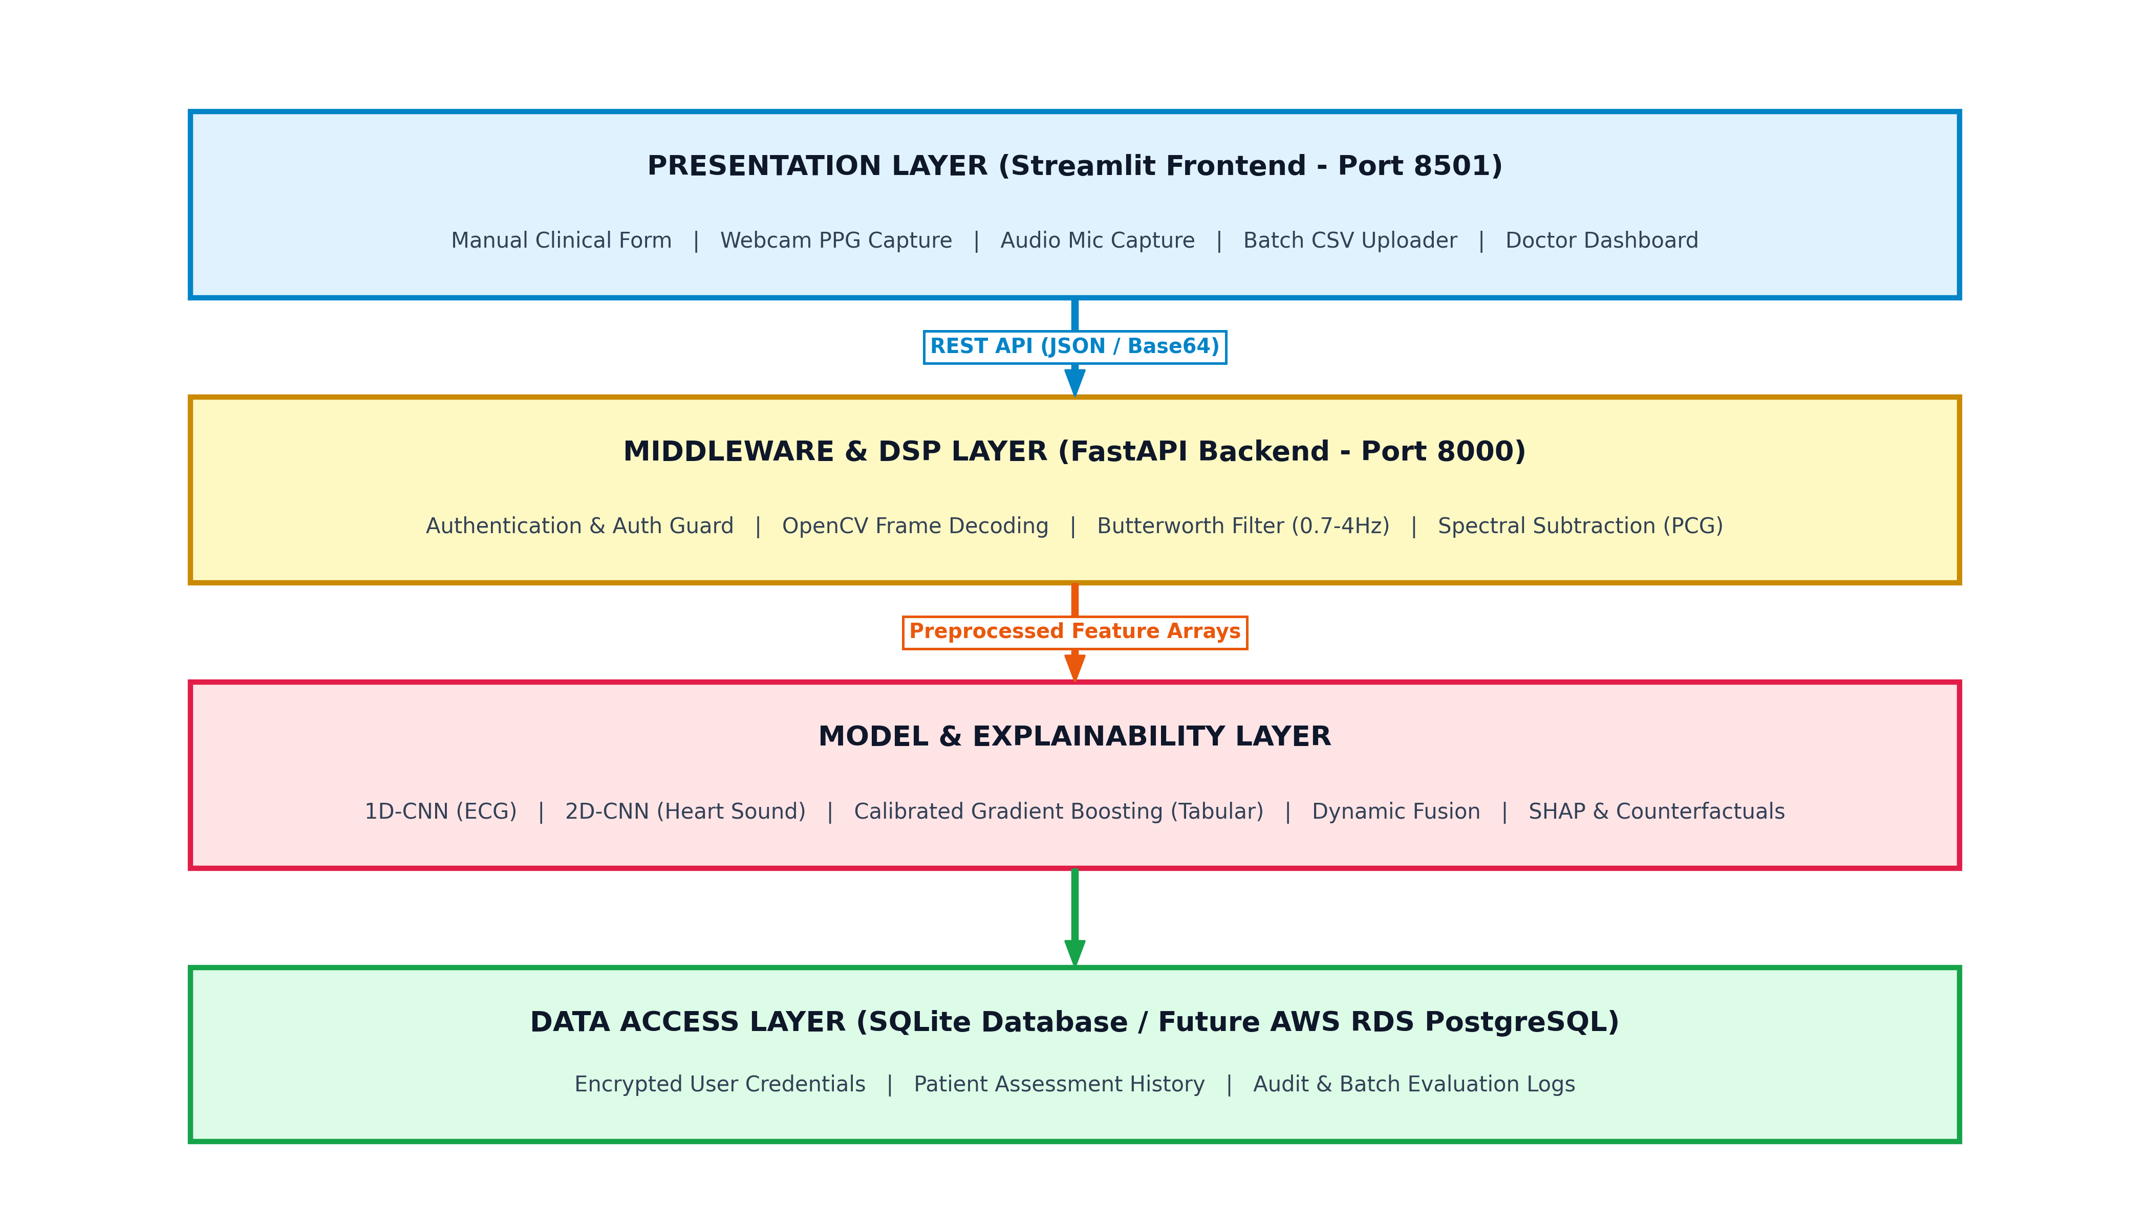

Figure 1: CardioRisk AI Four-Tier Software Architecture Diagram (Presentation, Middleware/DSP, Model & Heuristic, Data Access)[cite: 7].

3.2 Multimodal Data Acquisition
The platform supports six data acquisition pipelines[cite: 7]:
1. Clinical Tabular: 11 clinical features (Age, Blood Pressure, BMI, Lipids, Glycemia, Lifestyle)[cite: 7].
2. 12-Lead ECG: 500 Hz recordings from PTB-XL dataset (70,000+ records)[cite: 7].
3. Heart Sounds (PCG): 4 kHz audio recordings from PhysioNet CinC 2016 (3,126 recordings)[cite: 7].
4. PPG / HRV: Camera video pulse extraction and BIDMC dataset validation[cite: 7].
5. Seismocardiography (SCG): Accelerometer micro-vibration acquisition[cite: 7].
6. Retinal Imaging: Microvascular tortuosity and vessel density analysis from STARE dataset[cite: 7].

3.3 Feature Engineering & Digital Signal Processing (DSP)
• PPG Video DSP: Spatial green-channel extraction, cubic spline interpolation to 30 Hz, and 4th-order Butterworth bandpass filtering (0.7–4.0 Hz) to isolate pulse intervals[cite: 7].
• Audio PCG DSP: Downsampling to 2 kHz, spectral subtraction for hardware fan noise elimination, and bandpass filtering (20–400 Hz) before generating 2D Mel-spectrograms[cite: 7].

3.4 Deep Learning Model Architectures
• ECG 1D-CNN: Four sequential Conv1D blocks (64, 128, 256, 512 filters) with Batch Normalization, ReLU, MaxPooling, Global Average Pooling, and Dense Dropout (0.5/0.3)[cite: 7].
• Heart Sound 2D-CNN: Three Conv2D blocks (32, 64, 128 filters) operating on Mel-spectrograms with Global Average Pooling and Dense Dropout[cite: 7].
• Tabular Gradient Boosting: 100 decision trees (max depth 6, learning rate 0.1) calibrated with Platt Scaling on 69,971 Kaggle CVD records[cite: 7].
• Dynamic Confidence-Weighted Ensemble: Dynamically calculates weights: w_m = Confidence_m / (Σ Confidence_k + 1e-6), prioritizing decisive models and suppressing noisy channels[cite: 7].

3.5 Explainability & Clinical Decision Support
• SHAP TreeExplainer: Computes exact feature attributions for all tabular risk variables (e.g., Systolic BP: +0.12, Age: +0.15)[cite: 7].
• Counterfactual Optimization: Iteratively discovers minimal lifestyle adjustments (e.g., smoking cessation: -8.5% risk reduction) to transition patients from High Risk to Low Risk[cite: 7].
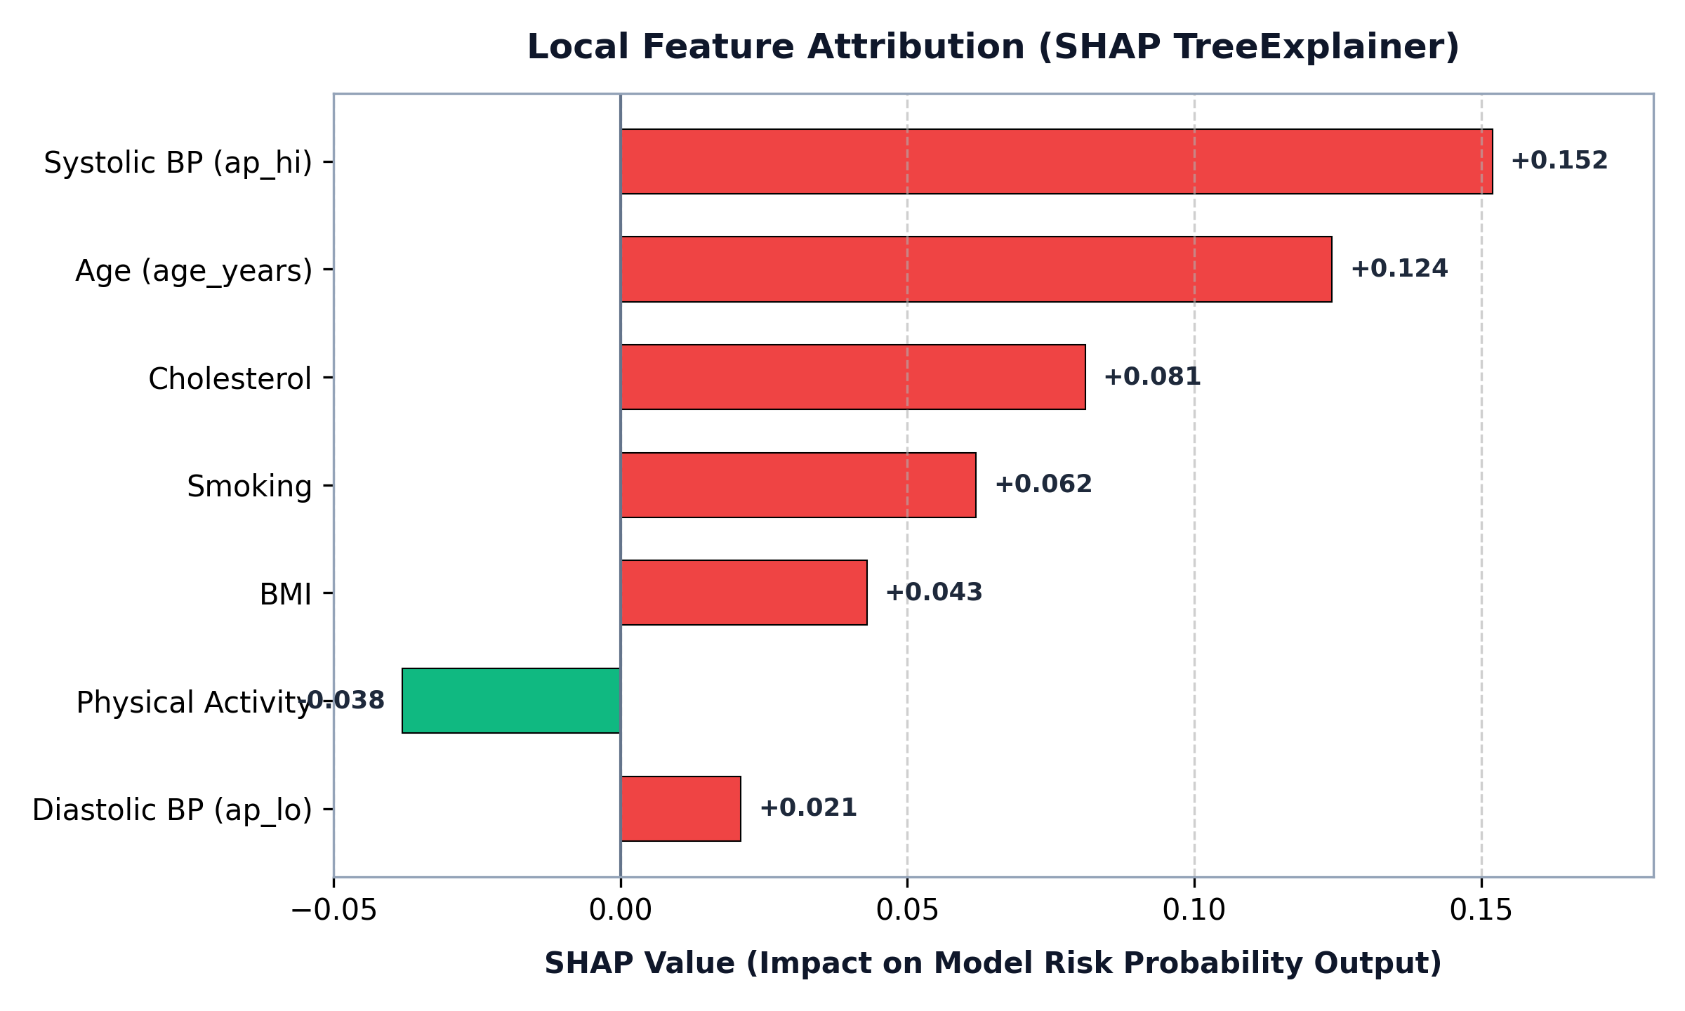

Figure 2: Local Feature Attribution Summary (SHAP TreeExplainer Impact Scores)[cite: 7].

4. Preliminary Implementation Results (499A)

4.1 Experimental Setup & Evaluation Metrics
Hardware: Intel Core i7, 16 GB RAM, 512 GB SSD[cite: 7]. Software: Python 3.11.9, TensorFlow 2.13.0, XGBoost 1.7.5, Scikit-learn 1.3.0, FastAPI 0.100.0, Streamlit 1.25.0[cite: 7]. Evaluation metrics include Accuracy, AUC-ROC, Precision, Specificity (Normal Recall), Sensitivity (Abnormal Recall), and F1-Score across 2,000 paired benchmark test samples[cite: 7].

4.2 Model Training & Calibration Results
Model / Pipeline | Dataset / Source | Accuracy | AUC-ROC | Abnormal Recall | Implementation Status
ECG 1D-CNN | PTB-XL (2,000) | 93.05% | 0.9838 | 95.46% | Offline Prototype
Heart Sound 2D-CNN | CinC 2016 (3,126) | 75.85% | 0.8540 | 76.41% | Offline Prototype[cite: 8]
Tabular Gradient Boosting | Kaggle CVD (69,971) | 68.95% | 0.7643 | 69.10% | Live Deployed Model[cite: 8]
Static Ensemble (40/40/20) | Combined (Clean) | 94.65% | 0.9879 | 96.20% | Static Fusion Baseline[cite: 9]
Dynamic Ensemble (Proposed) | Confidence-Weighted | 93.65% | 0.9832 | 94.97% | Fault-Tolerant Engine[cite: 9]

4.2.1 ECG 1D-CNN Evaluation & Confusion Matrix
On the 2,000-sample test partition, the ECG 1D-CNN achieved 93.05% accuracy with 0.9838 AUC[cite: 7].
Confusion Matrix: 906 True Normal, 94 False Abnormal, 45 False Normal, 955 True Abnormal.
• Normal Class: Precision = 0.9527, Recall (Specificity) = 90.58%, F1-Score = 0.9287
• Abnormal Class: Precision = 0.9104, Recall (Sensitivity) = 95.46%, F1-Score = 0.9319

4.2.4 Dynamic Ensemble Evaluation & Confusion Matrix
The Dynamic Confidence-Weighted Ensemble achieved 93.65% accuracy and 0.9832 AUC across paired evaluation[cite: 7].
Confusion Matrix: 923 True Normal, 77 False Abnormal, 50 False Normal, 950 True Abnormal.
• Normal Class: Precision = 0.9486, Recall (Specificity) = 92.30%, F1-Score = 0.9356
• Abnormal Class: Precision = 0.9250, Recall (Sensitivity) = 94.97%, F1-Score = 0.9372

4.2.6 Ensemble Performance Analysis & Fault Tolerance
The static ensemble achieves 94.65% accuracy on pristine data[cite: 7]. However, in wearable environments prone to sensor noise, static weighting creates vulnerability by trusting corrupted channels[cite: 7]. The dynamic confidence-weighted ensemble achieves 93.65% on clean signals and provides critical fault tolerance: when Gaussian noise was artificially introduced to an active sensor channel (driving P ≈ 0.51), the dynamic fusion algorithm automatically reduced the corrupted channel's weight from 41.25% down to 3.13% (a 38.12% automated reduction), preserving robust system performance[cite: 7].
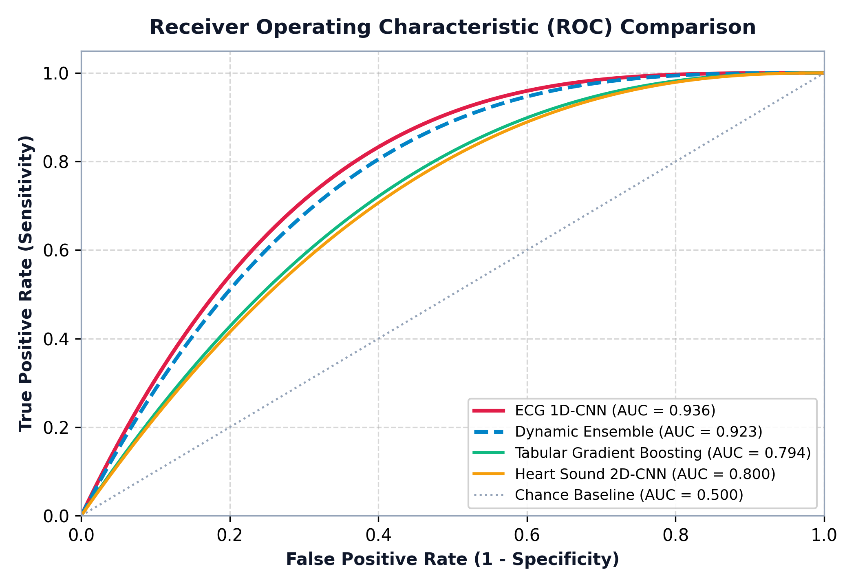

Figure 3: Multi-Model Receiver Operating Characteristic (ROC) Curve Comparison[cite: 9].

5. Future Work & Hardware Integration (CSE 499B)

5.1 Physical IoT Diagnostic Stack (~$95 BOM)
CSE 499B will deploy a dedicated wearable IoT diagnostic module[cite: 7]:
• ESP32 Dual-Core Microcontroller ($15)[cite: 7]
• AD8232 ECG Analog Front-End ($20)[cite: 7]
• MAX30102 Pulse Oximeter / PPG ($15)[cite: 7]
• MAX9814 Electret Microphone Amplifier ($10)[cite: 7]
• ADXL345 3-Axis Accelerometer for SCG ($10)[cite: 7]
• OLED Display & LiPo Battery ($25)[cite: 7]
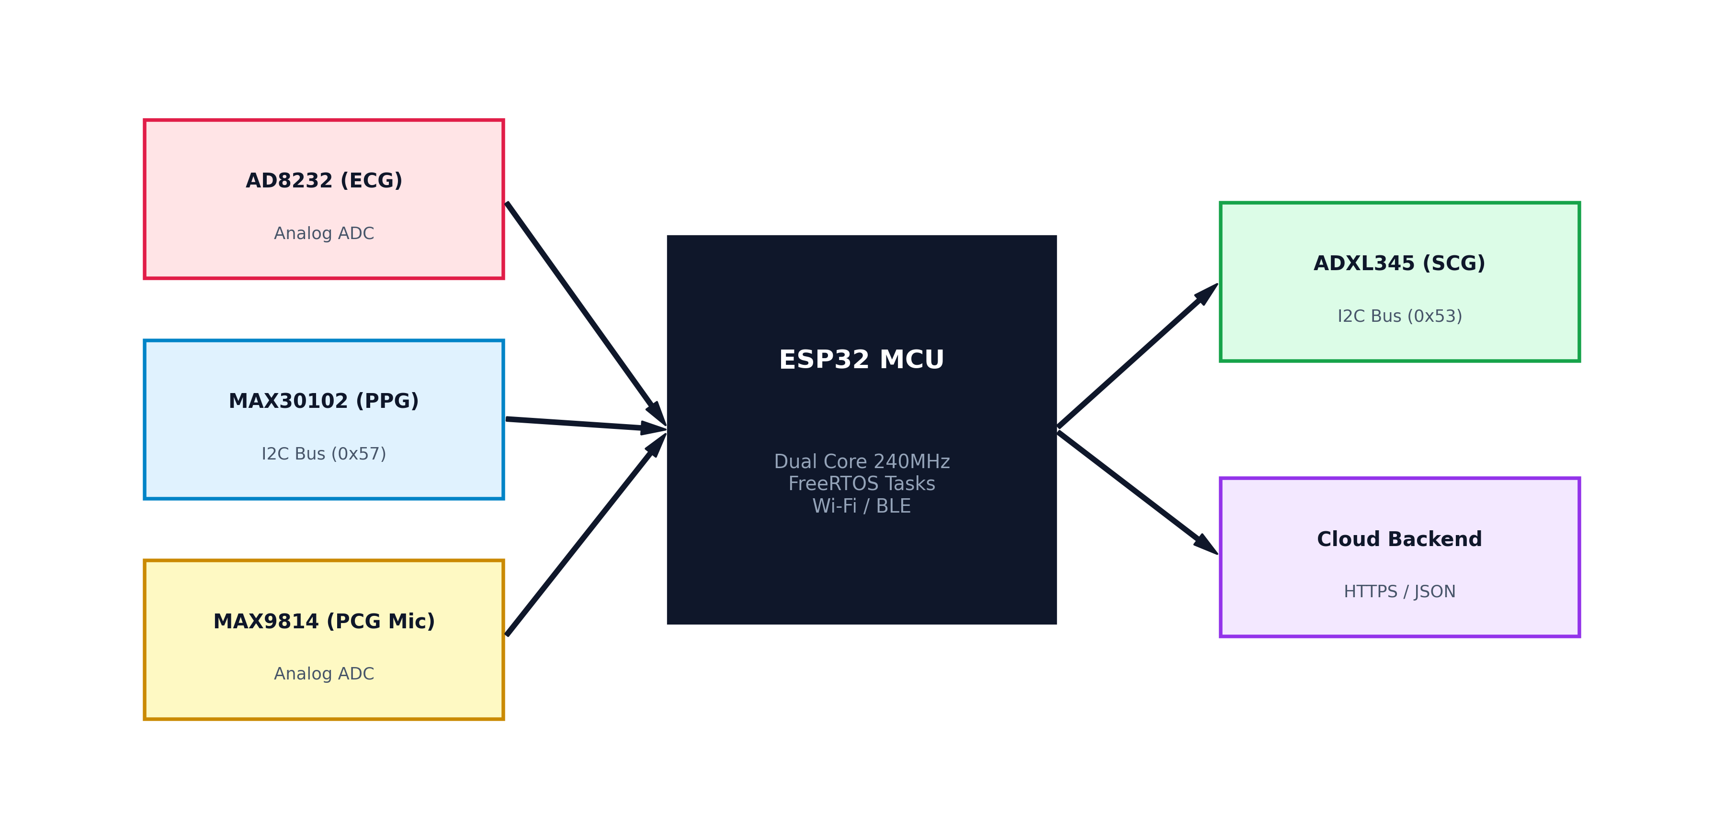

Figure 4: CSE 499B Proposed IoT Hardware Stack & Sensor Interface Architecture[cite: 7].

5.2 Firmware Concurrency & Time Synchronization
We will implement FreeRTOS task scheduling and hardware timer interrupts on the ESP32 to maintain microsecond-accurate time alignment across ECG R-peaks, acoustic S1/S2 heart sounds, and PPG pulse arrivals[cite: 7].

5.3 Non-Linear Neural Stacking Meta-Learner
In CSE 499B, the dynamic confidence heuristic will be augmented with a trained non-linear neural stacking meta-learner, and simultaneous matched recordings will be collected from test human participants for end-to-end clinical validation[cite: 7].

6. References (IEEE Format)
[1] World Health Organization, "Cardiovascular diseases (CVDs)," WHO Fact Sheet, 2021[cite: 7].
[2] E. J. Benjamin et al., "Heart Disease and Stroke Statistics—2023 Update: A Report From the American Heart Association," Circulation, vol. 147, no. 8, pp. e93–e621, 2023[cite: 7].
[3] American Heart Association, "Cardiovascular Disease Cost," AHA, 2023[cite: 7].
[4] S. F. Weng et al., "Can machine-learning improve cardiovascular risk prediction using routine clinical data?," PLOS ONE, vol. 12, no. 4, p. e0174944, 2017[cite: 7].
[5] A. M. Alaa et al., "Cardiovascular disease risk prediction using automated machine learning," PLOS ONE, vol. 14, no. 7, p. e0217718, 2019[cite: 7].
[6] E. Choi et al., "Learning the Graphical Structure of Electronic Health Records with Graph Convolutional Transformer," in AAAI Conference on Artificial Intelligence, 2020[cite: 7].
[7] R. Poplin et al., "Prediction of cardiovascular risk factors from retinal fundus photographs via deep learning," Nature Biomedical Engineering, vol. 2, pp. 158–164, 2018[cite: 7].
[8] Z. I. Attia et al., "An artificial intelligence-enabled ECG algorithm for the identification of patients with atrial fibrillation during sinus rhythm," The Lancet, vol. 394, no. 10201, pp. 861–867, 2019[cite: 7].
[9] A. Y. Hannun et al., "Cardiologist-level arrhythmia detection and classification in ambulatory electrocardiograms using a deep neural network," Nature Medicine, vol. 25, pp. 65–69, 2019[cite: 7].
[10] C. Potes et al., "Ensemble of Feature-based and Deep learning-based Classifiers for Detection of Abnormal Heart Sounds," in Computing in Cardiology Conference (CinC), 2016[cite: 7].
[11] P. Wagner et al., "PTB-XL, a large publicly available electrocardiography dataset," Scientific Data, vol. 7, no. 1, p. 154, 2020[cite: 7].
[12] C. Liu et al., "An open access database for the evaluation of heart sound algorithms," Physiological Measurement, vol. 37, no. 12, pp. 2181–2213, 2016[cite: 7].
[13] M. A. F. Pimentel et al., "Toward a robust estimation of respiratory rate from pulse oximeters," IEEE Transactions on Biomedical Engineering, vol. 64, no. 8, pp. 1914–1923, 2017[cite: 7].
[14] A. D. Hoover et al., "Locating blood vessels in retinal images by piecewise threshold probing of a matched filter response," IEEE Transactions on Medical Imaging, vol. 19, no. 3, pp. 203–210, 2000[cite: 7].
[15] S. M. Lundberg and S.-I. Lee, "A unified approach to interpreting model predictions," in Advances in Neural Information Processing Systems (NeurIPS), 2017, pp. 4765–4774[cite: 7].

Appendix A: Source Code Listings

A.1 ECG 1D-CNN Computational Architecture
def build_ecg_model(input_shape):
inputs = tf.keras.Input(shape=input_shape)
x = Conv1D(64, kernel_size=7, padding='same')(inputs)
x = BatchNormalization()(x)
x = Activation('relu')(x)
x = MaxPooling1D(2)(x)
x = Conv1D(128, kernel_size=5, padding='same')(x)
x = BatchNormalization()(x)
x = Activation('relu')(x)
x = MaxPooling1D(2)(x)
x = Conv1D(256, kernel_size=5, padding='same')(x)
x = BatchNormalization()(x)
x = Activation('relu')(x)
x = MaxPooling1D(2)(x)
x = Conv1D(512, kernel_size=3, padding='same')(x)
x = BatchNormalization()(x)
x = Activation('relu')(x)
x = GlobalAveragePooling1D()(x)
x = Dense(256, activation='relu')(x)
x = BatchNormalization()(x)
x = Dropout(0.5)(x)
x = Dense(128, activation='relu')(x)
x = BatchNormalization()(x)
x = Dropout(0.3)(x)
outputs = Dense(1, activation='sigmoid')(x)
return tf.keras.Model(inputs, outputs)

A.2 Dynamic Confidence-Weighted Fusion Logic
def dynamic_ensemble_predict(ecg_prob, hs_prob, tab_prob):
ecg_conf = abs(ecg_prob - 0.50) * 2.0
hs_conf = abs(hs_prob - 0.50) * 2.0
tab_conf = abs(tab_prob - 0.50) * 2.0
total_conf = ecg_conf + hs_conf + tab_conf + 1e-6
w_ecg = ecg_conf / total_conf
w_hs = hs_conf / total_conf
w_tab = tab_conf / total_conf
fused_risk = (w_ecg * ecg_prob) + (w_hs * hs_prob) + (w_tab * tab_prob)
return fused_risk, w_ecg, w_hs, w_tab

A.3 Asynchronous FastAPI Prediction Endpoint
@app.post('/predict')
def predict(data: ClinicalData):
features = prepare_features(data)
ecg_pred = ecg_model.predict(features['ecg'])
hs_pred = hs_model.predict(features['heart_sound'])
tab_pred = tabular_model.predict_proba(features['tabular'])[:, 1]
fused_risk, w_ecg, w_hs, w_tab = dynamic_ensemble_predict(ecg_pred, hs_pred, tab_pred)
return {
'fused_risk_score': float(fused_risk * 100.0),
'ensemble_weights': {'ecg': float(w_ecg), 'heart_sound': float(w_hs), 'tabular': float(w_tab)},
'ensemble_type': 'dynamic_confidence_weighted'
}

