Session Zero (Group 5)

## **Project Team Members**

1. **Summary /Conclusion Writer & Overall Editor**: Alex Sharpe
2. **Market Researcher**: Joel Wallingford
3. **Product Designer**: Autumn Seidlitz
4. **Devil’s Advocate/Critic/”Jack of all Trades”**: Abby Wiley, Philip Thomas

# **1. Executive Summary (Overview)**

Session Zero is for D&D character creation and finding campaigns. The app begins with you setting up a profile where you can create a character and a description of your play style. Afterwards, you can find a campaign that fits you. Firstly, characters. You start by pressing the “create new character” button. This would take you to a digital blank template where you can fill out your character’s information in textboxes or dropboxes. Each section that you fill out has a help button to explain its purpose. This help button will explain the section of the template you are filling out and the options. There will also be sources linked if you wish to use them. You can save your work when you finish, and you have the option to print out the template for physical use. After you make your character, it is time for campaign selection. DMs can post their campaigns and details in the campaign tab. From there players can search for a campaign and look at the descriptions to find one that fits them the best. You can also share your digital character sheets with the DM to aid in communication. Session zero is the ultimate streamlined app for campaign organization and setup.

# **2. Market Research and Need Justification**

Despite how big and popular D&D is, a lot of people have trouble finding groups of people to play with. There are countless forums on sites like [Roll20](https://app.roll20.net/forum/post/2825364/why-is-it-so-hard-to-find-a-group-for-dungeons-and-dragons), [StartPlaying](https://startplaying.games/blog/posts/why-is-it-so-hard-to-find-a-group-for-d-d), [Reddit](https://www.reddit.com/r/DnD/comments/nizuva/why_is_finding_a_group_so_hard/), [Quora](https://www.quora.com/What-do-I-do-if-I-have-a-hard-time-finding-any-DnD-groups-to-join-online), and many more, that discuss the difficulty of finding and staying in a campaign group.

While some websites do exist that try to remedy this, namely StartPlaying.games, that website is aimed at more experienced players, with most games having a fee for every session because the games are hosted and run by professional game masters.

Other sources also exist, such as ["Dnd Group Finder America"](https://www.facebook.com/groups/2590370451002251/) on FaceBook and the [DnD Discord](https://discord.gg/dnd), but these systems have their flaws that can make it harder for people to find the right groups, mainly in that they don’t have a way to sort groups, both by type of campaign (think horror, fantasy, sci-fi, etc.) or by the times the game master is available.

The website [Roll20](https://app.roll20.net/lfg/search/) does have a “looking for group” (LFG) feature that lets you search by time availability, but it is geared more towards a broader audience of all tabletop games, not just Dungeons and Dragons, and its search functions are limited when looking for a type of campaign to join, with the main functions being a title search, type of game (role playing, cards, etc.) and if the campaign is 18+ or not.

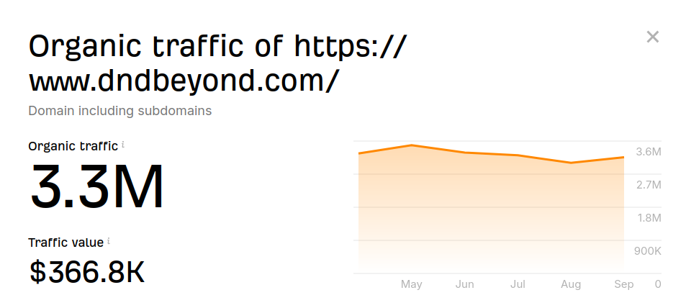

The above figure shows the traffic of dndbeyond, a popular D&D website.

# **3. Product Description**

App Creation:

* Platform
  + Unity application with different builds for different platforms, primarily developed for web browser
  + Written in C#
* Frontend:
  + Interface
    - App will be simple and easy to use, with clear and intuitive navigation
      * Large “Create Character” and “Find Campaign” buttons
  + Profile
    - Basic information about the user
      * Name, Pronouns, interests
    - Available times to play
      * Tuesdays, evenings, ect…
  + Character creation
    - Users will be able to create their character on the app listing their class, level, items, and personality
    - To help newer players, a survey will be available to help players make their first character
    - Survey
      * Users will take a survey with multiple sections to assess their character’s traits
      * At the end of the survey they are shown suggestions on what class, spells, and weapons best fits them
      * Users will be able to save their characters to their profile
  + Finding a campaign
    - Dungeon Masters
      * Dungeon Masters will be able to list their campaign and describe it
        + Campaigns will have tags like “High fantasy”, “One shot”, “Role-play focused”, ect… describing their campaigns for potential players.

Tags can include things like genre, meeting times, number of sessions, and party size

* + - Players
      * Players will use their characters created on the app to join a campaign that matches their interests
* Backend
  + Database handling
    - For ease of access, information about campaign, classes, spells and weapons will be in a TOML or JSON file
    - Taging
      * User profile things, character options, campaigns will have a list of tags assigned to them
      * These tags will be matched to show users what campaigns align with their characters
      * Survey Integration
        + Users will be assigned tags based on the results of the survey
        + At the end of the survey, Campaigns will be filtered based on what tags they share with the user and the ones with the most shared tags will appear at the top of the list
  + Monetization
    - Advertisements
      * Advertisements will be focused on DnD related products and, due to having such a target user base, we will be able to sell ad slots for more than the market rate
    - DMs can pay to advertise their campaigns
      * These campaigns will be more likely to show up at the top of people’s searches for campaigns
      * DMs can also make a traditional banner ad for their campaign

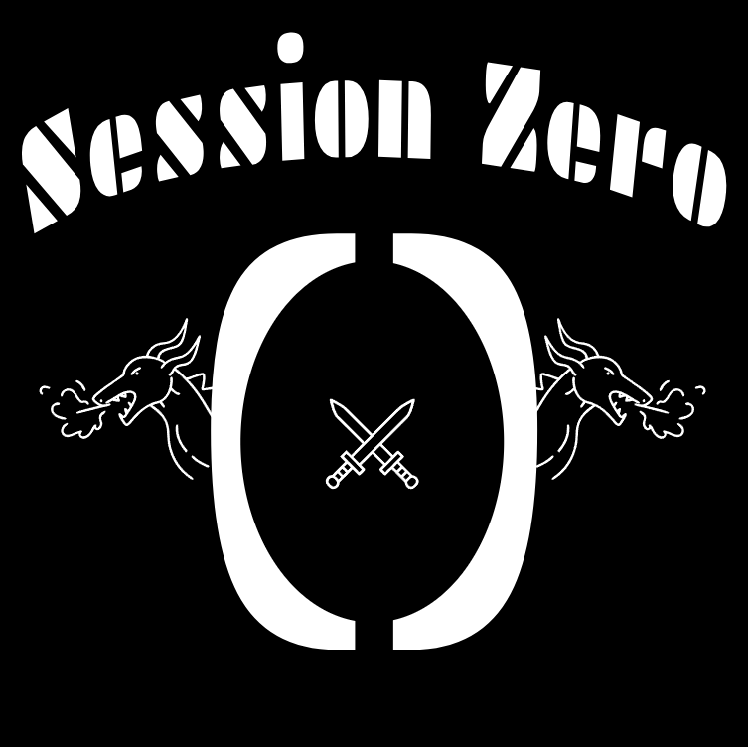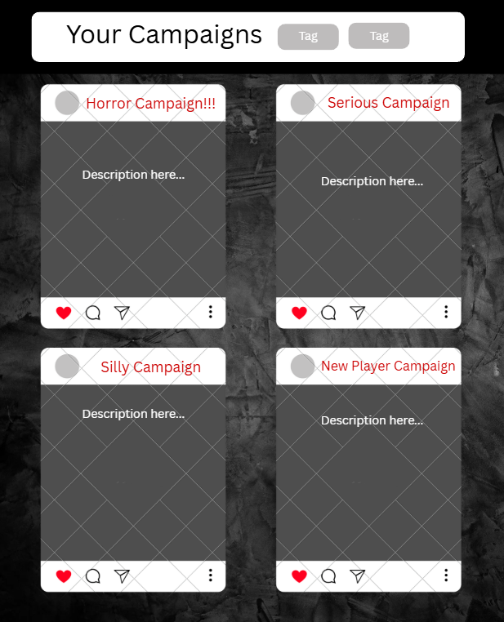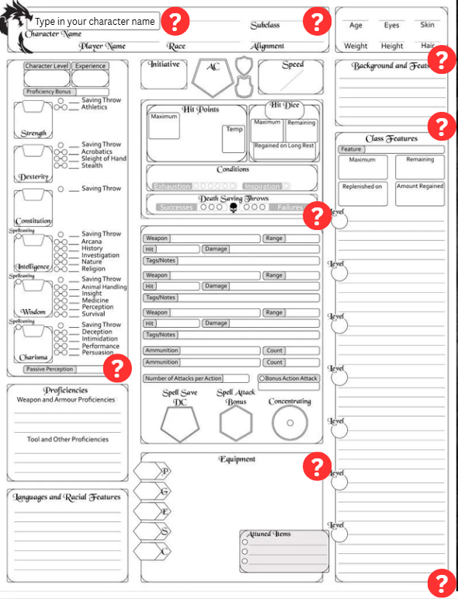

# **4. Possible Issues and Counterarguments**

There is an existing website called “startplaying.games” that provides a similar service, but it differs in how it sets players up with a professional Dungeon Master, often for a fee, instead of connecting players with a more casual DM.

Another possible competitor is the various D&D Discord servers, however, these servers are more often than not geared towards people who already understand D&D. They also still have a level of obscurity that prevents people from finding them and connecting for campaigns.

Possible Development Issues

* We could run into issues with Wizards Of The Coast pertaining to the content we make available to players and DMs using the app as a great deal of D&D’s official content is locked behind purchasing sourcebooks beyond the free basic rules.
  + To solve this, we could offer only what is available for free via D&D’s basic rules and later seek to partner with Wizards Of The Coast so we can implement the option to buy digital sourcebooks through the app
* Roll20, while primarily a website, does have an app on the appstore. However, it is highly unpopular and is only rated at 1.8 stars.

# **5. Conclusion and Recommendations**

This app confronts the broadest issue faced by the D&D community: Starting. There is often so much ambiguity that goes into starting a campaign on all fronts. Players setting up their characters, aligning times for meet ups and the tone of the campaign, and providing all these details in an easy and organised manner. This app clears that ambiguity, and hopefully it could help even you. If you have ever been even slightly interested in D&D this app is a great place to start. So, start making that character you had in the back of your mind and stop making excuses that you can not find people to play with. Session Zero is just your beginning.

# **6. Appendix**

Gerasimenko, D. (2010, July). *Website traffic checker: Estimate any site’s traffic*. Ahrefs. https://ahrefs.com/traffic-checker/?input=https%3A%2F%2Fwww.dndbeyond.com%2F&mode=subdomains

*Looking for group -- find a new group to play with online | ROLL20: Online virtual tabletop*. Roll20. (2012). https://app.roll20.net/lfg/search/

McDonald, J. (2020). *What do I do if I have a hard time finding any DND groups to join online?*. Quora. https://www.quora.com/What-do-I-do-if-I-have-a-hard-time-finding-any-DnD-groups-to-join-online

moons. (2016, January 13). *Virtual tabletop for playing D&D, Pathfinder, call of cthulhu, ttrpgs*. Roll20. https://app.roll20.net/forum/post/2825364/why-is-it-so-hard-to-find-a-group-for-dungeons-and-dragons

TheGrimblade1. (2021). *R/DND on reddit: Why is finding a group so hard?*. Reddit. https://www.reddit.com/r/DnD/comments/nizuva/why_is_finding_a_group_so_hard/

Tizzy. (2025, April 8). *Why is it so hard to find a group for D&D?*. StartPlaying. https://startplaying.games/blog/posts/why-is-it-so-hard-to-find-a-group-for-d-d