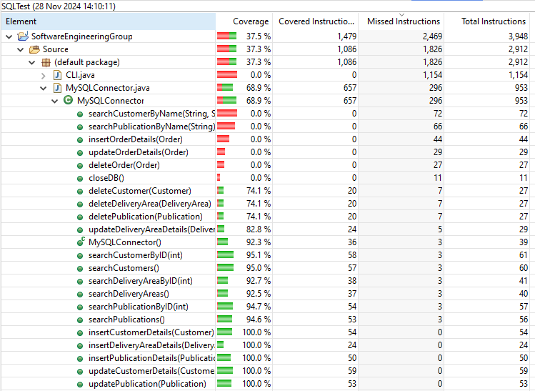

*SQLConnector Test Coverage Results*

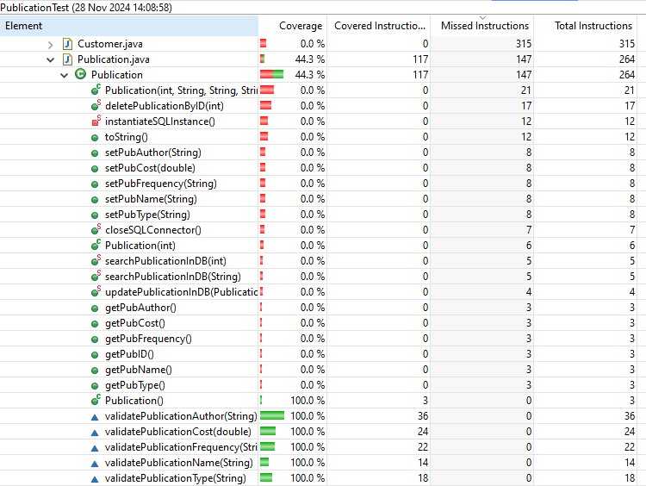

*Publication Test Coverage Results*

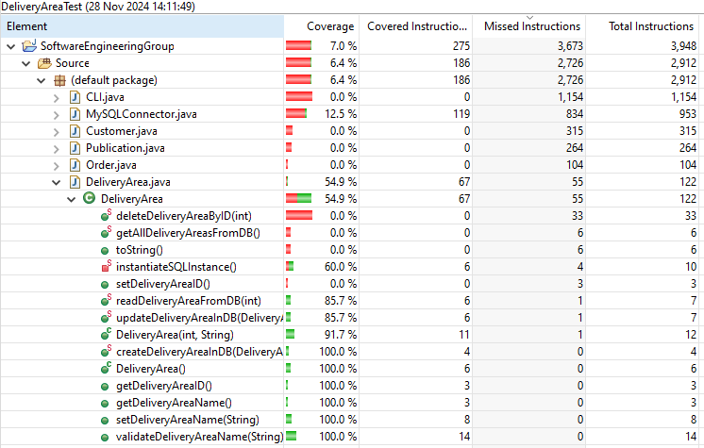

*Delivery Area Test Coverage Results*

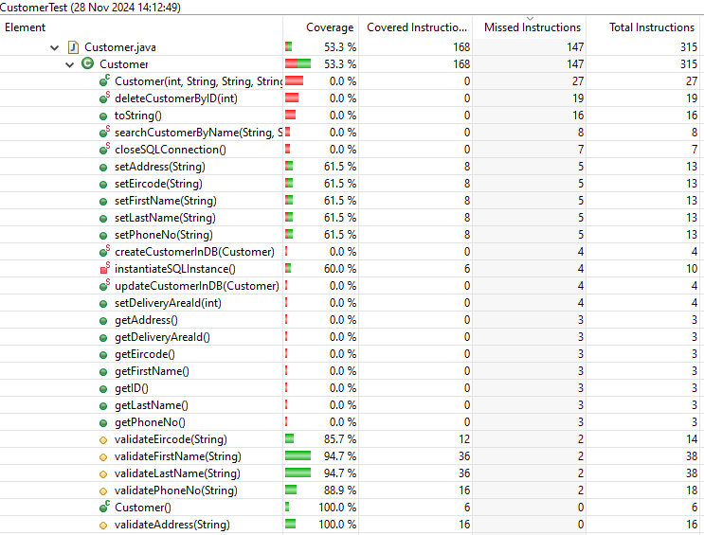

*Customer Test Coverage Results*