TP1 report

1. The description of data and my B Plus Tree

Source: <https://www.kaggle.com/lava18/google-play-store-apps>

Data: the data I used is a google play store data. This file contains all the details of the applications on Google Play. There are 13 features that describe a given app. I choose the first 20 tuples and four attributes “size”, ”price”, ”rating” and “reviews” as my attributes of the table.

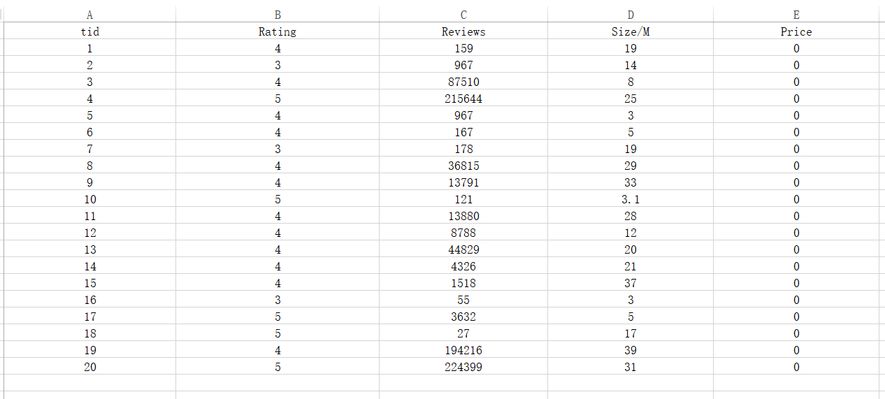

I choose “Rating” as the key for my B PLUS Tree

Using the web: <https://www.cs.usfca.edu/~galles/visualization/BPlusTree.html> we can visualization the b+ tree clearly. The right order of my b+ tree is below

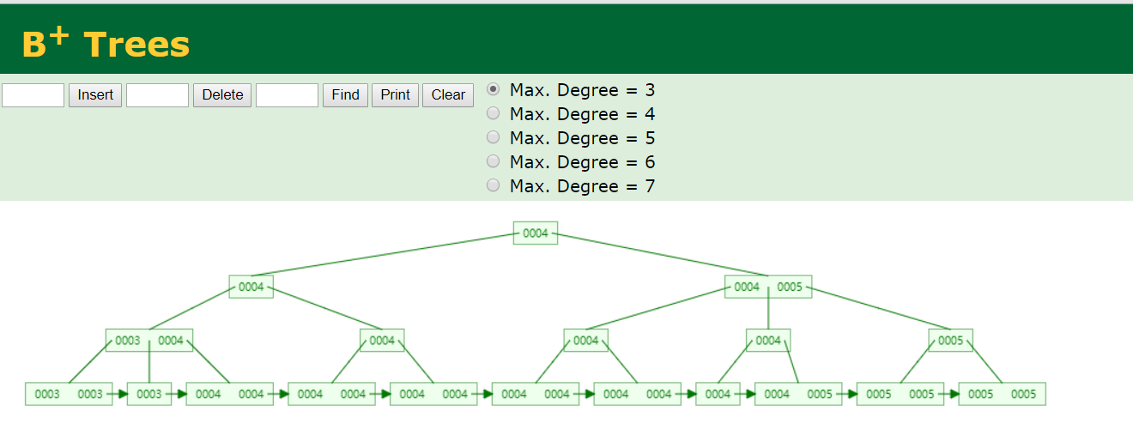

2.Instructions of my program

There is 7 operations required in the project pdf so we execute them one by one. And just press the run button in the pycharm to run the program. Must put csv file which is in the zip at the same catalogue as python file.

We can get the image below after running the program

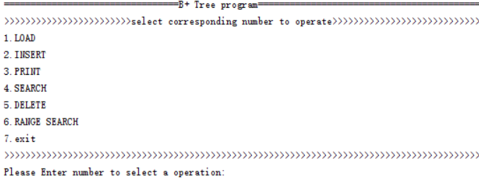

1.load : just enter 1 and enter the start tuple id 1 and end tuple id 20

Then it will notice that successful if loading completed.

2.insert: enter 2 to insert and it will insert the tuple you automatically(I tried but didn’t realize insert according to tuple id (O ^ ~ ^ O)) and return a successful message

3. print: input 3 and you can see the whole b plus tree by three heights.

The tuple printed has the form (key(rating),(tid,reviews,size,price)) and according the property of B Plus tree, in the height that is not 2, it will just store the key while in the leaf layer it will store the key and the values.

4.search: enter 4 and because this is just search the item with the same key so for example if you want to search the app with rating score 4, then enter the low score as 4 and enter the high rating score as 4 either. Then you will get all the tuples with rating 4.

5.delete: input 5 and input the tuple id that you want to delete but the id must between 1 and 20.

6.range search: enter 6 and enter low score as 3 and high as 5 then you can get the app tuples who has the rating between 4 and 5.

7.exit just enter 7