**ECE - 657A Homework 1**

**Tongdan Su 20754736**

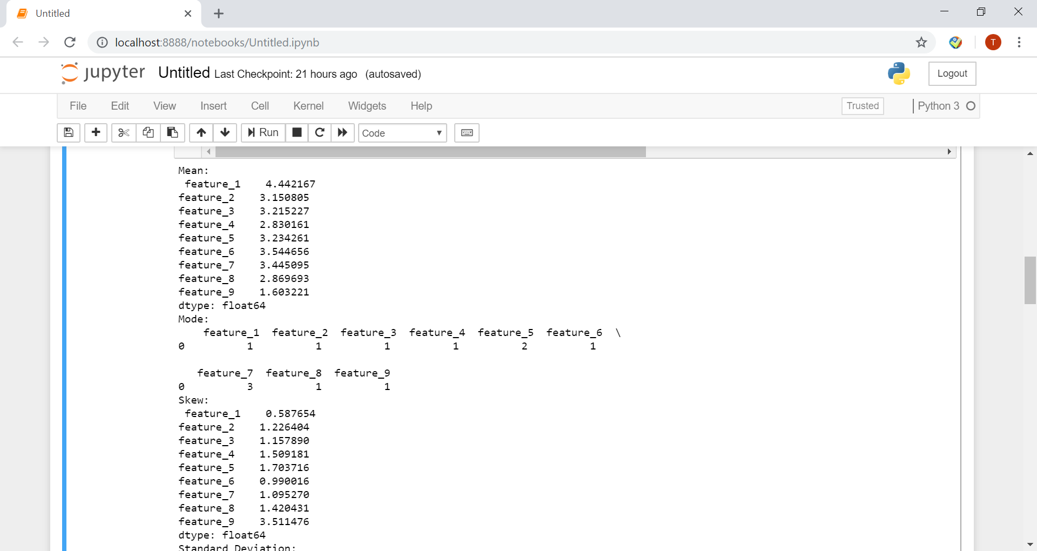**Q1:**

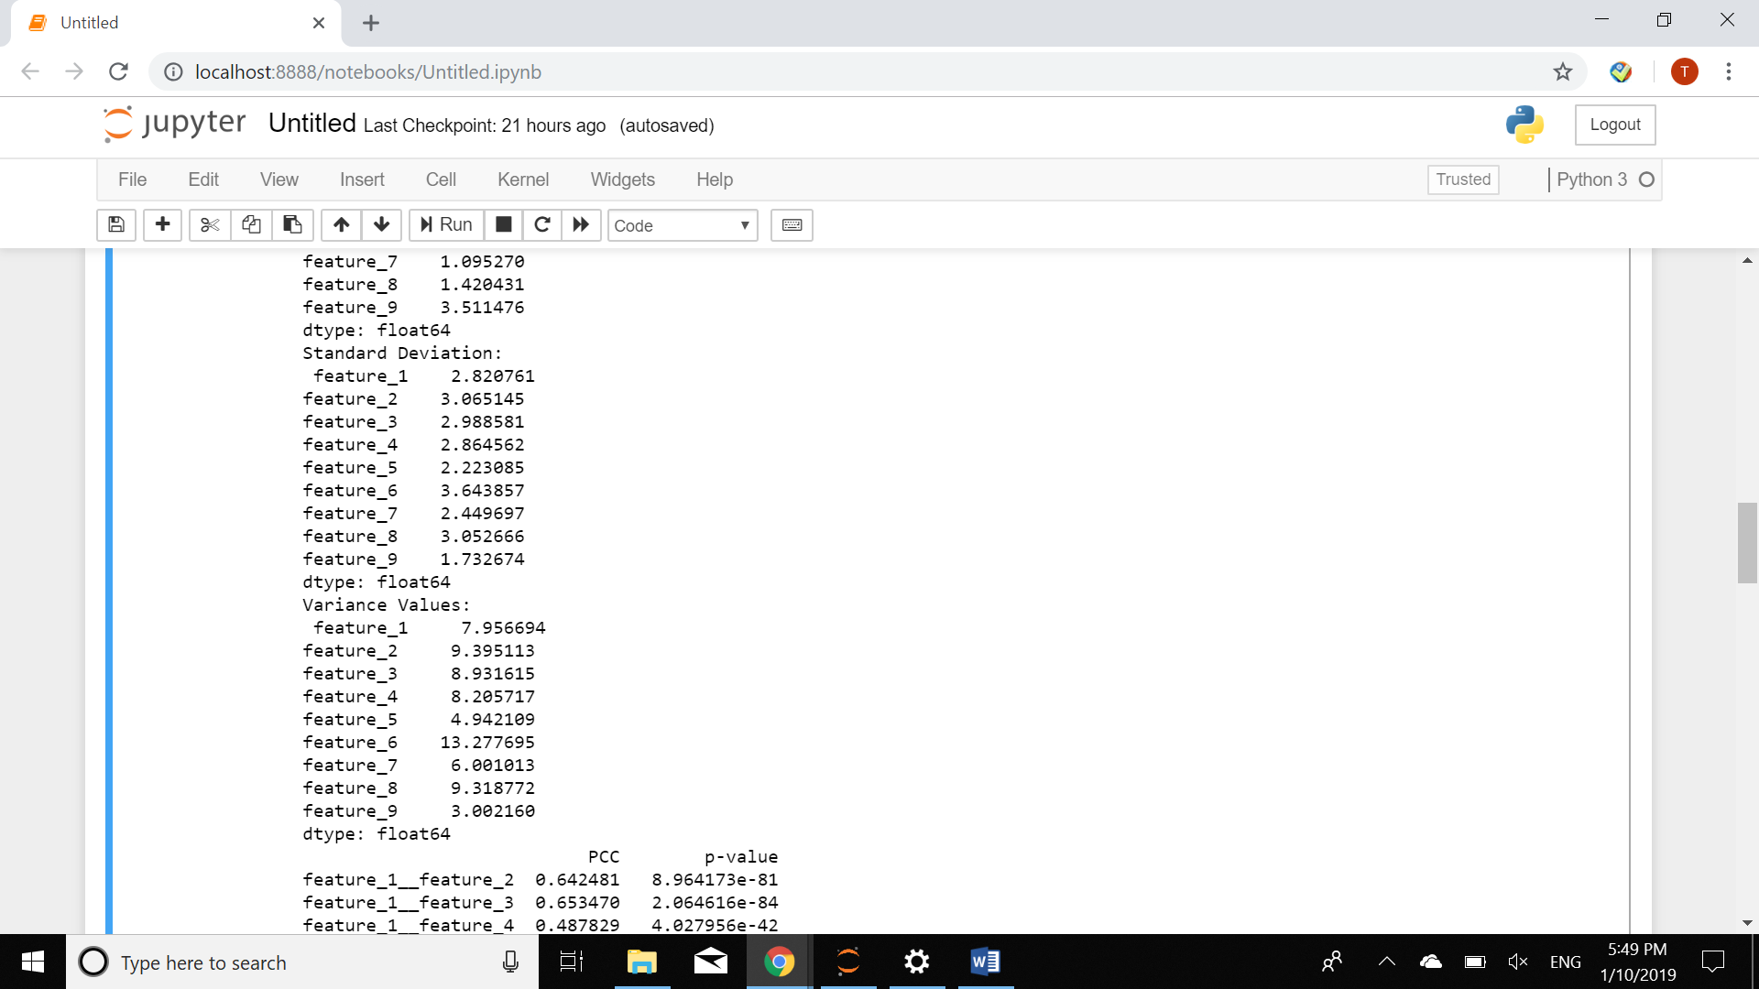

**Q2:**

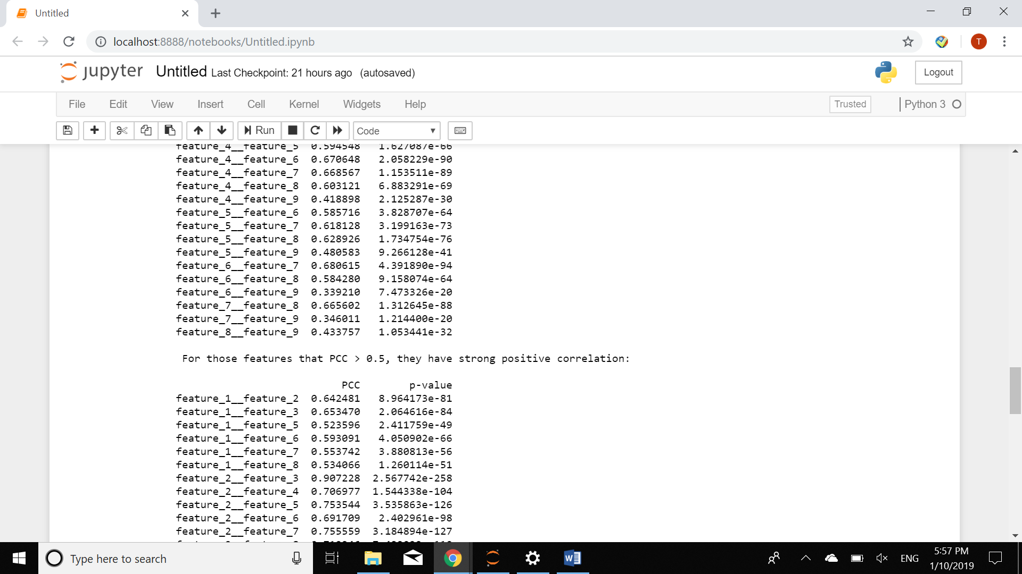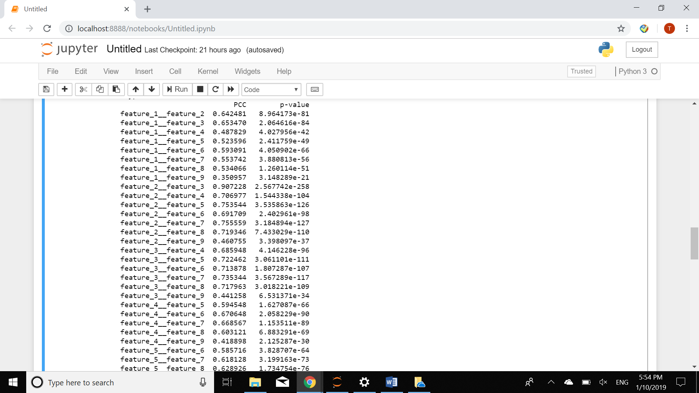Computing results for all the PCC numbers of each pair of features are shown as follows:

PCC results would be in range from -1 to 1, the greater PCC result is, the stronger positive correlation there is between 2 features. And the smaller PCC result is, the stronger negative correlation there would be. Independence could imply when PCC result is 0.

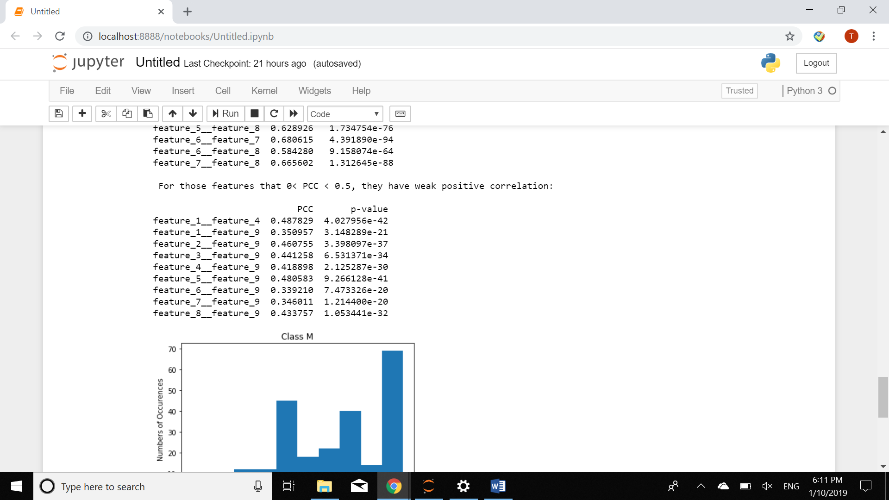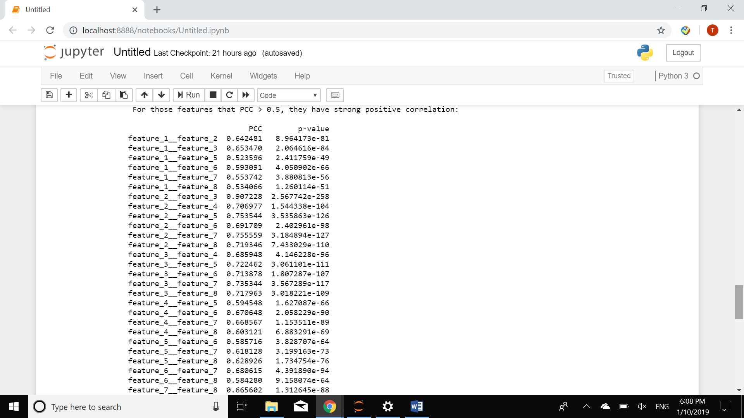Specifical results are shown as follow:

**Q3**

I take the firt feature to show the diagnosis results in graph for both the Class M and Class B.

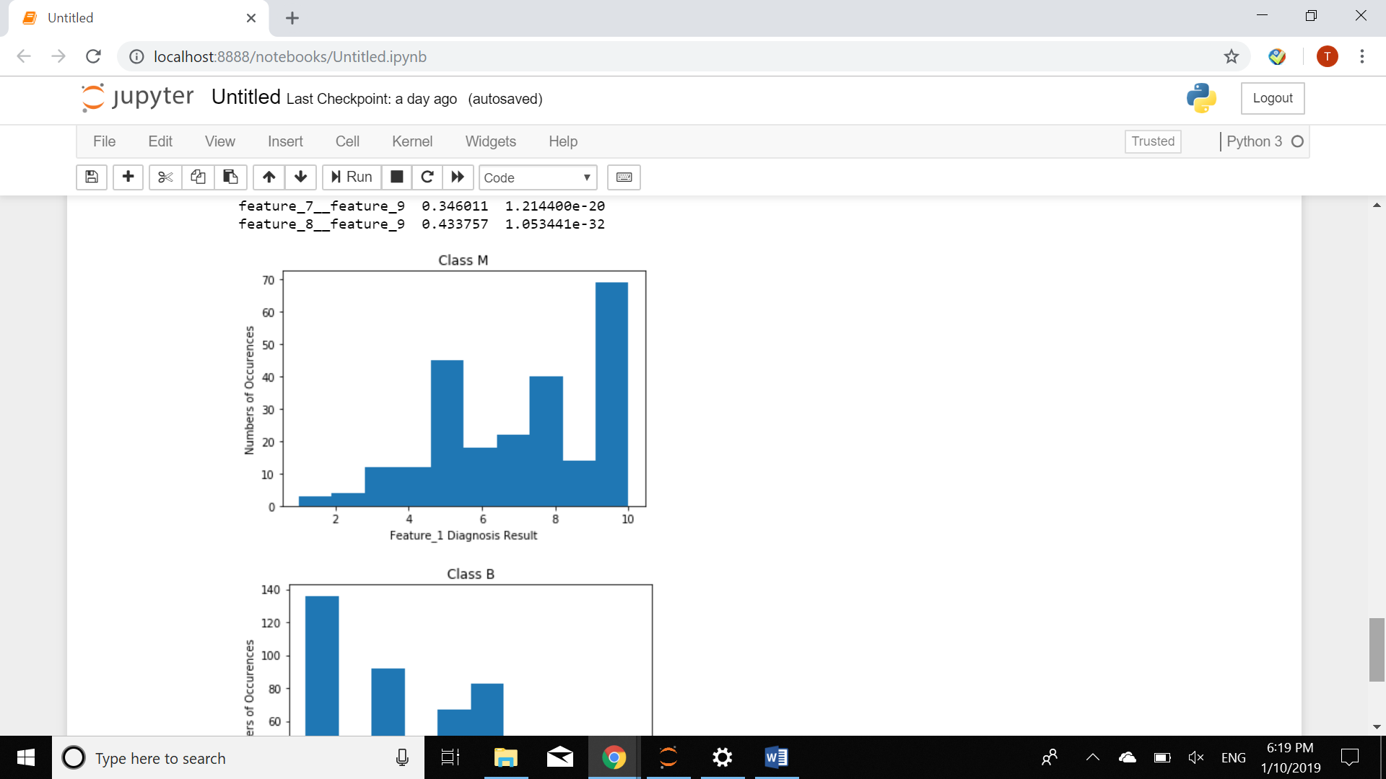

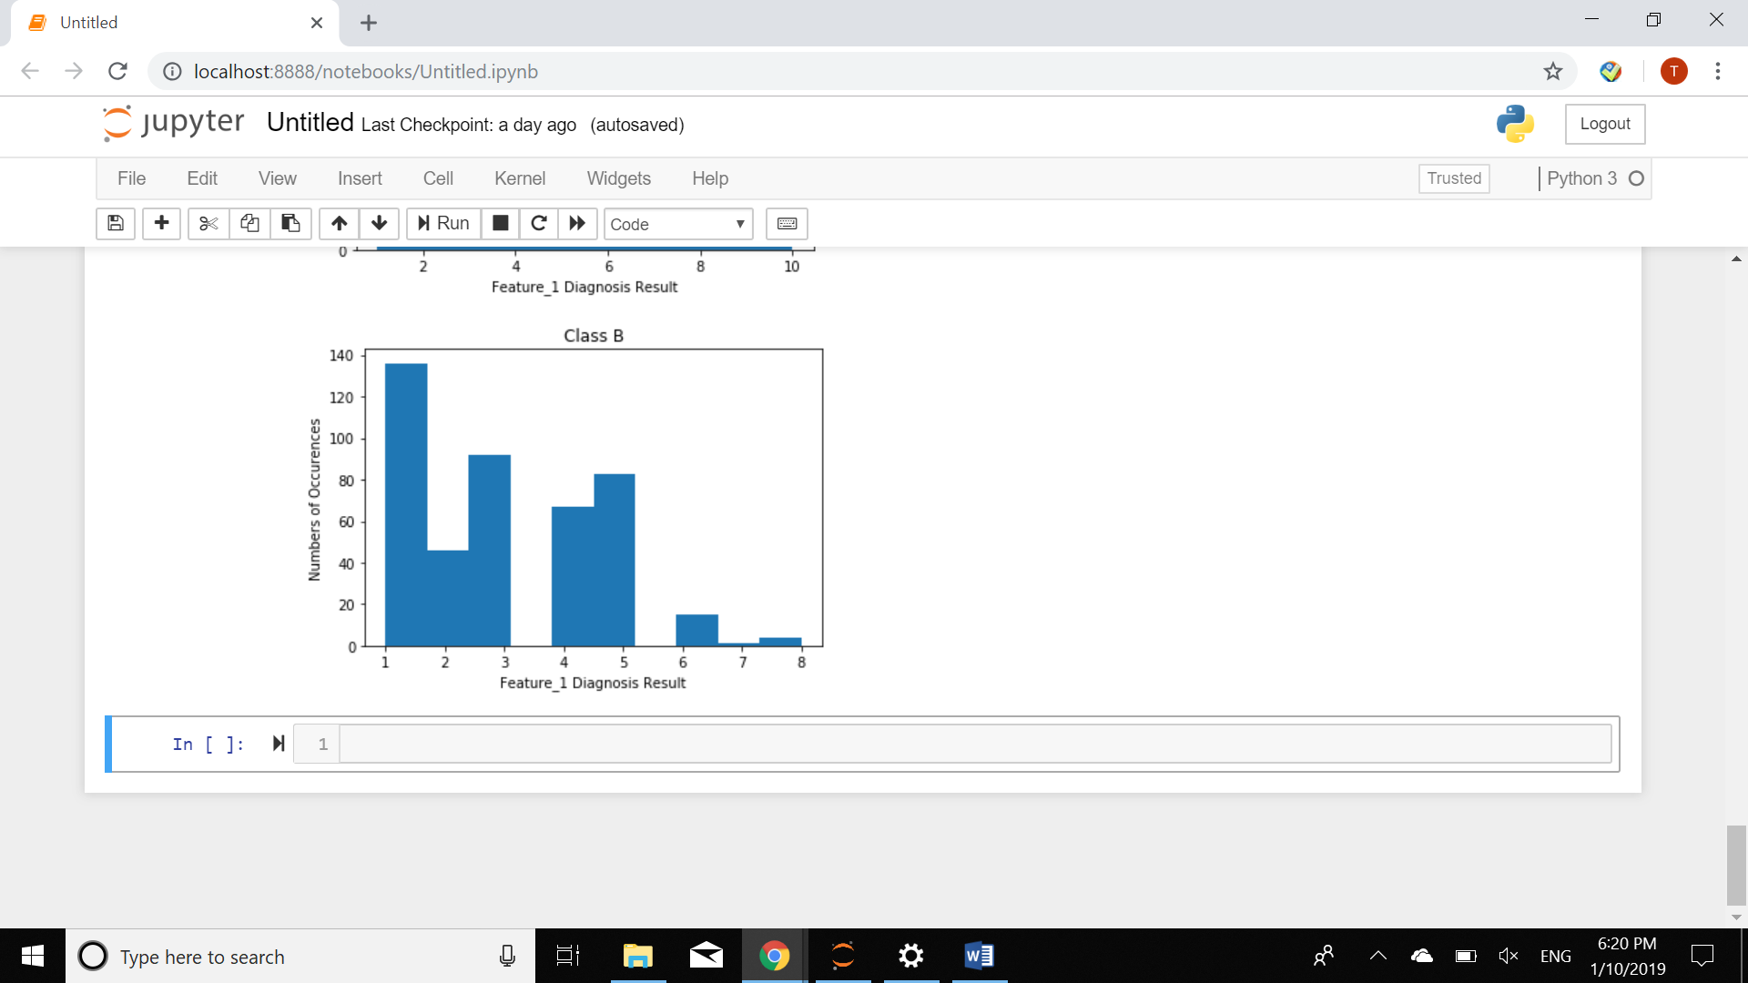

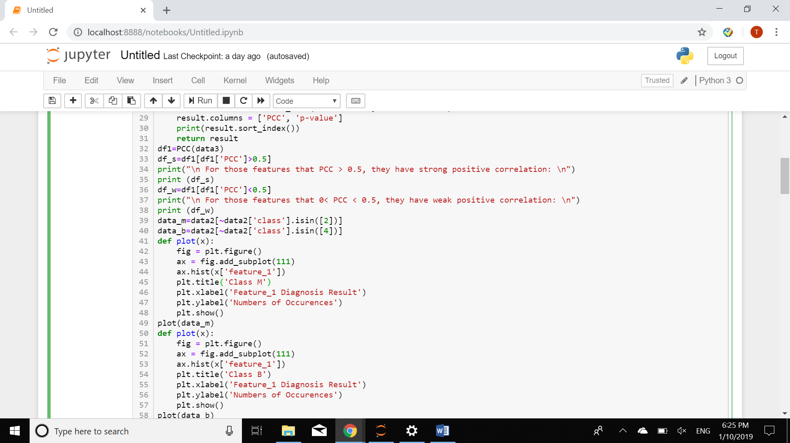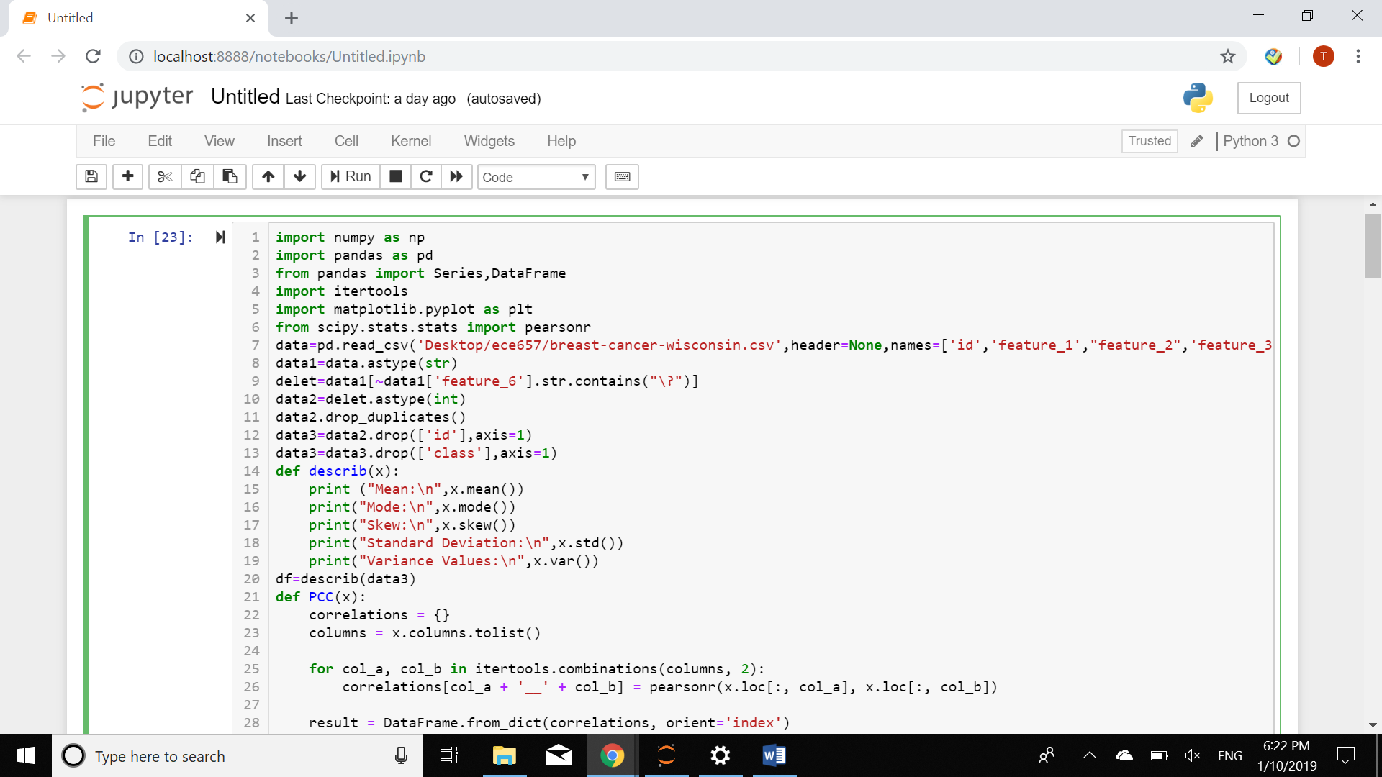Codes are attached as below: