**Computer Vision 16-720 HW-2**

**Feature Descriptors, Homographies & RANSAC**

Submitted by: Jennifer Li

Andrew id: jiatong2

**1. Keypoint Detector**

**1.2 The DoG Pyramid**

See function createDoGPyramid in keypointDetect.py

**1.3 Edge Suppression**

See function computePrincipalCurvature in keypointDetect.py

**1.4 Detecting Extrema**

See function getLocalExtrema in keypointDetect.py

**1.5 Putting it together**

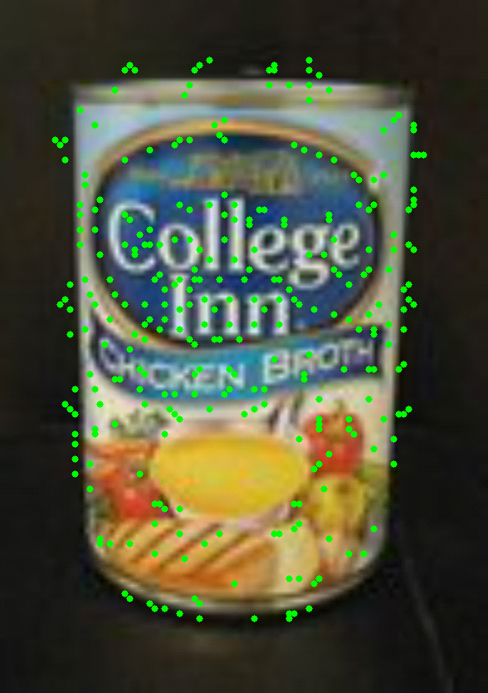 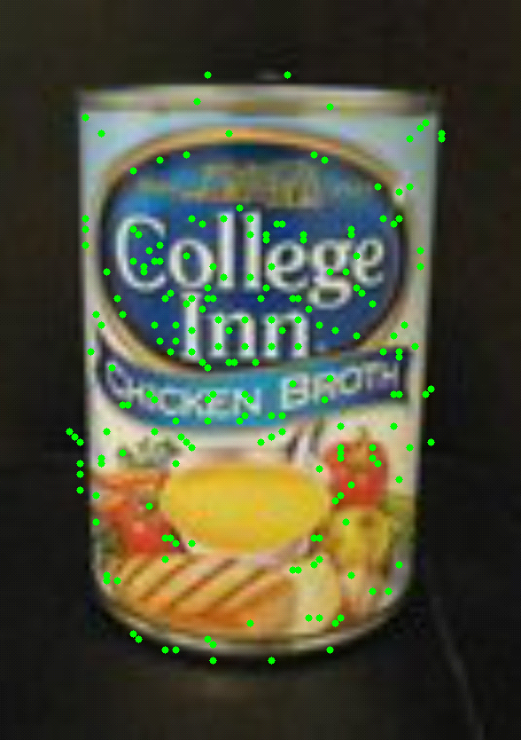

Left: Image without edge suppression Right: Image with edge suppresion

**2. BRIEF Descriptor**

**Q2.4**

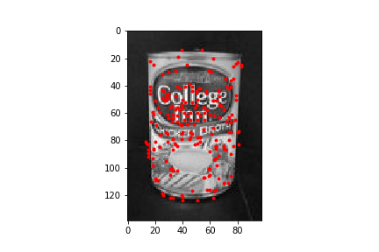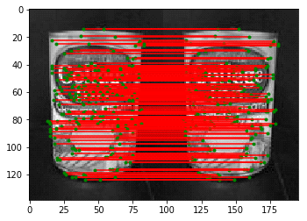

**Match with itself:** Shape of matches = (203, 2), so there are 203 matched points above.

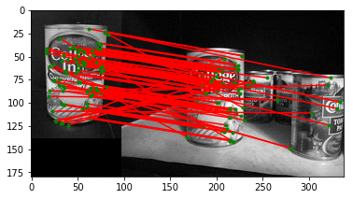

**ChickenBroth_01:** Shape of matches = (85, 2), so there are 85 matched points above.

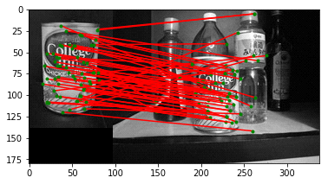

**ChickenBroth_02:** Shape of matches = (61, 2), so there are 61 matched points above.

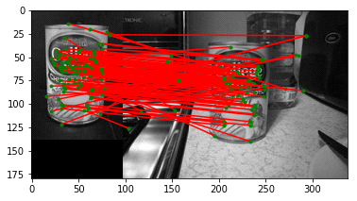

**ChickenBroth_03:** Shape of matches = (100, 2), so there are 100 matched points above.

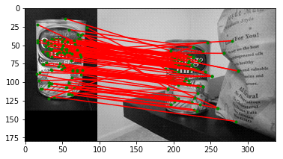

**ChickenBroth_04:** Shape of matches = (88, 2), so there are 88 matched points above.

 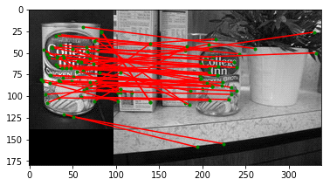

**ChickenBroth_05:** Shape of matches = (56, 2), so there are 56 matched points above.

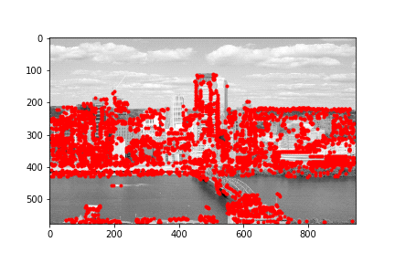

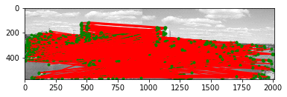

**Incline:** Shape of matches = (1302, 2), so there are 1302 matched points above.

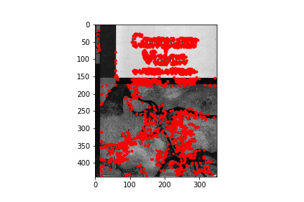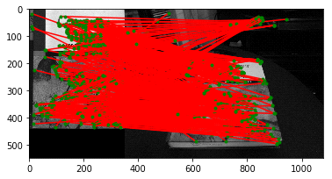

**Match with pf_desk.jpg:** Shape of matches = (432, 2), so there are 432 matched points above.

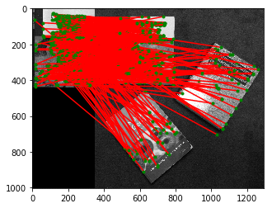

**Match with pf_floor.jpg:** Shape of matches = (478, 2), so there are 478 matched points above.

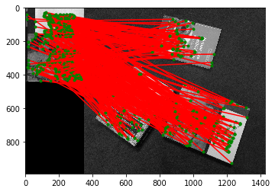

**Match with pf_floor_rot.jpg:** Shape of matches = (326, 2), so there are 326 matched points above.

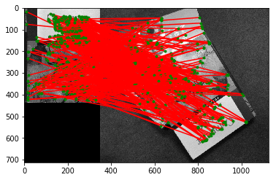

**Match with pf_pile.jpg:** Shape of matches = (333, 2), so there are 333 matched points above.

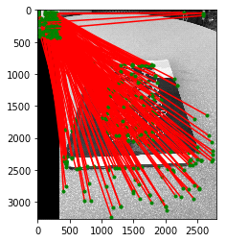

**Match with prince_book.jpg:** Shape of matches = (227, 2), so there are 227 matched points above.

Clearly that the image can match with itself much better than match with a image that contains many other stuff ( for example, the model_chickenbroth.jpg with chickenbroth_05.jpg). Those extra content would add much noise to the matching.

**2.5 BRIEF and rotations**

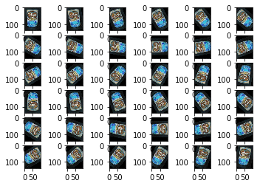

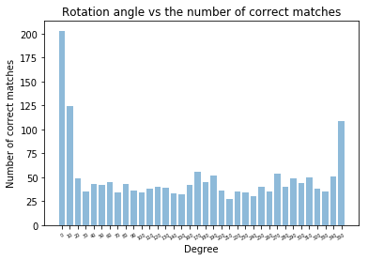

The above behavior proves that BRIEF does not have a strong rotation invariance. Its performance would be negatively affected when the image is rotated.

**3. Planar Homographies: Theory**