9732 H2 Economics

**Microeconomics**  
The Central Economic Problem 2

Demand, Supply and Elasticities 4

Market Structure 8

Market Failure 16

**Macroeconomics**  
The National Economy 22

Macroeconomic Problems 29

Macroeconomic Policies 32

The External Economy 36

The International Economy 37

Dear fellow 9732 candidates (and also our 8819 candidates),

Here it is, notes for economics. It should contain most of the content required for the examination, as well as some structured mechanisms to employ.  
(*In italics are the syllabus requirements,* adapted from the syllabus documents – which I have complied in a separate document on the same site)

It might be a situation where you may know the links, but are unable to expand beyond the scope of understanding into detailed explanation with clear use of economic analysis. What you can at least do as you explain the links is to state the assumptions (assuming ceteris paribus) and the cases for which it is true (especially for a small and open economy like Singapore), as well as to provide examples.

Please also do answer the question. For this I leave it to your revision and practices, and your teachers.

Ultimately, don’t lose hope. Start where you are, use what you have (which includes this set of notes), and do what you can.

All the best

# The Central Economic Problem

*Define broadly the* ***production possibility curve*** *(PPC) and illustrate graphically the concept of opportunity cost.*

PPC shows all **attainable output combinations** that a country can **produce** **within a specified time period**,   
when all the **resources are fully and efficiently used**, at a **given state of technology**  
– points on the PPC are **efficient** and **attainable** output combinations with given **resources** and level of **technology**,   
– points **within** PPC are inefficient and attainable  
– points **beyond** the PPC are unattainable combinations.

PPC is usually **convex** due to the **law of increasing opportunity cost**   
– all resources are not equally suited for the production of all goods

*Explain the central economic problem of scarcity.   
Illustrate the concepts of* ***scarcity****, inevitability of* ***choice*** *and* ***opportunity******cost****, and the nature of trade-offs in the allocation of resources*

**Scarcity** is the situation where **limited resources** are unable to satisfy **unlimited human** wants.  
(The limited resources could only produce what is attainable, that is, within the PPC or on the PPC)

**Choice** is a decision (what and how much, how, for whom) made in view of different output combinations **depending on the priorities** of the producer/country.  
(The economy can only choose to produce either A or B, and not both)

**Opportunity cost** is the **cost of any action or decision**, measured in terms of the **highest valued (or next best) alternative forgone**  
(The opportunity cost of producing B instead of A is to forgo SU of consumer good for RV of capital good)

**Factors** causing outward shift of the PPC (i.e. potential growth)   
– increase in **quantity** and **quality** of resources   
– improvement in **technology**

*Explain how the* ***price mechanism******allocates*** *scarce resources among* ***competing needs*** *in a free market*

Most economies seek to address **three basic economic questions** – ‘**what and how much to produce**’, ‘**for whom to produce**’, and ‘**how to produce**’.

In a market where government does not intervene at all, the price mechanism seeks to address the above basic economic questions by **determining the price and quantity** of goods and services, as well as the factors of production. This is done **through the interaction of the forces of demand and supply**. The **equilibrium price is the price at which the quantity demanded is equal to the quantity supplied**. It is determined by the **intersection of the demand and supply curve**. Market prices will adjust **to reflect where resources are required and where they are not**.

The basic principle underlying the price mechanism is that goods and services are provided through the market and that **consumers and producers act in their self-interest (rational behaviour)**. On the supply side are **profit-maximising producers** who will provide a certain good or service if the revenue they receive is equal to the cost of producing an additional unit of that good or service (MR=MC). On the demand side are consumers who will acquire a certain good or service to **maximise their satisfaction** if the price they have to pay it equal to the utility or benefit derived from consuming and additional unit of that good or service (P=MU).

The price mechanism answers the question ‘**What to produce**’, as prices perform a signalling function.

**For example**, demand for **meat** has seen large increases in recent years due a **rise in income**. **Without a change in supply**, the increase in demand **results in a shortage** and the **price of meat rises from P to P1**. On the producers’ side, the rise in **price is a signal to them to expand their production** to meet a higher demand. Producers begin to **shift their resources**, in this case arable land, **to the production of meat**, **away from the production of corn**, a good in competitive supply. Meanwhile, expecting that the demand for meat will continue to rise and consequently its prices, more farmers will devote more of their land to the **growing of cattle for meat**. Over time, there will be an **increase in the supply of meat**, which will bring about changes to the price and quantity demanded of meat.

Market prices will adjust to reflect **where resources are needed and where they are not**. The **price thus acts as a signal** which consumers send to producers indicating their demand for a good, and producers will **allocate scarce resources among competing needs** to the production of these goods **most desired by consumers**, **backed by their ability** to pay. In this way, the price mechanism plays the **allocative and rationing function**.

The price mechanism also answers the question of ‘**For whom to produce**’. Resources are allocated to the production of goods that are **backed by consumers’ willingness and ability to pay**. Those consumers who value a good more would be **willing to pay a higher price** for it. Therefore, more resources will be allocated to produce goods for these consumers than the others efficiently, ensuring **allocative efficiency** (instead of allocative inefficient methods like balloting, queuing etc.)

The price mechanism also answers the question of ‘**How to produce**’. It does so based on the prices of factors of production, which are determined by the demand and supply of these factors. Different combinations of factors of production will lead to different costs of production. **In seeking to minimize costs**, producers may choose the lowest-priced factors to produce a given product at a least-cost. For example, the farmers are choosing to use the least-cost fertilisers for their crops. Thus the price mechanism also ensures **productive efficiency**.

# Demand, Supply and Elasticities

|  |  |  |
| --- | --- | --- |
| Definition | **Demand**/**Supply** for a product is the **quantity** that **consumers**/**producers** **are willing and able to buy**/**make available for sale**  at **different prices**, in a **specified time period**, ceteris paribus. | |
| Law | The **law of demand**/**supply** states that the **quantity demanded**/**supplied** of a good during a specified time period  is **inversely**/**directly** related to its **price**, ceteris paribus. (This is why the demand/supply curve is downward/upward sloping) | |
| Non-price determinants  (factors that shift the demand or supply curve) | **Demand** reflects **consumers’ satisfaction.** | **Supply** reflects **opportunity** **costs.** |
| – **Prices of related goods** (Refer to determinants of XED)  – **Incomes** (Refer to determinants of YED)  – **Expected future prices and income** If prices are expected to rise (**inflation**), demand for the good will increase.  If income prospects are bad (**recession**), they will **save** instead  – **Availability of credit and cost of credit (interest rate)**  Higher demand when interest rates are low: especially for **big ticket items**  – **Distribution of income**  Affects the demand for various goods and services  – **Population size and composition**  e.g. aged population have different demand (like healthcare)  – **Government policies** Rules and regulations (thermometer, CASIO fx-95SG PLUS)  – **Climate and weather**  e.g. haze – demand for N95 masks increases  – **Tastes and preferences**  Anything (else) that affects **consumer satisfaction**: by advertising, fashion, observation, health considerations | – **Prices of related goods**  Goods in **competitive supply** – produced with the same resources (**land**)  Goods in **joint supply** – by-products of each other (**petrol** and **benzene**)  – **Costs of production**  Factor prices: land, labour, capital, raw materials  Improved **technology**, increased **productivity**, lowers COP  – **Expected future prices** If price of the good and cost of production is expected to increase, producers will build up their stocks instead which reduces supply  –**Taxes and subsidies by the government** Increases/Decreases the cost of production (usually to internalise externalities, or to promote equity) Ban (of a demerit good) eliminates supply  – **Climate and weather**  Natural disasters, epidemics reduce supply  while favourable weather conditions increase supply |

**Equilibrium** refers to a position of balance, a position from which there is no inherent tendency to move away.   
The **price mechanism** refers to the system in a market economy whereby changes in the price of the good (in response to demand and supply conditions) have the effect of equating the quantity demanded to the quantity supplied.  
The **equilibrium price** Pe is the price level at which the **quantity demanded by consumers is equal to the quantity supplied** by the producers.   
There is no shortage or surplus in the market at equilibrium price.

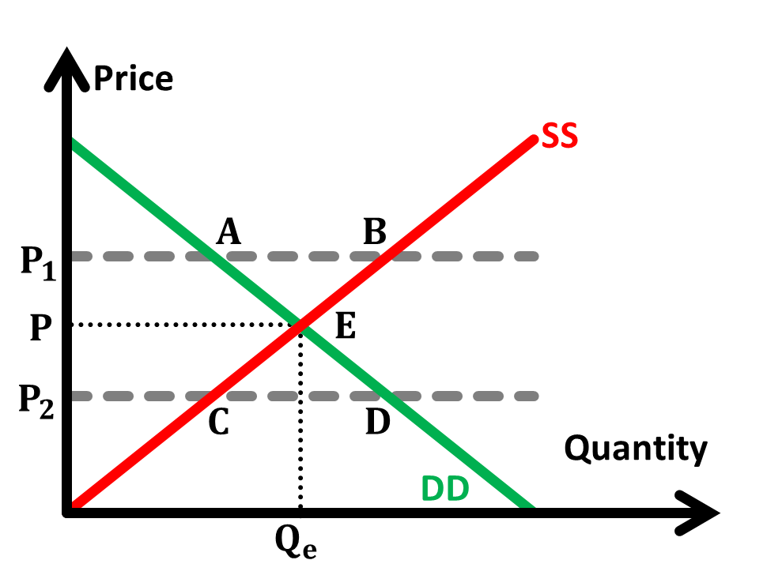**Surplus**:   
For instance, when the market price is at P1, the **quantity supplied will be greater than quantity demanded**.   
There will be a **surplus** (excess supply) represented by AB.   
As producers find that they are unable to sell all of their output at P1, producers will begin **competing against one another to sell their excess stock** by lowering prices.   
**Consumers will also recognise the excess supply** and begin to **offer lower prices**.   
Such market forces will cause a **movement along the demand curve** from Point A to Point E and a **movement along the supply curve** from Point B to Point E.  
 The market price falls unit the equilibrium price Pe is reached.

**Shortage**:   
Likewise, when the market price is at P2, the **quantity demanded will be greater than the quantity supplied**.   
There will be a **shortage** (excess demand) represented by CD.   
Consumers will **compete for the limited quantities available** by driving up the market price.   
**Recognising this willingness of consumers to offer higher prices** in an attempt to get what is available, producers will also **ask for higher prices**.  
Such market forces will cause a **movement along the demand curve** from Point D to Point E and a **movement along the supply curve** from Point C to Point E  
The market price increases until equilibrium price Pe is reached.

**Consumer surplus** is the difference between **what a person would have been prepared to pay** and **what he actually pays** for a good he consumes.  
**Producer surplus** is the difference between **what a producer would have been prepared to be paid** and **how much is he actually paid** for a good he produces.

|  |  |  |
| --- | --- | --- |
| **Price controls** | **Price floor** | **Price ceiling** |
| Mechanism | is defined as a **legally established minimum price** that buyers are required to pay for a good or service.  Producers are prohibited from selling below the stipulated price but prices can rise above it.  At the price floor Pf, **consumers** are unwilling and unable to consume as much quantity as before; they will only consume the amount corresponding to where the demand curve **intersects** the price floor at Qdd.  On the other hand, since the price is higher than what it should be at equilibrium, the **producers** are willing and able to supply more than the equilibrium quantity. They will supply up to the point where supply curve **intersects** the price floor line at Qss.  Thus at price floor P’, the quantity demanded Qdd is less than the quantity supplied Qss. There is a **surplus** with the implementation of price floor.  (likewise for price ceiling) | |
|  | **Stabilise prices** when there is a decrease in price due to high demand/low supply. Surplus can act as buffer stocks. | |
| Effectiveness | **Ensure equity**  Minimum wage policy allow low-skilled workers to earn substantial income  **Protect producers’ profits**  Producers may exit the industry if they make sub-normal profits. This reduces the total supply in the market.  **Encourage innovation**  Profits can then be used to find the least cost producing method. | **Ensure consumers’ purchasing power** Producers will not be able to charge exorbitant prices on necessities in the expense of consumers  **Encourage efficiency** Motivation to find and use the least cost method |
| Limitations | **Need to be high/low enough** In order for the price floor/ceiling to be effective **Deadweight loss incurred** asloss in consumer/producer surplus is greater than the gain in producer/consumer surplus **Changes in general price level -** inflation may mean that the ceiling need to be shifted upwards periodically | |
|  | **Government incurred expenditure** as they need to buy the surplus  **Complacency of producers** as the profits are being protected, thus producers are less motivated find efficient methods. **Productive inefficiency** results  **Unemployment** (for minimum wage) due to surplus in labour. | Fails to answer ”for whom to produce” – **allocative inefficiency** (resulting in long queues, waiting lists, favouritism)  Consumers may need to queue and wait for their purchase, which is a waste of time and thus allocative inefficient.  They might also turn to the **black market** to bypass the price restrictions, the government will thus have to incur higher costs to **monitor and prevent** illegaltrade, which is allocative inefficient. |

|  |  |  |  |  |  |  |  |  |  |
| --- | --- | --- | --- | --- | --- | --- | --- | --- | --- |
| **Elasticities** | PES  Price Elasticity of Supply | PED  Price Elasticity of Demand | XED  Cross Elasticity of Demand | | | | YED  Income Elasticity of Demand | | |
| Definition | measures the degree of **responsiveness** of **quantity** supplied/demanded of that good to a change in | | | | | | | | |
| price of the good itself | | | | price of another good | | | income of the people | |
| ceteris paribus | | | | | | | | |
| Calculation | percentage change in the quantity demand/supplied divided by the percentage change in the | | | | | | | | |
| price of the good itself | | | price of another good | | | | income the people | |
| Sign | always positive (law of supply) | always negative (law of demand) | | substitutes | | positive | | | necessity luxury |
| complements | | negative | | | inferior goods |
| Movement or shift | refer to the **movement** along the supply/demand curve  caused by the good’s own price | | | refer to a **shift** in the demand curve  caused by changes in the price of another good or income | | | | | |
| Determinants (link to responsive-ness) | – **level of stocks or inventories**  more price elastic if high  – **changes in marginal cost (MC)**  ease of factor substitution  availability of spare capacity to increase production quickly  – **nature of product**  simple/complex production process  – **time period** factors of production fixed in SR | – **degree of necessity** (YED)  – **closeness of substitutes** (XED)  – **proportion of consumer’s income** more price elastic if significant  – **time period**  more price elastic in LR because expenditure patterns can change and substitutes are developed | | “complement/substitutes – goods  in joint/competitive demand”  – **closeness of complement/substitutes**  narrowly or broadly defined  habits and brand loyalty  stronger the relationship, the larger the magnitude of XED  – **time period**  substitutes are developed in the LR | | | “inferior/necessity/luxury”  – **degree of necessity**  more basic the item, the more income/price inelastic the demand  – **consumers’ income levels**  higher the income, the degree of necessity of different goods changes | | |
| Applications  - firms  - government | Measure **extent of responsiveness**  – need to replenish stocks if supply is price inelastic  Analyse **price volatility** | Determine **direction and extent of change in total revenue** for a change in price of good itself (use areas to analyse)/another good  Make **non-pricing decisions** (**product differentiation/joint promotion**) | | | | | Determine which good to produce for impending economic **boom/recession** | | |
| Practice **price discrimination**  Analyse **tax incidence** Understand **effectiveness** of polices | | |  | |

# Market Structure

**Profit** is defined as the total revenue less total cost.

**Average revenue (AR)** is the revenue per unit output. The AR curve is the demand curve.  
**Marginal revenue (MR)** is the additional revenue earned form selling an additional unit of output.

**Average cost (AC)** is the cost per unit output, the sum of average fixed cost and the average variable cost.  
**Marginal cost (MC)** is the additional cost as a result of producing an additional unit of output.   
MC curve will pass through the minimum point of AC curve

**The law of diminishing returns** states that in all productive processes, adding more of one factor of production, "ceteris paribus",   
will at some point yield **lower incremental per-unit returns**

Firms (usually) make price and output decisions based on the **marginalist principle** MC = MR for **profit-maximisation**.  
Below Qe, MR > MC, which implies that **producing an additional unit of output** adds **more to the revenue than to cost**   
Hence, output should be raised to maximise profits. (Likewise for above Qe)  
At Qe where profit is maximised, AC-AR indicate type of profit (sub-normal, normal, super-normal profit)

**Long-run average cost (LRAC)** is defined as the long run costs per unit output produced.   
The LRAC curve shows the lowest possible cost per unit output of producing any given level of output.  
It is determined by the **level of technology** in the industry and the **costs of factors of production**. A change in these factors will cause a shift in the LRAC curve.

The **short-run average cost (SRAC)** curve shows the lowest possible cost per unit output of producing any given level of output,  
**when there are fixed factors of production**, such as plant size.

**Minimum efficient scale (MES)** is the lowest level of output per period where the average cost would be at a minimum.

**Economies of Scale (EOS)** refer to the situation in which the **cost of producing an additional unit of output** of a product **decreases** as the **volume of output increases**.  
EOS is said to be fully exploited at MES.

**Economies and Diseconomies of Scale**

|  |  |  |
| --- | --- | --- |
|  | Economies of Scale (also increasing returns to scale) – falling unit costs of production | Diseconomies of Scale |
| Internal  (move- ment along LRAC) | **Financial** Larger firms has higher sales volume and more assets to offer as collateral, and is hence deemed to be **more credit-worthy** compared to a small firm - so banks are more willing to offer loans, and at a **lower interest rate** with favourable terms and conditions.  They can also raise interest-free funds by issuing **shares/bonds** to the public.  **Marketing** Bulk purchase of inputs at a **lower per unit price** (**stronger position** to negotiate discounts) Bulk distribution of products through **large modes of transport** - lower per unit delivery cost Lower per unit **advertising** costs  **Administrative**  Lower **per unit** administrative costs as the firm is larger **Jobs that specialise in management -** better decision making, higher efficiency **Decentralised decision making** increases efficiency, avoid distortions and delays in information Large firms are able to offer higher pay to **keep the best staff**  **Risk-bearing** Able to **predict demand more accurately** due to greater market share **Diversification** (to different regions, countries) reduce risk, stabilise market demand **Technical**  **Specialisation** through division of labour (**increased skill and efficiency** through task **repetition**) Lower **per unit fixed costs** of machinery  - **larger** equipment are **more resource efficient**  - **indivisible equipment** (viable to produce only on a large scale)  - **principle of multiples** - “using more than one machine of different capacities” More **resources** available for **R&D** | **Management difficulties**  Difficult to co-**ordinate and control** the various departments Managers are unable to **check all the inefficiencies**  **Long chains of authority** to go through, leading to time lags in decision implementation **Extensive red tape** (rules and regulations) resulting in large firms responding more slowly to changes in market conditions  **Strained relationships** Difficult to ensure welfare of all workers, especially those at the lower end of the hierarchy  **Interdependencies in complex processes**  Disruption to the entire process if there is a hold-up at any stage of production |
| External  (shifts LRAC) | **Concentration**  **Training schools** may be set up to meet industry’s growing demand **Better infrastructure** may be developed to meet’s the industry’s needs Specialised firms supplying components and raw materials, lowering operating costs  **Information** Firms can **share the costs** of R&D  **Disintegration** **Specialisation** through **division of production processes** among firms | **Increased competition for the factors of production Increased demand** results in a **higher input price** **Trade unions** of larger firms tend to be more powerful, securing **higher wages**  **Increased strain on infrastructure** Concentration and expansion of firms may result in **congestion, overcrowding and pollution** **Worsens morale, health and productivity** |

**Barriers of entry** are obstacles or disadvantages that prevent new firms from competing with on an equal basis with existing firms in an industry.  
**Natural**   
– **factor endowment** (the amount of resources – land, labour and capital – that a country possesses and can exploit for manufacturing)  
– **high MES** (high start-up costs, only profitable with then companies are large enough, sometimes market can only accommodate one firm)   
**Artificial**   
– **aggressive pricing tactics** (to drive out competition, further reinforces BTE)  
– **government policies** (rules and regulations (setting limit to number of firms), **copyrights and patents** (e.g. pharmaceuticals, software)  
– **technological** superiority (e.g. design and production processes), **trade** secrets, information made more imperfect

**The Theory of Contestable Market** argues that what is crucial in determining price and output is not whether the industry is actually a monopoly or competitive, but   
if is there **a real threat of competition**, the firm tends to be competitive.

**If it is possible** for another firm to enter, a **monopolist** may **behave more like a competitive firm**. To deter a new firm from entering, the monopolist may engage in price competition by deliberately keeping prices low so that it makes only normal profits, and may produce as efficiently as possible, taking advantage of economies of scale and any new technologies. Otherwise, if it does not do so, **rivals would enter** and **potential competition may become actual competition**. The threat of competition has a similar effect to actual competition, and **may be enough to keep a monopoly efficient**.

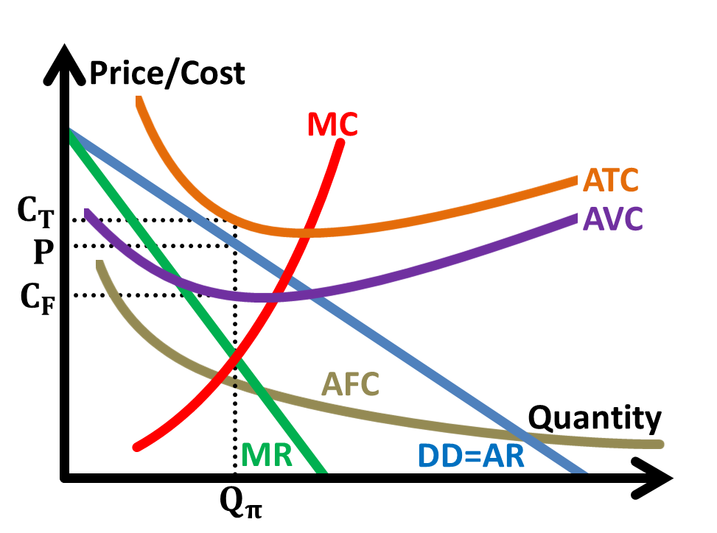

**Fixed cost and variable cost**

**Total Fixed Cost** (TFC) is the sum of all costs of production that do not vary without the level of output, and   
**has to be paid even if there is no production**. It does not change with the level of output.  
**Total Variable Cost** (TVC) is costs that vary directly with changes in level of output.  
**Total Cost** is the sum of TFC and TVC  
**Average** of the cost (of any of the above) is the **cost per unit output**.  
  
Shutdown depends on P and AVC.   
(If AR<AVC, leave the market, if AR>AVC continue, AR=AVC continue/depending on prospects)  
ATC and AFC is not relevant in the decision to remain in the market.

*Explain the* ***key******features*** *of each of the market structures.  
Understand the relevance of* ***barriers to entry*** *in explaining differences between market structures.*

|  |  |  |  |  |
| --- | --- | --- | --- | --- |
| Type | **Perfect Competition** | **Monopolistic Competition** | **Oligopoly** | **Monopoly** |
| Example | Currency (free-floating) | Clothing, Restaurants | Oil, Airline | Software, Pharmaceuticals |
| **Structure** | | | | |
| **Barriers to entry** (root cause) | No barriers to entry Complete freedom of entry/exit | Low barriers to entry | High/complete barriers to entry (artificial/natural) | High/complete barriers to entry (artificial/natural) |
| **Number of firms**  **Market share** | Many small firms  Insignificant market share | Relatively many small firms Small market share | A few large firms Significant market share | One large firm Complete market share |
| **Nature of product** | Homogeneous – perfect substitutes | **Differentiated** | Differentiated  or Identical (for natural BTE) | Unique  – no close substitutes |
| **Demand curve (firm)** | Horizontal  Perfectly price elastic | Downward-sloping  Relatively price elastic | Kinked demand curve | Downward-sloping  Less price elastic |
| **Degree of market power** | Zero market power:  Raising price will lose **all** customers to competitors  All firms are **price takers** | Limited market power:  raising price will lose customers to competitors  Less if products are differentiated | Limited market power:  **Mutually dependent**, raising price will lose customers to competitors | Total market power:  ability to raise prices without losing any customers to competitors. |
| Demand curve (firm) | Horizontal  Perfectly price elastic | Downward-sloping  Relatively price elastic at | Kinked demand curve | Downward-sloping  Less price elastic at |
| Diagram  (assuming normal profits) | (Why PC firms take prices) |  | (The kinked demand curve) |  |

*Explain* ***how firms compete*** *in the respective market structures based on their features   
(****price discrimination****,* ***price vs non-price competition****,* ***collusion vs competition****,* ***mutual interdependence*** *in the case of oligopolies)  
Compare the* ***performance*** *of different market structures on the basis of* ***productive*** *and* ***allocative******efficiency****,* ***equity****,* ***innovation*** *and* ***consumer choice.***

|  |  |  |  |  |
| --- | --- | --- | --- | --- |
| Type | **Perfect Competition (PC)** | **Monopolistic Competition (MC)** | **Oligopoly** | **Monopoly** |
| Example | Currency | Clothing, Restaurants | Oil, Airline | Software, Pharmaceuticals |
| **Conduct and performance** | | | | |
| Equilibrium Quantity | Profit maximising at Qe where MR=MC  for oligopoly/monopoly with market power, they may practice **price discrimination** | | | |
| – Allocative efficiency | Allocative efficient  Since demand curve AR=MR horizontal,  P=MC at Qe where MC=MR | Downward-sloping demand curve AR>MR  Maximises profit at output level at which P>MC: thus society values an additional unit of output more than the opportunity cost incurred from producing it, which is allocative inefficiency  Even more for oligopoly and monopoly | | |
| Profit in LR | Normal profit in the long run.  (Why no/low BTE implies normal profits in the LR) | Normal profit in the long run. (Why no/low BTE implies normal profits in the LR) | They can earn supernormal profits | They can earn supernormal profits |
| – Equity | Make only normal profit in the LR | | Earning supernormal profits at the expense of consumers | |
| – Productive efficiency (firm)  (society) | Produce on LRAC They can only make normal profits in the LR, need to survive | | May be X-inefficient (above LRAC) lack of competitive pressure,  can survive without minimising cost | |
| Productive efficient as firms operate at MES | Productive inefficient as they do not operate at MES, but instead at falling arm of LRAC curve | | |
| **Non-price competition** | Unable: Homogeneous products | Advertising and product differentiation (to aim for supernormal profit in LR) | Can compete if possible, however they are **mutually dependent**, refraining to prevent price war | No incentive, lack of competition.  (unless, theory of contestable market) |
| – Consumer choice | Identical products: no variety | Variety from product differentiation | Variety if they compete via product differentiation | Unique product – no variety  However monopolist may differentiate to raise BTE. |
| R&D | Lack ability and incentive to engage Homogeneous products | Lack ability and incentive to engage  Perhaps only superficially | Ability (can earn supernormal profit in the LR) and  incentive (patents and copyrights, imperfect info) to engage in innovation | |
| – Dynamic efficiency | No innovation | No innovation | may lack competition to motivate | may lack competition to motivate (but, theory of contestable market) |

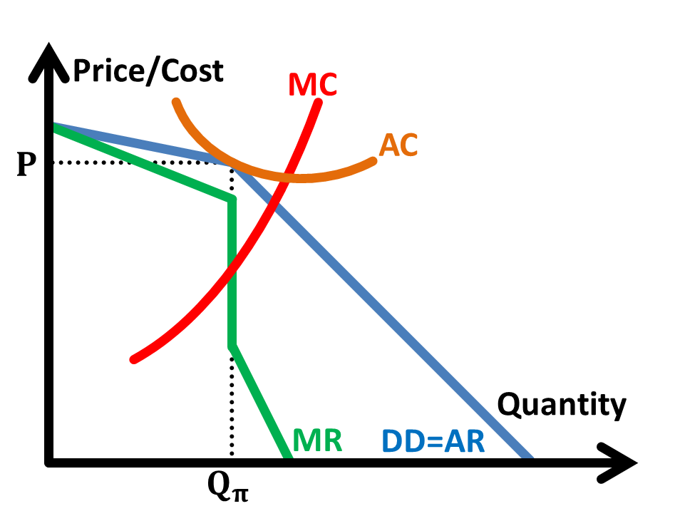**Non-collusive oligopoly (The kinked demand curve)**

If a **firm lowers its price**, its **competitors will follow suit** and reduce their prices to prevent losing their consumers.   
This leads to a **less than proportionate increase in quantity demanded**. Hence demand is **price inelastic** below the kink.  
If a **firm raises its price**, its **competitors will not follow suit** as they will gain consumers from the first firm by keeping their prices unchanged. This leads to a **more than proportionate fall in quantity demanded**.   
Hence demand is price elastic above the kink.  
In either case, the oligopolist is reluctant to change prices, because its decisions are mutually dependent on other oligopolists.

The kink in the demand (AR) curve **results in a break in the marginal revenue** (MR) curve. There will be two segments to the MR curve corresponding to the two portions of the firm demand curve. A discontinuous section in the MR curve appears at the currently produced quantity.

Profits are maximised where MC=MR. Thus if **marginal cost fluctuates within the discontinuous region**, the profit maximising price and output will be unchanged at the current levels. **Prices** will therefore remain **stable even with a considerable change in costs**.

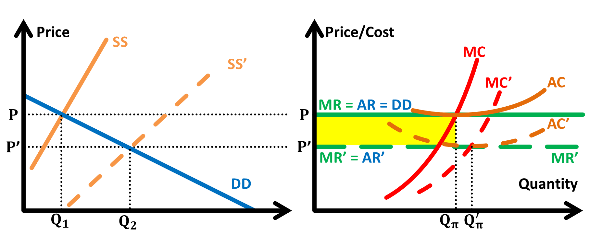**How PC firms take price and earn normal profits** **How recession decreases profits**

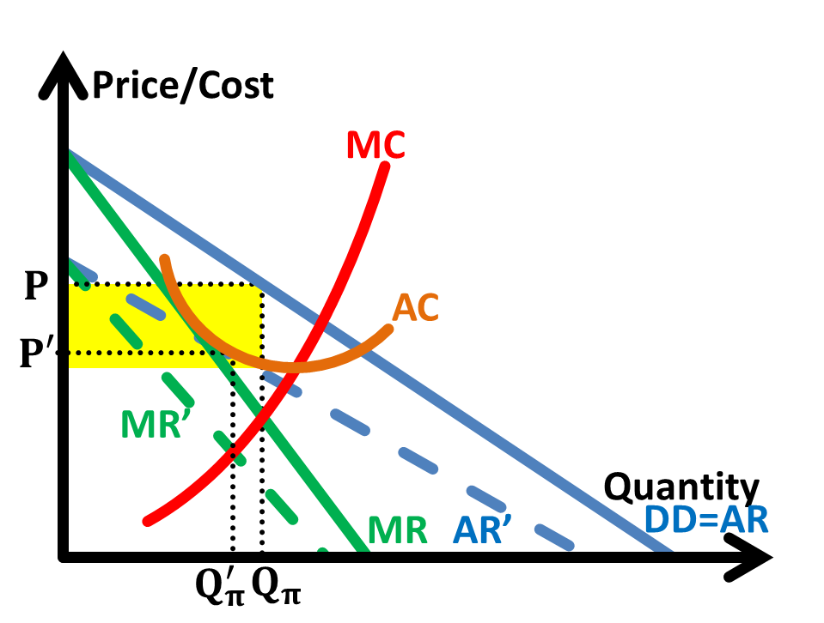

PC firm is a price taker, and the price is determined by market demand/supply. In times of recession (assuming normal good),  
Assume supernormal profit is earned in SR (shaded). Since there is perfect knowledge and no barriers to entry, decrease in national income reduces purchasing power,  
this leads to an entrance of firms and increases supply (shift in supply curve). which decreases demand. AR shifts to the left, and  
However, a downward pressure on price results, and PC takes the new price at P’, earning normal profits. demand is now more price elastic. Profit decreases.

**Price discrimination**occurs when a **producer charges different prices for different units** of the **same commodity for reasons not associated with differences in costs**.  
(examples – cinema tickets: adult and students, taxi fares: peak and off-peak, pharmaceuticals: more expensive in DC – a full list of examples on Wikipedia)

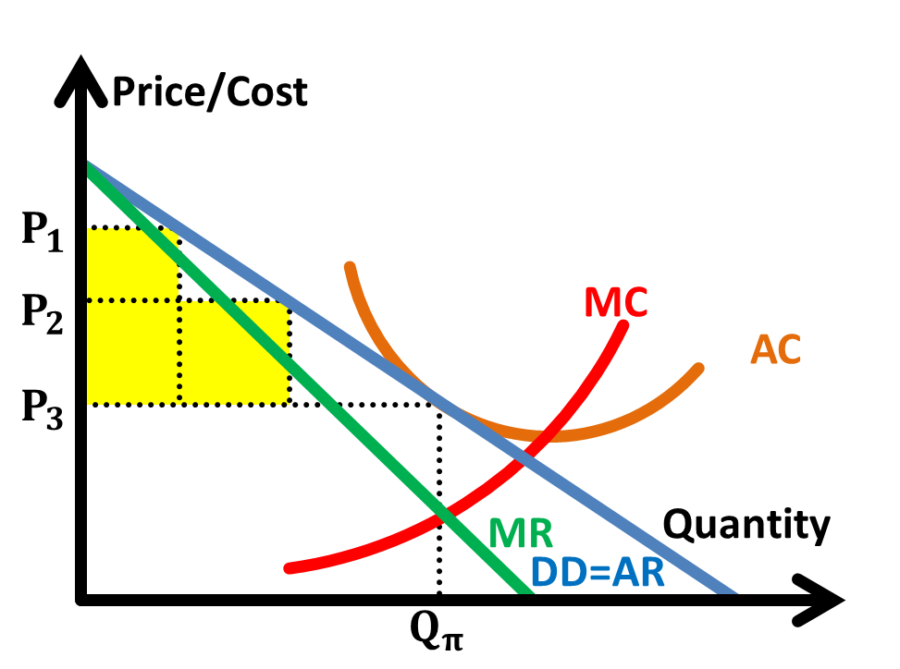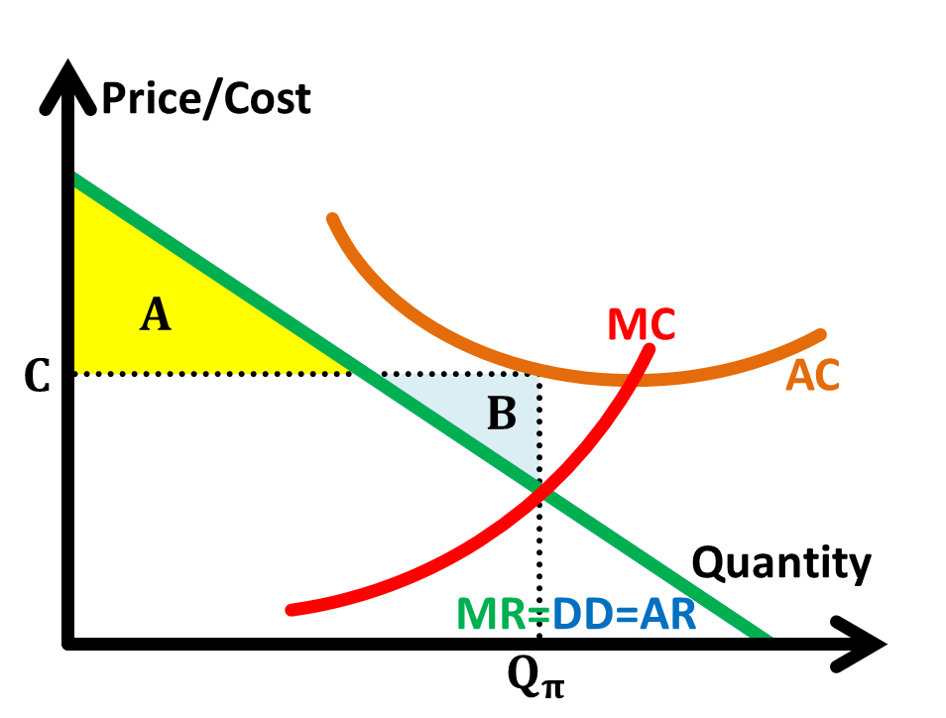**Conditions  
Market power**The firms must be able to influence the price. The greater the market power, the easier it is to engage in price discrimination. Consumers charged discriminatory prices cannot turn to an alternative producer who might sell the same good to them at a lower price.  
**No resale of good**Consumers in the lower-priced market must not be able to resell the product in the higher priced market  
**Gain from discrimination**Different sub-markets must each have different price elasticity of demand for price discrimination to be profitable.   
A higher price is charged where demand is more inelastic, charge a lower price in the market where demand is more price elastic.

**Type of price discrimination  
First** degree (perfect price discrimination), charges each consumer the maximum price he or she is willing and able to pay.   
**Second** degree (block pricing) where a firm charge a price per unit for a specific quantity of the commodity, a lower price for additional batch and so on  
**Third** degree, a separate price is charged in each sub-market

**Desirability** (as compared to a single price monopoly)   
**Captures more consumer surplus** (increased revenue and profits at the expense of consumers - increased **inequity**)   
**A lower price** can be charged for some people (increased **equity**)   
**Produce goods or services which would otherwise not be produced** (**increased consumer choice, thus welfare**)   
**Output will be generally higher** under price discrimination (smaller deadweight loss)

*Apply these models in analysing and comparing markets and* ***evaluate their usefulness*** *as explanations of* ***real world competitive behaviour*** *Use the* ***concept of profits*** *to illustrate real world competitive behaviour of firms (in protecting their profits). [An awareness of* ***other possible objectives*** *of firms is required]*

**Why firms** in the **real world fail to set prices** at **profit-maximising levels (MC=MR):**

**Government policies**  
- **price controls**  
price ceilings disallow firms to set their price to maximise profits

**Limitations of an organisation**  
- **divorce of ownership and control** (**principal-agent problem**)  
owners want to maximise profits, but managers, being self-interested, want to maximise their salary and career prospects  
- **complacency and inefficiency**  
using more inputs than necessary, produce above AC, due to lack of competition

**Imperfect information**   
- towards **MC**   
Firms usually only consider explicit costs that are easier to compute, but **implicit costs** are neglected. True MC is unknown  
- towards **MR**  
Even if firms conduct market research to determine demand and PED; such data may be **inaccurate** or **become outdated** quickly

**Alternative objectives**  
- **Revenue maximisation** (MR=0) or growth maximisation at normal profits (AR=AC)   
to **create demand** for the good or to gain market share and market power and increase profits in the long run  
to boost firm’s reputation among consumer and financial institutions  
- **Predatory dumping**  
selling below MC to remove competition  
- **Other objectives of firms**  
social responsibility corporates (charities), environmental cause

**Conclusion** – firms still do their best to seek profit maximisation for the LR (or at least need to earn normal profits to stay in the market if they have other main objective)

# Market Failure

*Explain why markets may not operate ideally and may fail in terms of* ***non-provision*** *of goods and services by the market, or* ***non-socially optimal*** *production/consumption.  
Analyse why* ***market dominance****,* ***imperfect information*** *and* ***immobility of factors of production*** *can lead to inefficiency.  
[Discussion of inequalities in the distribution of income and wealth not required for H1]*

**Productive efficiency** occurs when the economy is **using all of its resources** **efficiently**.  
**Allocative efficiency** occurs when is achieved when the **social surplus is maximized** with no deadweight loss.   
**Dynamic efficiency** is concerned with **efficiency over time** and involves **technological progressiveness and innovation**.

*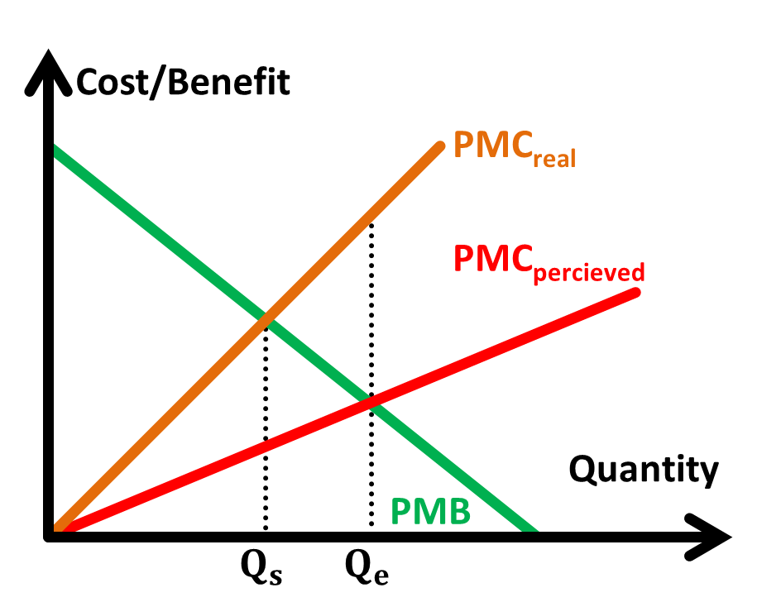***Explain how imperfect information might lead to market failure**

In the case of consumer ignorance, perceived costs may be lower than actual costs.

For example, demerit goods are often under-consumed because of **information failure**. Those people consuming demerit goods **do not fully appreciate how much** cost they are deriving from the consumption of such goods.   
For example, a rational individual **will find it difficult to predict** the monetary costs of smoking.  
The **individual may have ignored some** monetary cost of smoking which is the higher medical costs in the future.   
This means that his actual PMC is larger than his perceived PMC as shown in the following figure.

This will lead to the **over-consumption** of cigarette of Qe-Qs, leading to a deadweight loss of the area ABC and   
market failure results. (Likewise for perceived benefits)

**Explain how occupational immobility of labour leads to market failure**

Occupational immobility occurs when there are barriers to the mobility of factors of production between different sectors of the economy which leads to these factors remaining unemployed, or being used in ways that are not economically efficient. Labour often experiences occupational immobility.

For example, **workers made redundant in the sunset industries** (such as sheet metal industry or in heavy engineering) may find **it difficult to gain re-employment** in sunrise industries (such as the finance industry) as they **may not have job-specific skills** that are not needed. This implies that there is **structural unemployment**, where a **mismatch between the skills on offer from the unemployed** and those required by employers looking for extra workers exists. This leads to **productive inefficiency** as a **higher cost** is now needed to source for workers with the required skills. Market failure results.

**Explain how geographical immobility of labour leads to market failure**

Labour may also experience geographical immobility, where barriers make it difficult for **factors of production** to move from one area to another to produce.

This may be due to **financial costs** involved in moving across regions (usually the case in big countries), **cultural differences** as well as differences in standard of living. For instance, an unemployed person living in the state of Florida in the United States of America may not move to the state of Alaska to seek employment because of the financial costs of moving to a new location. Once again, this leads to **productive inefficiency** as workers who move from one area to another will often need to be **compensated for relocation**, resulting in **higher costs** of firms. Market failure results.

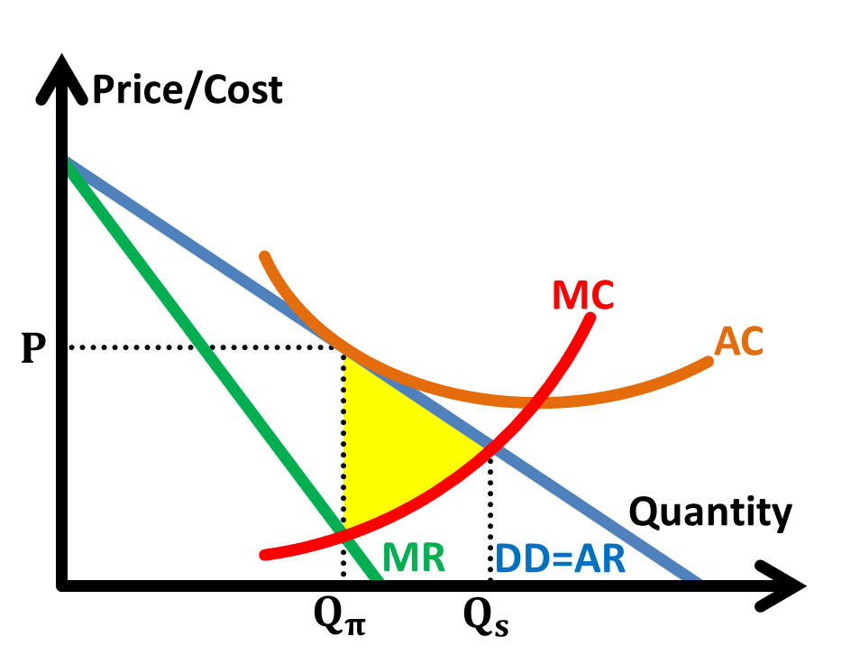**Explain how market dominance leads to market failure**

Market dominance occurs when there are **strong barriers to entry** and/or when there is imperfect information. By garnering high market power, firms with market dominance can set high price and restrict output.

With market power, profit maximising firms **may choose to restrict output** and **charge a higher price** than under perfect competition. They usually do so because the equilibrium quantity at the **profit maximising condition** MC=MR is below the allocative efficient quantity at Qs where P=MC, as MR < AR (the demand curve).

Thus, P>MC and this leads to allocative inefficiency as resources are under-allocated. The society values a good more than what it takes to produce. This is shown by the underproduction of the good by Qs-Qπ, leading to **deadweight loss** (shaded) and market failure occurs.

Also, due to a strong market power, **PED** value is likely to be **low**. Hence, the demand curve (AR) is relatively steeper as compared to those in the perfect competition market. Examples of market dominance can be seen in the pharmaceutical industry when patent periods are long. Hence, firms are able to **consolidate their market power** and **charge exorbitant prices** even further.

**Why inequity is market failure**

Consumer demand is based on the spending power of consumers, and unequal distribution of income leads to those with higher income determining which goods and services to be produced and at what quantity. Resources would be inevitably channelled to the production of goods and services wanted by the rich while **the poor** may be **unable to meet even their basic needs**. This means that the **market** **fails to allocate resources** in a way which are **socially optimal** in terms of fairness.

*Explain the characteristics of* ***public goods*** *(****non-excludability*** *and* ***non-rivalry*** *in consumption) and why public goods are not provided by the market*

Public good like street lighting is **non-rivalrous** in nature. There is **no opportunity cost of consumption** once the good is produced; consumption by one person does not reduce the amount of light available to other people that pass by the streetlight. If the lights are provided, they shine as brightly when you walk pass them as when 1,000 people walk pass them. This essentially means that the marginal cost (i.e. additional cost) of providing street lighting to an additional consumer is zero. Given that the condition for **allocative efficiency is P = MC** and since **MC = 0**, in this case, then **P = MC = 0**. It **would be socially inefficient to charge a price** since extra users can benefit at no extra costs to society. Charging a price would deter potential users and **reduce the total welfare** that can be obtained from the unit of good. A good for which no price can be charged will not be supplied by the free market since there is no incentive for producers to produce it. So that leads to no supply of the good in the market.

Public good like street lighting is **non-excludable**. The provision of street lighting to one person **automatically makes it available** to others - it is **technically impossible** or **extremely costly** to **restrict** the use of street lighting to only those who pay for it, since once provided, it shines on anyone who walks past it, regardless of whether the consumers have paid. The non-excludability property of public goods bring about the **free-rider problem**, where each consumer will find it in his interest to share in the provision made by others without paying to cover for the costs of provision of the good. This result in **no effective demand** (i.e. consumers are "**unwilling**" to pay for the good) for the goods, and producers are not given signals about what to produce and there is no one to whom they can sell.

Hence public goods like street lighting and lighthouses are usually provided by the government. Public goods lead to complete market failure. **Complete market failure** occurs when the price mechanism **does not allocate any resources** to the production of the good. In a perfectly competitive market without government intervention, the good will not be produced.

Since the public goods in general benefit the society the **government would intervene** by providing the public good at zero prices and fund the production **through taxation**. This is called **direct provision** of goods and services.

*Explain the characteristics of* ***merit*** *and* ***demerit goods*** *in terms of its* ***social desirability****.  
Explain positive (negative) externalities and* ***illustrate through examples****.   
Illustrate positive and negative* ***externalities*** *in both production and consumption* ***using simple demand and supply diagrams*** *Discuss the* ***divergence*** *between* ***private*** *and* ***social******costs****/****benefits*** *leading to under- (over-) consumption/production in the market and* ***inefficient allocation of resources****Explain* ***why governments intervene*** *in the market with regard to the provision of public, merit and demerit goods, positive and negative externalities.  
Analyse* ***how governments intervene*** *through* ***direct provision of goods and services****,* ***imposition of taxes****,* ***subsidies****,* ***tradable permits****,* ***rules and regulations*** *and****how they impact the achievement*** *of the socially optimal consumption/production level*

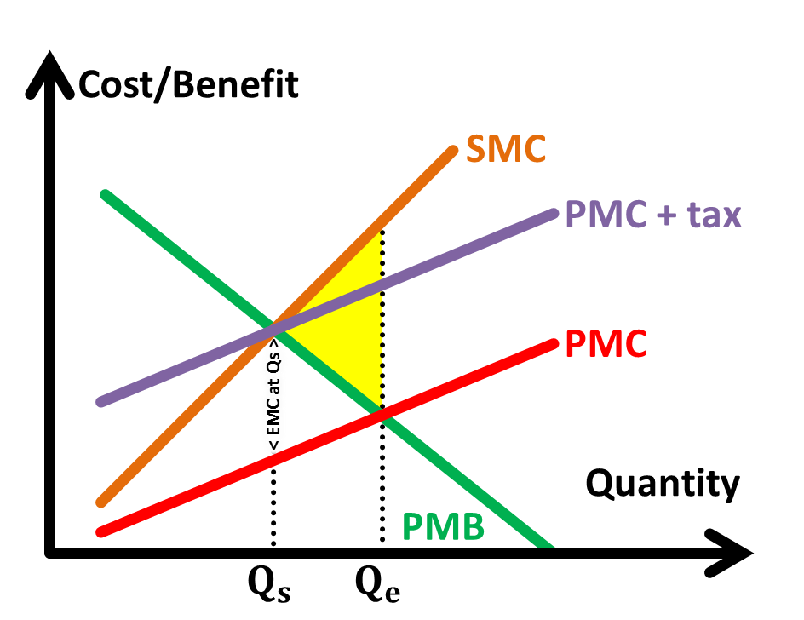A **merit good** is good that is **deemed by the government to be socially desirable** and has **positive externalities** associated with it.

When an individual **decide** whether to pursue higher levels of education, he **weighs his private marginal benefit (PMB) against his private marginal costs (PMC)**. The **private benefit** is **the knowledge that he acquires from education** as well as the **higher paying jobs that he can get in the future due to the knowledge** that he learnt, and the **private cost** islike the **paying for the expenditure on school fees and textbooks,** and the **opportunity cost of the time he will be spending**.

The individual however, **does not take into account the external benefits to the other people that his consumption of education brings**. A higher level of education will **increase the productivity level of the country**, which **will attract investment from multinational companies** (MNCs) leading to economic growth in future.   
**Third parties,** who did not consume or produce related courses, will be provided **provide job opportunities**. These external benefits lead to the **divergence** between PMB and social marginal benefit (SMB) where SMB > PMB.

When left to the free market, individuals, who are pursuing self-interest, will consume education at **market equilibrium level Qe** where PMC equates PMB. However at Qe, SMB is greater than social marginal cost (SMC), which is the PMC. **The society values an additional unit of education more than what it costs the society to consume**, as represented by the external marginal benefit (EMB). There is **under-allocation of resources to education**, shown by the under-consumption of education Qe < Qs, in which Qs is the socially optimum level of consumption where SMB=SMC.

The shaded area in the figure represents the **deadweight loss**, which is loss of welfare to society as a result of this. Society as a whole could be made better off if the units of education consumed, Qe, were to be increased to Qs where SMC = SMB and thus the socially efficient level of education.

The Singapore government provides subsidies on education to correct the market failure. Education from primary to tertiary level is heavily subsidised.   
The subsidy per unit is **equivalent to EMB at the Qs level** will decrease the private marginal cost of education by the extent of the subsidy per unit, hence shifting PMB curve upward from PMC to PMC'-subsidy. By decreasing the PMC of the consumer, this encourages them to **internalize the positive externality** of education and increase their consumption level from Qe to Qs.

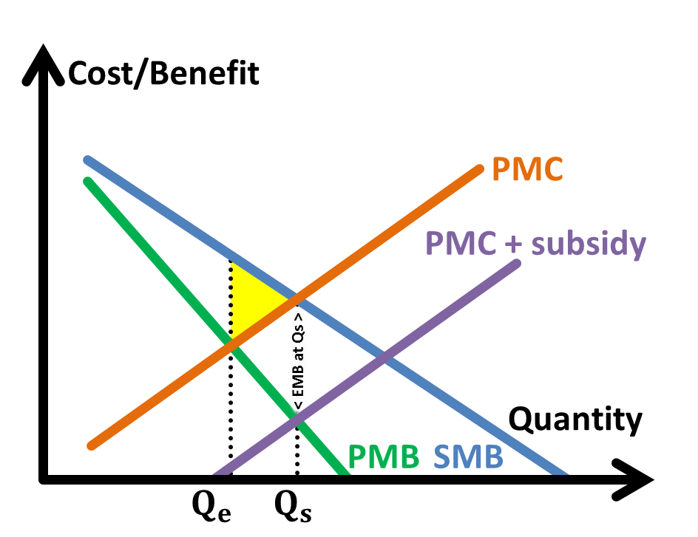A **demerit good** is good that is **deemed by the government to be socially undesirable** and has **negative externalities** associated with it.

When an individual **decide** whether to use a car, he **weighs his private marginal benefit (PMB) against his private marginal costs (PMC)**. The **private benefit** is **include saving transport time and not having to wait with uncertainty for public transport**, and the **private cost** is **expenditure on petrol, car maintenance and parking fees.**

The individual however, **does not take into account the external cost to the other people that his consumption of car brings**. These are **air pollution as a result of toxins released into the atmosphere** from his car's exhaust fumes. There is noise pollution and traffic congestion as a result of his usage.   
**Third parties**, such as pedestrians and residents **face increased incidences of respiratory, diseases and other health-related problems** from his car's exhaust fumes and other road users have **increased waiting time on road because of the traffic congestion** created by his car usage. The external costs lead to a **divergence** between PMC and social marginal cost (SMC) where SMC > PMC.

When left to the free market, individuals, who are pursuing self-interest, will consume car mileage at **market equilibrium level Qe** where PMC equates PMB. However at Qe, SMC is greater than social marginal benefit (SMB), which is equal to PMB. **The society values an additional unit of car usage less than what it costs the society to consume**, as represented by the external marginal benefit (EMC). There is **over-allocation of resources to education**, shown by the over-consumption of education Qe > Qs, in which Qs is the socially optimum level of consumption where SMB=SMC.

The shaded area in the figure represents the **deadweight loss**, which is loss of welfare to society as a result of this. Society as a whole could be made better off if the current level of cars on the roads, Qe, were to be reduced to Qs where SMC = SMB and thus the socially efficiently level of car usage.

The efficient allocation of resources is the use of a country's limited resources in such a manner that maximizes the total welfare of the people. In case of public goods and goods with externalities the market economy fails and thus **social welfare is not maximised**. Hence there is **a need for government intervention**.

The Singapore government imposes taxes to correct the market failure. One of such taxes is the Electronic Road Pricing (ERP).   
The tax per unit is **equivalent to the EMC at the Qs level** which will increase the PMC of driving by the extent of the tax per unit, hence shifting PMC curve upward from PMC to PMC+tax. By increasing the PMC of the drivers, this encourages drivers to **internalize the negative externality** and decrease their consumption level from Qe to Qs.

*Discuss the* ***effectiveness*** *of these policies in correcting market failure and their* ***limitations*** *due to factors   
such as* ***political objectives****,* ***administrative, implementation and monitoring costs*** *and* ***imperfect*** *or* ***inaccurate information***

|  |  |  |
| --- | --- | --- |
|  | Effectiveness | Limitations |
| Subsidy and  Taxation | Taxes provide **revenue** for the government.  They **still allow the market to operate**, allowing the workings of the price mechanism in allocating scarce resources.  Moreover, the subsidy/tax rate can be **easily adjusted** **periodically** according to the EMB/EMC. (give different subsidy rates to different levels of education - primary, secondary, tertiary) (ERP can be periodically adjusted depending on the level and time of congestion)  **Reduces inequity** as the rich pays more tax and the poor receives more subsidies. | **Subsidies require government expenditure**.  It is **very difficult to measure the monetary value of EMB/EMC** due to **insufficient information** and the **complexity of other factors**. (As labour is mobile in Singapore, there might be a brain drain which its extent depends on many factors, making it difficult to estimate the EMB at Qs)  **PED of consumption** (Once a car is bought along with the astronomically prized COE, the amount deducted by ERP may seem relatively insignificant. Hence, demand for travel on affected roads becomes **price inelastic**. This result in a less than proportionate fall in quantity demanded for road usage and **will not bring road usage to the socially optimal level**) |
| Tradable permits | A tradable permit, first sold by the government, gives the firm the right to emit a given quantity of waste into the environment. The total number of permit issued by a regulatory authority corresponds to the socially optimum level of production, thus enforcing production at Qs. | |
| It is sometimes **easier to determine the Qs level** (rate the resource extraction equals replenishment) than to determine the value of EMC at Qs. This motivates firms to **reduce their generation of negative externalities**.  **Selling of tradable permits** also provide tax revenue for the government. | May lead to the negative externalities **concentrating** in certain areas.  May result in **speculation**, allowing parties to benefit without input.  This **increases the cost of production** and **decreases SRAS**. The **resulting tax-push inflation** makes this policy very **unpopular**. |
| Rules and regulations | Regulations refer to the use of **legal intervention** to force consumers and producers to behave in a certain way,  in order to produce a more desirable economic outcome **than that achieved by the free market**.  The government can **impose laws to force** consumers and producers to consume and produce goods at a **socially efficient level**. (Compulsory Education Act in 1996 – it is illegal for parents to exclude education for their children) Laws can be imposed **where the negative externality is high** (prohibition of smoking at public places) | |
| Legal restrictions are **simple and clear** to understand, and **easy to administer**.  Sufficiently harsh penalties and frequent inspection add effectiveness to laws. Complete ban of an undesirable good **is much safer** than relying on taxes. | There is **no incentive** for a consumer/producers **to go beyond** what is required by law (e.g. reduction of pollution) It is a **costly process** which involves a lot of resources (manpower, paperwork) which could have been put to a better use. |

# The National Economy

*Explain the* ***circular flow of income*** *amongst* ***households****,* ***firms****,* ***government*** *and the* ***international economy****.  
(Understand that* ***income equals expenditure*** *from the flow)*

**Circular flow of income** refers to a simple economic model which describes the flow of payments and receipts between domestic firms and domestic households. Money flows from firms to households in the form of factor payments, and back again from households to firms as consumer expenditure on domestically produced goods and services (C). **Income equals expenditure from the flow**. This circular flow of income can be added by injections while reduced by withdrawals.

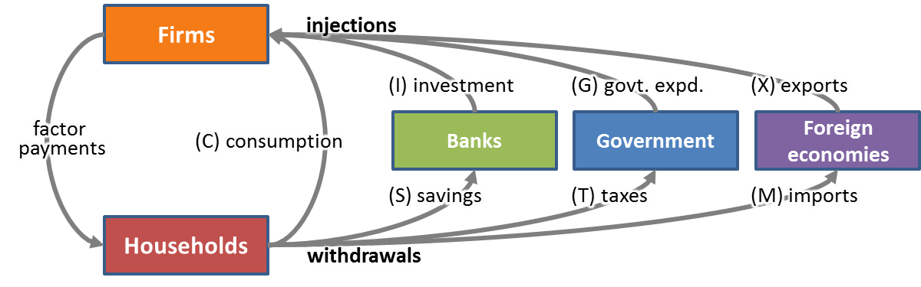

|  |  |  |
| --- | --- | --- |
|  | **Injection** represents (autonomous) spending on final goods and services in addition to domestic consumption. | **Withdrawal** (leakage) is any part of the income that not used to purchase other domestic goods and services. |
| Banking sector | **Investment (I)** refers to the planned net spending by firms on **capital goods** such as plants and machinery and equipment and stock of raw materials.  **Singapore (26.2%)**, as a small and open economy, lacks adequate capital to sustain its rapid growth rate and hence is **dependent on FDI** for its growth.  **USA (15.7%)**, being large, has a sizable sector of domestic enterprises injecting substantial private investment (I), in addition to C, into its circular flow. | **Net savings (S)** is net flow of income from households to the banking sector.  **Singapore (44.6%)**, with its mandatory savings scheme **Central Provident Fund** (CPF) that ensures workers save for their retirement, a relatively high proportion of income is leaked out as S. Singaporeans, who generally uphold Asian conservative values, also have separate savings.  **USA (13.5%)**, with **high levels of domestic spending** by its residents, S is a less significant withdrawal and household are less likely to save but spend. |
| Government sector | **Government expenditure (G)** is expenditure made by local and national government agencies on goods and services that firms produce.  **Singapore (10.3%)**, as there is **wide-spread implementation of supply-side policies** financed heavily by government spending helps Singapore **shift its comparative advantage** towards **knowledge-based, high value-add manufacturing activities** and equip workers with the required skills. However, Singapore practices **disciplined, prudent spending** to achieve a budget surplus. Hence the component of G is relatively smaller.  **USA (18.6%)** as they operate many **welfare-oriented policies** (Medicare and Medicaid) and maintain high military expenditure. | **Net taxes (T)** represent the net flow of money to the government from households and firms.  **Singapore (15.4%)**, due to the **need to attract talent** and companies to base their operations here. Thus, Singapore has low tax rates are in place both for corporations and individuals.  **USA (22.0%)**, as a high tax rate is needed to fund these programmes the many **welfare oriented policies** they operate. |
| Foreign sector | **Exports revenue (X)** is expenditure by foreigners on domestically produced goods and services.  **Singapore (195.8%)**, being a small economy, the **domestic sector is inadequate** in allowing its industries **to reap economies of scale** and sustaining growth. Singapore is **dependent on exports for growth**. As such, X is largely responsible for keeping Singapore's circular flow of income high relative to its domestic consumption, C.  **USA (13.4%)**, as a larger country has the luxury of a **huge domestic market** to supply goods and services for. This implies that USA is **less reliant on exports** as a source of injection given that C is already very high. | **Import expenditure (M)** is planned spending on foreign produced goods and services or factors of production.  **Singapore (170.7%)**, being a small economy, **lacks many resources** to support its production activities. As such, Singapore is **import reliant** in which the bulk of imports consists **raw materials, intermediate goods and commodities**.  **USA (16.3%)**, being a large country **endowed with more abundant resources**, is **less reliant on imports** for its raw materials and intermediate goods. Being less open, USA **could also be erecting trade barriers** against its imports. Hence, relatively speaking, M is a less notable withdrawal for the USA. |

*Explain what is meant by* ***equilibrium*** *in the macroeconomy using the circular flow of income and* ***how the equilibrium output is determined***

The equilibrium national income (output) is **attained when withdrawals equal injections**.   
Otherwise, when injections are higher than withdrawals, national income will increase until the level of withdrawals increase to match injections, and vice versa.   
(refer to multiplier effect)

**Aggregate Demand (AD)** is the **total quantity of goods and services demanded in an economy at a given price level** over a period of time.  
**Key determinants** of AD (followed by autonomous factors that shift the AD curve):

**(C) Consumption expenditure** refers to the planned spending on **consumer goods and services** () by all households in an economy. **Wealth** – greater wealth, less need to save, more likely to spend more  
**Expected future price/income changes** – if higher rate of inflation, or increase in income is expected, more likely to buy big ticket items (car, house, electrical appliances)  
**Interest rates and availability of credit** – if interest rates are low, the opportunity cost of consumption (which is savings) decreases, consumption increases  
**Preferences** – the more the **consumerist and materialistic** countries become, the higher the consumption expenditure

**(I) Investment expenditure** refers to the planned net spending by firms on **capital goods** such as plants and machinery and equipment and stock of raw materials.(relate to **rate of returns** and/or **investor confidence**) **Interest rate** – lower it is, the more likely the rate of returns of investment exceeds the cost of borrowing to finance the investment  
**Exchange rate** – if appreciation is expected, the external value of currency increases over time, the rate of returns is likely to be higher   
**Economic outlook –** if firms are optimistic on the rate of returns, they will be more inclined to invest  **Level of technology** – firms will tend to invest in the new technologies available in the country to increase efficiency   
**Infrastructure and political stability** – a good infrastructure, such as an effective transport and communication network, and stable politics, better returns are expected  
**Education level** – an educated workforce is easier to acquire new knowledge and skills that are necessary to enhance productivity

**(G) Government expenditure** is the planned spending on goods and services, transfer payments as well as investment goods **by the government**.   
discussed under **fiscal policy**

**(X-M) Net exports  
Foreign income levels** – higher the income, consumption expenditure increases, some of which is spent on imports (which is our exports)  
**Exchange rates** – a depreciation of domestic currency (assuming MLC satisfied) increases net exports  
**Relative price levels** – higher rate of inflation in foreign countries decrease net exports (assuming demand of their export in price elastic)  
**Non-price competitiveness** – If domestic goods are more attractive, domestic and foreign consumers are likely to switch to domestic produce. Net exports increase

**Aggregate Supply (AS)** is the **total quantity of goods and services produced in an economy at a given price level** over a period of time.

**Short-run aggregate supply** (SRAS) shows the **level of total planned national output** **when the general price level in the economy can change** but the prices and productivity of all factor inputs in assumed to be constant.

**Cost of production**  
- Direct tax rate  
- Wage rate  
- Price of imported raw materials

**Long-run aggregate supply** (LRAS) is a measure of a country’s ability to produce goods and services when all resources **are fully and efficiently employed**.  
It reflects the **productive capacity** (the potential output of goods and services) of the country,

**Quantity** of resources  
**land** – reclamation of land, discovery of natural resources  
**labour** – increase in size of working population, immigration of foreign talent  
**capital** – refers to the tangible capital goods like plant, equipment, machinery and building, financed by investment.   
Usage of capital goods can bring about higher level of **productivity** and hence higher potential output.

**Quality** of resources   
land – more efficient usage of land / natural resources  
labour – productivity – improves with level of education and vocational training, quality of management   
capital – **technological** improvement   
- **Invention**, which is the creation of new knowledge and new techniques of production   
- **innovation**, which is the application of new technology to the production processes  
They lead to greater productivity and hence more efficient usage of resources. This increase in productive capacity will result in an increase to the potential output. Technological progress can speed up due to government's initiatives to encourage research and development in the country such as the provision of tax incentives for firms.

*Use* ***AE-Income*** *analysis to determine equilibrium level of output and price.*

**National income** is said to be in **equilibrium** when there is **no inherent tendency for it to change**. It is when the plans of all economic agents in the economy are fulfilled and consistent with each other, regardless of whether the economy is at full employment.

Using the output-expenditure method, equilibrium is established when planned **output (Y)** equals **Aggregate Expenditure (AE)**, at income level Ye.

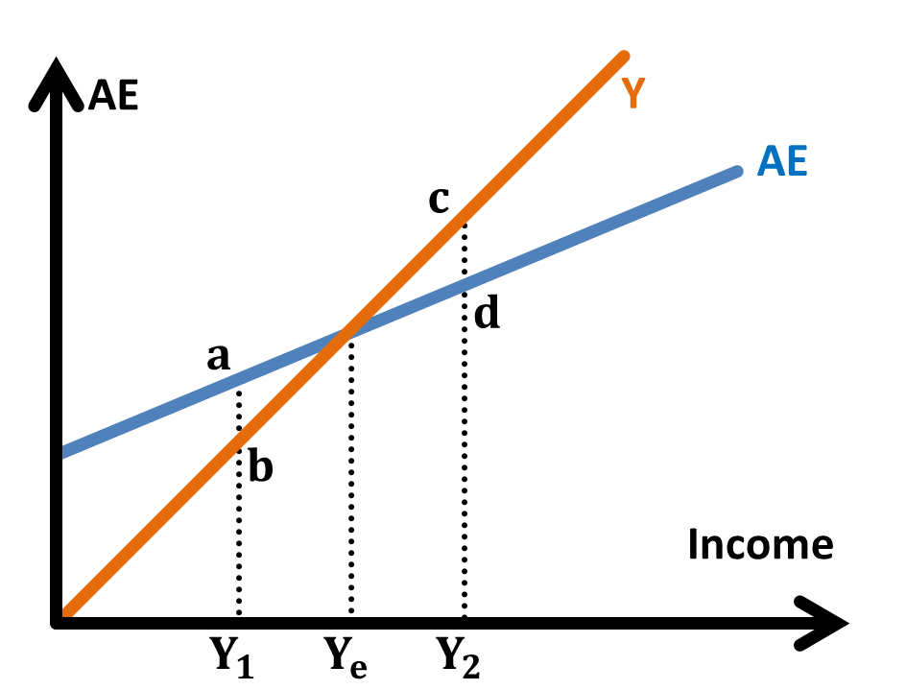**Aggregate Expenditure (AE)** is the total of all **planned expenditure** on **domestically produced goods and services** in the economy over a period of time.

At income level Y1, **planned expenditure (AE) exceeds planned output (Y)** by the **distance ab**.   
There will be **unplanned inventory depletio**n due to insufficient output.   
In the **next time period**, they will adjust their production plans and **increase output**.   
As long as planned expenditure exceeds planned output, firms will experience unplanned reductions in their stocks. Eventually, output will eventually be increased to Ye.

Similarly, at income level Y2, **planned expenditure (AE) falls short of planned output (Y)** by the **distance cd**.   
There will be **unplanned inventory accumulation** due to insufficient demand.   
In the **next time period**, they will adjust their production plans and **decrease output**.   
As long as planned output exceeds planned expenditure, firms will experience unplanned increases in their stocks.  
Eventually, output will eventually be decreased to Ye.

Therefore, **equilibrium** occurs where AE (=C+I+G+X-M) line cuts the income or output (Y) line. This is where firms are able to sell all their planned output without shortage. There will be **no unplanned changes** in stocks and hence no reason or tendency for firms to adjust their production plans.  
At other income levels, there is **disequilibrium** and the economy **will adjust** itself towards equilibrium.

**Changes in any of the components** of AE (C, I, G or X-M) will shift the AE line, thus establishing a **new equilibrium level of income** (output).   
For example, an increase in autonomous investment expenditure (I) will shift the AE line upwards and increase the equilibrium level of Y.

*Explain the* ***Multiplier Effect*** *[A detailed explanation of the multiplier process using numerical illustration and analysis is not required for H1]   
[A broad understanding of the simple multiplier concept – an increase in AD will have a multiplied effect on output – will suffice for H1.   
Mathematical analysis involving the derivation and use of the multiplier formula is not required for H1]*

**Multiplier effect**   
**The actual increase in national income will be greater than the increase in autonomous expenditure**, due to the multiplier effect.

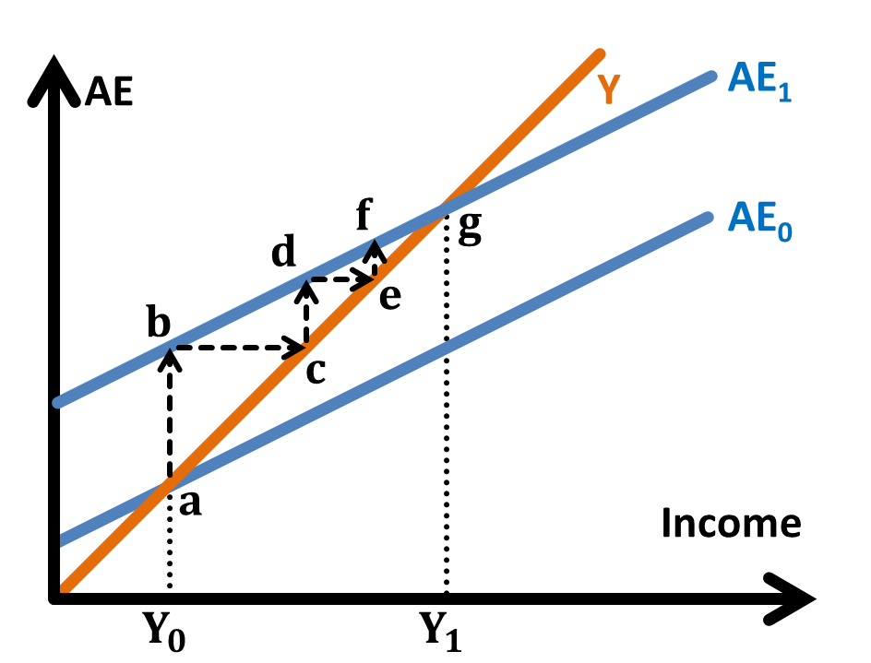If the economy experiences an increase in autonomous foreign investment of $100m (ab),   
there would be an **injection** and AE shifts from AE0 to AE1 and unplanned depletion of inventory results.  
This would create a situation where planned spending exceeds planned output at the existing level of national income.

**Assume that there are sufficient unemployed resources in the economy.** Firms involved in the production of the capital good for the investment   
would increase spending and employ more factors of production to meet the increase in demand.   
This will cause the **income** of the first group of recipients affected by this investment to rise by $100m (bc).

**Assuming that marginal propensity to consume MPC=0.5**,   
this group of people will increase their consumption by $50m (cd),   
and the rest is **withdrawn** as **imports, taxes and savings**.  
This will **increase the income for the second group of recipients**, mainly the retailers, by S50m (de).

Assuming constant MPC, the second group of recipients will also increase their expenditure by $25m (ef), **affecting the income of the third group of recipients**.

This **spending and re-spending effect** will go on until eventually the **original injection (increase in investment)** leads to an **equal increase in withdrawals**   
in the circular flow of income.

At the end of the multiplier process, the increase in the **national income of the country** ($200m) is **more than the initial increase in autonomous investment** ($100m).  
, where size of multiplier

*Explain what is meant by* ***real and nominal GDP/GNP per capita****.  
Explain* ***economic performance*** *(as* ***measured broadly by key economic indicators*** *such as GDP/GNP, inflation rate, unemployment rate, balance of payments)*

**Gross Domestic/National Product** (**GDP/GNP**) is the total market value of **all final goods and services produced** during a specified period  
**within the geographical boundaries** / **by productive factors owned by residents** of a country.

GDP/GNP **per capita** takes into account of population size and reflects the income per individual. **Real** GDP/GNP accounts from price differences **over time**, using the Consumer Price Index (CPI).  
**PPP-adjusted** GDP/GNP in terms of a common currency reflects the **actual purchasing power** of residents/nationals **over space.**

*Explain the meaning of* ***living standards*** *in terms of* ***quantitative*** *and* ***qualitative*** *aspects   
– as* ***measured by real GDP/GNP per capita****,* ***taking into account income distribution****,* ***leisure time****,* ***externalities****,* ***quality of life****, etc.*

**Measurement** problems:   
non-inclusion of **non-marketed activities** such as goods are not provided in organised markets, of do-it-yourself and other home-based activities  
non-inclusion of **underground economy** such as illegal transactions and undeclared transactions (e.g. moonlighting) especially for developing countries.  
**reliability** of measurement changes over time – as countries clamp down on tax evasion / people have greater incentives to evade

|  |  |  |
| --- | --- | --- |
|  | Material SOL | Non-material SOL |
| Indicator | Higher purchasing power to **increase accessibility** to material goods and services. As a higher consumption brings more **satisfaction**, standard of living is increased. **Increased equity** as there can be more transfer payments | **Supply-side polices** on education and healthcare leading to a higher literacy rate and longer life expectancy |
| Limitations | **Inequity** may result instead as growth usually benefit only the skilled population (SOL for the general population may not improve) **Composition of output** **ignored** as living standards depend on consumer goods however **capital goods** are also included, which do not improve welfare directly. | **Negative externalities** with increased emission and waste that worsen pollution, and result in environmental degradation.  **Leisure and human costs of production** due to more stressful and hectic lifestyles with less leisure hours because everyone worked more |

Why GDP or GNP is still the most commonly used measure  
- relatively easy to calculate and statistics are available to most countries, allowing for more international comparisons.  
However, we should bear in mind the limitations by referring to other indicators like HDI and MEW to reflect the standard of living.

# Macroeconomic Objectives

**Economic growth** refers to a **sustained increase in real national income over time**.   
It is indicated by real GDP/GNP.

**Actual growth** refers to the percentage annual increase in the level of national output that is actually produced by the economy  
– increase in AD below full employment, producing towards the PPC

**Potential growth** is the percentage annual increase in the capacity of the economy to produce output  
– increase in LRAS, outward shift of PPC

Causes of economic growth

For long-run economic growth, there is a need to ensure that there is a **continuous increase in AD over time (actual growth)**. Moreover, the increase in AD **need to be matched with a concurrent expansion in productive capacity**, or else the economy will not experience further economic growth as once the excess capacity has been exhausted, any increase in real national income will be accrued to growth of potential output.

Consequences of sustainable economic growth

**Increased equity (or inequity)** and improved (or worsened) material and non-material **standard of living** – (refer to why real GDP per capital can be an indicator of SOL)  
**Improve rate of returns and investors' confidence** (and the impact of increased investment expenditure)   
Attracts **foreign talent**, leading to higher potential growth  
**Worsening trade balance** as import expenditure grows faster than export revenue, due to increase in incomes

Side-effects in the pursuit of high economic growth

**Risk of over-heating** (demand-pull inflation) when **the increase in AD is not match with a sufficient increase in LRAS  
Lower unemployment rate** as firms will require more labour for the production and hence it will lead to job creation  
**Structural unemployment** if growth results from a change of structure of economy without the skills of the labour force adapting  
**Increased vulnerability** (Singapore is highly reliant on FDI, which aggravates the situation during economic downturns as they withdraw capital from Singapore)

**Inflation** is defined as a period of sustained and general increase in the average level of prices within an economy.   
Rate of inflation is the rate at which prices are increasing, and is usually measured by a **Consumer Price Index**.

Causes of inflation

**Demand-pull inflation** is a situation where AD persistently exceeds AS so that prices are being "pulled" upwards with the economy **near or at full employment**.   
Any increases in AD will **intensify the competition for the limited resources for production** and firms will **bid up the prices on factors of production**. To maintain profits, firms will **pass on** the higher factor prices to consumers **as a form of higher prices of goods and services, which in effect is a movement up along the AS curve.**

**Cost-push inflation** occurs when the price level is pushed upwards by increases in factor prices, resulting in a decrease in short-run Aggregate Supply (SRAS).  
**Imported inflation** – due to **depreciation** or rise in the price of imported factors of production  
Wage-push inflation – if trade unions push up wages without corresponding increase in labour productivity  
**Wage-cost spiral** – when firms face a rise in costs of production due to the increase in wages, they will respond by raising **prices of goods**, passing increase in costs **to households**. With this increase in prices, trade unions **may demand for further wage increase** in order **to maintain the real income of the workers**. This will in turn lead to further increases in costs of production and **further inflation**.

Consequences of high inflation

**Worsen investors' confidence and investment climate** (and its effects) due to **greater uncertainty**   
**Discourages savings** as interest rate is smaller than inflation rate, thus **decreasing supply of loanable funds** and **reducing domestic investment**  
**Hinder accurate economic decision-making** for government, firms and investors, due to **uncertainty of real prices**, resulting in allocative inefficiency  
**Worsen income inequality**, as **asset-owners have their wealth increased**, while **fixed-income earners and pensioners will have lower purchasing** power.  
**Loss in** **international price competitiveness** as relative export prices inflate due to rising cost of production. **Assuming that PEDx is price elastic**, the increase in relative price of the domestic economy's exports will **lead to a more than proportionate decrease** in the quantity demanded of exports, thereby **leading to an decrease in export revenue**. The higher relative rate of inflation will also **increase import expenditure** since it will be **cheaper for households to purchase imports**. Taken together, this **worsens the balance of trade**, and consequentially worsens the **current account**. The improvement in current account makes the currency **to depreciate**.

Side effects in the pursuit of the low inflation rate

**Inaccurate information and time lag** in implementing the anti-inflationary demand-management policies, there might be an **over-reduction in aggregate expenditure** (AE) which could lead to a **multiple reduction in national income** and thus, **reducing employment level** or **worsen demand-deficient unemployment**

**Unemployment** occurs when people are without work and actively seeking work.The rate of unemployment is the number of people unemployed as a percentage of the number of people in the labour force.

Causes of unemployment

**Cyclical** (or **demand-deficient**) unemployment  
is associated with the level of AD that is insufficient to provide enough jobs to ensure full employment.  
(since Singapore is highly dependent on trade (X+M is 3 times of GDP), she is particularly affected by changes in global demand)

**Structural** unemployment  
due to a change in pattern of demand or methods of production, the **skills** (or location) of the labour force **do not match** the **requirements of the jobs available**  
demand factors – **changes in consumer tastes**, or **loss of comparative advantage** due to competition from other industries  
supply factors – new techniques of production are invented or technology developed (with capital) is used to replace labour

**Frictional** (part of NAIRU) is caused by normal labour turnover, due to imperfect information  
Workers need to go through a process of job search. **Unemployment benefits** is likely to lengthen the time to find a job as people respond to incentives

Consequences of high unemployment rate

**Loss of production** as unemployment represents the underutilization of an economy's production capacity, or a waste of the economy's resources, which implies   
a loss in potential national income and lowering of standard of living (which is particular worrisome for Singapore where labour and human capital is our only resource). **Loss of human capital** may cause erosion of skills and knowledge during prolonged unemployment, reducing their productivity even if they are re-hired.   
**Loss of welfare of the unemployed**: loss of financial security and material well-being, loss of self-esteem and morale which affects mental health.  
**Financial cost on government** due to loss of tax revenue and increased spending on welfare payments and benefits.  
**Social instability** with increased incidences of crime and violence, incurring higher costs to restore order  
**Inequity** with rise in income inequality and relative poverty, since it is usually the low-skilled and poor who are unemployed

Side effects in the pursuit of low unemployment rate

**Higher rate of growth** as economy produces more nearer to full employment **Risk of over-heating** (demand-pull inflation) when **the increase in AD is not match with a sufficient increase in LRAS**

# Macroeconomic Policies

*Explain monetary policy in a broader international context where* ***interest rates*** *and* ***exchange rates*** *are alternative instruments.  
Explain the* ***causes and effects*** *(domestic and external) of changes in exchange rates and interest rates on the economy.****Evaluate the effectiveness*** *of monetary policy in achieving macroeconomic aims.*

**Monetary Policy** involves government changes in interest rates or exchange rates.

Expansionary monetary policy to increase AD:

|  |  |  |
| --- | --- | --- |
|  | Reduction in interest rates | Depreciation of exchange rate |
| Method | The central bank reduces the discount rate (rate on loans to commercial banks), which decreases interest rates. | Due short-term capital outflows due to fall in relative interest rate, or the government intervene sell its currency to buy foreign currency, resulting in an increase in supply and/or decrease in demand for the domestic currency, which depreciates the exchange rate. |
| Increasing AD | Increase in **consumption (C)** due to lower opportunity cost of consumption since credit is cheaper and saving earn lower interest  Increase in **investment expenditure (I)** as previously unprofitable projects (where rate of returns is lower than the rate of interest) are now profitable | **Assuming MLC is met**, depreciation will increase net exports (X-M). (Marshall-Lerner Condition: PEDx + PEDm > 1) MLC might not be satisfied in the short run, depreciation is likely to worsen the trade balance initially. In the long term, consumers will adjust to the new prices, and trade balance will improve. This is known as the J-curve effect. |
| Limitations | **Pessimistic** economic outlook - **unresponsiveness** **Liquidity trap** – near zero interest rates cannot be lowered further. (Money demand is interest inelastic) | This result in a **loss of investor confidence**. **Imported inflation** results, resulting in loss in non-price competitiveness, especially if export has high imported content |

As Singapore is a small and open economy, she is an interest rate taker.   
Any increase in interest rates will result in an inflow of hot money which increases the supply of loanable funds and bring interest rates back to equilibrium.  
Monetary policy is centred on exchange rate instead (managed float):  
- **modest and gradual appreciation** (**to keep imported inflation in check** and maintain the price competitiveness of Singapore’s exports)   
(However, Singapore also exports services, which has less imported content and does not benefit from the strong Singapore Dollar)   
- **zero per cent appreciation** (in times of recession to prevent net exports from falling further)

*Explain* ***government expenditure*** *and* ***taxation*** *as* ***tools of discretionary fiscal policy.****Evaluate the* ***effectiveness*** *of discretionary fiscal policy – for example,* ***accuracy of forecast****,* ***availability of information****,* ***time lags****,* ***crowding-out effect****,* ***policy acceptability***

**Discretionary Fiscal Policy** in which the government deliberately varies the level of government expenditure and/or taxation to influence AD and affect economic activity.  
(Automatic stabilisers (like progressive tax, transfer payments, unemployment payouts) reduce the magnitude of fluctuations of AD)

Expansionary fiscal policy to increase AD:

|  |  |  |
| --- | --- | --- |
| Method | Increase government expenditure | Reduce direct tax rate – and/or focus on indirect tax |
| Increasing AD | **Government expenditure (G)** is a part of AD (which leads to a multiplied increase in real national income, assuming below full employment) | Increase in **investment expenditure (I)** with more **after-tax profits** after corporate tax and the **rate of returns** is now higher for foreign investors Increase in **consumption (C)** with **higher disposable income** after income tax |
| Side-effects and  limitations | **Higher equity** if the poor gets more payouts | Inequity may arise from excessive focus on indirect tax |
| **Supply-side effects** (interventionist supply-side policies involve government expenditure)  **Strain on government budget**, as the increase in government expenditure and maintaining the budget position either means less resources are spent elsewhere (opportunity costs), unless taxes are increased.  Government debt, if incurred, needs to be financed in the future (including interest), which may spiral to a point where it is impossible to pay up.  **Size of multiplier** (small for Singapore) – large proportion of government spending will be leaked out on imports and savings.  **Crowding-out effect** arises when increase in government spending reduces other types of spending such as investment (if financed through loans) and consumer spending (if financed through taxes). AD will then not increase or increase very slowly.  **Time lags** of effect on AD and pessimistic consumer/investor sentiments which results in the economy not being effectively stimulated.  **Policy acceptability** (for contractionary FP) a welfare state may be seemed as a right of the people, and it might be difficult to implement austerity measures even when the government needs to recover from debt. | |

Singapore government expenditure and tax revenue   
Sources of tax revenue – 22% corporate tax, 17% Goods and Services Tax, 13% personal income tax  
Government expenditure – 22% defence, 20% education, 13% healthcare, 11% transport

**Supply-side policies** increase AS by improving the workings for factor and product markets.

Singapore, as an open economy closely linked to changes in the world's economy, is **particularly vulnerable** to changes in export demand and developments in other countries. There is hence a need to **constantly restructure** the economy to ensure that Singapore **remains viable**, **competitive and relevant** in the face of **global competition**. **Wide-spread implementation of supply-side policies** financed heavily by government spending helps Singapore **shift its comparative advantage** towards **knowledge-based, high value-add manufacturing activities** and equip workers with the required skills.

|  |  |  |
| --- | --- | --- |
| Supply-side policies | **Interventionist** supply-side policies:  To **counteract the deficiencies** of the markets To **prevent overheating** and achieve sustainable economic growth. | **Market-oriented** supply-side policies:  **Freeing** up the markets and **use its advantages** to increase AS. |
| To **increase LRAS** to encourage potential growth  by  attracting investment | **Increase in government spending**  - on training to **enhance productivity** (e.g. Continuing Education and Training)  - **research and development** subsidies (e.g. in green technology) - provision of **infrastructure** (e.g. flatted factories) which are perceived as risky investments by profit motivated firms.  **Reducing corporate tax**  **Increases after-tax profits** which release more funds **for investment**.  Banks are reluctant to lend to firms to finance their long-term investment. (Singapore corporate tax has been reduced to a low 17%) | **Reducing red tape and other impediments** to investment and risk taking, free up markets for investments. (Pro-Enterprise Panel to solicit feedback on rules and regulations from firms)  Establishment of **intellectual property rights** helps to create incentive for firms to innovate and increase efficiency and consumer choice.  (Singapore has a dual system of trade mark law to provide protection for trademarks under the Trade Marks Act and at common law) |
| To **increase SRAS** to reduce cost push inflation  by  reducing cost of production | **Subsidies on factors of production** Increases SRAS  (oil subsidies in Malaysia and Indonesia)  (Singapore Workfare Income Supplement – ensure the employees’ wages remain low, as it is borne by the government. This increases the income of older low-wage workers and also encourage them to stay employed)  **Increase government expenditure**  - In training of workers to **increase in labour productivity**  a fall in unit cost of labour, reduced wage push inflation and a rise in SRAS  **Appreciation of currency**  to reduce imported inflation, reduces cost of production and increase SRAS | **Flexible labour policies**  increase supply of labour (by introducing migrant workers) and increase competition in the labour market puts a downward pressure on the wages.  **Encouraging competition**  **Privatisation** involves transfer of a **natural monopoly** run by the government to the private sector. **Deregulation** involves the removal of monopoly rights.  As firms are **profit-motivated**, they will find more **cost efficient methods** to produce the goods and services and have **more incentive to innovate** (which also increases LRAS)  (e.g. Korea and Japan privatise their steel industry to enhance export competitiveness of automobile)  (deregulation of the telecommunications industry in Singapore) |
| To reduce structural unemployment | **Increase in government expenditure**  - for retraining and upgrading of skills allows low-skilled workers to find jobs in other sectors, increasing the supply of labour in needed sectors  - upgrading of skills increases the supply of skilled workers that are demanded by sunrise industries  (Singapore Workfare Training Support – help low-wage workers to train and upgrade skills to earn more) | **Reduce the power of the trade unions** creates more incentives for the workers to take up retraining and  work in other industries |

Limitations and side effects of supply-side policies

**Strain on government budget**  
Increase in government expenditure on these policies and maintaining the budget position either means less resources are spent elsewhere, unless taxes are increased

**Long time frame**  
Policies that require structural changes can only take effect in the long term

**Time lags, accuracy and availability of information**  
It is difficult to accurately predict and forecast the economy’s needs in the future

**Feasibility**  
**Illiterate people** will find it difficult to get new skills.

**Policy acceptability**  
It may be difficult to convince workers to go through retraining programs or switching jobs  
Introducing technology to take care of menial work may been seen as taking jobs away from low-skilled workers  
Increased competition resulting from the introduction of foreign talent and migrant workers may cause resentment

**Increases national income**   
Firms involved in the training would increase spending and employ more factors of production to meet the increase in demand,   
which eventually cause a **multiplied** increase in income

# The External Economy

The **balance of payments** (BOP) is an official record which **summarises all the economic transactions** which take place between the residents of a country   
with the rest of the world over a period of time, usually one year.

**BOP should return to equilibrium.** A BOP deficit results in an increase in supply of domestic currency and depreciates the exchange rate (assuming that it is free floating)   
Assuming MLC is satisfied, net export (X-M) will increase, and this results in an improvement of the BOP.

Consequences of a persistent BOP deficit

**Imported inflation** results from depreciation, which increases the cost of production.  
**Foreign debt** results due to **constant draw on foreign reserves.** It cannot be financed indefinitely,   
and the earnings of the country will have to be diverted to service the debt including interest, leading to lower national income.  
**Sudden depreciation** may occur to the exchange rate may as it does not have sufficient foreign reserves. This worsens the rate of returns and the investor confidence.

|  |  |  |  |  |
| --- | --- | --- | --- | --- |
|  | **Current account**  records transactions of currently produced goods, currently rendered services and unrequited transfers | | | **Capital account** records short-term and long-term capital flows. |
| Causes of deficit | **Higher relative growth**, resulting in import expenditure rising faster than export revenue. | price competitiveness | non-price competitiveness | Short term capital (**hot money**) **outflow** due to relatively lower **interest rate** elsewhere, or speculation of depreciation of currency  Deterioration of **investment climate** or a lower rate of returns compared to other countries, due to many reasons such as political instability, pessimistic economic outlook, better infrastructure and human capital elsewhere |
| **Higher** **production costs** resulting from the use of less efficient methods of production or lower rate of improvement in productivity  **Relatively high rate of inflation** compared to its major competitors | A **slower rate of improvement** in **design/quality of products** or  in **sales effort** compared to the other countries |
| Policies | **Expenditure reducing** policies (contractionary monetary or fiscal policies) | **Expenditure switching** policies (protectionism) Supply-side policies | Trade fairs  Supply-side policies | Raise interest rates for hot money  (not advised as they are unstable)  **Improve investment climate**  (with supply-side policies, political stability) |

Another cause of BOP deficit:   
Importing capital goods – to build up infrastructure and productive capacity - (however not persistent as it will result in improvement of the current account in the long run)

# The International Economy

*Explain the* ***gains from international trade*** *using the* ***concept of opportunity cost*** *and* ***comparative advantage****.*

**The theory of comparative advantage** (CA) makes the point that countries are better off when they **specialise** in the production of good that they have **CA** in (incur a **lower opportunity cost**) and **trade** for goods that they do not have CA in.

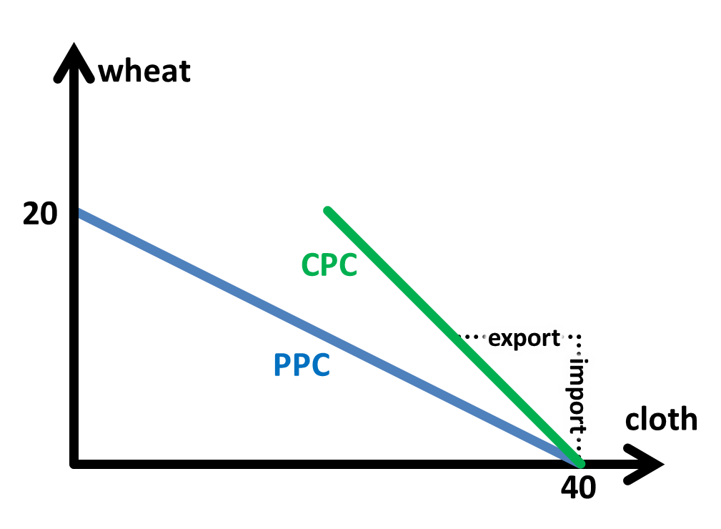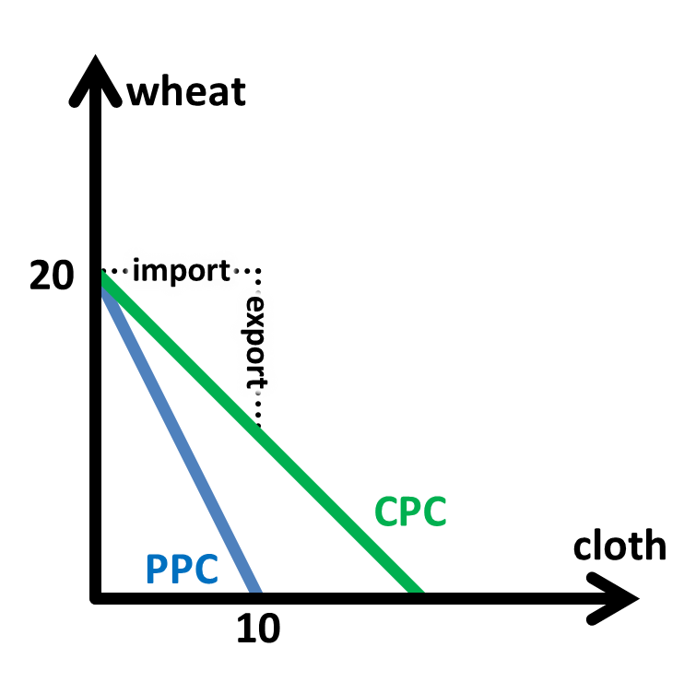

The theory assumes that there are **no barriers to trade**, **no transport cost**,   
**constant** average **cost of production** and constant **opportunity cost**  
perfect **factor mobility in the country**, and **factor immobility within countries**  
the **terms of trade** (TOT) between countries are mutually beneficial

Assume two countries, China and USA, produce two goods, wheat and cloth.   
The following diagram show the production possibility curve (PPC) to the two countries.

China has CA in producing cloth, with the opportunity cost of 0.5 wheat, compared to USA’s 2 wheat.  
USA has CA in producing wheat, with the opportunity cost of 0.5 cloth, compared to China’s 2 cloth.

Hence, both countries should **specialise completely in its area of comparative advantage**.  
So China produces 40 cloth and USA produces 20 wheat.

Both countries now settle terms of trade (TOT) that are mutually beneficial. Considering their CA, China will not accept less than 0.5 wheat for a cloth produced,   
USA will not accept less than 0.5 cloth for a wheat produced.  
Assume TOT is set at 1 wheat for 1 cloth, the following **consumption possibility curve** (CPC) is plotted.

By specialisation and trade, each country benefits because they can now **consume outside the PPC**, which was **previously unattainable**, **reducing** the problem of scarcity.

|  |  |  |
| --- | --- | --- |
| Assumptions of comparative advantage | Applicability and Limitations | Reference to real world trends |
| **Constant opportunity costs of production** (Straight line PPC) | **Law of Increasing Opportunity costs** Countries will lose their CA as they specialise further, as not all resources are equally suited for all types of production.  **Economies of Scale** Producing more good reduces average cost | |
| **Perfect factor mobility within each country** Resources can be easily transferred from the production of one good to another | Land may not be suitable for all uses, and require time to change the land usage. Labour requires time to be re-equipped with new skills. Machines cannot be transformed for other uses. Technology takes time to develop. | |
| **Factor immobility between countries**  Each country can only use her own resources | Labour, capital and technology and **can be transferred** between countries. | Globalisation results in **increasing capital flow** (FDI) and **labour flow** (foreign talent and migrant workers) |
| **No transport costs** | Transport cost may be very high in international trade, making it **cheaper to produce goods domestically** than to import them. | **Falling transport costs** with the development in technology.  However, transport costs are still a consideration, especially if they are shipped through aircraft. |
| **No trade restrictions** | Free trade does not always exist, due to **protectionism**  (refer to below) | Countries are signing of **FTA** to reduce trade restrictions. However, there is a **rising trend of protectionism** recently. |
| **Demand for the good is homogenous** | Countries may produce similar goods but different them enough such that countries producing similar goods will still import these goods. | Residents may prefer products designed and made by their countries just because it is “**patriotic**” or due to “buy-national” initiatives |
| **Demand for good is large enough** | Oversupply of a good (despite one has CA) will face an unfavourable TOT | Some goods have limited demand (tea leaves, luxury watches)  – which will be inexpensive if produced in excess |

Other arguments for free trade (and hence against protectionism)

**Higher revenue** through exports resulting in **economic growth** and increase in national income due to higher demand for exports from the opening of international markets.

**Lower prices** from **competition** in a larger market, allowing **factor price equalisation** and motivating R&D and technology advancement

**Lower average costs** from the exploitation of **economies of scale**, resulting in increased consumer surplus.

**Greater variety and lower cost** of goods and services which increases consumer welfare

**Social, political cultural ties**, providing stronger reasons for peace and harmony

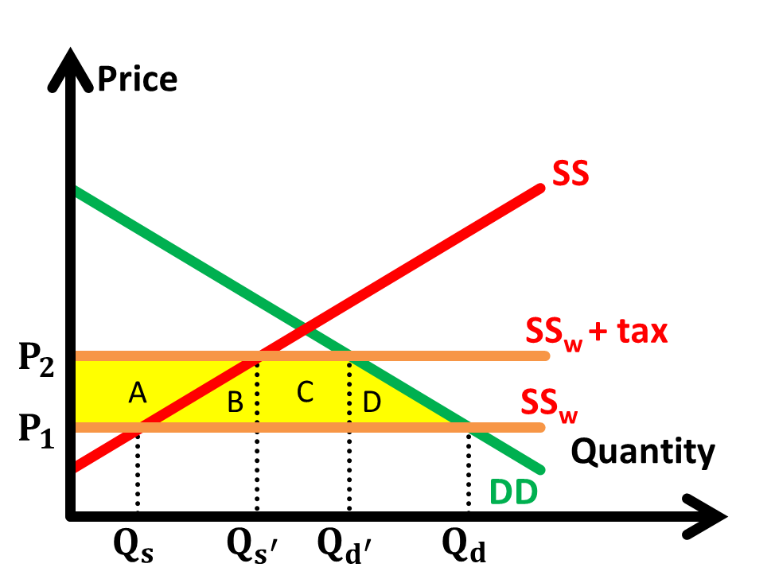**Protectionism** refers to any action that the government may take to influence market forces to provide an advantage to domestic industries over foreign producers.

**Tariffs** – taxes imposed on imported goods, raising the domestic price of imports (diagram on the right)  
**Quotas/Embargoes** – limits imposed on the quantity of a good that can be imported during a given period  
**Subsidies** – to increase the price competitiveness of exports  
**Exchange controls** – limits on how much foreign exchange can be made available to importers  
**Administrative restrictions and costs** – rules and regulations (aka red tape)

|  |  |
| --- | --- |
| Arguments for protectionism | Evaluation |
| **Improve BOP**  To restrict imports to curb excessive import expenditure over export revenue | Trading partners’ net exports fall and their income reduced. They will imports less, resulting in the **net exports** falling in the long run. **Retaliation** by trading partners is likely to result to prevent a loss in output  starting a vicious cycle of protectionism which will benefit none.   * Not tackling the root cause of the problem (loss in export competiveness) |
| **Reduce cyclical unemployment**  Protectionism will divert demand from foreign goods to domestically produced goods, protecting employment in those industries. |
| **Reduce structural unemployment** Allow sunset industries to decline slowly and prevent sudden structural unemployment by providing some buffer time for workers to be retrained and seek other jobs. | May **hinder the restructuring** of the economy, because there is reduced motivation to  move on and grow through the development of new sectors. |
| **Protection of infant industries**  Infant industries have potential CA, who need to be shielded from foreign competition in early stages, to give them time to develop and reap EOS. | Difficult to determine which industries have potential CA, and they may fail to develop CA. Should be a temporary measure, and it is difficult to judge when to withdraw protection. May breed inefficiency and complacency, resulting in high prices and low quality goods. |
| **Protection against dumping** Selling goods below MC, destroying local competition  Predatory dumping (become monopoly in the market, gain market power) | Domestic produces may falsely accuse foreign firms of dumping when they cannot match their lower prices, which may actually be so due to them being more efficient. |
| Other arguments (political embargoes, strategic industries, harmful goods) | depends on how its purpose and benefits of trade weigh out |

*Use* ***demand and supply analysis*** *to explain* ***pattern of trade*** *between countries   
Explain* ***Singapore’s*** *pattern of trade with the rest of the world and recent developments (e.g. FTAs)*

Singapore is the world's most trade dependent nation. In 2009, Singapore has the world's highest trade to Gross Domestic Product (GDP) ratio, with imports and exports amounting to about 3.5 times the value of the GDP. Our main trading partners are Malaysia, China and Indonesia and 70% of our total trade value is with countries in Asia.

Being a small and open economy with limited resources, Singapore is **largely dependent on goods imported** from other countries. The principal imports are crude petroleum, foodstuffs, consumer goods, chemicals, machinery and equipment, inclusive of electronics, imported mainly from Malaysia, US, China and Japan. Re-exports constitute an important component of Singapore's exports, taking up about 50% of Singapore's total exports.

On the other hand, Singapore then creates high value-added goods using imported factors of production, and **exports them to the trading partners**. The main exports include non-oil exports like computer equipment and electronic products, pharmaceutical products and petroleum products as well as services such as financial services. Singapore's main exports are sold to Malaysia, Hong Kong, Indonesia, China and US.

|  |  |  |
| --- | --- | --- |
| **Supply** | | Singapore |
| CA of the economy  (supply) | The theory of comparative advantage (CA) makes the point that countries are better off when they specialise in the production of good that they have CA in (incur a lower opportunity cost) and trade for goods that they do not have CA in. The difference in opportunity costs is due to the **differences in factor endowment**. Therefore, an economy will export goods that they have CA in, and import goods that they do not have CA in. | Singapore has CA in knowledge intensive and high value-added service industries. Thus Singapore exports pharmaceuticals, financial and shipping services, and imports crude oil and dairy products. |
| Government policies | Through incentive and provision of infrastructure, the government spearheads the development of various industries to gain CA. | Development of Jurong Island - petrochemical  Biopolis – biomedical R&D, pharmaceutical |
| Free Trade Agreement (FTAs) | FTA is trade treaties between two or more countries, whereby trade barriers between member countries are reduced, or totally removed while barrier remain against non-member countries.  As FTAs and economic cooperation facilitates cross border movement of goods and service between member countries, a **country’s main trading partners** are other countries with which she has FTAs. | Singapore, as a small and open economy highly dependent on free trade, has a strong interest in FTAs and support regional initiative such as APEC and ASEAN. Singapore also has a FTA with US (2nd top importer of non-oil domestic exports) |
| **Demand** | |  |
| Consumer taste and preferences | While a country may produce and export agricultural products, they may still import the good of the same kind as the people demand variety | While Singapore export finished electronics, we import other electronics partly because of demand. |

*Discuss how economic globalisation* ***impacts*** *on* ***trade in goods and services*** *and* ***foreign direct investment*** *with respect to the* ***Singapore*** *economy*

**Globalisation** refers to the closer integration of counties and peoples of the world, resulting in increased openness of economies to international trade, financial flows and foreign direct investment.

|  |  |  |
| --- | --- | --- |
| Immediate impacts of globalisation | | |
| **Greater trade and competition** | **Greater mobility of labour** | **Greater mobility of capital** |
| Benefits of trade apply.  Difficult for **developing countries** to **compete** with **advanced countries with advanced technologies** which allow them to produce with very low costs. Some governments heavily subsidise producers to produce and export at artificially low prices.  This intensifies global inequality and the poor are being marginalised.  Difficult for **advanced countries** to **compete** with the **emerging economies with low cost of labour**. Advanced economies need to speed up the process of structural changes to find new areas of CA in high value goods and services – **structural unemployment** may result due to factor resources occupational and geographical immobile.  **Greater vulnerabilities** result from the higher dependence on the international market, such as **imported inflation** resulting in rise of the cost of production, and **global recession** resulting in fall in export revenue. | **Low skilled migrant workers**  Workers seek work in more developed countries, due to domestic unemployment and poverty. They contribute to home countries through remittance which improves current account balance which is a component of BOP.  **Outsourcing**  Firms can outsource work to countries with lower labour costs to decrease the cost of production. However, it may cause the wages low skilled workers depressed and structural unemployment.  **High skilled foreign talent** The well-educated are likely to migrate in search for better working prospects (and enhance their skills through on-the-job training and increased exposure). There are also greater opportunities to attract foreign talent which augment the labour force and create potential growth.  However, the home country is deprived of the human capital necessary to drive productivity and growth. | **Hot money**  Decreased restrictions on foreign capital allow rapid exist of international capital from a country. Capital flight results. Economic instability results for small and open economies that are vulnerable to external shocks.  **Foreign Direct Investment** (FDI)  FDI supplements domestic investment and create jobs and economic growth through transfer of skills, technology and knowledge, as well as the introduction of the export market.  Increases the level of competition with MNCs.  SMEs may not be able to compete against large MNCs with market power to drive out competition. Over-reliance of MNCs also makes the economy vulnerable, due to their footloose nature.  MNCs tend to exploit non-renewable resources and use the cheapest method of production at the expense of the environment and labour, resulting in high negative externalities. |

