<https://iapp.org/news/a/the-industry-of-privacy-project-early-insights/> growing importance of privacy professionals

<https://www.youtube.com/watch?v=HAC6sqq7_-U> video on democratizing access to data using ideas from cryptography - encrypted, decentralised AI

Deep learning, federated learning, homomorphic encryption, and blockchain smart contracts.

<http://www.oecd-ilibrary.org/science-and-technology/exploring-the-economics-of-personal-data_5k486qtxldmq-en> paper on how to measure the value of privacy

One of the most important ways to understand the monetary value of data is to look at its price in competitive markets. The price for data in the market is determined by the intersection of supply and demand. But personal data is a “non-rival” or “non-substractable” good in economics, meaning that the use of the data by one person does not diminish the stock of the good; the same record can be sold many times to many customers, and the same record can be used multiple times by the same customer. As a result, the market price for a record sold to one customer does not reflect the full monetary value of the underlying data but rather provides an indication of the market clearing price that individual customers pay for a copy of the data. The average revenue per record highlighted in the first methodology is comparable to the sum of the prices that all customers paid for an individual record over the course of one year.

**pg30**

• First, people tend to differ with respect to their  
o individual valuation of personal data (i.e., amount of money sufficient for them to  
disclose personal data)  
o individual valuation of privacy (e.g., amount of money they are ready to spend to  
protect their personal data from disclosure)  
• Second, these valuations are extremely context dependent, and cannot be measured with an  
absolute certainty and precision.

<https://www.bloomberg.com/news/articles/2017-11-21/uber-concealed-cyberattack-that-exposed-57-million-people-s-data> big data breach with many data values that we can compare with.

Uber paying hackers $100,000 to conceal data breach

A patchwork of state and federal laws require companies to alert people and government agencies when sensitive data breaches occur. Uber said it was obligated to report the hack of driver’s license information and failed to do so.

In January 2016, the New York attorney general fined Uber $20,000 for failing to promptly disclose an earlier data breach in 2014.

The company plans to release a [statement](https://www.uber.com/newsroom/2016-data-incident/) to customers saying it has seen “no evidence of fraud or misuse tied to the incident.” Uber said it will provide drivers whose licenses were compromised with free credit protection monitoring and identity theft protection.

<https://www.theatlantic.com/technology/archive/2016/12/businesses-regularly-pay-ransoms-for-their-data/511418/> value of data to companies is very high, often rising above $40,000 to pay ransomware.

<https://www.thenational.ae/business/technology/all-of-yahoo-s-accounts-were-hacked-in-2013-data-theft-1.663902> 2013 Yahoo data theft. The breach of 3 billion accounts was the largest in history

<https://www.thenational.ae/uae/how-much-your-personal-data-is-worth-to-hackers-1.681692#2> price list by symantec stating the price of black market stuff in 2017.

## The price of your data

<https://www.forbes.com/sites/robertlenzner/2013/09/23/attverizonsprint-are-paid-cash-by-nsa-for-your-private-communications/#3928647a43cb>

AT&T charges $325 for each activation fee and $10 a day to monitor the account, according to the AP. Verizon charges $775 per tapping for the first month and then $500 a month thereafter, according to the Associated Press today. In a separate report the Washington Post reported that NSA pays the telcos roughly $300 million annually for access to information on their communications.

Reported SEP 23, 2013

<http://blogs.teradata.com/international/putting-a-price-on-data/>

Think about some of the world’s largest tech companies for a moment. Google has declared assets of US$110B. Yet only 5% of this is tangible assets. Another example is Facebook. The company was initially valued by the market at $104 billion, despite having recorded assets worth only $6.3 billion. These stores of data are, as such, not reported in financial statements.

Consider current valuation of companies:

|  |  |  |  |  |
| --- | --- | --- | --- | --- |
| Company | Monthly active users | Description | Market Valuation | Reference |
| Google |  | Search engine |  |  |
| Facebook |  | Social network |  |  |
| Twitter |  | Short message sharing |  |  |
| Instagram | (at acquisition) | Image sharing | (acquired at) |  |
| Snapchat |  | Short video sharing |  |  |
| Quora |  | Question and answer |  |  |
| Whatsapp | (at acquisition) |  | (acquired at) |  |
|  |  |  |  |  |

<https://www.theguardian.com/news/datablog/2014/apr/22/how-much-is-personal-data-worth> (Reported 22 April 2014)

Some startups have taken moves to re-appropriate saleable user data such as Handshake and Datacoup. These companies offer ways of cutting out the middleman and selling your data straight to third parties. You won’t make £288 though. Datacoup will only pay you $8 a month and while Handshake allows you to negotiate with brands wanting to buy your data, it is still in beta so it remains to be seen what money there is to be made there. (Those two are down already.)

<https://ig.ft.com/how-much-is-your-personal-data-worth/> (JUNE 13, 2013)

Calculator for how much your data is worth, based on your demographics and purchasing power and purchasing potential. Can test the value of certain attributes.

<https://www.ft.com/content/3cb056c6-d343-11e2-b3ff-00144feab7de>

(JUNE 13, 2013)

Article from 2013 that states that personal data comes cheap - Good for comparing the articles over time and their valuation of data.

General information about a person, such as their age, gender and location is worth a mere $0.0005 per person, or $0.50 per 1,000 people. A person who is shopping for a car, a financial product or a vacation is more valuable to companies eager to pitch those goods. Auto buyers, for instance, are worth about $0.0021 a pop, or $2.11 per 1,000 people.  
  
Certain milestones in a person’s life prompt major changes in buying patterns, whether that’s becoming a new parent, moving homes, getting engaged, buying a car, or going through a divorce. Marketers are willing to pay more to reach consumers at those major life events. Knowing that a woman is expecting a baby and is in her second trimester of pregnancy, for instance, sends the price to tag for that information about her to $0.11.  
  
The more intimate the information, the more valuable it is. Some of the most personal and secretive troves of data rank as the most expensive. For $0.26 per person, buyers can access lists of people with specific health conditions or taking certain prescriptions.

However, even adding those details up, the sum total for most individuals often is less than a dollar.

<http://www.visualcapitalist.com/much-personal-data-worth/> 12 Dec 2016

Good visualization of all the types of useful data to companies

How much data is worth to companies. A study of 9 key data brokers found that they generated approximately $426 million in revenue.

$196,206,100 spent on Marketing products (Marketing analytics, customizing marketing messages), $177,842,153 spent on risk mitigation products (identity verification and fraud detection), $52,694,542 spent on People Search products (To locate and track people)

<https://techcrunch.com/2015/10/13/whats-the-value-of-your-data/>

Good case study of the first time a company evaluates the price of personal data and compensates people for the data breach.

On September 18, 2015, Comcast reached a $33 million settlement over claims that it published personal information of more than 75,000 customers — even though those customers had specifically paid a fee for their information to be kept private. As a consequence, the company will pay a $100 compensation to each victim.

**Data valuation by shareholder**

In light of this valuation method, Facebook decided to acquire WhatsApp for $19 billion; that is, to pay $30 for each of its 600 million users. Similarly, the company headquartered in Menlo Park also paid $30 for each of the 33 million Instagram users back in 2012. A similar computation was applied when Minecraft was acquired by Microsoft.

In this situation, the value of a user varies from about $15 to more than $40. The difference lies mostly in the potential expected from each user.

**Data Valuation By The Company Itself**

A second way to approach this question is to account for the revenues generated by the customers (when they do. It was not the case for Instagram or Whatsapp at the time of their acquisitions.) The generally accepted valuation method in this situation is to estimate the value of a client as a function of the net present value it will generate for the company in the future. This is called the Customer Lifetime Value (CLV).

**Data valuation by the individual user**

Finally, how do we, as users of products and services of digital companies, value our own personal data? It is interesting to note that while many fiercely oppose corporations using their personal data, very few are willing to pay an extra fee to protect it.

**Data as a strategic asset in the knowledge economy**

The value of raw data varies from a hundred cents to a hundred dollars per individual. If raw data has a very low value, the more it is enriched, analyzed and leveraged for specialized uses, the more its value increases.

<http://www.zeit.de/digital/datenschutz/2011-03/data-protection-malte-spitz>

Every ten minutes, Spitz’s phone checked in with his provider to see if there were new emails, a function that many smartphone owners have activated. Since his phone was rarely turned off, Spitz’s movements were tracked 78 percent of the time.

<https://nypost.com/2017/06/23/heres-how-much-your-personal-data-is-worth-to-hackers/> (June 2017)

Keeper, a password management app, claims that hackers have stolen around $100 billion worth of personal details since 2010. They estimate that each makes around $41.47 per hour by cracking into valuable databases. Most expensive is a complete medical record – gaining up to $1,000. This could be used for bribery or to sell on to insurance companies. Next up is your credit card details – getting up to $22.39 per person. A driver’s license would make someone $20. Your precious Netflix password will go for around $3.05. Spotify passwords cost $2.80 and email addresses get a measly $2.29.

<https://keepersecurity.com/blog/2017/05/12/what-is-the-value-of-stolen-digital-data/> price of average Paypal credential is $1.50. Bank accounts lower than $2000 cost around 100, bank accounts with $15000 more more cost $1000 or more.

<https://keepersecurity.com/assets/pdf/Infographic-how-hackers-make-money.pdf> average cost of unlocking a computer is $1077.

<http://bgr.com/2016/12/29/facebook-instagram-acquisition-1-billion-genius/>

From an economic standpoint, Instagram is already paying dividends via highly targeted and lucrative ads. During the first quarter of 2016, for example, it was estimated that revenue from Instagram checked in at $572.5 million and accounted for 10% of Facebook’s overall revenue. In fact, analysts at Credit Suisse believe that Instagram will have delivered $3.2 billion in revenue for Facebook by the time 2016 comes to a close. That’s not bad for a $1 billion acquisition that Facebook is still in the relatively early stages of monetizing.

<http://www.visualcapitalist.com/much-personal-data-worth/>

Very useful information

<https://www.wired.com/story/decentralized-social-networks-sound-great-too-bad-theyll-never-work/> (09 AUG 2017)

Our research—a combination of technical and historical analysis, and dozens of interviews with open web advocates—indicates that there is no straightforward technical solution to the problem of platform monopolies. Moreover, it’s not clear we can solve the nuanced issues of centralization by pushing for “re-decentralization” of publishing online.

A better strategy would be to pursue policies that strengthen the environment for decentralized platforms, including data portability, interoperability, and alternatives to advertising-based funding models. For instance, if users have more control of their data, including the right to export and reuse content they’ve created and friends they follow, they’ll be more willing to experiment with new platforms. Decentralized web advocates have good intentions, but there’s no silver-bullet technical solution for the challenges that lie ahead.

<https://www.mcafee.com/us/resources/reports/rp-hidden-data-economy.pdf> MacAfee’s report on the prices of information, similar to those obtained by Keeper.

<https://www.trendmicro.com/vinfo/us/security/news/internet-of-things/how-much-is-your-personal-data-worth-survey-says> 2015 how much people money do people think their personal data is worth, sorted by area. Cultural impacts make a huge difference

<http://www.more-with-mobile.com/2013/06/prices-and-value-of-consumer-data.html> price decline of data over time. Many unreliable numbers of individual’s worth of data also

<https://thegreatdissonance.wordpress.com/2017/06/03/how-much-is-data-worth/> value of personal data is actually increasing over time, partially due to network effects

Finding someone’s information:

<https://www.pcworld.com/article/151556/usesensitive.html>

<https://www.makeuseof.com/tag/4-steps-find-information-someone-online/>

<https://www.peekyou.com/>

<https://www.beenverified.com>

<https://www.valuepenguin.com/banking/average-checking-account-balance> median amount of money in an American’s account is 2900. Average is 4436.

<https://www.creditdonkey.com/average-american-savings-statistics.html>

<https://www.technologyreview.com/s/528866/researchers-test-personal-data-market-to-find-out-how-much-your-information-is-worth/> Satiano experiment outline

<https://arxiv.org/abs/1407.0566> paper by staiano

<http://www.totallymoney.com/personal-data/infographic/> infographic showing how much difference between what consumers think something is worth, and what something really is worth, to consumers. 2013 study. Prices are overly high in comparison.

<http://www.telegraph.co.uk/technology/news/12012191/How-much-is-your-personal-data-worth.html> According to a new survey of 5,000 consumers by digital storage company Western Digital, the average consumer values their personal data at £3,241.

## Actions taken to protect data

<https://www.pdpc.gov.sg/Legislation-and-Guidelines/Personal-Data-Protection-Act-Overview>

Objectives of the Personal Data Protection Act

Today, vast amounts of personal data are collected, used and even transferred to third party organisations for a variety of reasons. This trend is expected to grow exponentially as the processing and analysis of large amounts of personal data becomes possible with increasingly sophisticated technology.

With such a trend comes growing concerns from individuals about how their personal data is being used. Hence, a data protection regime to govern the collection, use and disclosure of personal data is necessary to address these concerns and to maintain individuals’ trust in organisations that manage data.

By regulating the flow of personal data among organisations, the PDPA also aims to strengthen and entrench Singapore’s competitiveness and position as a trusted, world-class hub for businesses.

<http://ieeexplore.ieee.org/stamp/stamp.jsp?tp=&arnumber=7163223>

Decentralizing Privacy: Using Blockchain to Protect Personal Data

## The Network Effect (Value of Quantity/Quality of Connections)

<https://cepr.org/sites/default/files/Weiergr%C3%A4ber%20-%20paper.pdf>

Consumers indeed value a large network. When reference groups are defined in a geographical dimension, the willingness to pay for a 20%-point increase in an operator’s market share within a consumer’s reference group is around 10 US-$ per month, but also varies significantly across consumer types.

<https://pdfs.semanticscholar.org/e5fd/e1f6d46d1d2f8e966548e71232f1fd6ebec0.pdf>

This purchase and user transfer reportedly resulted in the addition of approximately 150,000 new users to Ashley Madison’s Brazilian website. Our calculations suggest an overall net benefit to the platform equivalent to an approximate 17% increase in the rate of acquisition of male users, and thus revenue. We find that the treatment increased both rates of enrollment and rates of exit, amongst both genders, with a net positive effect that translated to a 17% increase in short-term revenue for the platform.

<https://papers.ssrn.com/sol3/papers.cfm?abstract_id=2848515>

We empirically examine and quantify network effects on a large online dating platform in Brazil. We consider the effects of a seeding intervention by the platform operator, wherein it acquired its primary competitor and subsequently imported the competitor’s 150,000 user accounts over a 3-day period. Our estimates indicate that the treatment increased the rates of both enrollment and exit, for both genders, with a net positive effect that translated to a 22% increase in short-term revenue for the platform.

<https://books.google.com.sg/books?id=hhteABO4xToC&pg=PA142&lpg=PA142&dq=does+the+value+of+a+person%27s+information+increase+proportional+to+his+connections&source=bl&ots=Ljpj9zejps&sig=1TtOBUgqYBcX_48cAIk4wflmyJo&hl=en&sa=X&ved=0ahUKEwjE88fW2JvZAhUJS48KHSBqCZsQ6AEIQzAF#v=onepage&q&f=false>

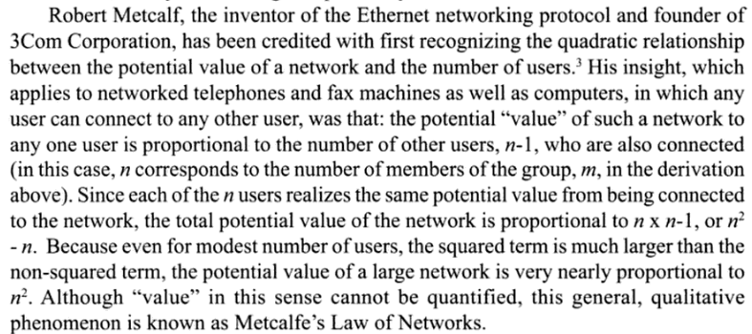

<https://pubsonline.informs.org/doi/pdf/10.1287/mksc.2016.0976>

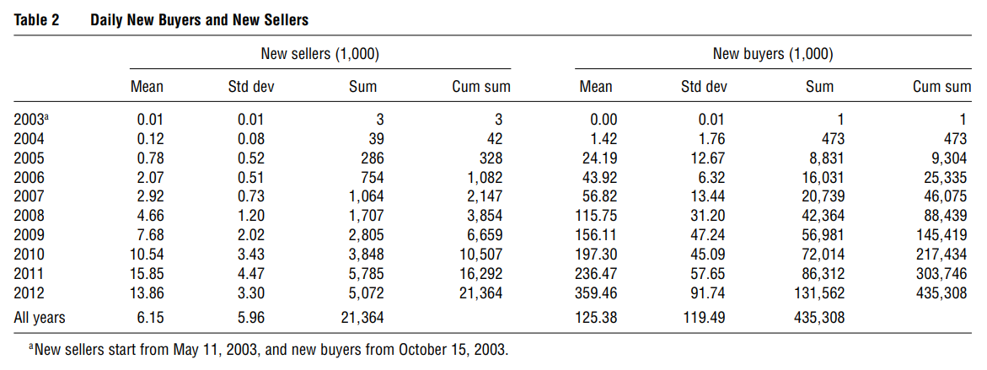

Table 2 summarizes daily new sellers and new buyers, their annual totals and growth;

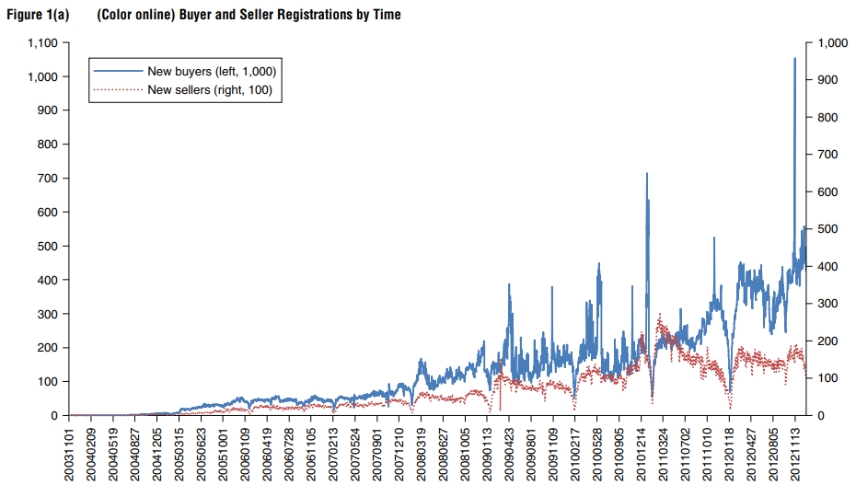

Figure 1(a) plots the evolution of daily registrations over time. There are huge variations in daily registrations. During October to December 2003, the average number of new sellers and buyers on a day was 15 and 3, respectively. Daily new sellers reached three digits and daily new buyers reached four digits in 2004. The platform really started to take off in 2007—nearly 3,000 sellers and 57,000 buyers registered each day, and over one million sellers and 20 million buyers registered in that year. The seller installed base reached two million and the buyer installed base exceeded 46 million. Since then, both buyer and seller numbers continued to grow. In 2012, there were 14,000 new sellers and 360,000 new buyers added to the platform each day. By the end of 2012, the installed base was 21 million (sellers) and 435 million (buyers). Over time, the total number of transactions per day has gone from 2,000 per day in 2004 to 13 million in 2012.

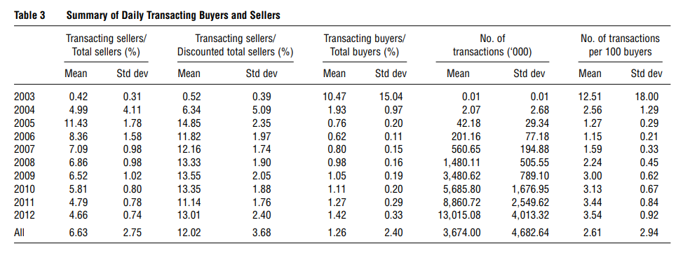

Table 3 reports percentages of sellers and buyers with transactions over total sellers and buyers as well as total transactions per day. The share of sellers with a transaction has remained stable in the last three or four years at around 5% (around 11% once we account for seller attrition). On the other hand, the share of buyers making purchases has been rising slowly since 2006, culminating at about 1.4 out of 100 registered buyers making a purchase in end 2012.

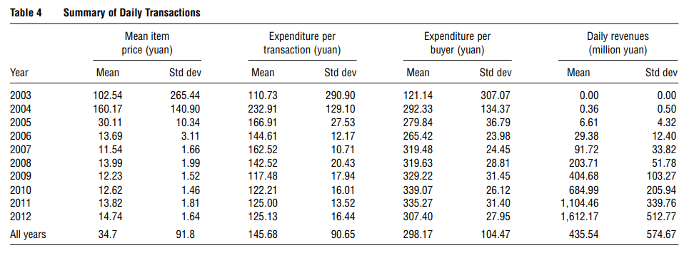

Table 4 shows some characteristics of daily transactions, including mean item price, size of each transaction, and revenues. The daily transaction revenue has been increasing rapidly and reached 1.61 billion yuan (USD $258 million) in 2012. The average item price stabilized to around 13 yuan (USD $2.09) by 2006 after some initial fluctuation. The value of each transaction has also stabilized to around 125 yuan (USD $20) with the expenditure per buyer being around 325 yuan (USD $52.17).

<https://www.wired.com/insights/2014/03/building-next-whatsapp-instagram-network-effect-playbook/>

The Secret to Network Value: Startups often fail to appreciate the gap between technology and value proposition. For products like Evernote, technology serves the entire value proposition. However, for social products, the value proposition is a combination of technology and the content that users create on top of it. YouTube’s value lies in its hosting and streaming capability, but more importantly in its vast repository of videos. The secret to creating a social product that demonstrates immediate value is to enable content before creating the network. Content created on the network is the new source of competitive advantage. The videos on YouTube, the pictures on Instagram, the answers on Quora are the primary source of value for users and the key driver of competitive advantage for these platforms.