Analysis Report

East Boston Gentrification

(K-mean and Hierarchical Clustering)

Tongjia (Colin) Cui, Che (Charles) Liu, Matthew MclSaac

Contents
Introduction 3
Data Summary 4
Methodology 6
Results 11
Application 16
Conclusion 19

Introduction

Gentrification is a process of urban transformation that occurs when wealthier populations move into historically lower-income neighborhoods, producing economic improvements in housing, businesses, and infrastructure. While these changes can improve the overall quality of life in the area, they are often accompanied by the displacement of longstanding residents who can no longer afford the rising costs of living. This duality makes gentrification a highly debated topic that necessitates rigorous quantitative analysis.
In this case study, a local community’s economic characteristics are examined to uncover the neighborhood-specific trends of gentrification. Specifically, the study is set in East Boston, a traditionally working-class immigrant neighborhood. As the communities of Boston become increasingly affluent, East Boston has seen certain characteristics of gentrification, such as the increase in luxury apartments, retail and services, restaurants, and accessibility to Downtown Boston. Using machine learning techniques such as Ordinary Least Squares (OLS) regression, and clustering methods to examine trends such as housing rental costs, changes in income levels, educational attainment, and labor force participation rates, this study aims to quantify the effects of these variables to extract insights on gentrification in East Boston using a statistical approach. The findings will provide evidence-based insights into the impacts of gentrification, inform policymaking aimed at mitigating displacement, and suggest directions for future research. By leveraging machine learning methods, this study contributes to a data-driven understanding of the complex and evolving dynamics of urban transformation.

Data Summary

The data used in this project comes from the U.S. Census Bureau. The observations are based on the block groups associated with East Boston census tracts. Relevant data was collected across a ten-year period (2013-2022) in order to capture the progression of gentrification.
The East Boston census tracts contain around 34 block groups, with certain years adding additional block groups. Overall, the data yields 344 observations in total. Certain block groups exhibit missing entries. For instance, the block group associated with Logan Airport does not have any data on the variables for the analysis, given that it is not a residential block group.
From the data collected, the trend in the average rental cost displays an upward growth trend, as illustrated in the graph below.
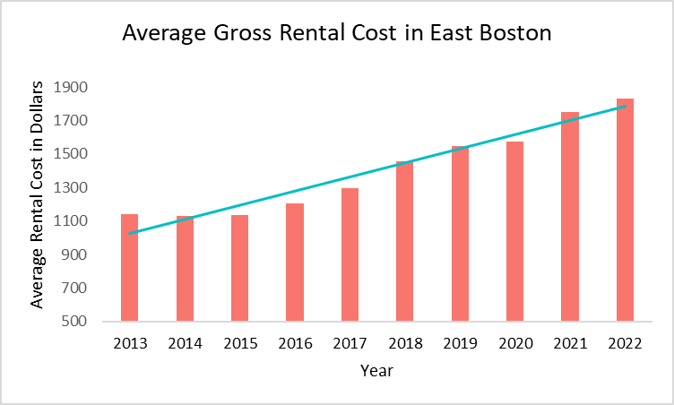

This trend is consistent with the gentrification narrative. Between 2013 and 2022, the average rental cost has nearly doubled. To investigate the factors behind this rising trend, we have identified the following variables: median gross rental cost, year, median house hold income, labor force participation rate, degree attainment rate (bachelor’s and above), and public
assistance rate (the specifics of each variable will be discussed in the Methodology section).

With the data gathered, the table below displays the important summary statistics associated with each variable (excluding year):

 | Mean | Median | Mininmum | Maximum | Standard Deviation
Median Gross Rental Cost | 1407.051724 | 1369.5 | 298 | 3121 | 495.5112589
Median Household Income | 64428.50345 | 63490 | 12013 | 245000 | 28095.68827
Labor Force Participation Rate | 0.762606668 | 0.777469991 | 0.302290076 | 1 | 0.130452789
Degree Attainment Rate (Bachelor’s and above) | 0.211351064 | 0.172370877 | 0 | 1 | 0.159066374
Public Assistance Rate | 0.03295422 | 0.016097331 | 0 | 0.285714286 | 0.044884881
It is worth noting that the summary statistics show that the demographics of East Boston is diverse, with some block groups that have achieved 100% labor force participation and degree (bachelor’s and above) and some groups with 0%.
The range of median gross rental cost, median household income, and degree attainment
rate also shows that while its median and mean of are close to each other, the disparity between rental prices can be significant. The standard deviation, in relation to the mean, is also considerably large, suggesting significant variability within the observations.
Lastly, the data suggests that overall, the degree attainment rate and public assistance rate are both low. This signals that East Boston’s population on average has not pursued or obtained advanced degrees. On the other hand, the community also either has a strong working-class presence independent of public support or has little exposure to public assistance.

Methodology

Our methodology encompasses data collection, preparation, statistical modeling, and clustering techniques to reveal localized relationships that might otherwise be obscured in aggregated analyses. The steps below detail the processes used to conduct this research.
To investigate the socioeconomic and demographic dynamics of gentrification in East Boston, we developed an approach that integrates data collection, statistical modeling, and clustering techniques. The methodology is detailed as follows.

Data Collection and Preparation

The analysis relied on panel data collected from East Boston block groups over multiple years. The dataset was sourced to capture key variables believed to influence gentrification:

Dependent Variable:

  - Median Gross Rent, represents the primary economic indicator of gentrification pressures within communities.

Independent Variables:

  - Year to track temporal trends and structural changes in the housing market.

  - Median Household Income to gauge economic growth and the financial capability of residents.
  - Labor Force Participation Rate, reflecting economic activity levels within block groups.
  - Degree Attainment Rate (Bachelor’s and above) as a proxy for educational attainment, which can influence economic stratification.
  - Public Assistance Rate, measuring reliance on social safety nets, is often inversely related to neighborhood affluence.

Other Variables:

  - While reviewing the first OLS regression we ran. We saw that there were a few variables that had no significance in the regression because of this, we took them out of our model.
During data preparation, we ensured the dataset met the quality requirements for robust statistical analysis. All variables were converted to numeric formats, and missing values were addressed by omitting incomplete observations. The data cleaning step aimed to minimize potential biases caused by incomplete records while maintaining a good sample size for the analyses. However, the dataset presented several limitations, primarily due to its reliance on census data. A significant number of values were missing which may have introduced biases. Additionally, the census didn’t have enough data points as we wanted. While efforts were made to clean and normalize the data, these limitations might have affected our research.
With the dataset prepared and key variables defined, we conducted an initial regression analysis to establish baseline relationships between median gross rent and socioeconomic indicators.

Initial Analysis: Ordinary Least Squares (OLS) Regression

To establish a baseline understanding of the relationships between the dependent variable and the explanatory variables, we conducted an Ordinary Least Squares (OLS) regression on the complete dataset. The initial regression model provided insight into the overall effect of socioeconomic and demographic variables on median gross rent.
To ensure the reliability and interpretability of the OLS model, we addressed potential multicollinearity issues. Variance Inflation Factor (VIF) analysis was performed, and all variables exhibited acceptable VIF values, indicating low multicollinearity. Further, diagnostic tests such as residual plots and the Shapiro-Wilk test were conducted to assess the assumptions of normality and linearity. These tests revealed some deviations, particularly regarding residual normality and heteroscedasticity, which are discussed further in the results section.
While the OLS model provided a broad understanding of rent dynamics, we recognized the need to capture localized variations. To address this, we implemented clustering techniques to identify neighborhood-level patterns

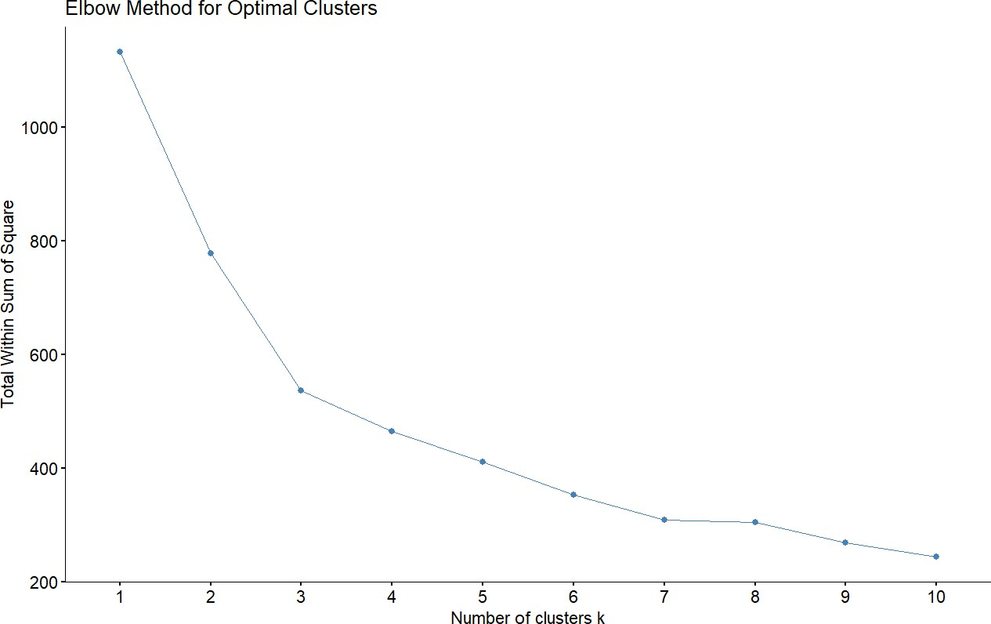
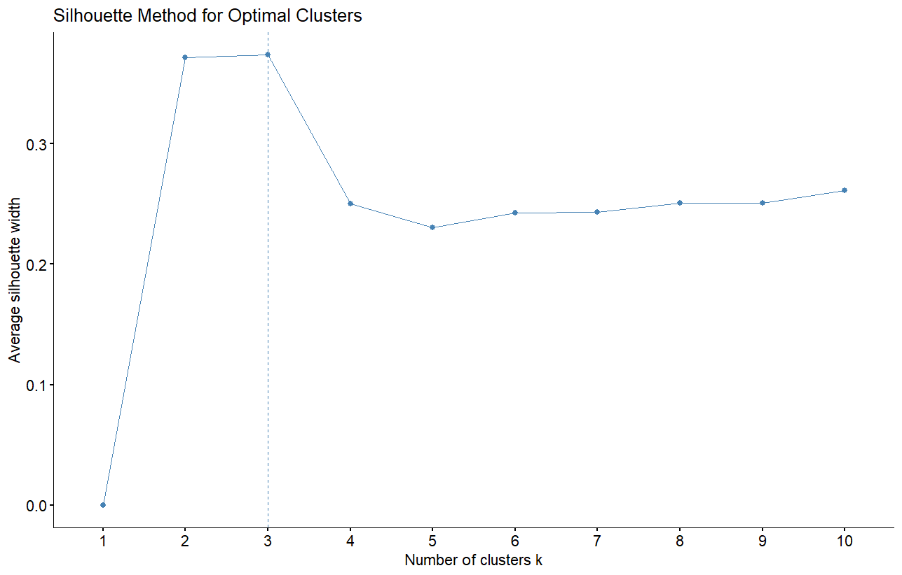
Clustering Analysis: Capturing Localized Patterns

Recognizing the heterogeneity within East Boston, we implemented clustering techniques to group block groups with similar socioeconomic and demographic profiles. Two clustering methods were employed to explore the segmentation of the dataset:

K-Means Clustering:

  - To identify distinct clusters, we standardized all independent variables to account for differences in scale.
  - Using the Elbow Method, Silhouette Analysis, and NbClust, the optimal number of clusters was determined to be three. This choice was supported by both visual inspection and statistical criteria.

Hierarchical Clustering:

  - Hierarchical clustering provided a complementary approach, relying on a Euclidean distance matrix and Ward’s method for linkage.
  - The dendrogram produced from this analysis indicated that three clusters also represented a meaningful division of the data.

Cluster-Specific Regression Analysis

With the identified clusters, we conducted separate OLS regressions within each group. This allowed us to explore how the relationships between median gross rent and the independent variables varied across clusters, reflecting localized dynamics of gentrification.

Results of K-Means Clustering:

  - The cluster-specific regressions revealed that the influence of income and educational attainment on rents differed significantly between clusters. For instance, areas with higher degree attainment exhibited steeper increases in rent, likely reflecting gentrification hotspots.
  - R-squared values ranged from 64.1% to 77.8%, indicating that the models captured varying degrees of variance within clusters.

Results of Hierarchical Clustering:

  - Similarly, hierarchical clusters displayed unique patterns, though R-squared values varied more widely, from 36.2% to 88.2%. This suggests that while hierarchical clustering captured some localized nuances, it may have overfit certain groups.
Regression diagnostics for each cluster were conducted to ensure model validity, and deviations in residuals and heteroscedasticity were noted.

Statistical Diagnostics and Robustness Checks

Throughout the analysis, we employed rigorous statistical diagnostics to validate our models:

- Residual Analysis: Plots of residuals versus fitted values revealed minor heteroscedasticity, confirmed by the Breusch-Pagan test, which reported statistically significant results. This suggests that the variability in rent changes was not entirely consistent across the dataset.
- Normality of Residuals: The Shapiro-Wilk test indicated that residuals deviated slightly from normality. Despite these deviations, the results were deemed reliable due to the robustness of regression methods against moderate violations.

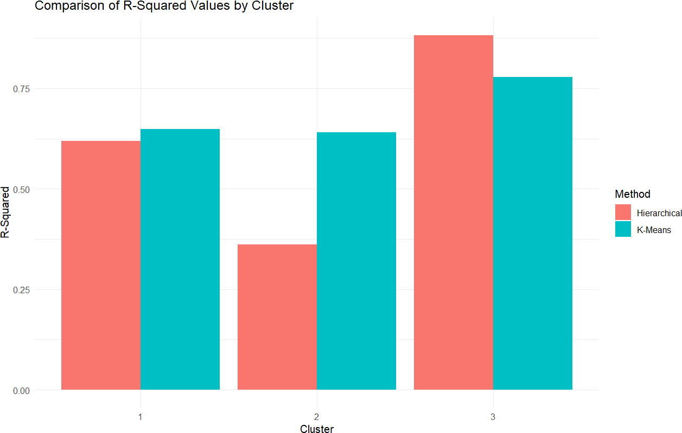

Comparative Assessment of Clustering Methods

The two clustering methods were compared based on their ability to segment the dataset and explain variance in median gross rent:
- K-means clustering provided more balanced results across clusters, with relatively consistent R-squared values and clearer segmentation of socioeconomic patterns.
- Hierarchical Clustering offered deeper insights for certain clusters but exhibited wider variability in explanatory power, potentially due to overfitting in smaller clusters.
After review, K-Means Clustering appears more suitable for this project due to its consistency in model performance across clusters.

Results

Building on our methodological approach, we now present the key findings from our analysis.

Initial OLS Model Results

The Ordinary Least Squares (OLS) regression analysis provided significant insights into the factors influencing median gross rent in East Boston:
- Year: The positive coefficient (B = 45.00, p < 0.001) indicates that rents have increased by approximately $45 annually, demonstrating a steady upward trend over the study period.
- Median Household Income: A significant positive association (B = 0.007962, p < 0.001) suggests that for every additional dollar in household income, rents increase by about $0.008, reflecting the economic impact of rising affluence.
- Labor Force Participation Rate: A strong positive effect (B = 1,363, p < 0.001) highlights that higher employment rates are associated with increased demand for housing, driving rents upward.
- Degree Attainment Rate (Bachelor's and above): A positive coefficient (B = 375.3, p = 0.00406) underscores the influence of higher education levels on rent increases, likely due to increased earning potential and housing demand.
- Public Assistance Rate: The negative coefficient (B = -943.9, p = 0.02527) indicates that areas with higher public assistance rates tend to have lower rents, reflecting socioeconomic disparities.
These findings confirm that there is a critical role in socioeconomic factors, such as income, employment, and education, in shaping rent dynamics and driving gentrification processes.

Cluster Analysis Results

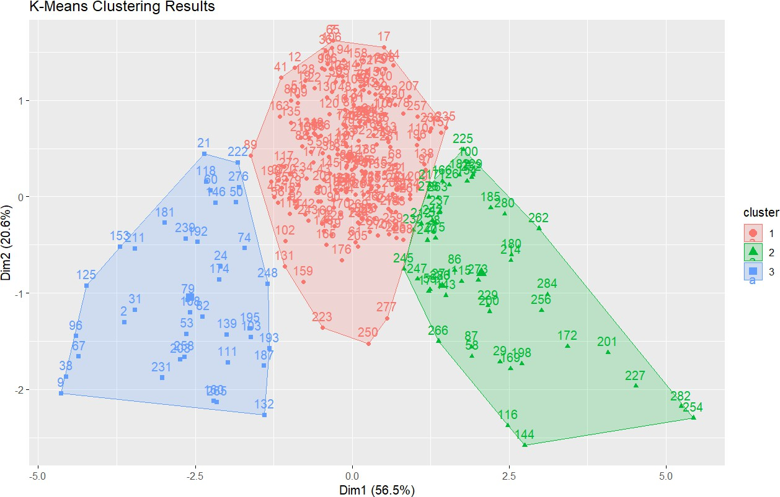

Using k-means clustering, we were able to segment neighborhoods into three clusters, each representing distinct stages of gentrification to then conduct separate OLS regressions within each cluster to uncover localized relationships.

Cluster 1: Moderate-Income, Emerging Gentrification

- Significant predictors include:

  - Year (B = 62.21, p < 0.001): Reflects steady annual rent increases as these neighborhoods experience economic growth.
  - Median Household Income (B = 0.005327, p < 0.001): Modestly but significantly drives rents upward.
  - Labor Force Participation Rate (B = 769.0, p < 0.001): Highlights the role of employment opportunities in driving rents.
- Non-significant predictors: The Degree Attainment Rate and Public Assistance Rate
showed no significant impact in this cluster.

- Summary: Cluster 1 captures neighborhoods transitioning economically, characterized by moderate incomes and early gentrification indicators such as rising rents and growing employment.

Cluster 2: High-Income, Advanced Gentrification

- Significant predictors include:

  - Year (B = 76.04, p < 0.001): The strongest annual rent increase among all clusters.
  - Median Household Income (B = 0.003794, p = 0.034): Positively influences rents, though to a lesser extent than in Cluster 1.
  - Degree Attainment Rate (B = 1,458, p < 0.001): Strongly drives rent increases, reflecting the influx of affluent, educated residents.
- Marginal predictors: The Labor Force Participation Rate (p = 0.0551) and Public
Assistance Rate (p = 0.0987) showed weaker, marginal associations signifying that this may be a highly gentrified area.
- Summary: These areas have the highest rents, largely driven by an influx of affluent, highly educated residents. These neighborhoods are in advanced stages of gentrification, with luxury housing, sustained rent increases, and high-income professionals shaping their character.

Cluster 3: Mixed-Income, Stable, or Transitional Areas

- Significant predictors include:

  - Median Household Income (B = 0.0228, p < 0.001): The strongest income effect among the clusters.
  - Degree Attainment Rate (B = -1,641, p = 0.046): A surprising negative relationship, possibly due to local factors such as proximity to universities or rent control.

- Non-significant predictors: Year, Labor Force Participation Rate, and Public Assistance Rate had no significant impact in this cluster.
- Summary: Cluster 3 captures mixed-income areas with relatively stable rents, where non-significant Year and negative Degree Attainment Rate coefficients suggest unique local factors, such as rent control or proximity to universities, that buffer against rapid gentrification despite higher education levels.

Reflections on Cluster Comparisons

The K-means clustering graph shows that Cluster 1 (red) is more cohesive and well-defined compared to Clusters 2 (green) and 3 (blue). The points in Cluster 1 are densely packed, with clear boundaries, indicating consistent socioeconomic and demographic patterns. In contrast, Clusters 2 and 3 are more dispersed, with Cluster 3 overlapping partially with Cluster 1, suggesting less distinct characteristics and potential challenges in separating these groups.
Cluster 1’s clarity likely reflects neighborhoods in a more uniform stage of gentrification, while the dispersion in Clusters 2 and 3 may stem from mixed-income areas or overlapping trends.
This does show the stronger explanatory power of Cluster 1. While we appreciate the significance of this observation, time constraints limited our ability to refine the clustering or address the dispersion in Clusters 2 and 3. We do suggest further research to refine this area of clustering.

Cross-Cluster Trends

Several trends emerged across the clusters:

- Median Household Income: Positively associated with rent in all clusters, with the largest effect in Cluster 3.
- Year: Significant in Clusters 1 and 2, reflecting ongoing rent increases, but non-significant in Cluster 3, indicating temporal stability.

- Labor Force Participation Rate: Significant in Cluster 1, marginal in Cluster 2, and non-significant in Cluster 3, highlighting its diminishing role in advanced or stable neighborhoods.
- Degree Attainment Rate: Positive in Cluster 2, reflecting higher education's impact on rent, but negative in Cluster 3, where it may signal unique socioeconomic dynamics.
- Public Assistance Rate: Generally non-significant across all clusters.

These findings illustrate the complexity of socioeconomic and demographic factors in driving gentrification, with patterns emerging across different neighborhood types. Each cluster highlights a unique stage of gentrification, from early economic improvements in Cluster 1 to the advanced urbanization of Cluster 2 and the transitional stability of Cluster 3.

Application

Through the analysis using the OLS regression model and clustering methods, the following key drivers of gentrification in East Boston are identified:
Median Household Income: displaying positive effect and statistical significance on median rental cost in both the initial OLS model and across the clusters
Labor Force Participation Rate: having statistical significance and positive effect on median rental cost in both the initial OLS model and across clusters 1 and 2
Degree Attainment Rate has statistical significance and a positive effect on median rental cost in both the initial OLS model and in cluster 2
These key drivers of gentrification, along with their effects, reveal that the patterns of gentrification is tangential to the specific areas of East Boston. There are clear distinctions between clusters, suggesting that varied levels of gentrification exist in different block groups. Overall, East Boston’s gentrification pattern can be summarized in three groups:
High-income areas: block groups exhibiting characteristics of advanced gentrification, where the communities in these block groups are displaying significant levels of displacement of the less affluent groups.
Lower-income areas: block groups that are yet to be gentrified but may be at risk of future gentrification and displacement.
Given the analysis of our results, we have identified the following policy suggestions that can aim to address the issue of gentrification in East Boston:
First and foremost, the housing authorities in Boston can institute the following policies to ensure the overall affordability of housing in East Boston:
- The housing authority can institute rental control by setting a ceiling on rental costs. This is a straightforward policy that institutes a hard limit on what the rental cost can be to prevent rent from exceeding a certain threshold. This ceiling on rental cost, then, needs

to consider the specific profile of the residents in the area, making sure that the ceiling is appropriate for the residents and landlords.
- Besides setting a rental control ceiling, rental stabilization measures can provide an extra layer of safety net to financially vulnerable residents. This policy sets a percentage cap on the rate of rental increase. This allows the landlord to adjust rental prices within reason to combat macroeconomic shocks as well as inflation. With rental stabilization, the tenants are shielded from sudden and drastic rental spikes.
Second, community engagement can be another way to keep housing affordable to those who are at risk of displacement. Specifically, by establishing non-profit organizations such as Community Land Trusts (CLTs), the local community initiatives can directly prevent displacement by keeping housing affordable:
- CLTs can directly purchase land/properties and lease them to tenants through themselves. This negates the need for the tenants to seek out for-profit real-estate agencies that prioritize profit maximization rather than housing affordability.
- CLTs can also sell properties directly to residents. To prevent the sales value of the properties from appreciating beyond the affordable level of the buyers, the resale price of the residents-owned CLT properties is restricted under a predetermined formula.
Lastly, economic development measures can be instituted by local authorities to incentivize the growth of the local communities, strengthening the vulnerable communities and their abilities to combat trends of displacement:
- The government can institute local educational initiatives that help local residents to become more competitive through low-cost vocational training, certificate programs, affordable education for children, language training for non-English speakers, etc. This ensures that the local residents have better opportunities and access to education.
- Given the proximity of East Boston to Downtown Boston, most of the more affluent residents commute to Downtown for work. The local government can provide initiatives that support entrepreneurship and small businesses local to East Boston. By supporting local businesses, the government is able to promote the local economic wellness of the local residents.

By instituting a combination of these initiatives, Boston authorities can ensure that the less affluent residents of East Boston are protected through a well-rounded approach while allowing urban development in the community without displacing the economically vulnerable population.
With these applicable policies in mind, it is also important to note that in the prior robustness checks, our model displayed violations to OLS assumptions; more specifically, the normality and homoscedasticity assumptions. Due to these violations, the statistical significance of the variables needs to be treated with caution. Nevertheless, the policy recommendations proposed in this section can still have a positive effect on the local community regardless of the violations.

Conclusion

The case study was able to successfully identify significant socio-economic factors at play in the gentrification of East Boston. Specifically, the study finds that median household income, year, labor force participation rate, and degree attainment rate are all contributing factors. Their impacts vary across clusters, but each one helps to explain the effects in at least one area.
Clustering was integral to identifying the effects of gentrification. Gentrification as a process has different phases and comes in different forms. It is therefore difficult to find a one-size-fits-all model that can explain all that it encompasses. As a result, clustering was necessary to parse out what was significant and where each variable had its effects.
The study evaluated two types of clustering: K-Means and Hierarchical. While hierarchical clustering offered deeper analysis for certain clusters with easier interpretation, it was prone to overfitting and was overall unsuitable for the case. K-means clustering was chosen because it provided more consistent results and yielded high R-squared values across all clusters.
3 main clusters were identified in the study. The first cluster was identified as a cluster in the process of being gentrified. It is characterized by moderate incomes, rising rent, and growing employment. The second cluster was the advanced gentrification cluster. This cluster has luxury housing, sustained rent increases, and high-income residents. The final cluster identified by
K-Means clustering is a mix of the remaining areas. Some are in a transitionary period, while others remain unchanged. It has mixed incomes and relatively stable rent.
The findings of this study have several policy implications. First, we would recommend implementing affordable housing initiatives. Specifically, this report argues that rent control and rent stabilization programs would be useful in combating the rent spikes associated with gentrification. A second recommended program would be aiding community engagement through a community land trust (CLT). A CLT would help prevent existing residents from being priced out of staying in the community. Finally, this study supports the implementation of job creation and education programs. These initiatives can help the local residents stay competitive in the developing job markets. In turn, these programs can help prevent the existing residents from being displaced.

There are some areas for improvement in the study. The model’s residuals are not normally distributed, and there is heteroscedasticity present. Future research should investigate using robust regression techniques and transforming some of the variables to address this issue. There were also data limitations in the study. The data cleaning process left many non-numeric entries and there are certainly other variables that could help explain gentrification that were not part of the study. Finally, a longitudinal study that analyzes certain trends over time could explain gentrification differently than the cross-sectional analysis done in this study.

