Flint Water Crisis: A Regression Analysis on Flint’s Community Mean Water Age

Tongjia Cui

December 16, 2025

Introduction and Literature Review
The Flint Water Crisis represents one of the most widely documented public health tragedies in recent United States history. The scale of the crisis, however, exceeds that of a pure infrastructural failure; in fact, it is also a social justice crisis. In April 2014, the City of Flint, Michigan switched its municipal water source from treated water supplied by Detroit to the Flint River as a cost-saving measure. The Flint River, a body of water that lacked sufficient treatment for everyday usage, supplied the community through the city’s outdated distribution infrastructure. The cost-cutting measure then led to widespread corrosion of the aging lead pipes. The absence of corrosion control resulted in elevated lead concentrations in drinking water, increased blood lead levels among residents, particularly children, and severe long-term public health consequences (Hanna-Attisha et al., 2016).
By now, a substantial amount of research has been done to document both the health impacts of lead exposure and the broader issue surrounding social justice and systemic racism that allowed the crisis to occur. Public health studies demonstrated significant invasive bodily harms done to adults and children alike, with disproportionate effects in low-income and predominantly non-White neighborhoods (Hanna-Attisha et al., 2016). Sociological and policy-oriented analyses have framed the Flint crisis as a textbook case of environmental violence, emphasizing the role of systemic political failures which willingly sacrificed the vulnerable and marginalized communities in favor of fiscal solvency and short-term economic gains (Pulido, 2016; Sadler & Highsmith, 2016).
Then, it becomes clear that an issue of this gravity warrants extensive study. The basis of this project, produced by Sadler et al., examines the role of infrastructure and hydraulic system behavior in shaping water quality risk. This modeling research uses simulated water distribution systems to examine how infrastructure configuration affects water age, a system-level metric related to disinfectant decay, corrosion potential, and microbial growth (Sadler et al., 2025).
Importantly, water age is used as an index involving crucial elements and measuring the quality of water. It is an engineering metric commonly used to assess distribution system performance and potential water quality degradation. This distinction has important implications for empirical analysis. Water age is generated through hydraulic simulation and is driven primarily by network topology, pipe volume, and flow patterns. Social variables may influence water age indirectly, through their association with infrastructure placement and system configuration, but strong linear relationships between neighborhood socioeconomic vulnerability and water age should not be assumed.
The present study builds on the hydraulic study presented in the literature. It asks a narrower empirical question. Rather than evaluating infrastructure “rightsizing” scenarios, which are hypothetical pipe rightsizing measures the authors of the hydraulic study employed to assess the improvements to the water age, this analysis focuses exclusively on the present system conditions and examines whether neighborhood socioeconomic characteristics and hydraulic performance explain meaningful variation in mean water age across Flint census tracts.
Thus, this study seeks to investigate the following questions: under the current system conditions in Flint, how are neighborhood socioeconomic characteristics and hydraulic performance associated with mean water age, and do these variables explain substantial variation in water age across census tracts?

Methods and Sample
The unit of analysis for this study is the census tract. The dataset combines hydraulic simulation outputs with neighborhood-level socioeconomic and demographic indicators.
Hydraulic variables were derived from a calibrated distribution system model that simulates water movement throughout Flint’s network and computes water age at nodes over time.
Node-level values were aggregated to the census-tract level (Sadler et al., 2025). To perform the analysis that answers the research questions, the following variables presented in Table 1 were selected from the dataset.
Table 1
Variable Names, Definitions, and Value Ranges

Variable name | Definition | Value range
GEOID | Census tract identifier | Text
AvgP | Mean water pressure (psi) | [27.23, 92.61]
Ag50 | Mean water age (hours; dependent variable) | [6.49, 420]
Distress | Distressed Communities Index | [–4.50, 18.66]
PercVacant | Percentage of vacant parcels | [0.00, 0.77]
PrcNW | Percentage of non-white residents | [0.00, 100.00]
WhiteDominant | Majority-white tract indicator | {0, 1}
Note. Variables were derived from Sadler et al. (2025). WhiteDominant was created by dichotomizing PrcNW at 50% (1 = majority White, 0 = majority non-White).
To examine the relationship between neighborhood characteristics and mean water age, two ordinary least squares (OLS) regression models were estimated. The first model included Ag50 as the outcome variable, and predictors used are AvgP, Distress, PercVacant, WhiteDominant, and an interaction term between AvgP and Distress to assess whether hydraulic conditions moderated the association between socioeconomic distress and water age. The WhiteDominant predictor, notably, is a dummy variable constructed from PrcNW using dummy coding. A second, reduced model excluded the interaction term to evaluate whether model fit and coefficient stability improved under a more parsimonious specification. In Table 2 below, the descriptive statistics for the variables involved in producing the models are presented.

Table 2
Descriptive Statistics for Variables

Variable | n | M | SD | Min | Max
Continuous variables  AvgP (psi) | 894 | 64.53 | 13.17 | 27.23 | 92.61
Ag50 (hours) | 894 | 68.37 | 48.93 | 6.49 | 420.00
Distress index | 894 | 4.14 | 3.54 | -4.50 | 18.66
PercVacant (proportion) | 784 | 0.26 | 0.20 | 0.00 | 0.77
PrcNW (%) | 887 | 61.41 | 32.04 | 2.44 | 100.00
Binary variable
WhiteDominant n = 887
1 (Majority white) 524 (59.0%)
0 (Majority non-white) 364 (41.0%)
Note. M = mean; SD = standard deviation. WhiteDominant is a binary variable derived from PrcNW (1 = majority White tract, PrcNW 50%; 0 = majority non-White tract, PrcNW < 50%). Sample sizes vary due to missing values.
As the table suggests, two variables (PercVacant and PrcNW) contained missing values. Rather than using complete-case analysis, missing data were addressed using multiple imputation by predictive mean matching (PMM). PMM preserves the observed distribution of the data and avoids imputing implausible values. Ten imputed datasets were generated with ten iterations each. The binary indicator WhiteDominant was then reconstructed from the imputed PrcNW values. The diagnostics showed that the imputation process did not introduce any systemic bias and preserved the underlying data structure. Then, the two multiple regression models were constructed separately within each imputed dataset and pooled using Rubin’s rules.

Findings
With the data cleaned and variables constructed as described in the Methods and Sample section, pooled OLS regression models were estimated. Based on the literature discussed in the Introduction section, several expectations can be drawn regarding the coefficients before fitting the model. Higher average water pressure was expected to be associated with lower median water age, as increased pressure generally corresponds to higher flow velocities and reduced residence time within distribution systems (Sadler et al., 2025). Neighborhood distress and parcel vacancy were expected to be positively associated with water age, reflecting the possibility that economically distressed or highly vacant areas experience slower system turnover due to systemic neglect and suboptimal status of the water infrastructure. Finally, census tracts classified as majority-White were expected to exhibit lower water age on average, consistent with literature documenting racial disparities in infrastructure investment and service quality (Pulido, 2016). With these expectations established, the models are fitted, and the results are presented in Table 3 below.

Table 3
Pooled OLS Regression Results Predicting mean Water Age

Predictors | Full model | Reduced model
AvgP | −0.319 (0.172) | −0.306∗ (0.121)
Distress | −3.383 (2.153) | −3.162∗∗∗ (0.491)
PercVacant | −11.313 (9.722) | –11.291 (9.714)
WhiteDominant | 0.482 (3.444) | 0.498 (3.438)
AvgP × Distress | 0.003 (0.031) | Does not apply
Intercept | 104.736∗∗∗ (11.775) | 103.858∗∗∗ (8.308)
R2 | 0.070 | 0.070
Adjusted R² | 0.065 | 0.066
Observations | 894 | 894
Imputations | 10 | 10
Note. Entries are pooled coefficient estimates with standard errors in parentheses. Results are based on multiple imputation with predictive mean matching (10 imputations). ∗p < .05, ∗∗∗p <
.001.
Results from the pooled reduced regression model are presented in Table 3. Both the full and reduced models explained approximately 7% of the variance in mean water age, indicating substantial unexplained variation. These results suggest that the inclusion of the interaction term did not improve the explanatory power of the model.
In the reduced specification, mean water pressure was negatively associated with mean water age (b = –0.306, p < .05), consistent with hydraulic expectations that higher pressure reduces residence time within the distribution system. Neither parcel vacancy rate nor the majority-White indicator were statistically significant, suggesting that these neighborhood characteristics do not meaningfully predict mean water age in this specification.
Given the limited explanatory power of both models, observed values of mean water age were plotted against fitted values from the reduced model using one of the iterations from the imputation process to visually assess predictive performance (Figure 1). Fitted values from the reduced model are presented exclusively, as the interaction term included in the full model did not contribute significantly to model fit and was therefore omitted.

Figure 1
Observed Versus Fitted Values Plot
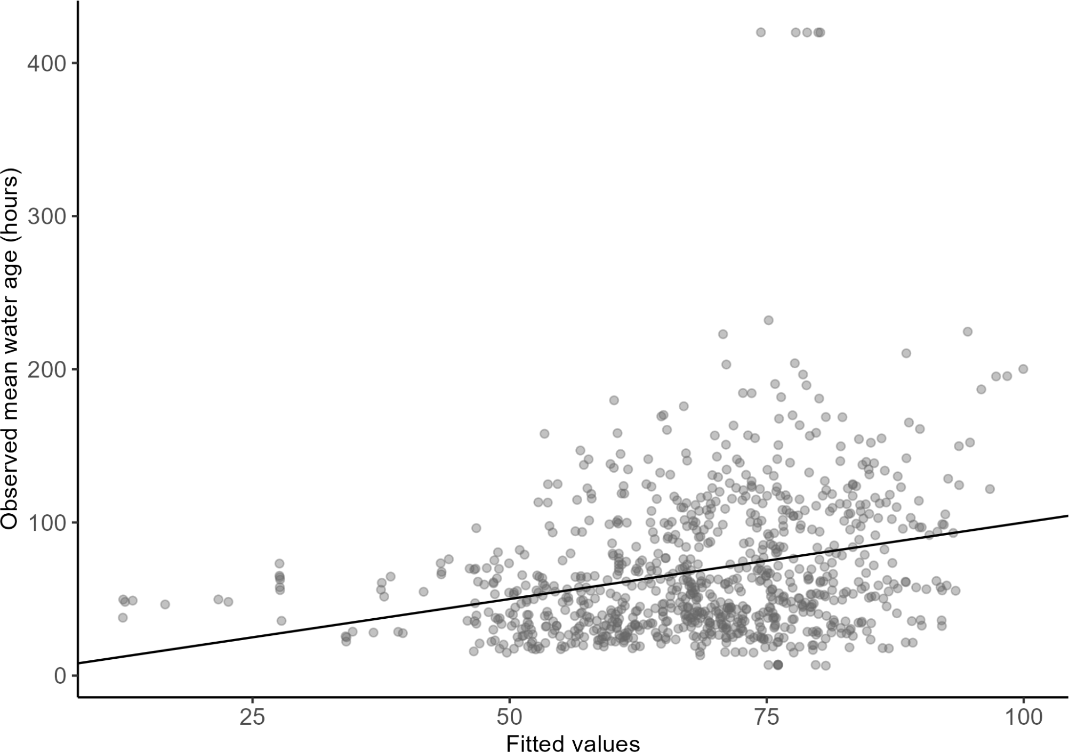

The wide dispersion of points around the 45-degree reference line indicates substantial deviation between observed and predicted values across the range of fitted outcomes. While fitted values increase modestly with observed water age, most observations are not closely aligned with the line of perfect prediction, reflecting the model’s limited explanatory power. This is consistent with the low R² values obtained from the initial model fit. To further investigate the issue behind the poor model performance, the residuals are plotted against the fitted values of the reduced model (Figure 2).

Figure 2
Residuals Versus Fitted Values Plot
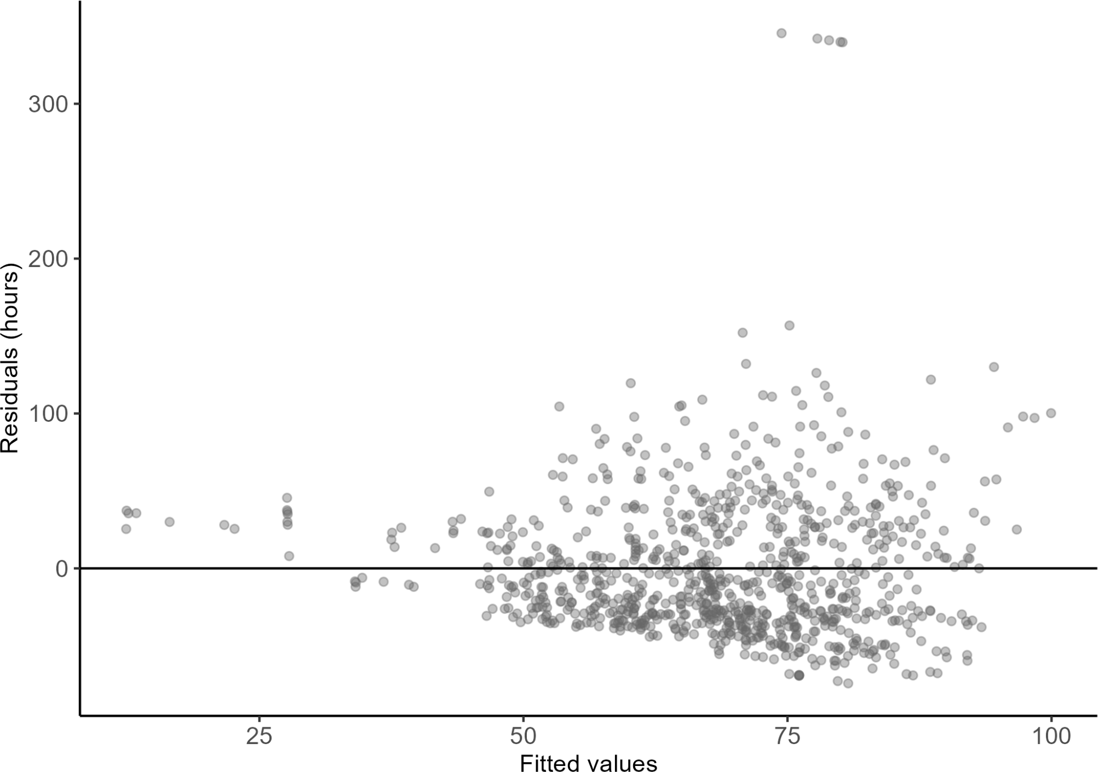

Finally, the multicollinearity diagnostics was run, and it did not reveal problematic correlations among predictors. These findings suggest that although some predictors align with theoretical expectations, mean water age in Flint’s distribution system is largely driven by physical network conditions not captured by the included social variables.

Discussion
The most notable feature of the results is the model’s limited explanatory power.
Even in the reduced model, socioeconomic and hydraulic predictors combined explain less than ten percent of the variation in mean water age. Hence, the nature and potential drawbacks of the outcome variable warrants exploration. As the research from Sadler et al. suggests, water age is a hydraulically simulated system output driven primarily by network topology, pipe volume, and flow dynamics. Then, as an index for water quality in a given census tract, it may not necessarily meaningfully represent water quality statistically. Other factors could likely contribute to the mean water age just as much as the lead concentration and presence of corrosive chemicals which are the central public health problems identified in Flint. For instance, the pipe diameters in different communities could contribute to the flow rate of water which directly impacts the amount of time that water remains in the pipes. The frequency and volume of water usage in a community could also have an impact on the mean water age, as a higher rate of water usage means more water is released from the pipes and consequently reduces mean water age. This discussion around mean water age

is important, as the weak associations between water age and socioeconomic vulnerability do not necessarily contradict the extensive environmental justice literature documenting inequitable lead exposure in Flint.
Hence, while the models themselves are flawed, the findings underscore the importance of aligning outcome measures with research questions in environmental justice studies. Infrastructure metrics such as water age are valuable for system design and operations but proved to be poorly suited for detecting social gradients in exposure which warrants further study and research from the academic community at large to refine the analytical methods and identify more relevant variables regarding Flint Water Crisis to produce more statistically significant results. With statistically meaningful findings, policy recommendations can then be extracted and subsequently implemented.

References

Hanna-Attisha, Mona, et al. “Elevated Blood Lead Levels in Children Associated with the Flint Drinking Water Crisis: A Spatial Analysis of Risk and Public Health Response.” American Journal of Public Health, vol. 106, no. 2, 21 Jan. 2016, pp. 283–290, www.ncbi.nlm.nih.gov/pmc/articles/PMC4985856/, https://doi.org/10.2105/ajph.2015.303003.
Pulido, Laura. “Flint, Environmental Racism, and Racial Capitalism.” Capitalism Nature Socialism, vol. 27, no. 3, 2 July 2016, pp. 1–16, https://doi.org/10.1080/10455752.2016.1213013.
Sadler, R. C., et al. “Water Distribution System Rightsizing and Water Age Impacts in Shrinking Cities: A Flint, Michigan Case Study.” PLOS One, 2025, https://doi.org/10.1371/journal.pwat.00.
Sadler, Richard Casey, and Andrew R. Highsmith. “Rethinking Tiebout: The Contribution of Political Fragmentation and Racial/Economic Segregation to the Flint Water Crisis.” Environmental Justice, vol. 9, no. 5, Oct. 2016, pp. 143–151,
https://doi.org/10.1089/env.2016.0015. Accessed 14 May 2019.

