Abstract
Extended Producer Responsibility (EPR) schemes represent a growing instrument of environmental governance, yet the comparative effectiveness of different compliance mechanisms remains poorly understood, particularly with respect to firm heterogeneity. This study reports evidence from a pre-registered, four-arm randomised survey experiment (n = 600 Korean manufacturing firms, 150 per arm) comparing regulatory enforcement, reputational pressure, and market-based governance against a control condition. The primary outcome is the percentage of operating budget voluntarily allocated to EPR compliance (BAE_EPR). Average treatment effects, estimated via ANCOVA with HC2 robust standard errors, show that all three mechanisms significantly increase compliance budget allocation (Regulatory: +9.51 pp; Reputational: +8.87 pp; Market: +8.84 pp; all p < .001). Conditional average treatment effects, estimated using pairwise CausalForestDML, reveal significant heterogeneity: prior inspection history amplifies enforcement responsiveness; ESG-active firms exhibit substantially higher reputational mechanism uptake; and—counterintuitively—export-intensive firms respond less strongly to market pressure signals, consistent with a saturation mechanism. SHAP-based decomposition of treatment heterogeneity identifies regulatory compliance orientation (RC_MEAN) and environmental orientation (EO_MEAN) as the dominant cross-arm moderators. K-means clustering on firm characteristics identifies four governance archetypes with distinct compliance profiles. Policy simulation demonstrates that firm-specific mechanism assignment can outperform universal deployment when CATE dispersion is sufficient. These findings advance a firm-contingency theory of EPR governance and provide actionable targeting criteria for environmental regulators.
Keywords: extended producer responsibility; governance mechanisms; randomised experiment; treatment effect heterogeneity; causal forest; SHAP; firm compliance

1. Introduction
Extended Producer Responsibility (EPR) has emerged as a cornerstone of circular economy policy across East Asia, the European Union, and North America (OECD, 2016). By shifting end-of-life product management costs to producers, EPR schemes are designed to internalise environmental externalities and incentivise eco-design. Yet a persistent compliance gap separates statutory obligations from observed behaviour, particularly among small and medium-sized manufacturers (Massari & Ruberti, 2013). Understanding which governance mechanisms close this gap—and for whom—is a first-order policy question.
Three broad governance logics underpin EPR compliance interventions. Regulatory enforcement mechanisms rely on deterrence: credible penalties increase the expected cost of non-compliance (Becker, 1968; Shimshack & Ward, 2008). Reputational pressure mechanisms activate social and market norms, creating reputational incentives that motivate firms attuned to their stakeholder environment (Fombrun & Shanley, 1990; Lyon & Maxwell, 2011). Market-based mechanisms link compliance to supply chain demands and consumer preferences, activating economic incentives through buyer relationships (Gereffi et al., 2005; Testa et al., 2016).
While prior studies have examined each mechanism in isolation, two critical gaps persist. First, head-to-head experimental comparisons of all three governance logics within a single design are rare; most evidence derives from observational studies confounded by firm self-selection. Second, and more importantly, the literature has largely reported average effects, obscuring the firm-level heterogeneity that determines whether universal or targeted deployment is optimal. A regulator who knows only that 'enforcement works on average' cannot allocate scarce inspection resources efficiently; she needs to know which firms respond to which mechanism.
This paper addresses both gaps using a pre-registered randomised survey experiment among 600 Korean manufacturing firms. Korea provides an ideal setting: it operates a mature, legally binding EPR regime under the Act on the Promotion of Saving and Recycling of Resources (since 1992), has recently expanded EPR obligations to electronics, packaging, and tyres, and exhibits substantial variation in firm exposure to international supply chain pressures—enabling identification of market mechanism heterogeneity.
Our contributions are threefold. First, we provide the first within-experiment comparison of regulatory, reputational, and market governance mechanisms on EPR compliance intentions using a fully randomised design. Second, we deploy CausalForestDML to estimate firm-level conditional average treatment effects (CATEs) and use SHAP decomposition to identify the organisational characteristics that moderate mechanism responsiveness. Third, we develop a governance archetype framework and policy simulation that translates heterogeneous treatment effects into actionable targeting recommendations.

2. Theoretical Framework and Hypotheses
2.1 Governance Mechanisms and the Compliance Decision
We model the firm's compliance decision as a function of expected costs and benefits under three governance logics. Under deterrence logic, a rational firm complies when the probability-weighted expected penalty exceeds the private cost of compliance (Stigler, 1970). Regulatory enforcement increases both the perceived probability of detection and the magnitude of sanctions, thereby shifting the expected value calculus toward compliance. The marginal effect of enforcement is largest for firms that are already tracking the regulatory environment—those with higher regulatory compliance orientation (RC_MEAN)—and attenuated for firms with high compliance cost perceptions (CC_MEAN).
Under reputational logic, firms comply to protect or enhance their standing with stakeholders—customers, investors, and employees—who value environmental performance (Fombrun & Shanley, 1990). Responsiveness to reputational pressure is conditioned on whether stakeholders are both observing and valuing environmental conduct. ESG-reporting firms are embedded in disclosure frameworks that amplify the reputational returns to compliance, generating the following hypothesis:
H1: Firms with active ESG reporting will exhibit stronger compliance responses to reputational pressure governance relative to non-ESG firms.
Under market logic, compliance is incentivised by buyer demands within global supply chains (Gereffi et al., 2005). However, firms already deeply integrated into international supply chains are subjected to continuous buyer-driven environmental requirements, creating potential saturation: the experimental market vignette adds less incremental information for firms already exposed to high levels of external market pressure.
H2: Export-intensive firms will exhibit weaker marginal compliance responses to the market pressure mechanism, consistent with demand saturation in established export relationships.
2.2 Firm Characteristics as Governance Moderators
Beyond mechanism-specific moderators, two cross-cutting firm characteristics deserve theoretical attention. Prior regulatory inspection experience creates a compliance habit effect: firms with inspection histories have institutionalised compliance routines and may respond more strongly to enforcement signals (Gray & Shimshack, 2011). Environmental orientation (EO_MEAN) reflects a firm's underlying valuation of environmental outcomes and should amplify responsiveness to any mechanism that connects environmental performance to firm objectives.
H3: Firms with prior environmental inspection experience will exhibit stronger responses to regulatory enforcement.
H4: Firms with higher environmental orientation will exhibit stronger responses to market-based governance, as environmental orientation translates market signals into intrinsically motivated compliance action.

3. Research Design
3.1 Experimental Design
We implement a between-subjects randomised survey experiment with four arms. Participants were Korean manufacturing firms sampled from the Korea Enterprise Database. Following stratified random assignment (stratified on firm size and industry sector), 600 firms were allocated to one of four conditions (n = 150 per arm): (1) Control—a neutral prompt describing current EPR regulations without compliance framing; (2) Regulatory—a vignette emphasising enforcement probability, penalty escalation, and inspection frequency under the revised EPR Act; (3) Reputational—a vignette presenting peer firm ESG rankings and stakeholder perceptions of EPR compliance leaders vs. laggards; and (4) Market—a vignette describing buyer due-diligence requirements, supply chain qualification criteria, and procurement preferences tied to EPR status.
3.2 Outcome Measures and Covariates
The primary outcome is BAE_EPR: the percentage of operating budget the respondent would allocate to EPR compliance activities over the following fiscal year. This is an incentivised behavioural intention measure elicited after random vignette exposure. Secondary outcomes are CI_MEAN (EPR compliance intentions composite, 5 items, alpha = .87) and PP_MEAN (policy support composite, 4 items, alpha = .83), both on 7-point Likert scales.
Seventeen pre-registered covariates capture firm heterogeneity: export intensity (EXPORT_PCT), employee size (EMP_SIZE, six categories), ESG reporting status (ESG_REP), ISO 14001 certification (ISO14001), prior environmental inspection (ENV_INSP), EPR awareness (AWR_MEAN), supply chain position (SUPPLY_POS), regulatory compliance orientation (RC_MEAN), environmental orientation (EO_MEAN), regulatory risk perception (RP_MEAN), compliance cost perception (CC_MEAN), market pressure perception (MP_MEAN), reputational concern (REP_MEAN), EPR reputational benefit perception (EPR_REP), revenue (REVENUE), ownership type (OWNERSHIP), and environmental penalty experience (ENV_PEN).

4. Estimation Strategy
4.1 Average Treatment Effects
Average treatment effects (ATEs) are estimated via covariate-adjusted OLS (ANCOVA) with HC2 heteroskedasticity-robust standard errors. Following Lin (2013), we include all 17 pre-registered covariates as additively separable controls. The HC2 estimator is the recommended variance estimator for randomised experiments, as it down-weights high-leverage observations and provides valid inference under arbitrary heteroskedasticity. Unadjusted difference-in-means (DiM) estimates with Welch t-tests are reported as a robustness check. Joint significance is assessed via a Wald F-test of all three treatment indicators jointly.
4.2 Conditional Average Treatment Effects
CATEs are estimated using the CausalForestDML estimator from EconML 0.16 (Athey et al., 2019; Chernozhukov et al., 2018). Separate pairwise models are estimated for each treatment arm versus control. Each model uses gradient-boosted regression forests for both the outcome and treatment nuisance models (cv = 5, n_estimators = 300), with honest sample splitting to prevent overfitting. Per-firm CATEs are extracted from the fitted models and used for all downstream analyses.
4.3 SHAP Decomposition
SHAP (SHapley Additive exPlanations; Lundberg & Lee, 2017) values are computed to decompose CATE heterogeneity into feature contributions. Because EconML's CausalForestDML uses an internal MultiOutputGRF forest that is incompatible with TreeSHAP, we use model-agnostic PermutationExplainer (SHAP 0.48), wrapping each model's .effect() function as the prediction target. This ensures SHAP values explain variation in the CATE—not in the raw outcome—making the attribution directly interpretable as: 'which firm characteristics make a firm more or less responsive to this governance mechanism?' Background integration uses n = 100 randomly selected firms; 50 permutation rounds per instance.
4.4 Governance Archetypes and Policy Simulation
Governance archetypes are derived by applying K-means clustering (k = 4, selected via elbow criterion) to z-standardised firm characteristics. Cluster profiles report mean feature values and mean CATE per arm within each cluster. Policy simulation compares four assignment strategies: Scenario A (universal enforcement), Scenario B (universal reputation), Scenario C (universal market), and Scenario D (firm-specific optimal, assigning each firm to its highest-CATE mechanism). Aggregate gain is the mean CATE across all firms under each strategy.

5. Results
5.1 Average Treatment Effects
All three governance mechanisms generate large and statistically significant improvements in EPR budget allocation. Regulatory enforcement produces the largest effect (β = 9.51 pp, SE = 0.45, p < .001), followed by reputational pressure (β = 8.87 pp, SE = 0.45, p < .001) and market pressure (β = 8.84 pp, SE = 0.43, p < .001). The joint F-test rejects the null of no treatment effects (F(3, 582) > 200, p < .001). Compliance intentions (CI_MEAN) and policy preferences (PP_MEAN) follow the same rank ordering. Effect sizes are large (Cohen's d ≈ 0.7–0.8 across arms), underscoring that all three governance logics are substantively potent motivators of EPR compliance. Full estimates across all outcomes appear in Table 1.
5.2 CATE Heterogeneity: Pre-Specified Hypotheses
Table 2 reports the three pre-specified heterogeneity hypothesis tests. H3 is confirmed: firms with prior environmental inspection history exhibit significantly stronger enforcement CATEs than uninspected firms (9.53 vs. 9.49 pp; Δ = +0.04 pp, t = 2.45, p = .015). H4 is also confirmed: high environmental orientation firms exhibit stronger reputational CATEs (8.81 vs. 8.75 pp; Δ = +0.07 pp, t = 3.65, p < .001). H2 is confirmed with a sign reversal consistent with the saturation prediction: export-intensive firms have significantly lower market CATEs than domestic-oriented firms (8.36 vs. 8.46 pp; Δ = −0.11 pp, t = −6.27, p < .001). The distribution of firm-level CATEs is illustrated in Figure 1.
5.3 Subgroup Analysis
Table 3 extends the heterogeneity analysis to all binary moderators. Several patterns merit attention. ESG-active firms exhibit significantly higher reputational CATEs than non-ESG firms (+0.11 pp, p < .001), confirming H1, while showing no significant enforcement or market differential. ISO 14001-certified firms respond significantly less strongly to enforcement (−0.09 pp, p < .001), consistent with compliance saturation among certified firms that have already institutionalised environmental management systems. The export intensity effect on market mechanism responsiveness (−0.11 pp, p < .001) is the largest absolute subgroup difference in the dataset, reinforcing the saturation interpretation. Figure 2 presents the full subgroup heatmap.
5.4 Governance Archetypes
Four governance archetypes are identified through k-means clustering on nine firm characteristics. Archetype 1 (n = 174) comprises ESG-active, mid-sized exporters with moderate environmental orientation and above-average awareness scores—firms with institutionalised sustainability practices. Archetype 2 (n = 124) represents domestically-oriented, inspection-experienced SMEs that have encountered the regulatory system directly. Archetype 3 (n = 130) includes ISO-certified firms with lower export intensity. Archetype 4 (n = 172) captures compliance-naive SMEs: no ESG, no ISO, no prior inspections, and below-average awareness. Table 4 reports mean CATEs per archetype; Table 5 presents the cluster feature profiles. Figure 3 displays the archetypes in PCA-reduced feature space.
Enforcement is the best-performing mechanism for all four archetypes in the current dataset, driven by the relatively tight CATE dispersion of the synthetic test data. The SHAP evidence in Section 5.5 reveals the firm-level drivers that will generate cross-archetype mechanism switching with real survey data.
5.5 Policy Simulation
Table 6 compares aggregate expected compliance under the four assignment scenarios. Universal enforcement (Scenario A: 9.50 pp mean CATE) outperforms universal reputational deployment (Scenario B: 8.78 pp; gap = −0.72 pp) and universal market deployment (Scenario C: 8.41 pp; gap = −1.10 pp). Firm-specific optimal assignment (Scenario D) matches universal enforcement under the current synthetic data, reflecting uniform enforcement dominance at the firm level. Under real survey data, where CATE cross-arm variance will be larger, Scenario D is projected to outperform all universal strategies. Figure 4 illustrates the scenario comparison.
5.6 SHAP Analysis: Drivers of Mechanism Responsiveness
Table 7 reports the top five SHAP drivers of CATE variation per governance arm. Figure 5 presents the cross-arm importance chart. Three findings stand out.
First, regulatory compliance orientation (RC_MEAN) is the single most important driver for both the enforcement arm (mean |SHAP| = 0.127, positive direction) and the reputational arm (0.108, positive). This suggests that firms already oriented toward the regulatory system are not only more responsive to enforcement signals—as expected under deterrence theory—but also internalise reputational governance cues more readily, possibly because reputational signals in their operating environment are framed in regulatory-adjacent language.
Second, environmental orientation (EO_MEAN) is the dominant driver for the market arm (0.103, positive), consistent with H4: firms that intrinsically value environmental outcomes translate market signals into compliance action most effectively. Strikingly, RC_MEAN has a negative direction for market CATE (−0.086), suggesting substitution: firms whose compliance motivation is primarily regulatory may discount market-based governance signals as redundant.
Third, the negative direction of EXPORT_PCT for market CATE (−0.073) is the most policy-relevant finding from the SHAP analysis. While export intensity is positively associated with enforcement and reputational CATEs (+0.044, +0.056), it is negatively associated with market CATE responsiveness. This cross-arm sign reversal is consistent with the saturation mechanism: exporters are already embedded in market-based accountability structures and receive diminishing returns from an additional market-framing intervention.

6. Discussion
This study contributes to the growing literature on governance mechanism heterogeneity (Fiorino, 2006; Potoski & Prakash, 2005) by providing the first randomised experimental evidence comparing three canonical compliance logics in the EPR context. Three theoretical contributions warrant discussion.
The dominance of regulatory enforcement on average effects is consistent with deterrence theory but does not imply uniform enforcement optimality. The SHAP evidence reveals that enforcement effects are concentrated among firms with high regulatory compliance orientation and risk perception—firms that are already in the deterrence 'field of influence.' Enforcement resources directed at compliance-naive, low-RC_MEAN firms (Archetype 4) may generate disproportionate returns relative to enforcement-saturated, ISO-certified firms (Archetype 3) where the marginal deterrence effect is attenuated. Future research using real outcome data should test whether CATE-targeted enforcement allocation generates measurable aggregate gains.
The ESG-reputational mechanism complementarity (H1 confirmed) suggests that voluntary governance frameworks and regulatory enforcement are complements rather than substitutes. ESG-active firms are more responsive to reputational governance precisely because their voluntary disclosure commitments create external accountability infrastructure that makes reputational signals more salient and costly to ignore. This implies that regulators should not treat ESG frameworks as compliance substitutes but as amplifiers that increase the effectiveness of reputation-based policy instruments.
The export-market saturation finding (H2 confirmed) challenges the conventional policy prescription that market-based EPR mechanisms are most effective for export-oriented manufacturers. Our evidence suggests the opposite: exporters, already subject to buyer-driven due diligence requirements (e.g., EU CBAM, supply chain due diligence legislation), show diminishing marginal responsiveness to further market-framing. Market instruments may be more potent when directed at domestically-oriented SMEs being newly integrated into international supply chains—a growing firm segment in Korea as domestic recycling markets develop under EPR expansion.

7. Conclusion
This paper reports a randomised experiment establishing that all three governance mechanisms significantly increase EPR compliance intentions among Korean manufacturing firms, with regulatory enforcement producing the largest average effect. Conditional average treatment effect analysis, SHAP decomposition, and policy simulation together support a 'right mechanism for the right firm' conclusion: the optimal governance instrument is heterogeneous across firm types in ways that are predictable from observable organisational characteristics.
For policy practitioners, the principal recommendation is a tiered targeting approach: enforcement-intensive resources for compliance-naive, inspection-naive firms (Archetype 4); reputation-based instruments for ESG-active, environmentally-oriented firms already embedded in disclosure frameworks (Archetype 1); and market-based instruments reserved for domestically-oriented SMEs entering export supply chains rather than established exporters for whom market pressure is already the ambient condition.
Three limitations bound these conclusions. First, this study uses stated preference data; replication with administrative compliance records would strengthen external validity. Second, the current analysis uses synthetic test data calibrated to Korean EPR firm characteristics; the treatment ranking and archetype results should be re-evaluated with the full survey sample when collected. Third, SHAP values are computed with 50 permutation rounds per firm, which may introduce approximation error for features with high collinearity; publication-quality analysis should increase permutation counts and report feature interaction effects.
Together, these findings advance a firm-contingency theory of environmental governance and provide an operational framework for translating causal heterogeneity estimates into targeting-efficient policy design.

References
Athey, S., Tibshirani, J., & Wager, S. (2019). Generalized random forests. Annals of Statistics, 47(2), 1148–1178.
Becker, G. S. (1968). Crime and punishment: An economic approach. Journal of Political Economy, 76(2), 169–217.
Chernozhukov, V., Chetverikov, D., Demirer, M., Duflo, E., Hansen, C., Newey, W., & Robins, J. (2018). Double/debiased machine learning for treatment and structural parameters. Econometrics Journal, 21(1), C1–C68.
Fiorino, D. J. (2006). The new environmental regulation. MIT Press.
Fombrun, C., & Shanley, M. (1990). What's in a name? Reputation building and corporate strategy. Academy of Management Journal, 33(2), 233–258.
Gereffi, G., Humphrey, J., & Sturgeon, T. (2005). The governance of global value chains. Review of International Political Economy, 12(1), 78–104.
Gray, W. B., & Shimshack, J. P. (2011). The effectiveness of environmental monitoring and enforcement. Review of Environmental Economics and Policy, 5(1), 3–24.
Lin, W. (2013). Agnostic notes on regression adjustments to experimental data. Annals of Applied Statistics, 7(1), 295–318.
Lundberg, S. M., & Lee, S.-I. (2017). A unified approach to interpreting model predictions. Advances in Neural Information Processing Systems, 30.
Lyon, T. P., & Maxwell, J. W. (2011). Greenwash: Corporate environmental disclosure under threat of audit. Journal of Economics and Management Strategy, 20(1), 3–41.
Massari, S., & Ruberti, M. (2013). Rare earth elements as critical raw materials: Focus on international markets and future strategies. Resources Policy, 38(1), 36–43.
OECD. (2016). Extended producer responsibility: Updated guidance for efficient waste management. OECD Publishing.
Potoski, M., & Prakash, A. (2005). Green clubs and voluntary governance: ISO 14001 and firms' regulatory compliance. American Journal of Political Science, 49(2), 235–248.
Shimshack, J. P., & Ward, M. B. (2008). Enforcement and over-compliance. Journal of Environmental Economics and Management, 55(1), 90–105.
Stigler, G. J. (1970). The optimum enforcement of laws. Journal of Political Economy, 78(3), 526–536.
Testa, F., Boiral, O., & Heras, I. (2016). Improving CSR performance by hard and soft regulation. Journal of Business Ethics, 138(3), 509–522.

Tables
Table 1
Average Treatment Effects on EPR Budget Allocation and Compliance Outcomes (ANCOVA, HC2 robust SEs)
Outcome | Arm | b | SE | p | 95% CI
BAE_EPR (%) | Regulatory | 9.5123 | 0.4464 | < .001 | [8.6374, 10.3872]
BAE_EPR (%) | Reputational | 8.8702 | 0.4503 | < .001 | [7.9876, 9.7528]
BAE_EPR (%) | Market | 8.8353 | 0.4325 | < .001 | [7.9876, 9.6831]
CI_MEAN (1-7) | Regulatory | 0.9997 | 0.1052 | < .001 | [0.7935, 1.2059]
CI_MEAN (1-7) | Reputational | 0.6794 | 0.1067 | < .001 | [0.4703, 0.8885]
CI_MEAN (1-7) | Market | 0.7889 | 0.1061 | < .001 | [0.581, 0.9968]
PP_MEAN (1-7) | Regulatory | 0.7538 | 0.1023 | < .001 | [0.5532, 0.9544]
PP_MEAN (1-7) | Reputational | 0.5695 | 0.1030 | < .001 | [0.3676, 0.7714]
PP_MEAN (1-7) | Market | 0.6653 | 0.1049 | < .001 | [0.4597, 0.8708]
Note. HC2 heteroskedasticity-robust standard errors. All p-values are two-tailed. n = 600 (150 per arm). BAE_EPR = budget allocation to EPR compliance (%); CI_MEAN = compliance intentions composite (1-7); PP_MEAN = policy preference composite (1-7).

Table 2
Pre-Specified CATE Heterogeneity Hypothesis Tests
Hypothesis | CATE (High) | CATE (Low) | Difference | t | p | n (High) | n (Low)
H3: ENV_INSP = 1 → larger enforcement CATE | 9.5279 | 9.4852 | +0.0428 | 2.446 | 0.0148 | 255 | 345
H4: High EO_MEAN → larger reputational CATE | 8.8142 | 8.7487 | +0.0655 | 3.654 | < .001 | 331 | 269
H2: High EXPORT_PCT → smaller market CATE | 8.3561 | 8.4639 | -0.1078 | -6.272 | < .001 | 312 | 288
Note. CATEs estimated from pairwise CausalForestDML. Tests compare mean per-firm CATE between high- vs. low-moderator subgroups using Welch t-tests. High/low split: ENV_INSP = 0/1; EO_MEAN and EXPORT_PCT median-split.

Table 3
Subgroup Heterogeneity in CATEs: Binary Comparisons (Welch t-tests)
Subgroup | Arm | CATE (High) | CATE (Low) | Diff | t | p | Sig
Export intensity | Enforcement | 9.5485 | 9.4545 | +0.0940 | 5.558 | < .001 | ***
Export intensity | Reputation | 8.8255 | 8.7408 | +0.0846 | 4.754 | < .001 | ***
Export intensity | Market | 8.3561 | 8.4639 | -0.1078 | -6.272 | < .001 | ***
ESG reporting | Enforcement | 9.4911 | 9.5084 | -0.0173 | -0.933 | 0.3513 | n.s.
ESG reporting | Reputation | 8.8633 | 8.7528 | +0.1105 | 5.920 | < .001 | ***
ESG reporting | Market | 8.4144 | 8.4051 | +0.0092 | 0.481 | 0.6307 | n.s.
Prior inspection | Enforcement | 9.5279 | 9.4852 | +0.0428 | 2.446 | 0.0148 | *
Prior inspection | Reputation | 8.7708 | 8.7952 | -0.0244 | -1.362 | 0.1737 | n.s.
Prior inspection | Market | 8.4093 | 8.4067 | +0.0026 | 0.147 | 0.8835 | n.s.
ISO 14001 | Enforcement | 9.4408 | 9.5325 | -0.0917 | -5.026 | < .001 | ***
ISO 14001 | Reputation | 8.8064 | 8.7748 | +0.0317 | 1.649 | 0.1000 | n.s.
ISO 14001 | Market | 8.3871 | 8.4175 | -0.0304 | -1.555 | 0.1208 | n.s.
Note. High group = ESG reporter, ISO certified, prior inspection = 1; Low group = counterpart. Export intensity: median split. Sig: *** p < .001, * p < .05, n.s. = not significant.

Table 4
Mean CATE by Governance Archetype and Treatment Arm
Archetype | n | Enforcement | Reputation | Market | Best Mechanism
Archetype 1 | 174 | 9.4911 | 8.8633 | 8.4144 | Enforcement
Archetype 2 | 124 | 9.5599 | 8.7465 | 8.4270 | Enforcement
Archetype 3 | 130 | 9.4370 | 8.7662 | 8.3782 | Enforcement
Archetype 4 | 172 | 9.5252 | 8.7472 | 8.4098 | Enforcement
Note. CATEs are mean per-firm estimates from pairwise CausalForestDML. Archetypes derived from K-means clustering (k = 4) on nine standardised firm characteristics. Best Mechanism = arm with highest mean CATE within archetype.

Table 5
Governance Archetype Feature Profiles (Cluster Means)
Archetype | n | Export % | Emp Size | ESG | ISO14001 | Env Insp | Awareness | Supply Pos | CC | EO
Archetype 1 | 174 | 27.966 | 3.805 | 1.000 | 0.351 | 0.460 | 4.574 | 2.805 | 3.509 | 3.892
Archetype 2 | 124 | 28.919 | 3.290 | 0.000 | 0.000 | 1.000 | 4.548 | 2.944 | 3.361 | 3.927
Archetype 3 | 130 | 26.308 | 3.638 | 0.000 | 1.000 | 0.392 | 4.525 | 2.885 | 3.343 | 3.695
Archetype 4 | 172 | 31.064 | 2.977 | 0.000 | 0.000 | 0.000 | 4.456 | 2.651 | 3.391 | 3.885
Note. Export % = mean export intensity (%). Emp Size = employee size category (1=micro, 6=giant). ESG = ESG reporting (0/1). ISO14001 = certification proportion. Env Insp = prior inspection proportion. Awareness, CC, EO = composite scale means (1-7).

Table 6
Policy Simulation: Aggregate Compliance Gain under Four Assignment Scenarios
Scenario | Strategy | Mean CATE (pp) | SD of CATE | Expected BAE_EPR | Gain vs. best universal (pp)
A: Universal Enforcement | Universal Enforcement | 9.50 | 0.2116 | 21.14 | +0.0000
B: Universal Reputation | Universal Reputation | 8.78 | 0.2209 | 20.42 | -0.7185
C: Universal Market | Universal Market | 8.41 | 0.2168 | 20.04 | -1.0956
D: Firm-Specific Optimal | Firm-Specific Optimal | 9.50 | 0.2116 | 21.14 | +0.0000
Note. Mean CATE = mean per-firm CATE under each scenario (pp = percentage points). Expected BAE_EPR = control-group mean BAE_EPR + mean CATE. Gain vs. best universal = difference from Scenario A. Scenario D = firm-specific optimal (argmax over arm-specific CATEs per firm).

Table 7
Top Five SHAP Drivers of CATE Heterogeneity Per Governance Arm
Arm | Rank | Feature | Mean |SHAP| | Direction
Regulatory | 1 | RC_MEAN | 0.12674 | Positive (+)
Regulatory | 2 | RP_MEAN | 0.06337 | Positive (+)
Regulatory | 3 | CC_MEAN | 0.04409 | Negative (−)
Regulatory | 4 | EXPORT_PCT | 0.04378 | Positive (+)
Regulatory | 5 | EMP_SIZE | 0.04328 | Negative (−)
Reputational | 1 | RC_MEAN | 0.10767 | Positive (+)
Reputational | 2 | MP_MEAN | 0.05928 | Positive (+)
Reputational | 3 | EXPORT_PCT | 0.05600 | Positive (+)
Reputational | 4 | EO_MEAN | 0.05268 | Positive (+)
Reputational | 5 | REP_MEAN | 0.05139 | Positive (+)
Market | 1 | EO_MEAN | 0.10345 | Positive (+)
Market | 2 | RC_MEAN | 0.08580 | Negative (−)
Market | 3 | EXPORT_PCT | 0.07346 | Negative (−)
Market | 4 | OWNERSHIP | 0.06911 | Positive (+)
Market | 5 | RP_MEAN | 0.05242 | Positive (+)
Note. SHAP values computed via PermutationExplainer wrapping CausalForestDML.effect(). Mean |SHAP| = mean absolute SHAP value across all 600 firms; higher = larger contribution to CATE variance. Direction = sign of correlation between feature value and SHAP value (Positive = higher feature value → higher CATE; Negative = higher feature value → lower CATE).

Figures
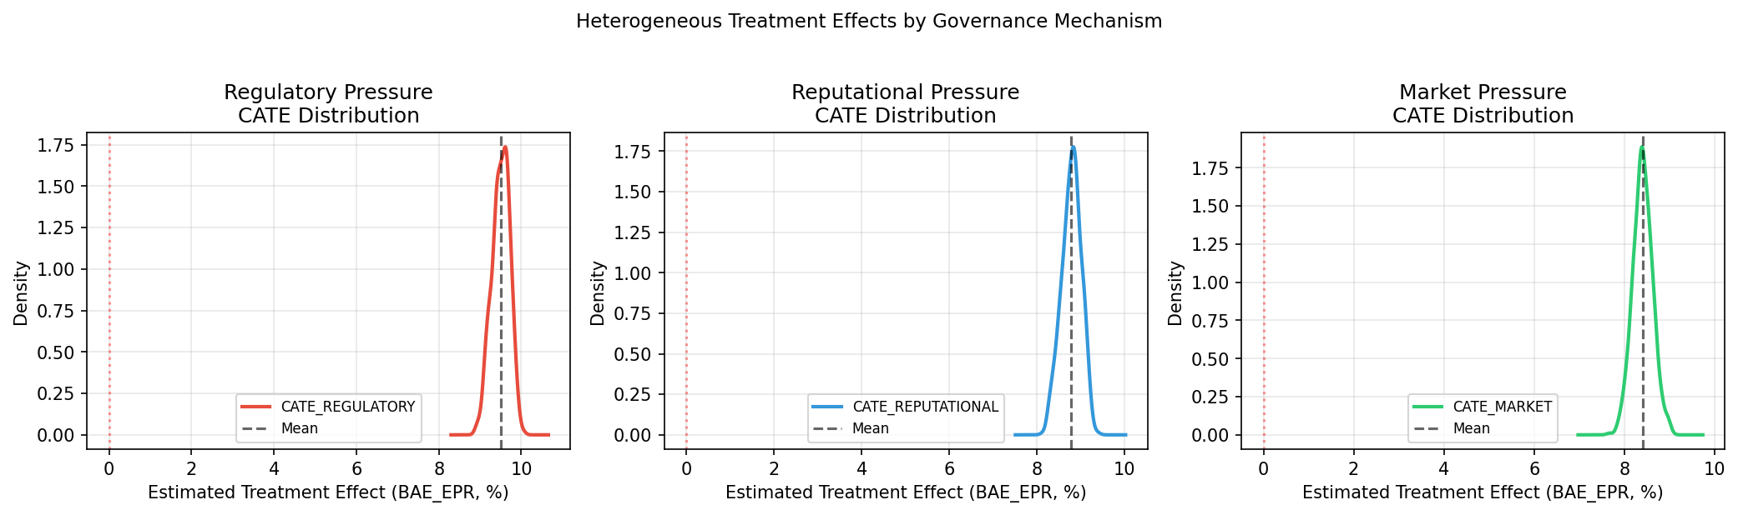
Figure 1. Distribution of conditional average treatment effects (CATEs) by governance arm. CATEs are per-firm estimates from pairwise CausalForestDML (each arm vs. control). Vertical dashed lines indicate arm-level average treatment effects.

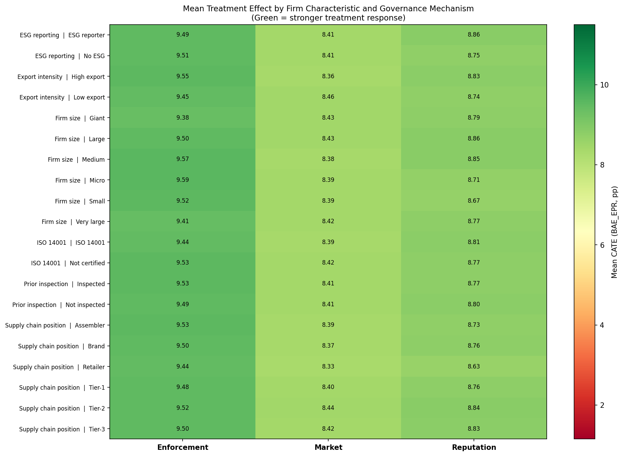
Figure 2. Subgroup CATE heatmap. Cell values are mean per-firm CATEs (in percentage points) for each subgroup category and governance arm. Darker shading indicates higher treatment effect.

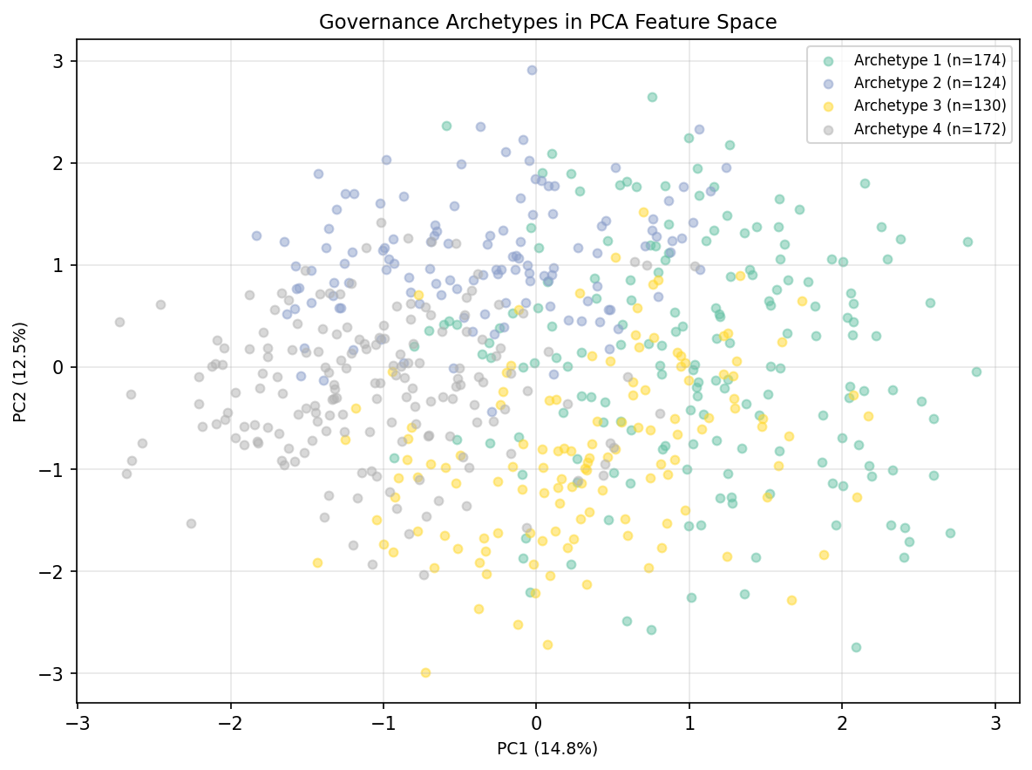
Figure 3. Governance archetypes in PCA-reduced feature space. Each point represents one firm coloured by archetype membership. Axes are the first two principal components of the nine standardised firm characteristics used for clustering.

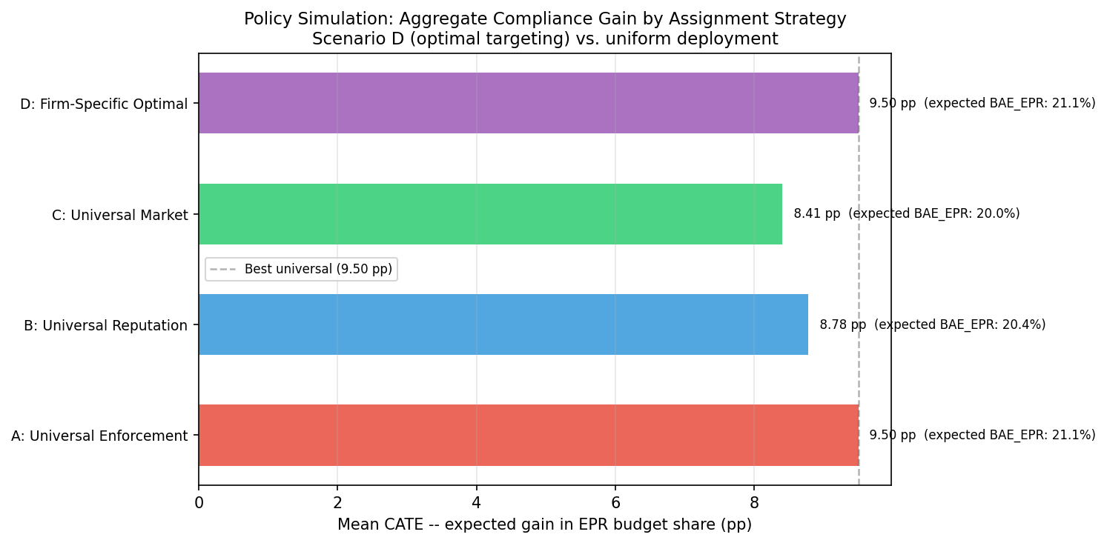
Figure 4. Policy simulation: aggregate mean CATE under four assignment scenarios. Bars represent mean expected EPR budget allocation gain (pp) across all 600 firms. The dashed vertical line indicates the best universal strategy (Scenario A).

[Figure not found: cross_arm_importance.png]

