IN6227 Assignment 1, Variant 2: Tabular Classification SKILL
LIN TONG, G2608825L
IN6227-2023-Assignment-1

INTRODUCTION

This report presents an end-to-end tabular classification workflow applied to the dataset (31112 rows, 15 features). The target variable is label with 2 classes: no, yes. Class distribution (train): no=23645, yes=7464, imbalance ratio 3.168:1. The data contains 50 missing values. Column types: 7 numeric, 8 categorical. The goal is to build a leakage-safe, reproducible classification pipeline and compare multiple models.

METHODS OR PROCEDURES

All learned preprocessing (median imputation for numerics, most-frequent imputation and one-hot encoding for categorics, standard scaling) is embedded inside sklearn Pipeline / ColumnTransformer, so during cross-validation the imputer, scaler, and encoder are refit on each training fold only. No manual feature selection is applied. Four classifiers are trained: DummyClassifier (stratified baseline), LogisticRegression (max_iter=1000, class_weight=balanced), RandomForest (n_estimators=200, class_weight=balanced), and GradientBoosting (n_estimators=100, max_depth=3). Cross-validation uses Stratified 5-fold (random_state=42). Model selection uses mean CV F1. The best model is retrained on the full training set and evaluated once on the held-out test set.

RESULTS

Cross-validation results (5-fold, stratified):

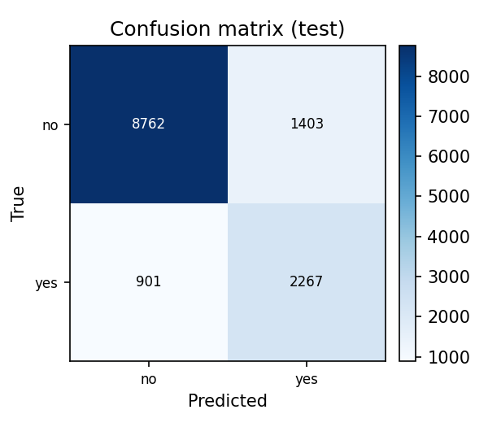Model Accuracy Precision Recall F1 ROC-AUC PR-AUC
dummy 0.6351 0.2365 0.2337 0.2351 0.4978 0.2391
logistic_regression 0.7903 0.5401 0.8493 0.6602 0.8905 0.7049
random_forest (best) 0.8266 0.6204 0.7146 0.6641 0.8892 0.7058
gradient_boosting 0.8392 0.7083 0.5610 0.6260 0.8913 0.7131

Test-set performance (best model: random_forest): accuracy=0.8272, precision=0.6177, recall=0.7156, F1=0.6631, ROC-AUC=0.8887, PR-AUC=0.7010.

DISCUSSION

Best model: random_forest, selected by CV F1=0.6641. Its advantage over LogisticRegression (CV F1=0.6602) was small (delta=0.0039); the two models are comparable in discriminative power. The Dummy baseline (F1=0.2351) confirms a no-information classifier performs well below all meaningful models. LogisticRegression achieves higher recall (0.849 vs 0.715) at the cost of lower precision (0.540 vs 0.620). Test F1 (0.6631) closely matches CV F1 (0.6641), indicating stable generalisation.

CONCLUSION

The SKILL successfully builds a reusable, leakage-safe tabular classification pipeline. RandomForest was selected as the best model by CV F1, though the margin over LogisticRegression was small. All numerical values are pulled from results.json. Model: GLM-5.2; LLM interface: TraeCode (Codex); GitHub: [PLACEHOLDER: Enter your GitHub repository link].

REFERENCES

[1] Pedregosa, F. et al. (2011). Scikit-learn: Machine Learning in Python. Journal of Machine Learning Research, 12, 2825-2830.
[2] Breiman, L. (2001). Random Forests. Machine Learning, 45(1), 5-32.
Name: LIN TONG
Matric number: G2608825L
Model (LLM): GLM-5.2
LLM interface: TraeCode (Codex)
GitHub: [PLACEHOLDER: Enter your GitHub repository link]

