**CONTROL MOBILE ROBOT USING ARGUMENT REALITY**

# ABSTRACT

The human-machine interface is an essential part of an intelligent robotic system. Through the human-machine interface, the human user can interact with the robot. A mobile robot is an automatic machine that is capable of movement in a given environment. Many techniques of automatic control are proposed. We have created an infrastructure that allows a human to collaborate in a natural manner with a robotic system. In this paper, we describe our system and its implementation with a mobile robot. Argument Reality using Unity is the method that we apply for this project. In this paper, we will introduce you to controlling mobile robots using the AR environment in Unity. The authors developed a mobile robot that moves to indicated points manually. With the AR environment in Unity, we are easily able to get the parameters of all of the objects that we are working with. Those parameters include position matrix, velocity, direction, etc… The most remarkable point is we can observe them instantaneously and direction on our interfacing, so operation will become much easier compared to traditional control ways. All we have to do is develop a user interface that we can interact with mobile robots and transmit the parameters between the user interface to the mobile robots using a local hotspot.

# 1.Introduction

Mobile robots can be useful in many ways in homes and offices monitoring and measuring the environment. They can be used as moving communications platforms or they can be simply toys or companions. More specialized robots can perform services such as cleaning and transportation of small objects.

Augmented Reality (AR) is a technology that overlays 3D virtual graphics onto the users view of the real world (Azuma, Baillot et al. 2001). AR allows real time interaction with these 3D graphics, enabling the user to reach into the augmented world and manipulate it directly. In human-robot collaborative endeavours the lack of situational awareness deteriorates robotic performance (Murphy 2004; Yanco, Drury et al. 2004). In our work we use AR to provide a common 3D graphic of the robot’s workspace that both the human and robot can reference. In this way we enable the human to maintain situational awareness of the robot and its surroundings and give the human-robot team the ability to ground their communication (Clark and Brennan 1991). By coupling AR with spoken dialogue we have developed a multimodal interface that enables natural and efficient communication between the human and robot team members, thus enabling effective collaboration. Specifically in this article, we will connect robots with humans through the software interface of our software. A control application via virtual reality and augmented reality technology (based on Unity3d) will provide an immediate, precise, and detailed monitoring and navigation of the robot's movements.

# Related work

With today's rapidly developing technology, many research papers and methods have been proposed to optimize human interaction and control with robots. The following prominent studies can be mentioned.

Skubic et al. (Skubic, Perzanowski et al. 2004) conducted a study on human-robot spatial dialogue. A multimodal interface was used, with input from speech, gestures, sensors and personal electronic devices. The robot was able to use dynamic levels of autonomy to reassess its spatial situation in the environment through the use of sensor readings and an evidence grid map. The result was natural human-robot spatial dialog enabling the robot to communicate obstacle locations relative to itself and receive verbal commands to move to an object it had detected.

Collaborative control was developed by Fong et al. (Fong,Thorpe et al.2003) for mobile autonomous robots. The robots work autonomously until they run into a problem they are unable to solve. At this point, the robots ask the remote operator for assistance, allowing human-robot interaction and autonomy to vary as needed. Robot performance increases with the addition of human skills, perception and cognition, and benefits from human advice and expertise. The human and robots engage in dialogue (through messaging, not spoken dialogue),exchange information, ask questions and resolve differences.

In more recent work, Fong et al. (Fong, Kunz et al. 2006) note that for humans and robots to work together as peers, the system must provide mechanisms for these peers to communicate effectively. The Human-Robot Interaction Operating System (HRI/OS) introduced enables a team of humans and robots to work together on tasks that are well defined and narrow in scope. The agents are able to use dialogue to communicate and the autonomous agents are able to use spatial reasoning to interpret ‘left of’ type dialogue elements. The ambiguities arising from such dialogue are resolved through modelling the situation in a simulation.

Giesler et al. (Giesler, Salb et al. 2004) implemented an AR system that creates a path for a mobile robot to follow using voice commands and a ‘magic wand’ made from AR fiducial markers. Pointing the wand at the floor, which is calibrated using multiple fiducial markers, voice commands can be used to create nodes along a motion path. These nodes can be interactively moved or deleted. As goal nodes are reached, the node depicted in AR changes colour to keep the user informed of the robots progress. The robot will retrace steps if an obstruction is encountered and create a new plan to arrive at the goal destination.

The above studies all have their advantages and disadvantages. Discussing their limitations and drawback, we can mention that there is no interface to directly interact with the mobile robot, when controlling, it is impossible to see the parameters of each robot, reducing accuracy, etc. However in general, they all have great contributions to the field of Collaborating with a Mobile Robot. Understanding that, we have inherited and promoted the advantages from other studies and overcome their limitations in our research paper. Our research is research in that it uses AR to provide the remote user with an interface in our app. AR enables the user to select a point in 3D space and refer to it using deictic references such as “go forward” , “turn left” , “turn right” and “go back”. Moreover, our tasks is more and more complicated so we normally will connect, communicate and control any mobile robot, usually with one controller and one robot. But in fact, many applications and jobs need the coordination of many robots together. To do that we cannot connect normally. To solve this, our the AR method of connecting control was born. With AR control technology and communication with mobile robots via UDP, we can solve many problems that cannot be solved by traditional methods. The outstanding features of the application of AR are the ability to communicate, control multiple mobile robots at the same time, and display the parameters of the mobile robot in real-time and these parameters are attached to the mobile robot.

# Architecture

Our research approach through the use of AR that allows humans to naturally communicate with our mobile robot. Through this architecture the robot receives the discrete information to operate while allowing the human to communicate in a natural and effective manner by referencing objects, positions and intentions through natural touches . The human and robot maintain situational awareness by referencing the shared 3D visuals of the workspace in the AR environment. The architectural design is shown in Fig. 1. When a defined dialogue goal is achieved the required information is sent to the robot through local hotspot.

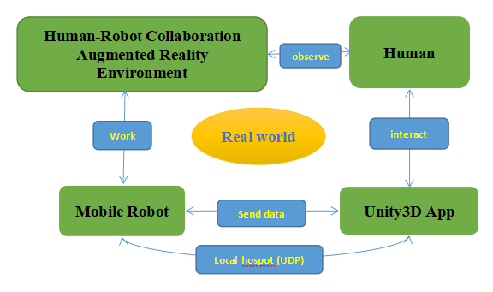

*Fig.1. Human Robot Collaboration System Architecture*

Thanks to a very optimized and intelligible human-robot collaboration system architecture, we have an overview of how the system works that the team is aiming for. Now, we will go deeper into the details of the system to fully understand how it works. The first is how our "main character" (mobile robot) moves. The model of a wheeled robot considered in this paper is shown in Fig. 2. The robot has two independent driving wheels, and its translational velocity *v* 1 and rotational velocity *v* 2 can be controlled. The ground coordinate system is defined as shown in Fig. 2. The central position of the two wheels is denoted by the (*x*, *y*) coordinates, and the heading angle with respect to the *x*-axis is denoted by *θ*. The special thing here is that the coordinate system (x,y) will now be the virtual coordinate system in Unity 3D. And this will give us the exact location of the mobile robot clearly and quickly because each mobile robot in our augmented reality environment is continuously tracked by the Vuforia in Unity 3D.

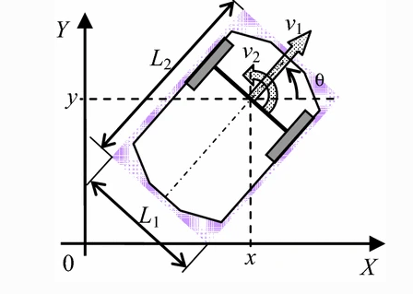

*Fig.2. Model of the two-wheeled robot*

After turning on Unity 3D, there will appear an interface with options that appear so that we can interact with the robot as follows:

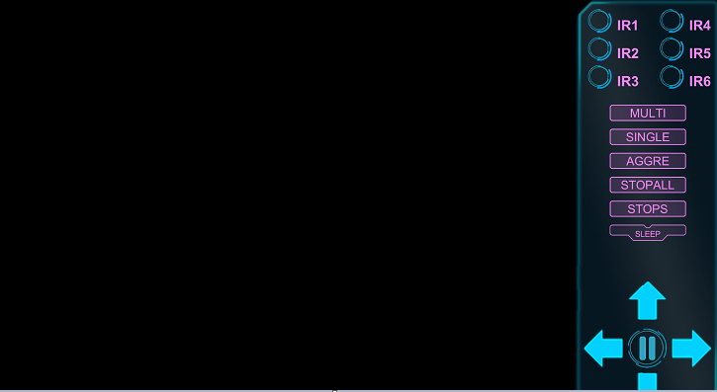

*Fig.3. The interface of Unity 3D App*

Because the inherent property of vuforia unity3d is that we have to constantly track the mobile robot. So for the best control interaction, we need to continuously rotate the device's camera to the robot. Then we will always get the fastest correct parameters of the mobile robot displayed on the panel.

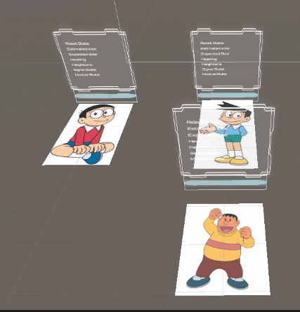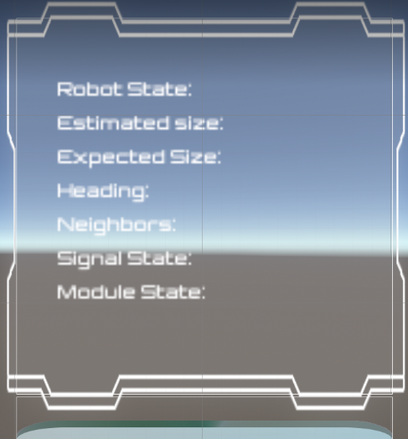

*Fig.4. The panels show their parameters*

Let's talk briefly about how the panels will display information, while the robot is operating it will continuously send information in the form of strings to our unity 3d app through the local hotspot. Our app will have a unique IP address but each mobile robot will have its IP address. By parsing the received string, we will have the specific parameters of each child, and since we have its IP address we push these parameters back to their respective panel.

Now we just need to control the robot as we want thanks to the control options. What stands out is the easy control but also the observation of the parameters. With this outstanding ability of Unity 3D, we can see the status of the robot and quickly repair, upgrade or replace the battery for them quickly. The following algorithm Fig.5. will explain more to better figure out the nature of how the system is progressing over time:

s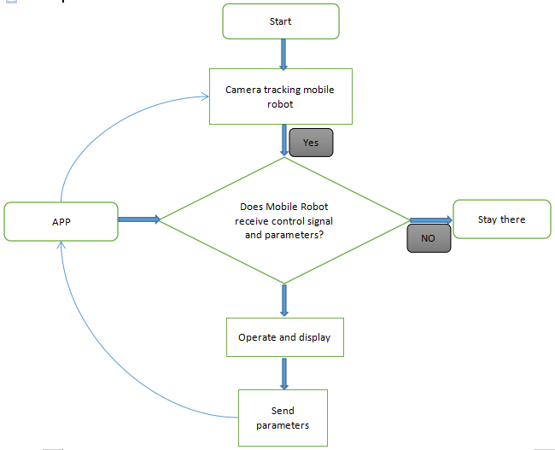

*Fig.5. The operational algorithm*

# Conclusions

In this paper we introduced our prototype system for human-robot collaboration. This system uses Augmented Reality to provide a means for a human to effectively communicate with a robot. AR provides an app has clear interface that the human can interact with. . Our system allows the human to maintain situational awareness of the robot through the use of AR. The robot displays its internal state and intentions in the AR imagery. This interface enables the human to communicate in a natural manner using the most simple touches. Unity 3D app turns these touches into data sends the robot information in a form that the robot needs to operate. In this manner our system enables a human to effectively collaborate with a mobile robot.

# References

Azuma, R., Y. Baillot, et al. (2001). Recent advances in augmented reality, IEEE Computer Graphics and Applications, 21, (6), 34-47.

Billinghurst, M., R. Grasset, et al. (2005). Designing Augmented Reality Interfaces, Computer Graphics SIGGRAPH Quarterly, 39(1), 17-22 Feb.

Clark, H. H. and S. E. Brennan (1991). Grounding in Communication, Perspectives on Socially Shared Cognition, L. Resnick, Levine J., Teasley, S., Washington D.C., American Psychological Association: 127 - 149.

Collett, T. H. J. and B. A. MacDonald (2006). Developer Oriented Visualisation of a Robot Program, Proceedings 2006 ACM Conference on Human-Robot Interaction, March 2-4, 49-56.

Fong, T., C. Kunz, et al. (2006). The Human-Robot Interaction Operating System, Proceedings of 2006 ACM Conference on Human-Robot Interaction, March 2-4, 41-48 Fong, T., C. Thorpe, et al. (2003). Multi-robot remote driving with collaborative control, IEEE Transactions on Industrial Electronics, 50, (4), 699-704.

Giesler, B., T. Salb, et al. (2004). Using augmented reality to interact with an autonomous mobile platform, Proceedings2004 IEEE International Conference on Robotics and Automation, Apr 26-May 1, New Orleans, LA, United States, Institute of Electrical and Electronics Engineers Inc., Piscataway, United States.

Navigation Simulation of a Mecanum Wheel Mobile Robot Based on an Improved A* Algorithm in Unity3D

by [Yunwang Li](https://sciprofiles.com/profile/698636" \t "https://www.mdpi.com/1424-8220/19/13/2976/_blank) , [Sumei Dai](https://sciprofiles.com/profile/708613" \t "https://www.mdpi.com/1424-8220/19/13/2976/_blank),[Yong Shi](https://sciprofiles.com/profile/author/R0FTZlF6SUVUNm1lUktMektWM0lmQmJ2UzBVVFhrbDZXQ0RTVmxjRExWMD0=" \t "https://www.mdpi.com/1424-8220/19/13/2976/_blank), [Lala Zhao](https://sciprofiles.com/profile/author/KytQbFpPU2N1K0lIVmFXOXNJbXYzSkYwM1d3UU5iUVhLN0RkZE9mN1IyQT0=" \t "https://www.mdpi.com/1424-8220/19/13/2976/_blank), [Minghua Ding](https://sciprofiles.com/profile/author/UXIyMG9LUU5OUkhoWVp6Y1BVWHNYV0dWZE5qMGtLZ2Q0ZG5zZXNFZEc5bz0=" \t "https://www.mdpi.com/1424-8220/19/13/2976/_blank)

Collaborating with a Mobile Robot: An Augmented Reality Multimodal Interface by Scott A.Green, Xioa Qi Chen, Mark Billinghurst, J. Geoffrey Chase