CRUD Equipment API

/equipment

Hiển thị danh sách API

/search

# Example 1 - (no query)

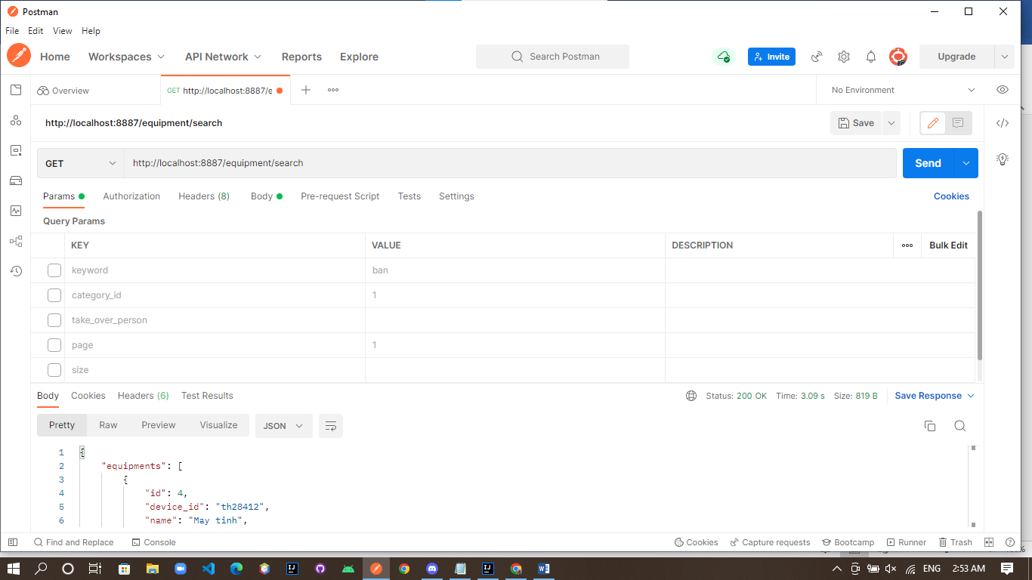

Result:

{

"equipments": [

{

"id": 4,

"device_id": "th28412",

"name": "May tinh",

"start_status": 1,

"price": 3.5E7,

"depreciated_value": 3.0,

"depreciation_period": 1.0,

"period_type": 1,

"import_date": 20211221100500,

"takeover_status": 1,

"category_id": 1,

"device_status": 1,

"created_by": "tuongvy",

"created_time": 20211221100500,

"updated_by": "tatthanh",

"updated_time": 0,

"takeover_person_id": "tuongvy",

"takeover_person_name": "Tường Vy"

},

{

"id": 5,

"device_id": "thkskdfm",

"name": "Ban phim",

"start_status": 1,

"price": 3500000.0,

"depreciated_value": 3.0,

"depreciation_period": 1.0,

"period_type": 1,

"import_date": 20211221100500,

"takeover_status": 0,

"category_id": 1,

"device_status": 0,

"created_by": "tuongvy",

"created_time": 20211221100500,

"updated_time": 0

},

{

"id": 6,

"device_id": "thkskdfsffm",

"name": "Ban phim telex",

"start_status": 1,

"price": 3500000.0,

"depreciated_value": 3.0,

"depreciation_period": 1.0,

"period_type": 1,

"import_date": 20211221100500,

"takeover_status": 0,

"category_id": 2,

"device_status": 1,

"created_by": "tuongvy",

"created_time": 20211221100500,

"updated_time": 0

},

{

"id": 7,

"device_id": "miluwalnuts",

"name": "DELL UPDATE",

"start_status": 1,

"price": 1.2E7,

"depreciated_value": 0.05,

"depreciation_period": 50.0,

"period_type": 1,

"import_date": 1520215210502,

"takeover_status": 0,

"category_id": 1,

"device_status": 1,

"created_by": "tuongvy",

"created_time": 51532155215421,

"updated_by": "tuongvy",

"updated_time": 51532155215421

},

{

"id": 8,

"device_id": "tuongvy",

"name": "DELL UPDATE",

"start_status": 1,

"price": 1.2E7,

"depreciated_value": 0.05,

"depreciation_period": 50.0,

"period_type": 1,

"import_date": 1520215210502,

"takeover_status": 0,

"category_id": 1,

"device_status": 1,

"created_by": "tuongvy",

"created_time": 51532155215421,

"updated_time": 0

}

],

"empty": false,

"total_equipments": 6,

"total_take_over_equipments": 1,

"total_inventory_equipments": 5,

"total_damaged_equipments": 0,

"total_lost_equipment": 1,

"page_numbers": [

{

"value": 1,

"is_current": true

},

{

"value": 2,

"is_current": false

}

],

"first_page": true,

"last_page": false,

"previous_page": 0,

"next_page": 2

}

# Example 2: 1 trong số query params

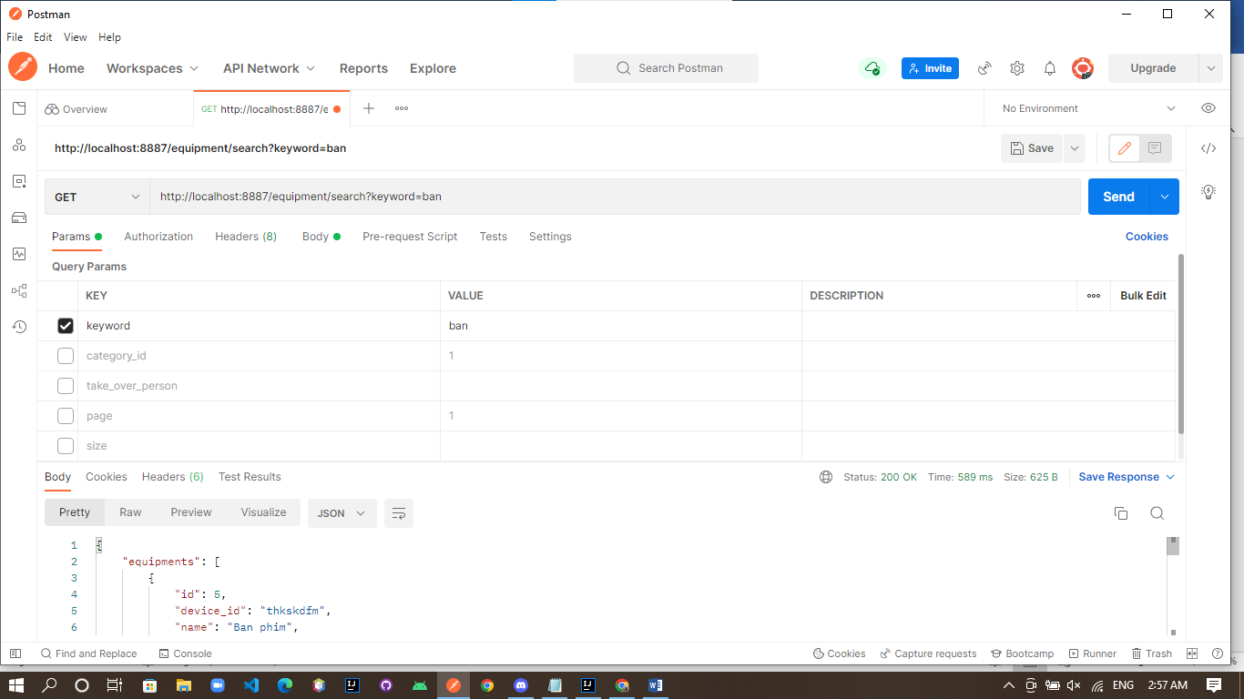

Result:

{

"equipments": [

{

"id": 5,

"device_id": "thkskdfm",

"name": "Ban phim",

"start_status": 1,

"price": 3500000.0,

"depreciated_value": 3.0,

"depreciation_period": 1.0,

"period_type": 1,

"import_date": 20211221100500,

"takeover_status": 0,

"category_id": 1,

"device_status": 0,

"created_by": "tuongvy",

"created_time": 20211221100500,

"updated_time": 0

},

{

"id": 6,

"device_id": "thkskdfsffm",

"name": "Ban phim telex",

"start_status": 1,

"price": 3500000.0,

"depreciated_value": 3.0,

"depreciation_period": 1.0,

"period_type": 1,

"import_date": 20211221100500,

"takeover_status": 0,

"category_id": 2,

"device_status": 1,

"created_by": "tuongvy",

"created_time": 20211221100500,

"updated_time": 0

}

],

"empty": false,

"total_equipments": 2,

"total_take_over_equipments": 0,

"total_inventory_equipments": 2,

"total_damaged_equipments": 0,

"total_lost_equipment": 1,

"page_numbers": [

{

"value": 1,

"is_current": true

}

],

"first_page": true,

"last_page": true,

"previous_page": 0,

"next_page": 2

}

# Example 3: nhiều query params

{

"equipments": [

{

"id": 5,

"device_id": "thkskdfm",

"name": "Ban phim",

"start_status": 1,

"price": 3500000.0,

"depreciated_value": 3.0,

"depreciation_period": 1.0,

"period_type": 1,

"import_date": 20211221100500,

"takeover_status": 0,

"category_id": 1,

"device_status": 0,

"created_by": "tuongvy",

"created_time": 20211221100500,

"updated_time": 0

}

],

"empty": false,

"total_equipments": 1,

"total_take_over_equipments": 0,

"total_inventory_equipments": 1,

"total_damaged_equipments": 0,

"total_lost_equipment": 1,

"page_numbers": [

{

"value": 1,

"is_current": true

}

],

"first_page": true,

"last_page": true,

"previous_page": 0,

"next_page": 2

}

UPDATE THÔNG TIN THIẾT BỊ

/update

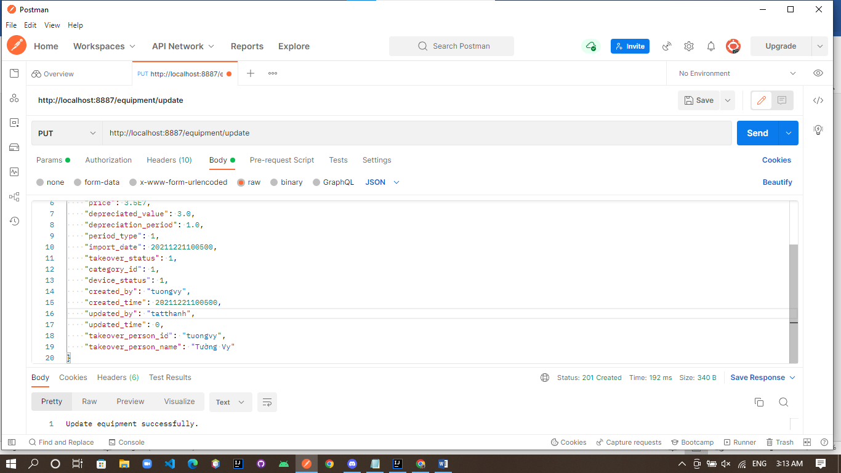

Body:

{

    "id": 4,

    "device_id": "th28412",

    "name": "May tinh xach tay",

    "start_status": 1,

    "price": 3.5E7,

    "depreciated_value": 3.0,

    "depreciation_period": 1.0,

    "period_type": 1,

    "import_date": 20211221100500,

    "takeover_status": 1,

    "category_id": 1,

    "device_status": 1,

    "created_by": "tuongvy",

    "created_time": 20211221100500,

    "updated_by": "tatthanh",

    "updated_time": 0,

    "takeover_person_id": "tuongvy",

    "takeover_person_name": "Tường Vy"

}

HIỂN THỊ THÔNG TIN CHI TIẾT

/:id

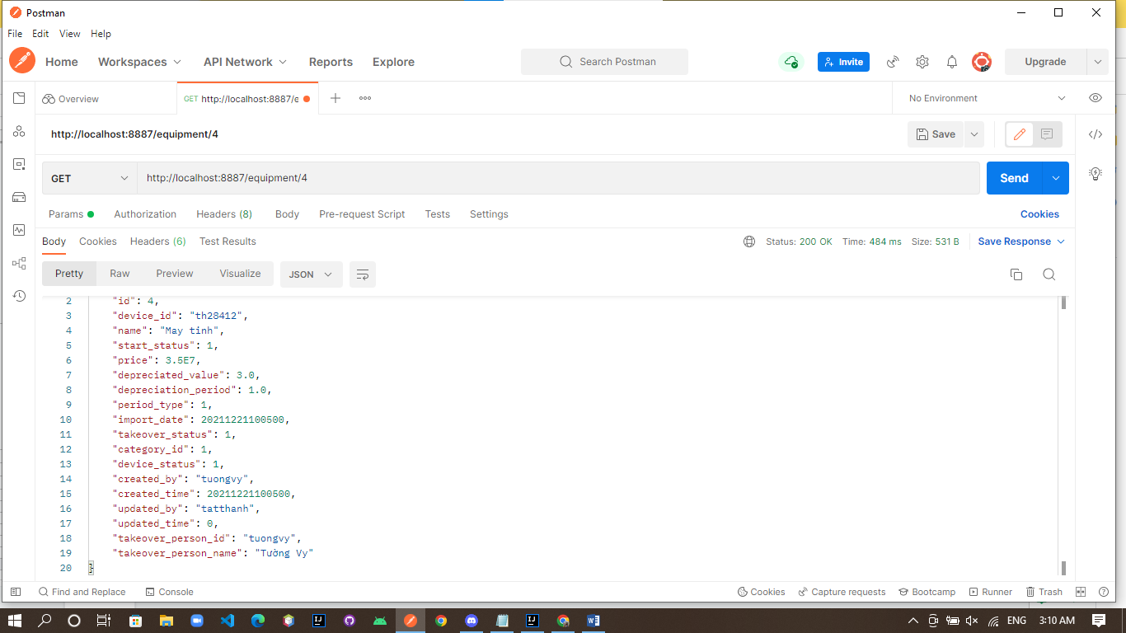

XÓA THIẾT BỊ

/del

