Bài 2: layout

**Bài tập 1:**

Exercise 1.xml

|  |
| --- |
| *<?***xml version="1.0" encoding="utf-8"***?>* <**androidx.constraintlayout.widget.ConstraintLayout xmlns:android="http://schemas.android.com/apk/res/android"  xmlns:app="http://schemas.android.com/apk/res-auto"  xmlns:tools="http://schemas.android.com/tools"  android:layout_width="match_parent"  android:layout_height="match_parent"  android:orientation="vertical"** >   <**LinearLayout  android:layout_width="match_parent"  android:layout_height="match_parent"  android:orientation="horizontal"**>   <**ScrollView  android:layout_width="match_parent"  android:layout_height="match_parent"**>   <**LinearLayout  android:layout_width="match_parent"  android:layout_height="wrap_content"  android:orientation="vertical"** >   <**ImageView  android:id="@+id/imageView7"  android:layout_width="170dp"  android:layout_height="141dp"  app:srcCompat="@mipmap/ic_launcher"** />   <**TextView  android:id="@+id/textView33"  android:layout_width="189dp"  android:layout_height="30dp"  android:text="select the plaform you like"** />   <**CheckBox  android:id="@+id/checkBox"  android:layout_width="91dp"  android:layout_height="wrap_content"  android:text="IPhone"** />   <**CheckBox  android:id="@+id/checkBox2"  android:checked="true"  android:layout_width="wrap_content"  android:layout_height="wrap_content"  android:duplicateParentState="false"  android:text="Android"** />   <**CheckBox  android:id="@+id/checkBox3"  android:layout_width="wrap_content"  android:layout_height="wrap_content"  android:text="Window mobile"** />   <**TextView  android:id="@+id/textView34"  android:layout_width="68dp"  android:layout_height="wrap_content"  android:text="Gender"** />   <**RadioButton  android:id="@+id/radioButton"  android:checked="true"  android:layout_width="wrap_content"  android:layout_height="wrap_content"  android:text="MALE"** />   <**RadioButton  android:id="@+id/radioButton2"  android:layout_width="wrap_content"  android:layout_height="wrap_content"  android:text="FEMALE"** />   <**TextView  android:id="@+id/textView35"  android:layout_width="wrap_content"  android:layout_height="wrap_content"  android:text="Rate your girl /guy in love with you"** />   <**RatingBar  android:id="@+id/ratingBar"  android:layout_width="wrap_content"  android:layout_height="wrap_content"  android:numStars="4"  android:rating="2"  android:stepSize="1"** />   <**TextView  android:id="@+id/textView36"  android:layout_width="wrap_content"  android:layout_height="wrap_content"  android:text="Your Country"** />   <**Spinner  android:layout_width="218dp"  android:layout_height="44dp"  android:entries="@array/country"** />   <**TextView  android:id="@+id/textView37"  android:layout_width="wrap_content"  android:layout_height="wrap_content"  android:text="Your University"** />   <**Spinner  android:layout_width="187dp"  android:layout_height="42dp"  android:entries="@array/university"** />   <**TextView  android:id="@+id/textView38"  android:layout_width="wrap_content"  android:layout_height="wrap_content"  android:text="Your favourite"** />   <**CheckBox  android:id="@+id/checkBox6"  android:checked="true"  android:layout_width="match_parent"  android:layout_height="wrap_content"  android:text="Tennis"** />   <**CheckBox  android:id="@+id/checkBox7"  android:layout_width="match_parent"  android:layout_height="wrap_content"  android:text="Running"** />   <**CheckBox  android:id="@+id/checkBox8"  android:layout_width="match_parent"  android:layout_height="wrap_content"  android:checked="true"  android:text="Swimming"** />   <**CheckBox  android:id="@+id/checkBox9"  android:layout_width="match_parent"  android:layout_height="wrap_content"  android:text="Sleeping"** />   <**CheckBox  android:id="@+id/checkBox10"  android:layout_width="match_parent"  android:layout_height="wrap_content"  android:text="Reading"** />   <**Button  android:id="@+id/button"  android:layout_width="match_parent"  android:layout_height="wrap_content"  android:text="Submit"** />    </**LinearLayout**>  </**ScrollView**>  </**LinearLayout**> </**androidx.constraintlayout.widget.ConstraintLayout**> |

Strings.xml

|  |
| --- |
| <**resources**>  <**string name="app_name"**>scsc</**string**>  <**string-array name="country"**>  <**item**>Việt Nam</**item**>  <**item**>Hàn Quốc</**item**>  <**item**>Trung Quốc</**item**>  <**item**>Philippines</**item**>  <**item**>Ấn Độ</**item**>  <**item**>Nga</**item**>  <**item**>Mỹ</**item**>   </**string-array**>   <**string-array name="university"**>  <**item**>PTIT</**item**>  <**item**>HEU</**item**>  <**item**>HUBT</**item**>  <**item**>APTECH</**item**>  <**item**>FPT</**item**>  <**item**>AMSTERDAM</**item**>  <**item**>KingKong</**item**>   </**string-array**> </**resources**> |

MainActivity

|  |
| --- |
| **package** com.example.scsc;  **import** androidx.appcompat.app.AppCompatActivity;  **import** android.os.Bundle;  **public class** MainActivity **extends** AppCompatActivity {   @Override  **protected void** onCreate(Bundle savedInstanceState) {  **super**.onCreate(savedInstanceState);  setContentView(R.layout.***exersice1***);  } } |

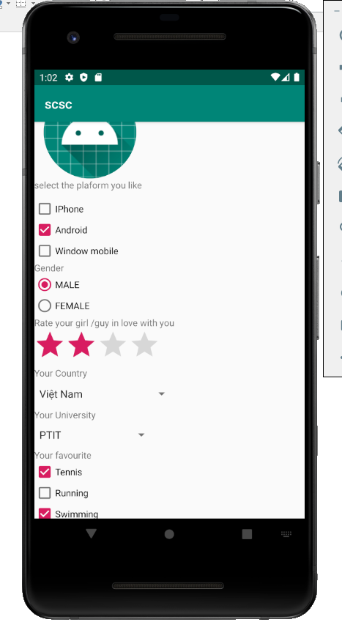

**Bài Tập 2:**

Exercise 2.xml:

|  |
| --- |
| *<?***xml version="1.0" encoding="utf-8"***?>* <**androidx.constraintlayout.widget.ConstraintLayout xmlns:android="http://schemas.android.com/apk/res/android"  xmlns:app="http://schemas.android.com/apk/res-auto"  xmlns:tools="http://schemas.android.com/tools"  android:layout_width="match_parent"  android:layout_height="match_parent"  android:orientation="vertical"**>   <**Button  android:id="@+id/button4"  android:layout_width="wrap_content"  android:layout_height="wrap_content"  android:layout_marginTop="442dp"  android:layout_marginEnd="307dp"  android:layout_marginRight="307dp"  android:layout_marginBottom="241dp"  android:text="Home"  app:layout_constraintBottom_toBottomOf="parent"  app:layout_constraintEnd_toEndOf="parent"  app:layout_constraintTop_toTopOf="parent"** />   <**Button  android:id="@+id/button5"  android:layout_width="wrap_content"  android:layout_height="wrap_content"  android:layout_marginStart="161dp"  android:layout_marginLeft="161dp"  android:layout_marginTop="442dp"  android:layout_marginEnd="162dp"  android:layout_marginRight="162dp"  android:layout_marginBottom="241dp"  android:text="Buy Now"  app:layout_constraintBottom_toBottomOf="parent"  app:layout_constraintEnd_toEndOf="parent"  app:layout_constraintStart_toStartOf="parent"  app:layout_constraintTop_toTopOf="parent"** />   <**Button  android:id="@+id/button6"  android:layout_width="wrap_content"  android:layout_height="wrap_content"  android:layout_marginStart="297dp"  android:layout_marginLeft="297dp"  android:layout_marginTop="442dp"  android:layout_marginEnd="26dp"  android:layout_marginRight="26dp"  android:layout_marginBottom="241dp"  android:text="detail"  app:layout_constraintBottom_toBottomOf="parent"  app:layout_constraintEnd_toEndOf="parent"  app:layout_constraintStart_toStartOf="parent"  app:layout_constraintTop_toTopOf="parent"** />   <**ImageView  android:id="@+id/imageView2"  android:layout_width="208dp"  android:layout_height="291dp"  android:layout_marginStart="3dp"  android:layout_marginLeft="3dp"  android:layout_marginEnd="200dp"  android:layout_marginRight="200dp"  android:layout_marginBottom="440dp"  app:layout_constraintBottom_toBottomOf="parent"  app:layout_constraintEnd_toEndOf="parent"  app:layout_constraintStart_toStartOf="parent"  app:layout_constraintTop_toTopOf="parent"  app:srcCompat="@drawable/iPhone_12_pro_8"** />   <**TextView  android:id="@+id/textView"  android:layout_width="wrap_content"  android:layout_height="wrap_content"  android:layout_marginStart="238dp"  android:layout_marginLeft="238dp"  android:layout_marginTop="52dp"  android:layout_marginEnd="89dp"  android:layout_marginRight="89dp"  android:layout_marginBottom="660dp"  android:text="35.090.000 đ"  app:layout_constraintBottom_toBottomOf="parent"  app:layout_constraintEnd_toEndOf="parent"  app:layout_constraintHorizontal_bias="1.0"  app:layout_constraintStart_toStartOf="parent"  app:layout_constraintTop_toTopOf="parent"  app:layout_constraintVertical_bias="1.0"** />   <**TextView  android:id="@+id/textView2"  android:layout_width="wrap_content"  android:layout_height="wrap_content"  android:layout_marginStart="211dp"  android:layout_marginLeft="211dp"  android:layout_marginTop="128dp"  android:layout_marginEnd="8dp"  android:layout_marginRight="8dp"  android:layout_marginBottom="550dp"  android:text="Điện thoại iPhone 12 \n - Siêu phẩm \n - iPhone khẳng định đẳng cấp"  app:layout_constraintBottom_toBottomOf="parent"  app:layout_constraintEnd_toEndOf="parent"  app:layout_constraintStart_toStartOf="parent"  app:layout_constraintTop_toTopOf="parent"** />  </**androidx.constraintlayout.widget.ConstraintLayout**> |

MainActivity

|  |
| --- |
| **package** com.example.scsc;  **import** androidx.appcompat.app.AppCompatActivity;  **import** android.os.Bundle;  **public class** MainActivity **extends** AppCompatActivity {   @Override  **protected void** onCreate(Bundle savedInstanceState) {  **super**.onCreate(savedInstanceState);  setContentView(R.layout.***exersice2***);  } } |

