2120151025 欧阳童

# 数据摘要

winter 频数 ：62

spring 频数 ：53

autumn 频数 ：40

summer 频数 ：45

small 频数 ：71

spring 频数 ：84

autumn 频数 ：45

low 频数 ：33

medium 频数 ：83

high 频数 ：84

mxPH的最大值为9.7,的最小值为5.6,均值为8.011733668341707,缺少值有1,中值为8.06,四分数7.7,8.4

mnO2的最大值为13.4,的最小值为1.5,均值为9.117777777777775,缺少值有2,中值为9.8,四分数7.7,10.8

Cl的最大值为391.5,的最小值为0.222,均值为43.636278842105284,缺少值有10,中值为32.730000000000004,四分数10.936,57.75

NO3的最大值为45.65,的最小值为0.05,均值为3.282388888888888,缺少值有2,中值为2.675,四分数1.287,4.188

NH4的最大值为24064.0,的最小值为5.0,均值为501.29582838383845,缺少值有2,中值为103.1665,四分数37.778,224.286

oPO4的最大值为564.59998,的最小值为1.0,均值为73.59059595959597,缺少值有2,中值为40.15,四分数14.667,87.333

PO4的最大值为771.59998,的最小值为1.0,均值为137.882100959596,缺少值有2,中值为103.2855,四分数40.0,211.66701

Chla的最大值为110.456,的最小值为0.2,均值为13.971196808510639,缺少值有12,中值为5.475,四分数2.0,18.3

a1的最大值为89.8,的最小值为0.0,均值为16.923499999999997,缺少值有0,中值为6.95,四分数1.5,24.8

a2的最大值为72.6,的最小值为0.0,均值为7.458500000000003,缺少值有0,中值为3.0,四分数0.0,11.3

a3的最大值为42.8,的最小值为0.0,均值为4.309500000000001,缺少值有0,中值为1.55,四分数0.0,4.9

a4的最大值为44.6,的最小值为0.0,均值为1.9924999999999995,缺少值有0,中值为0.0,四分数0.0,2.4

a5的最大值为44.4,的最小值为0.0,均值为5.064500000000001,缺少值有0,中值为1.9,四分数0.0,7.5

a6的最大值为77.6,的最小值为0.0,均值为5.9639999999999995,缺少值有0,中值为0.0,四分数0.0,6.9

a7的最大值为31.6,的最小值为0.0,均值为2.4954999999999985,缺少值有0,中值为1.0,四分数0.0,2.4

## 数据的可视化

绘制直方图

以mxPH为例

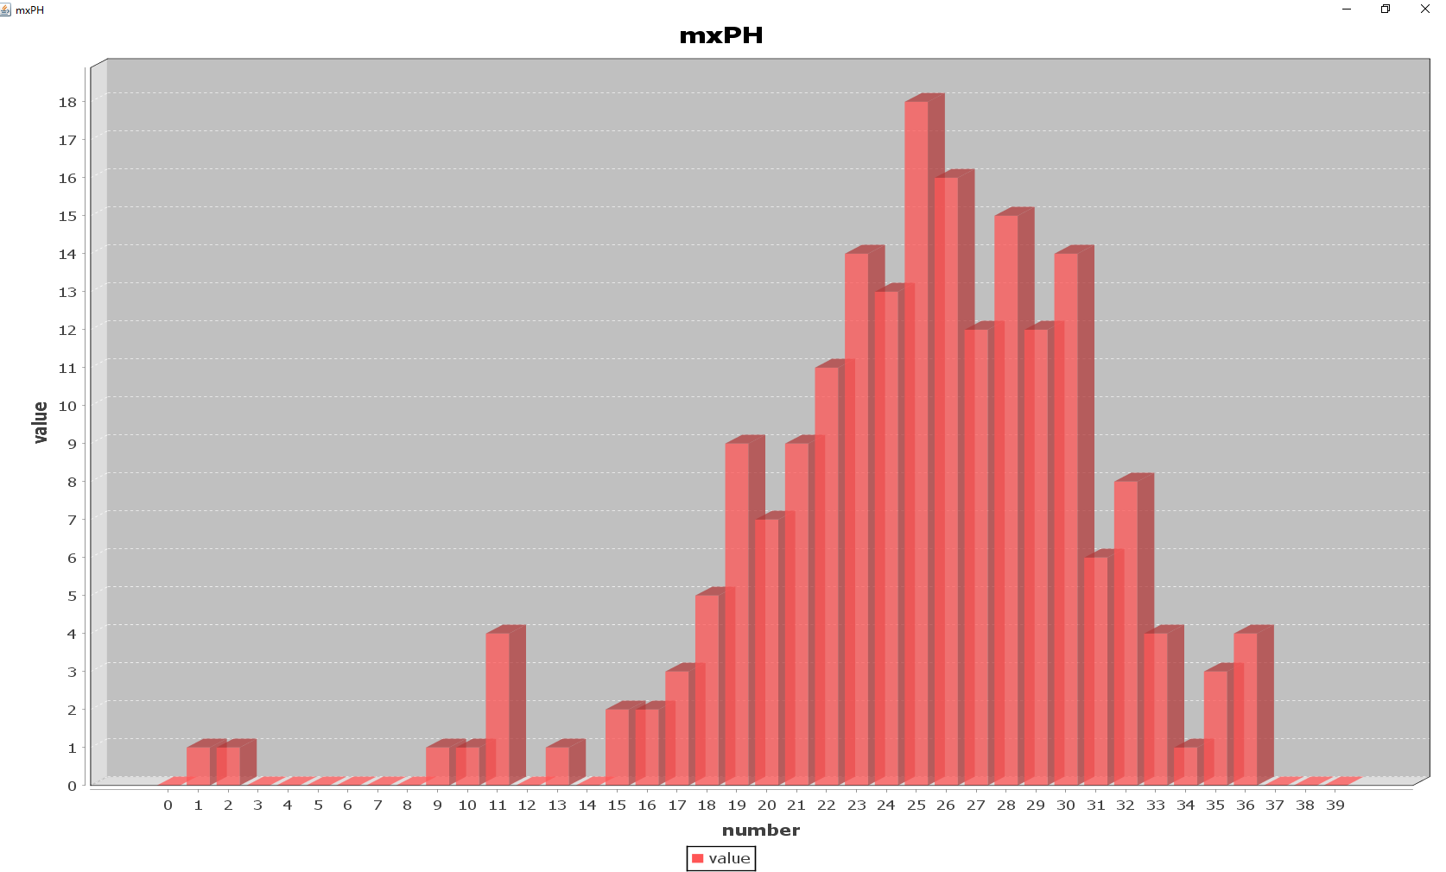

**直方图**

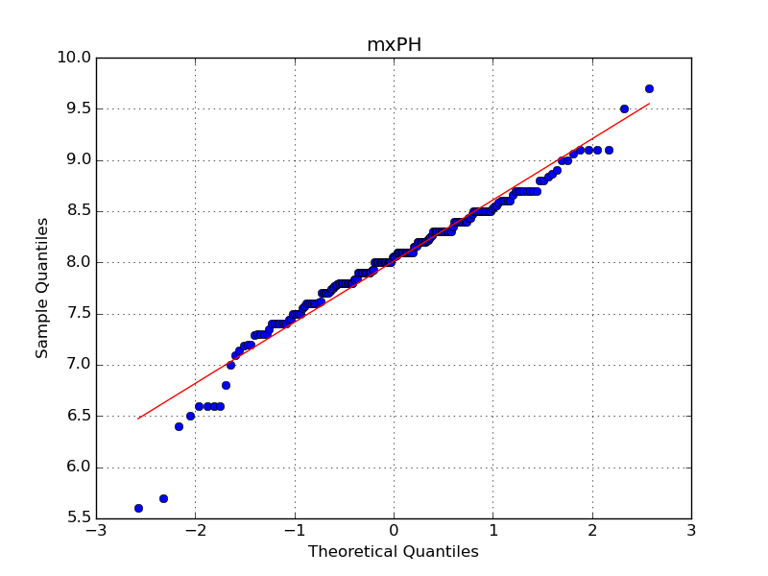

**Q-Q图**

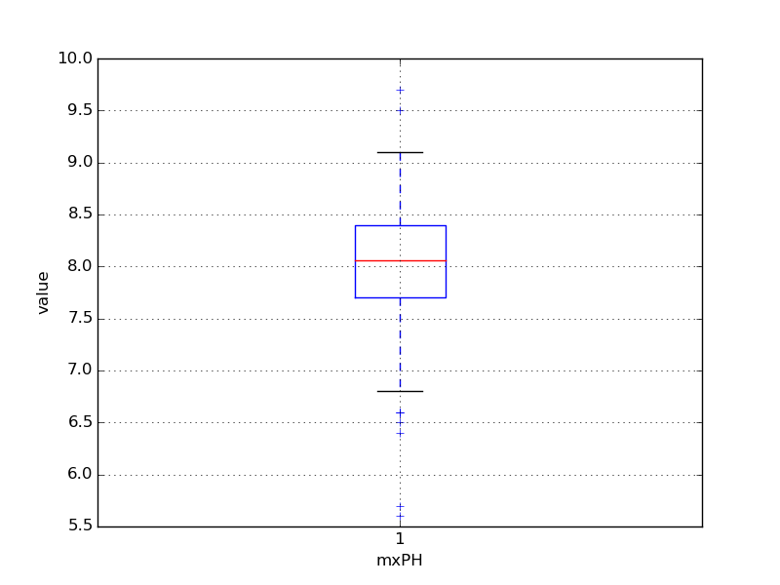

**盒图**

# 数据缺失项的处理

1、将缺失部分剔除

参见Analysis_without_lost.txt

形如：

|winter|small|medium|8.00000|9.80000|60.80000|6.23800|578.00000|105.00000|170.00000|50.00000|0.00000|0.00000|0.00000|0.00000|34.20000|8.30000|0.00000|

|spring|small|medium|8.35000|8.00000|57.75000|1.28800|370.00000|428.75000|558.75000|1.30000|1.40000|7.60000|4.80000|1.90000|6.70000|0.00000|2.10000|

|autumn|small|medium|8.10000|11.40000|40.02000|5.33000|346.66699|125.66700|187.05701|15.60000|3.30000|53.60000|1.90000|0.00000|0.00000|0.00000|9.70000|

|spring|small|medium|8.07000|4.80000|77.36400|2.30200|98.18200|61.18200|138.70000|1.40000|3.10000|41.00000|18.90000|0.00000|1.40000|0.00000|1.40000|

|autumn|small|medium|8.06000|9.00000|55.35000|10.41600|233.70000|58.22200|97.58000|10.50000|9.20000|2.90000|7.50000|0.00000|7.50000|4.10000|1.00000|

|winter|small|high|8.25000|13.10000|65.75000|9.24800|430.00000|18.25000|56.66700|28.40000|15.10000|14.60000|1.40000|0.00000|22.50000|12.60000|2.90000|

|summer|small|high|8.15000|10.30000|73.25000|1.53500|110.00000|61.25000|111.75000|3.20000|2.40000|1.20000|3.20000|3.90000|5.80000|6.80000|0.00000|

|autumn|small|high|8.05000|10.60000|59.06700|4.99000|205.66701|44.66700|77.43400|6.90000|18.20000|1.60000|0.00000|0.00000|5.50000|8.70000|0.00000|

|winter|small|medium|8.70000|3.40000|21.95000|0.88600|102.75000|36.30000|71.00000|5.54400|25.40000|5.40000|2.50000|0.00000|0.00000|0.00000|0.00000|

2、用最高频率值来填补缺失值

参见Analysis_freq.txt

形如：

|winter|small|medium|8.00000|9.80000|60.80000|6.23800|578.00000|105.00000|170.00000|50.00000|0.00000|0.00000|0.00000|0.00000|34.20000|8.30000|0.00000|

|spring|small|medium|8.00000|9.80000|60.80000|6.23800|578.00000|105.00000|170.00000|50.00000|1.40000|7.60000|4.80000|1.90000|6.70000|0.00000|2.10000|

|autumn|small|medium|8.00000|9.80000|60.80000|6.23800|578.00000|105.00000|170.00000|50.00000|3.30000|53.60000|1.90000|0.00000|0.00000|0.00000|9.70000|

|spring|small|medium|8.00000|9.80000|60.80000|6.23800|578.00000|105.00000|170.00000|50.00000|3.10000|41.00000|18.90000|0.00000|1.40000|0.00000|1.40000|

|autumn|small|medium|8.00000|9.80000|60.80000|6.23800|578.00000|105.00000|170.00000|50.00000|9.20000|2.90000|7.50000|0.00000|7.50000|4.10000|1.00000|

|winter|small|high|8.00000|9.80000|60.80000|6.23800|578.00000|105.00000|170.00000|50.00000|15.10000|14.60000|1.40000|0.00000|22.50000|12.60000|2.90000|

|summer|small|high|8.00000|9.80000|60.80000|6.23800|578.00000|105.00000|170.00000|50.00000|2.40000|1.20000|3.20000|3.90000|5.80000|6.80000|0.00000|

|autumn|small|high|8.00000|9.80000|60.80000|6.23800|578.00000|105.00000|170.00000|50.00000|18.20000|1.60000|0.00000|0.00000|5.50000|8.70000|0.00000|

|winter|small|medium|8.00000|9.80000|60.80000|6.23800|578.00000|105.00000|170.00000|50.00000|25.40000|5.40000|2.50000|0.00000|0.00000|0.00000|0.00000|