Get a Git Repository
-Initializing a Repository in an Existing Directory
$git init
Initialized empty Git repository in /home/tongust/Program/cpp/sbwt/test-git/.git/
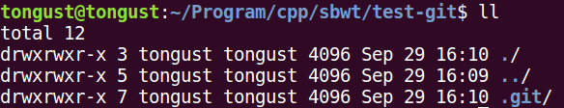
$ git add readme.txt
$ cat readme.txt
read me
$ git commit -m “wrote a readme file”
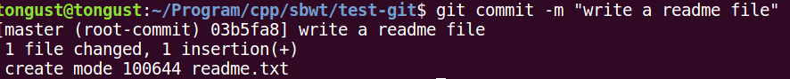
$ vi readme.txt
editorializing the file…
$ cat readme.txt
read me
read me again
$ git status
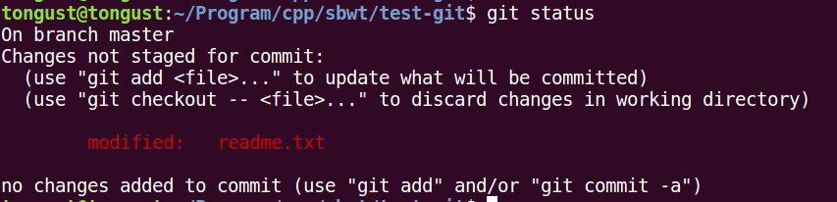
$ git diff
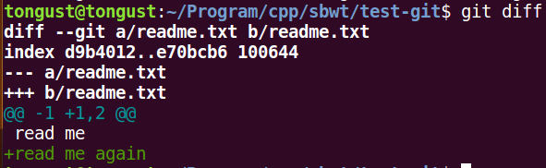
# Every time you modify a file or write a new file you should use “ git add NewFile ” before committing your files.
$ git add readme.txt
$ git commit -m “modify the readme file”
$ git status
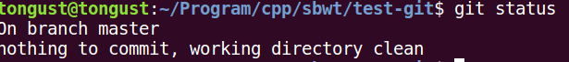
$ git log
# see the history of commit
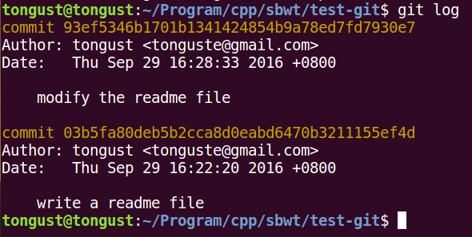
$ git reflog
# check the command history
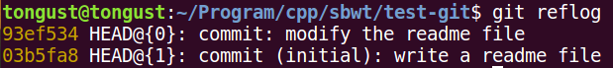
93ef534 is the abbreviated commit id

### Undoing
首先，Git必须知道当前版本是哪个版本，在Git中，用HEAD表示当前版本，也就是最新的提交3628164...882e1e0（注意我的提交ID和你的肯定不一样），上一个版本就是HEAD^，上上一个版本就是HEAD^^，当然往上100个版本写100个^比较容易数不过来，所以写成HEAD~100。
$ get reset --hard HEAD^
or
$ get reset --hard 03b5fa8
############################EXAMPLE#############################
$ cat readme.txt
read me # corresponding to the commit 03b5…
read me # corresponding to the commit “modify the readme file” 93ef…
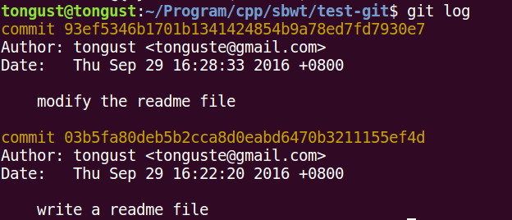
# back to “Write a readme file ” stage
$ git log
# first we check the current-stage log
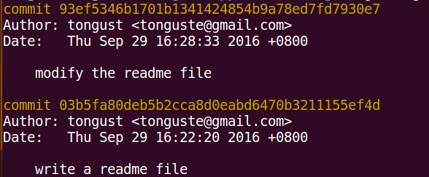
Attention:
reflog is difference with log
reflog track any commit command and its ids, while the log only store the valid current-stage commit command and HEAD.
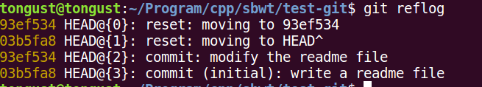
$ git reset --hard HEAD~1 # not HEAD~3
or
$ git reset --hard 03b5fa8
# Then check the current-stage commit
$ git log

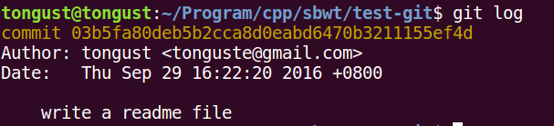
$ cat readme.txt
read me
# the commission “modify the readme file” just disappear
# Go forward if you want, you have to ask for “reflog”
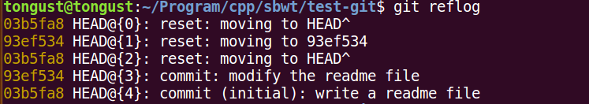
# the reset id is same with the commit id
$ git reset --hard 93ef534
HEAD is now at 93ef534 modify the readme file
$ cat readme.txt
read me
read me again # the commit comes forward.
$ git log
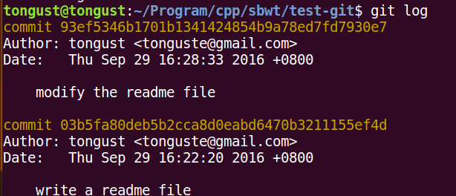
# 撤销修改
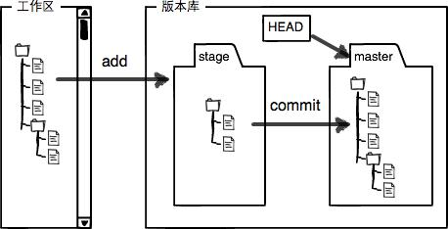
# Workshop undoing before “add” or “rm”
$ git checkout – readme.txt
# Stage undoing before “commit”
$ git reset HEAD readme.txt
########################### create the remote github repository ############
## create the github item sbwa-buildIndex
##{ssh mode neednt any password just public key}
git remote add origin git@github.com:tongust/sbwa-buildIndex.git
git push -u origin master

#### the push mode is different between HTTP and ssh

# from now on you only need the commands
$ git push origin master
to update you codes.
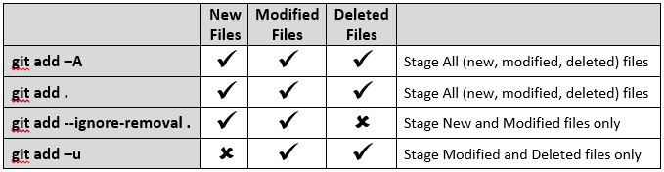
# remove the remote originak
Remove untracked files from the working tree
Step 1 is to show what will be deleted by using the -n option:
git clean -f -n
Clean Step - beware: this will delete files:
git clean -f
- To remove directories, run git clean -f -d or git clean -fd
- To remove ignored files, run git clean -f -X or git clean -fX
- To remove ignored and non-ignored files, run git clean -f -x or git clean -fx
Note the case difference on the X for the two latter commands.
If clean.requireForce is set to "true" (the default) in your configuration, one needs to specify -f otherwise nothing will actually happen.
Ref: http://stackoverflow.com/questions/61212/how-to-remove-local-untracked-files-from-the-current-git-branch

