# 9大过滤器

1. lowercase

{{lowercase_expression|lowercase}}

$filter(‘lowercase’)(stringValue)

Example:

$filter(‘lowercase’)(‘ABC’) //abc

1. uppercase

{{uppercase_expression|uppercase}}

$filter(‘uppercase’)(‘abc’) //ABC

1. currency

{{currency_expression|currency:symbol:fractionSize}}

$filter(‘currency’)(amount,symbol,fractionSize)

Example:

$filter('currency')(34.453,"$",2); //34.45

4.number

{{number_expression|number:fractionSize}}

$filter(‘number’)(number,fractionSize)

Example:

$filter(‘number’)(1212.56,1) //1212.6

1. date

{{date_expression|date:format:timezone}}

$filter(“date”)(date_value,format,timezone);

Example:

$filter(“date”)(new Date(),”yyyy-MM-dd”)

1. json(转换为json数据)

{{json_expression|json:spacing}} //spacing默认是2，表示空格个数

$filter(‘json’)(object,spacing) //数组也是object

Example:

$filter(“json”)({name:”tongwl”},4)

1. limitTo

{{limitTo_expression|limitTo:length:begin}} **//beigin好像没什么用!!!length可以为负值，表示从后面开始截取。**

$filter(‘limitTo’)(123456789,-5) //56789

1. orderBy

{{orderrBy_expression|orderBy:expression:reverse:comparator}}

$filter(‘orderBy’)(collection,expression,reverse,comparator)

1. 自定义过滤器(可以用在循环)

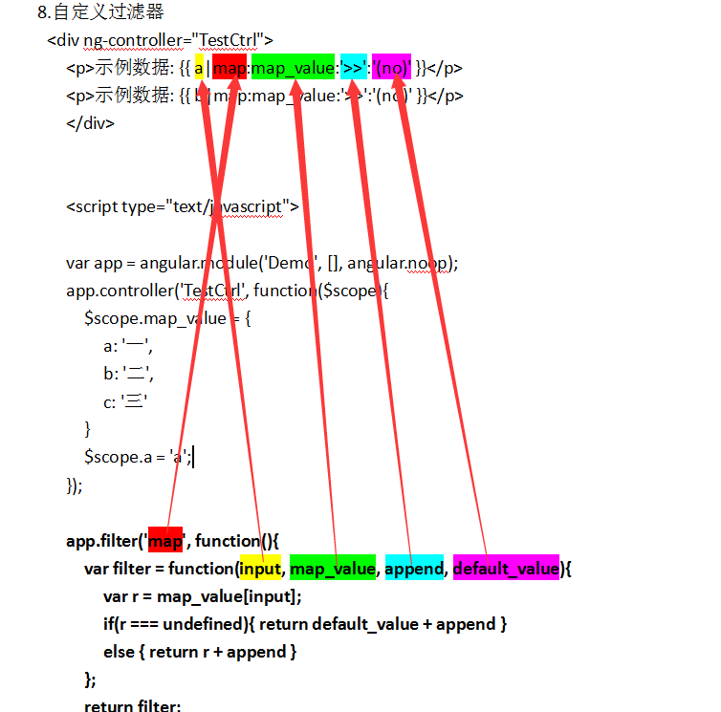

以下是源码：

<div ng-controller="TestCtrl">

<p>示例数据: {{ a|map:map_value:'>>':'(no)' }}</p>

<p>示例数据: {{ b|map:map_value:'>>':'(no)' }}</p>

</div>

<script type="text/javascript">

var app = angular.module('Demo', [], angular.noop);

app.controller('TestCtrl', function($scope){

$scope.map_value = {

a: '一',

b: '二',

c: '三'

}

$scope.a = 'a';

});

**app.filter('map', function(){**

**var filter = function(input, map_value, append, default_value){**

**var r = map_value[input];**

**if(r === undefined){ return default_value + append }**

**else { return r + append }**

**};**

**return filter;**

**});**

angular.bootstrap(document, ['Demo']);

</script>